Figure S1

Figure S1 Scatter plot analysis of the selected modules

(A–E) Scatterplots of gene significance versus module membership showing 2380 key module genes related to asthma.

Table S1 Primers used for real-time quantitative PCR
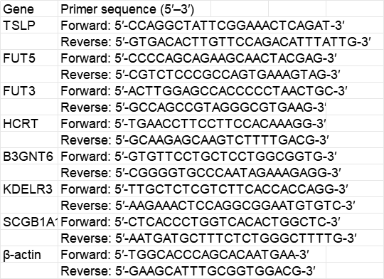

Table S2 The clinical characteristics of the asthma patients
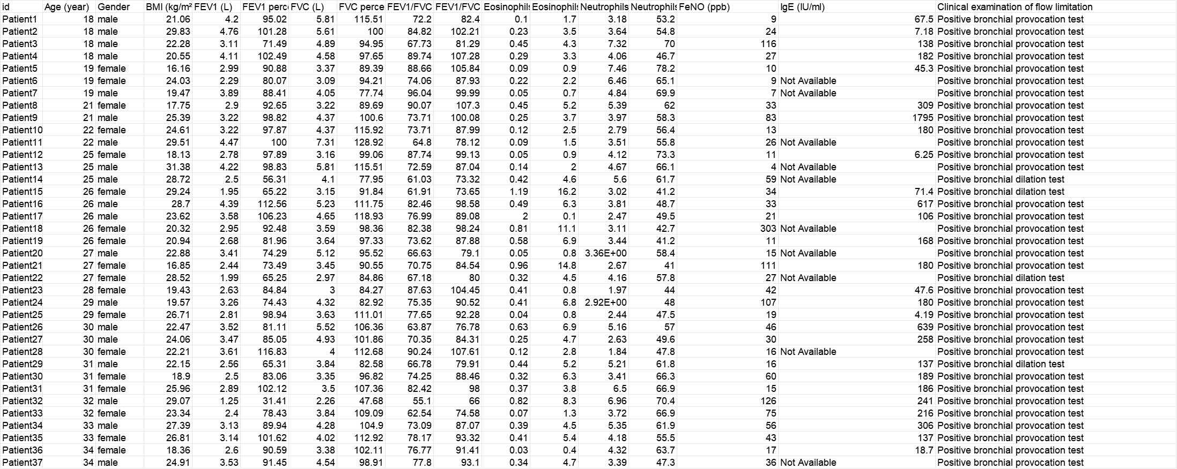

Table S3 Differentially expressed genes of the GSE63142 dataset
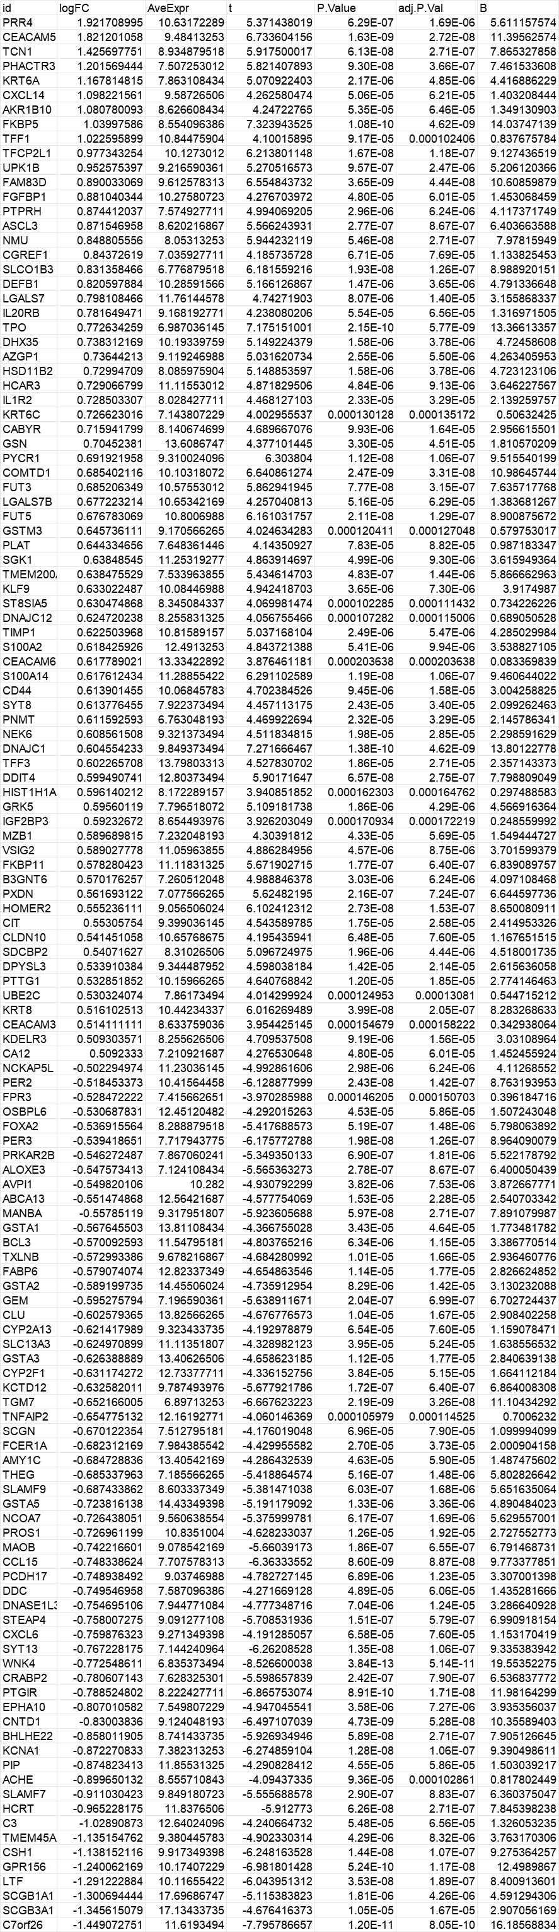
Table S4 Key module genes related to asthma
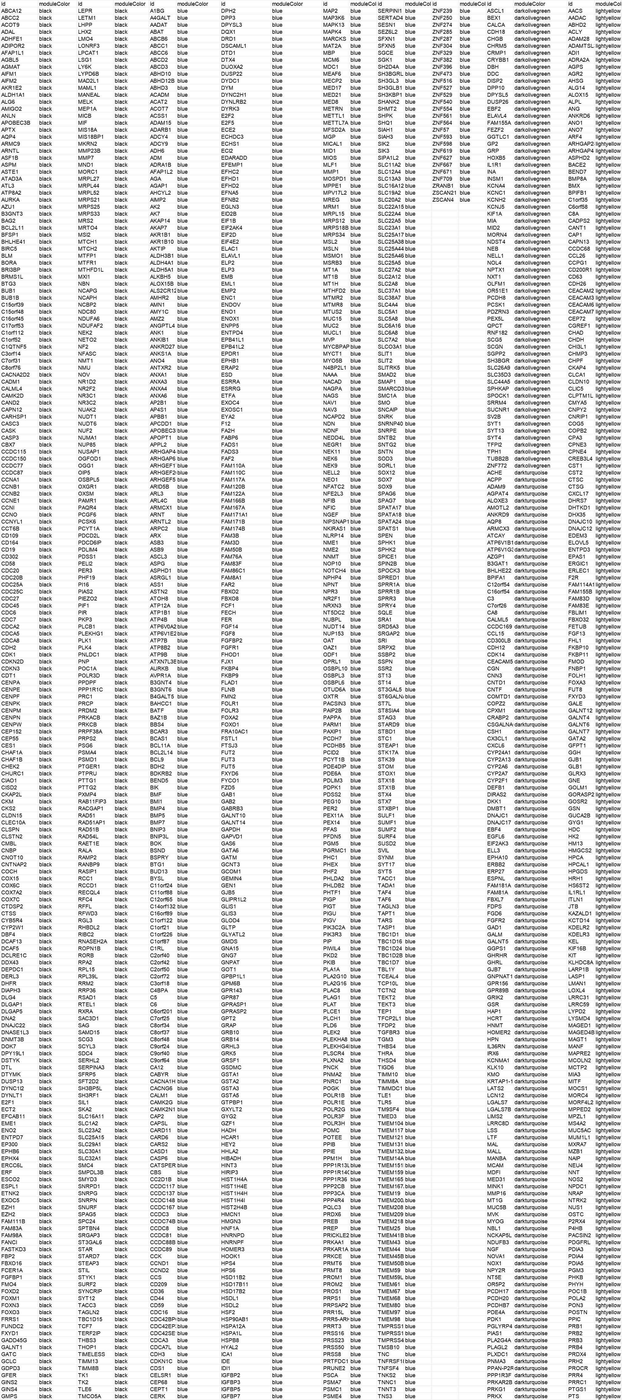
Table S5 The transcription factors that may regulate key glycosylation-related genes
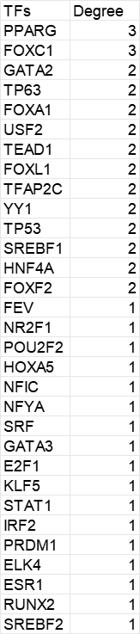

Table S6 The proportion of immune infiltrating cells in the asthma immune microenvironment using the GSE63142 database
