Figure S1 The representative figures for the expression of FOXP3. A) Negative expression of FOXP3; B) Positive expression of FOXP3.
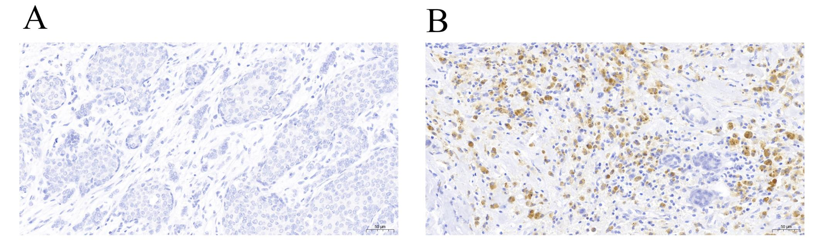

Figure S2 Survival curve of FOXP3 expression level and prognosis in patients with breast cancer received chemotherapy for (A) disease-free survival and (B) overall survival.
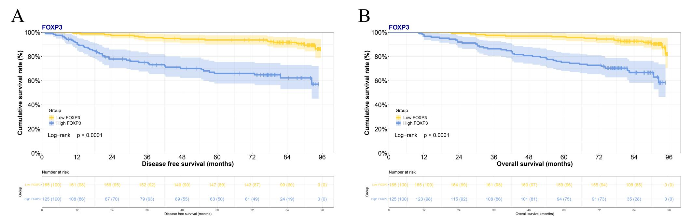

Figure S3 Survival curve of FOXP3 expression level and prognosis in patients with breast cancer received endocrine therapy for (A) disease-free survival and (B) overall survival.
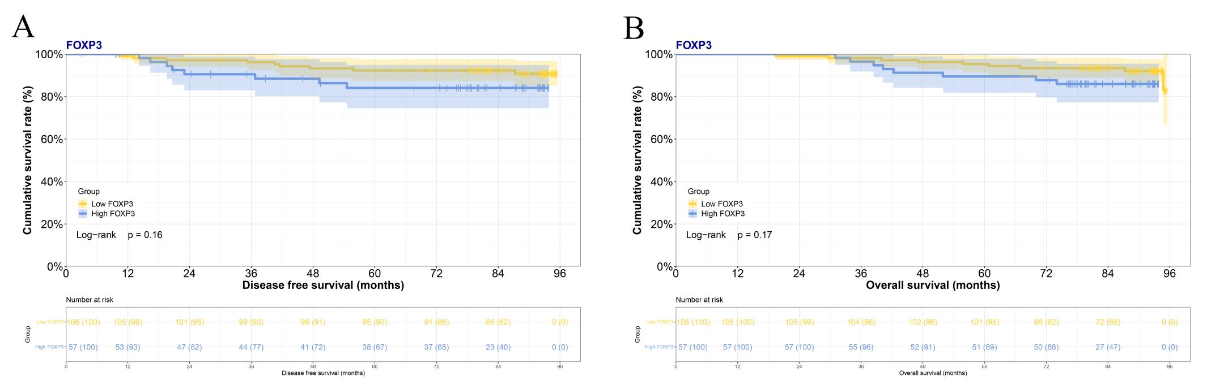

Figure S4 Survival curve of FOXP3 expression level and prognosis in patients with breast cancer received radiotherapy for (A) disease-free survival and (B) overall survival.
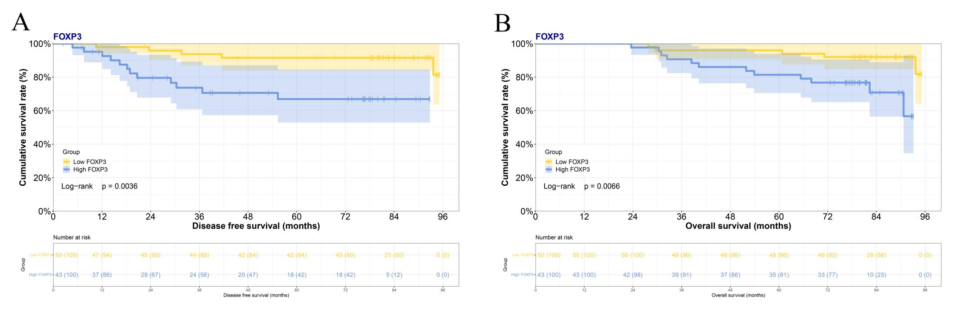

Figure S5 Survival curve of FOXP3 expression level and prognosis in breast cancer patients with stage I for (A) disease-free survival and (B) overall survival.
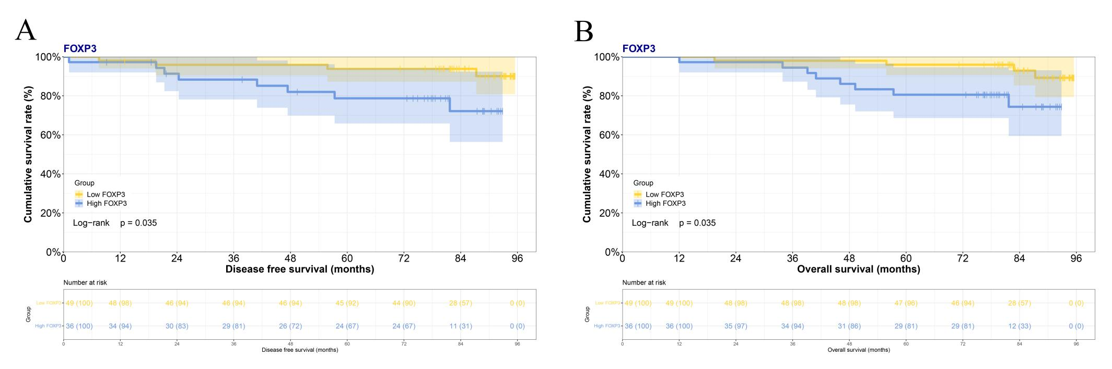

Figure S6 Survival curve of FOXP3 expression level and prognosis in breast cancer patients with stage II for (A) disease-free survival and (B) overall survival.
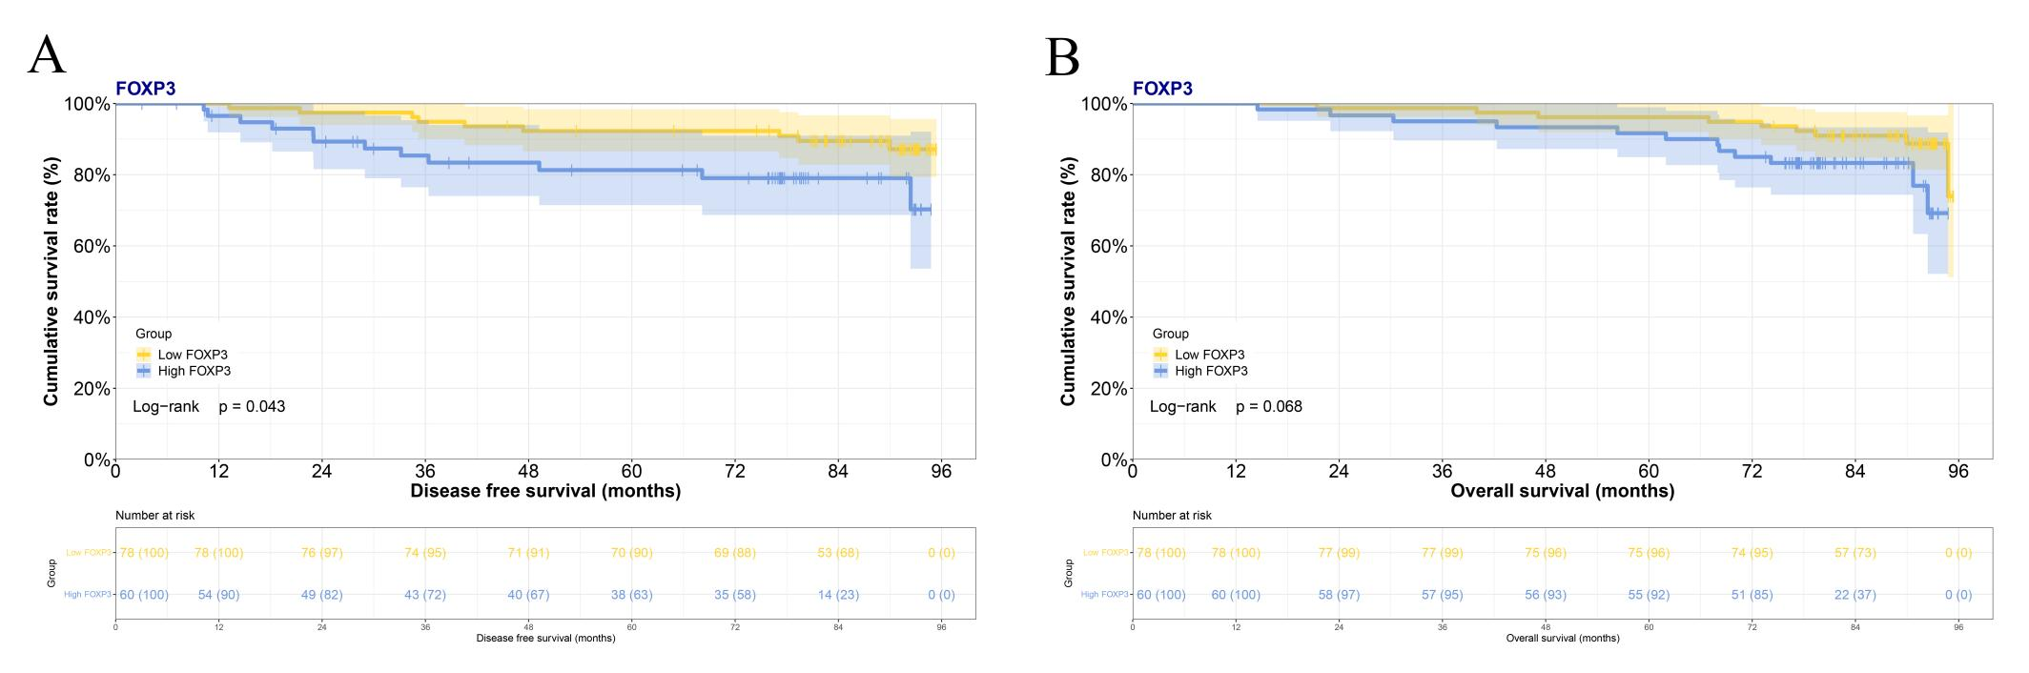

Figure S7 Survival curve of FOXP3 expression level and prognosis in breast cancer patients with stage III for (A) disease-free survival and (B) overall survival.
