APPENDIX 1

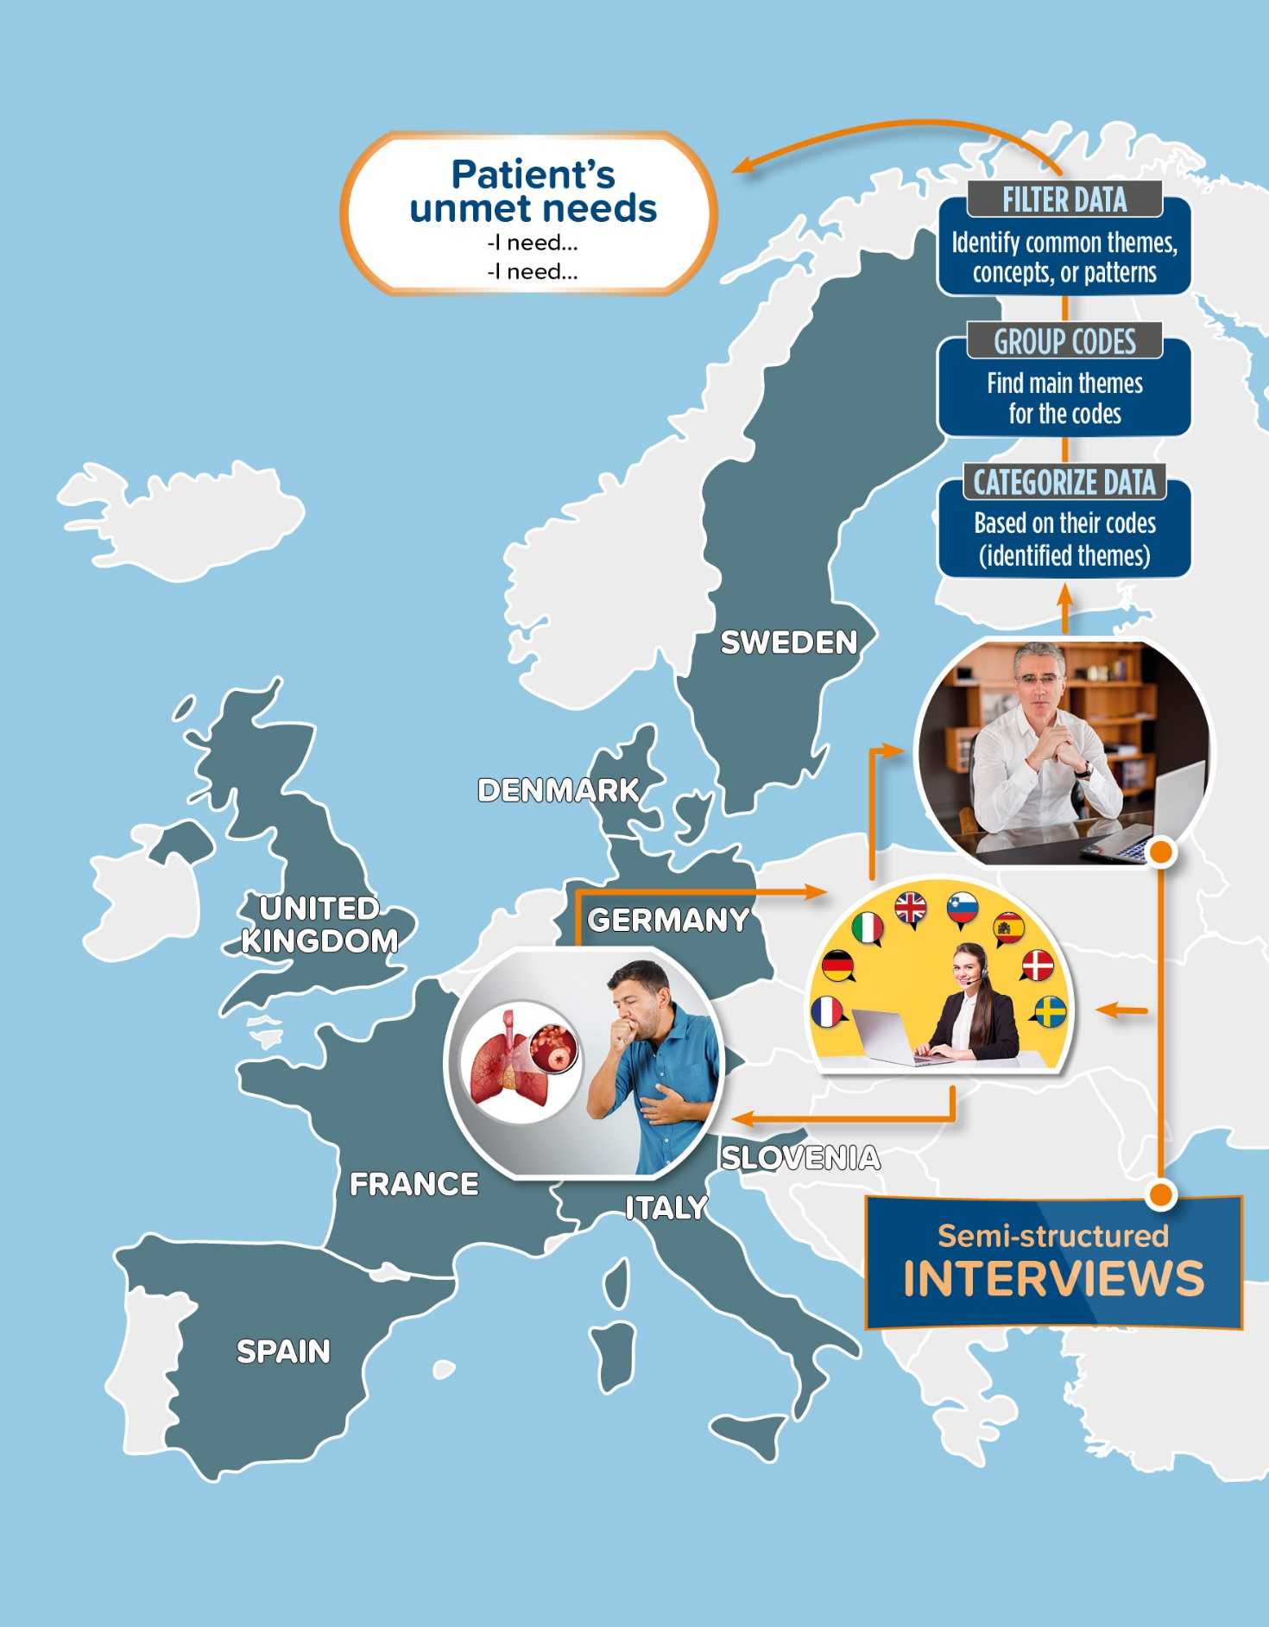
Figure 1A - Summary of the study methods. Countries involved in the study are indicated in grey

Figure 2A - NEXThaler - Participants’ interpretation of the click

Figure 3A - NEXThaler - Average rating of the impact of the ‘click of confidence’ on a patient’s life

Figure 4A - NEXThaler - Average rating of the impact of the ‘click of confidence’ on a patient’s treatment experience

Figure 5A - NEXThaler - Average rating of the impact of the ‘click of confidence’ on a patient’s confidence

Figure 6A - NEXThaler - Average rating of the impact of the inhalation effort on a patient’s life

Figure 7A - NEXThaler - Average rating of the impact of the inhalation effort on a patient’s treatment experience

Figure 8A - NEXThaler - Average rating of the impact of the inhalation effort on a patient’s confidence

Figure 9A - NEXThaler - Average rating of the impact of the inhalation counter on a patient’s life

Figure 10A - NEXThaler - Average rating of the impact of the inhalation counter on a patient’s treatment experience

Figure 11A - NEXThaler - Average rating of the impact of the inhalation counter on a patient’s confidence

