Figure S1. (A-B) The samples were divided into gene clusterA (n=177) and gene clusterB (n=235) by unsupervised clustering based on DEGs (K=2).
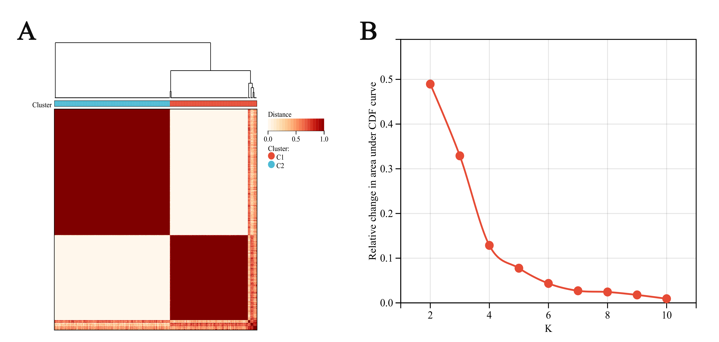

Figure S2. WB original blots in supplementary information. (A) GAPDH 37kda. (B) CXCL13 13kda.
A
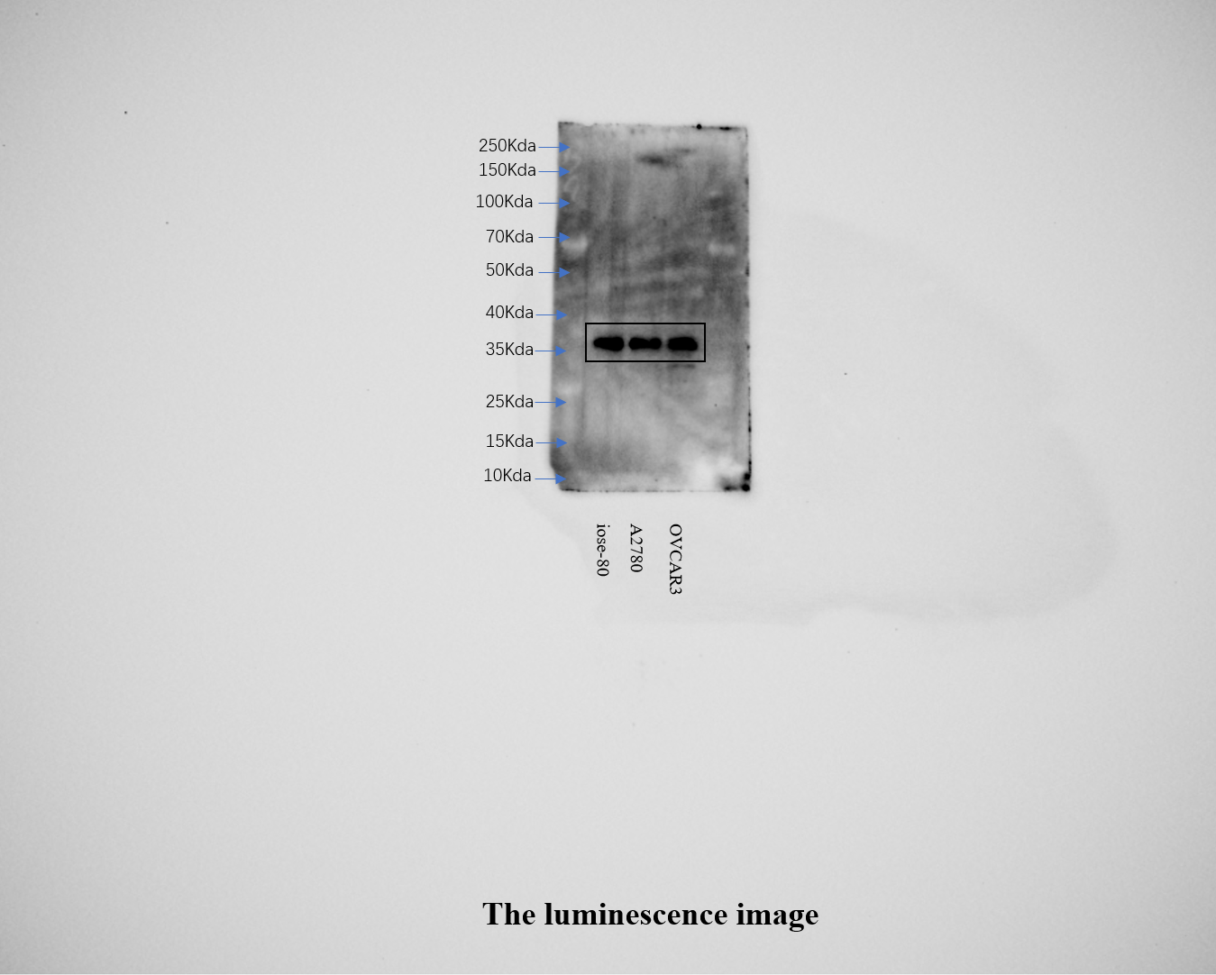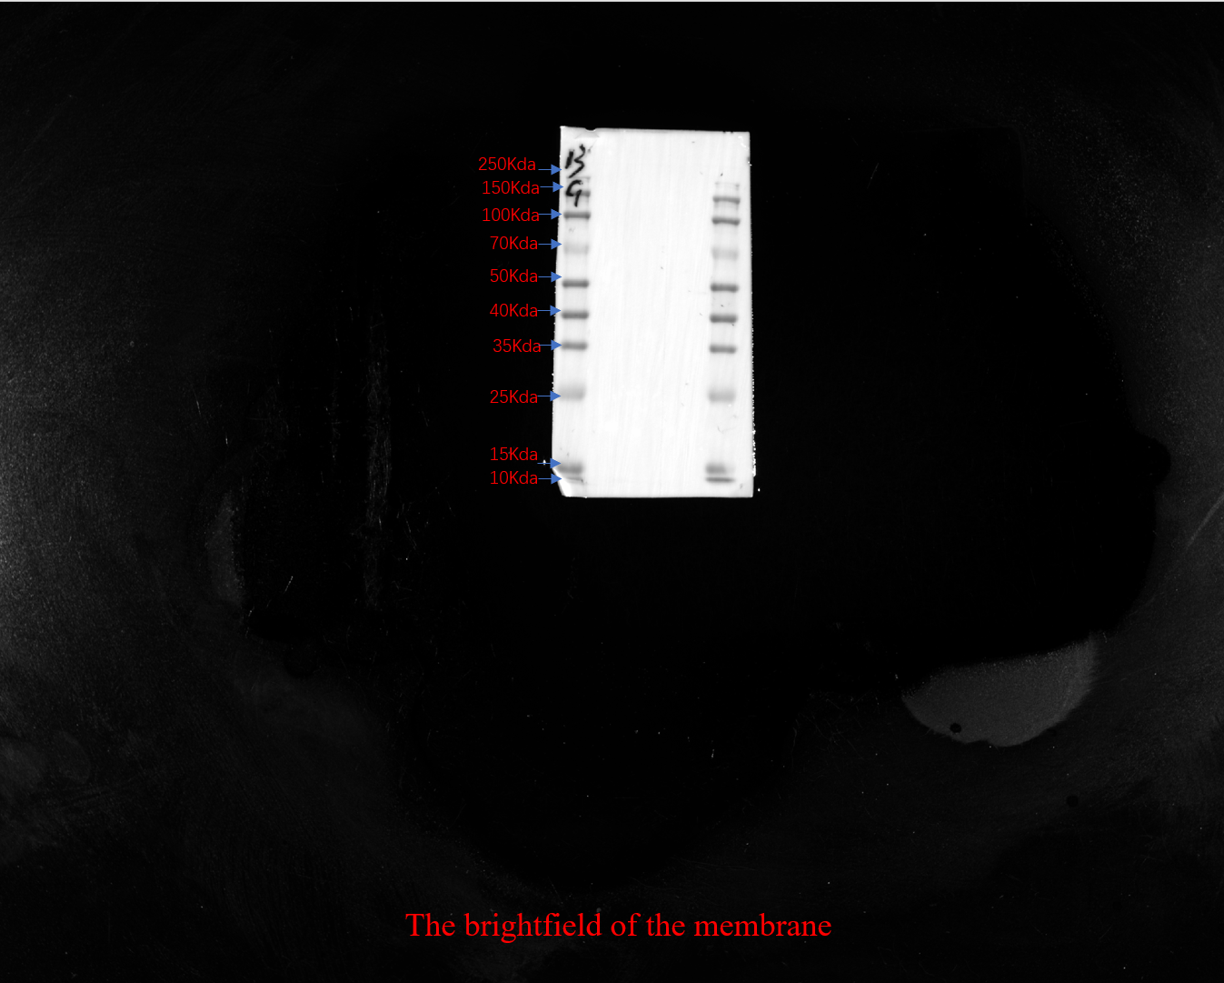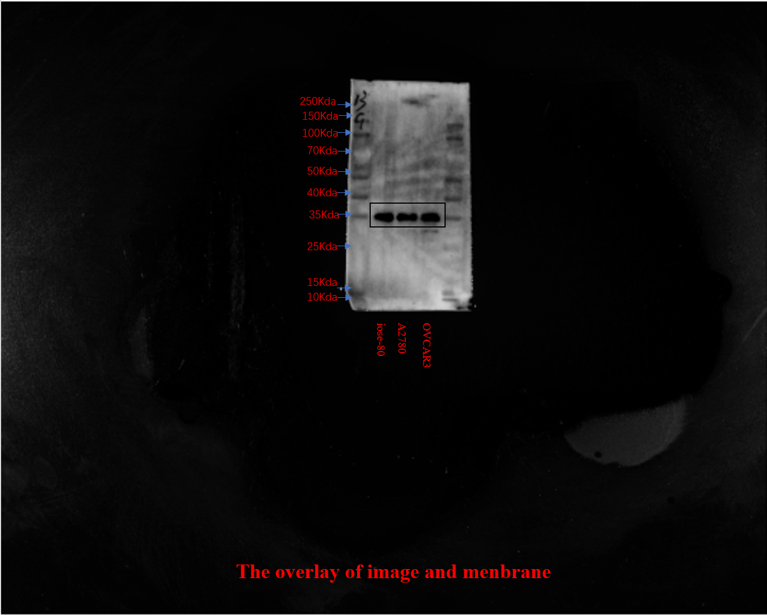

B
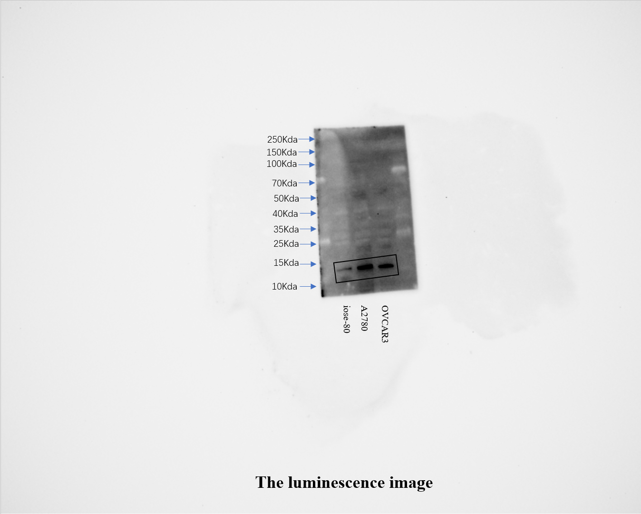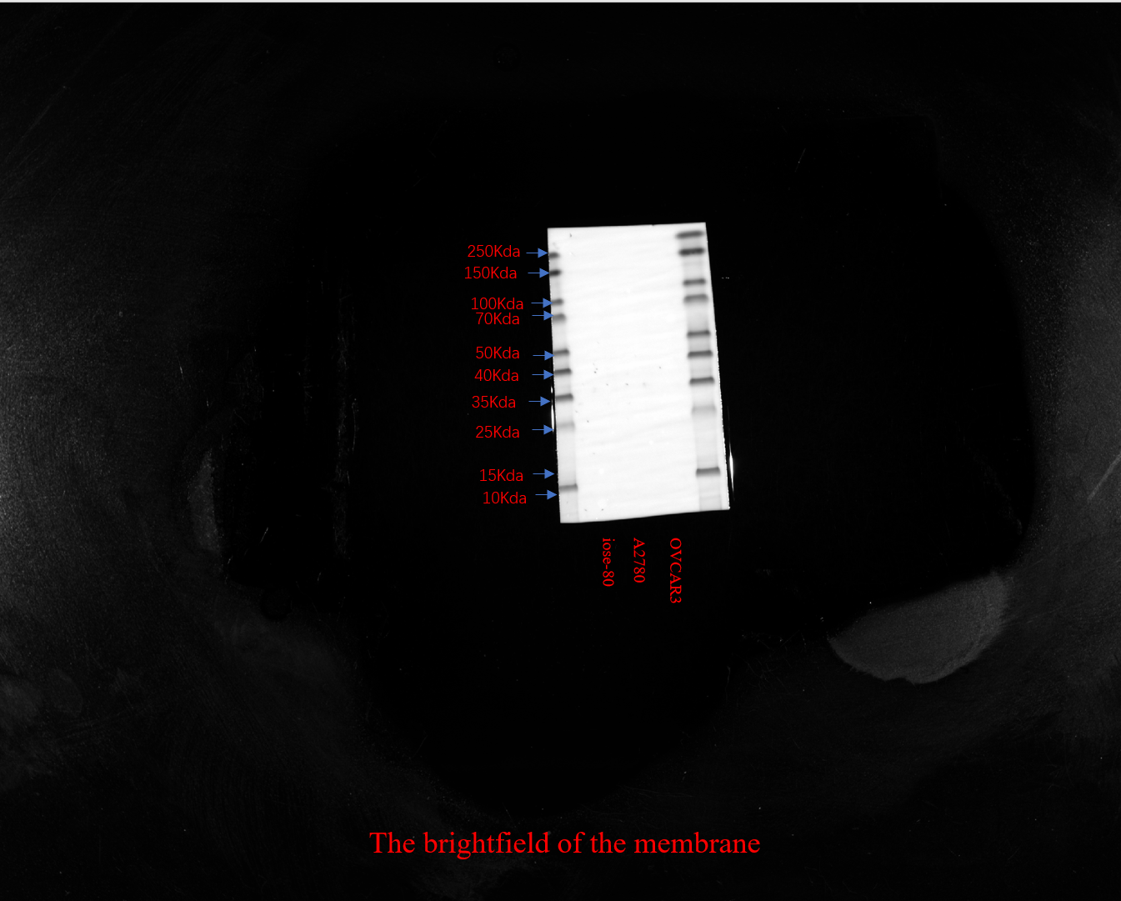
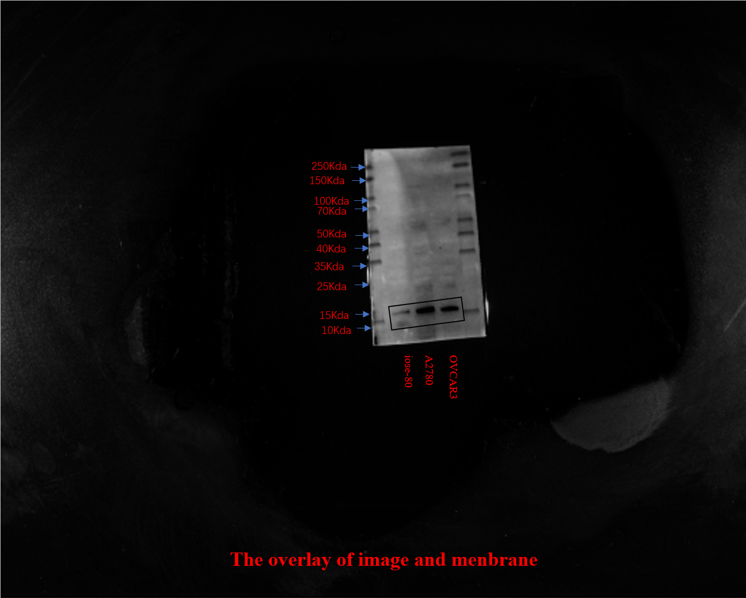

Table S1. The PANoptosis-related genes (PRGs).
CASP8 | FADD | CASP6 | NLRP3
TAB2 | TAB3 | PSTPIP2 | TNFAIP3
CASP7 | PARP1 | GSDMD | MLKL
IRF1 | AIM2 | ZBP1 | CASP1
RIPK1 | RIPK3 | TRADD

