Fig S1. Ovariectomy in mice induces uterine atrophy. A. The morphology of the uterus. B. The diameter of the uterus. C. HE staining of the uterus.

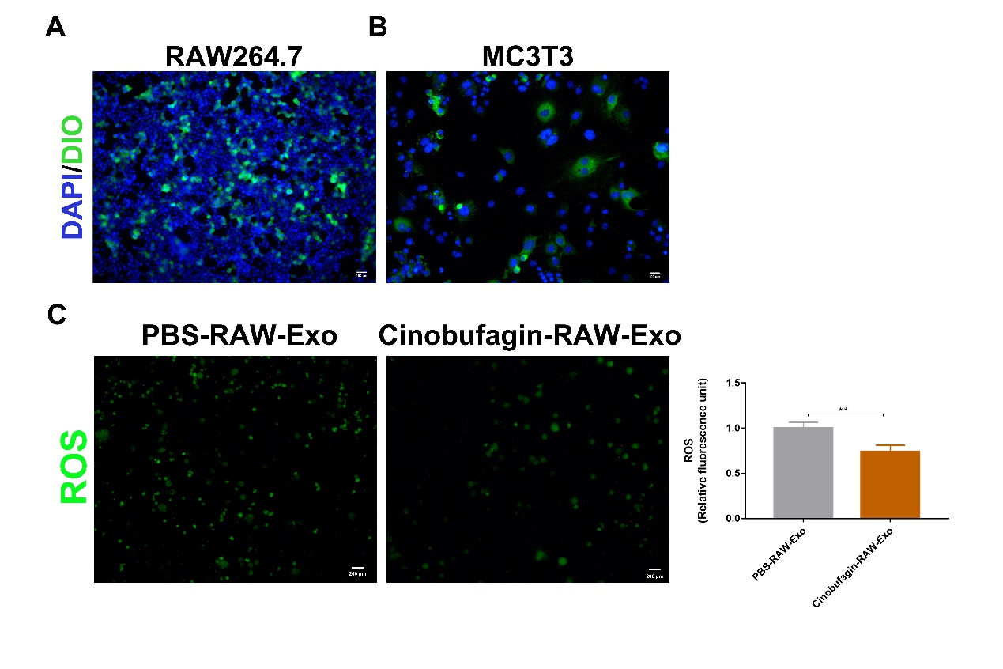
Fig S2. RAW-Exos inhibit cellular reactive oxygen species levels. A. Uptake of RAW-Exos by RAW264.7 cells. Green fluorescence indicates the presence of RAW-Exos. B. Uptake of RAW-Exos by MC3T3 cells. Green fluorescence indicates the presence of RAW-Exos. C. Intracellular levels of reactive oxygen species (ROS). N=3.
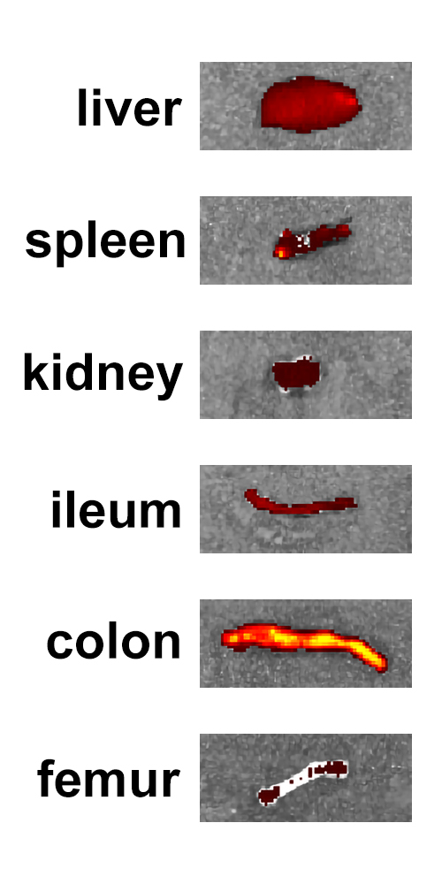
Fig S3. Tracking RAW-Exos in vivo for 24 hours.

