Table S1 Clinical characteristics of HCC patients involved in the study
 | TCGA cohort  (N=342) | ICGC cohort  (N=227) | GSE14520 cohort  (N=216)
Gender Male | 233 | 61 | 187
Female | 109 | 166 | 29
Age ≤60 years | 165 | 49 | 178
>60 years | 177 | 178 | 38
Grade G1/2 | 214
G3/4 | 123
unknown | 5
TNM Stage I/II | 238 | 140 | 167
III/IV | 83 | 87 | 49
unknown | 21 | 0 | 0
Vascular Invasion Yes | 101
No | 187
unknown | 54
Recurrence With tumor | 122 |  | 120
Tumor free | 153 |  | 96
unknown | 67
Cirrhosis With | 65 |  | 198
Without | 134 |  | 18
unknown | 143 |  | 0
HBV or HCV Infection | 199
Yes | 61 |  | 209
No | 82 |  | 6
unknown |  |  | 1
Child-Pugh A | 141
B | 161
C | 40
unknown | 233 | 61

Table S2 The sequences of the qRT-PCR primers used in this study
Gene | Forward primer | Reverse primer
SLC10A1 | CATAGGGATCGTCCTCAAATCCA | GCCACACTGCACAAGAGAATG
β-ACTIN | CGTGGGCCGCCCTAGGCACCA | TTGGCTTAGGGTTCAGGGGGG

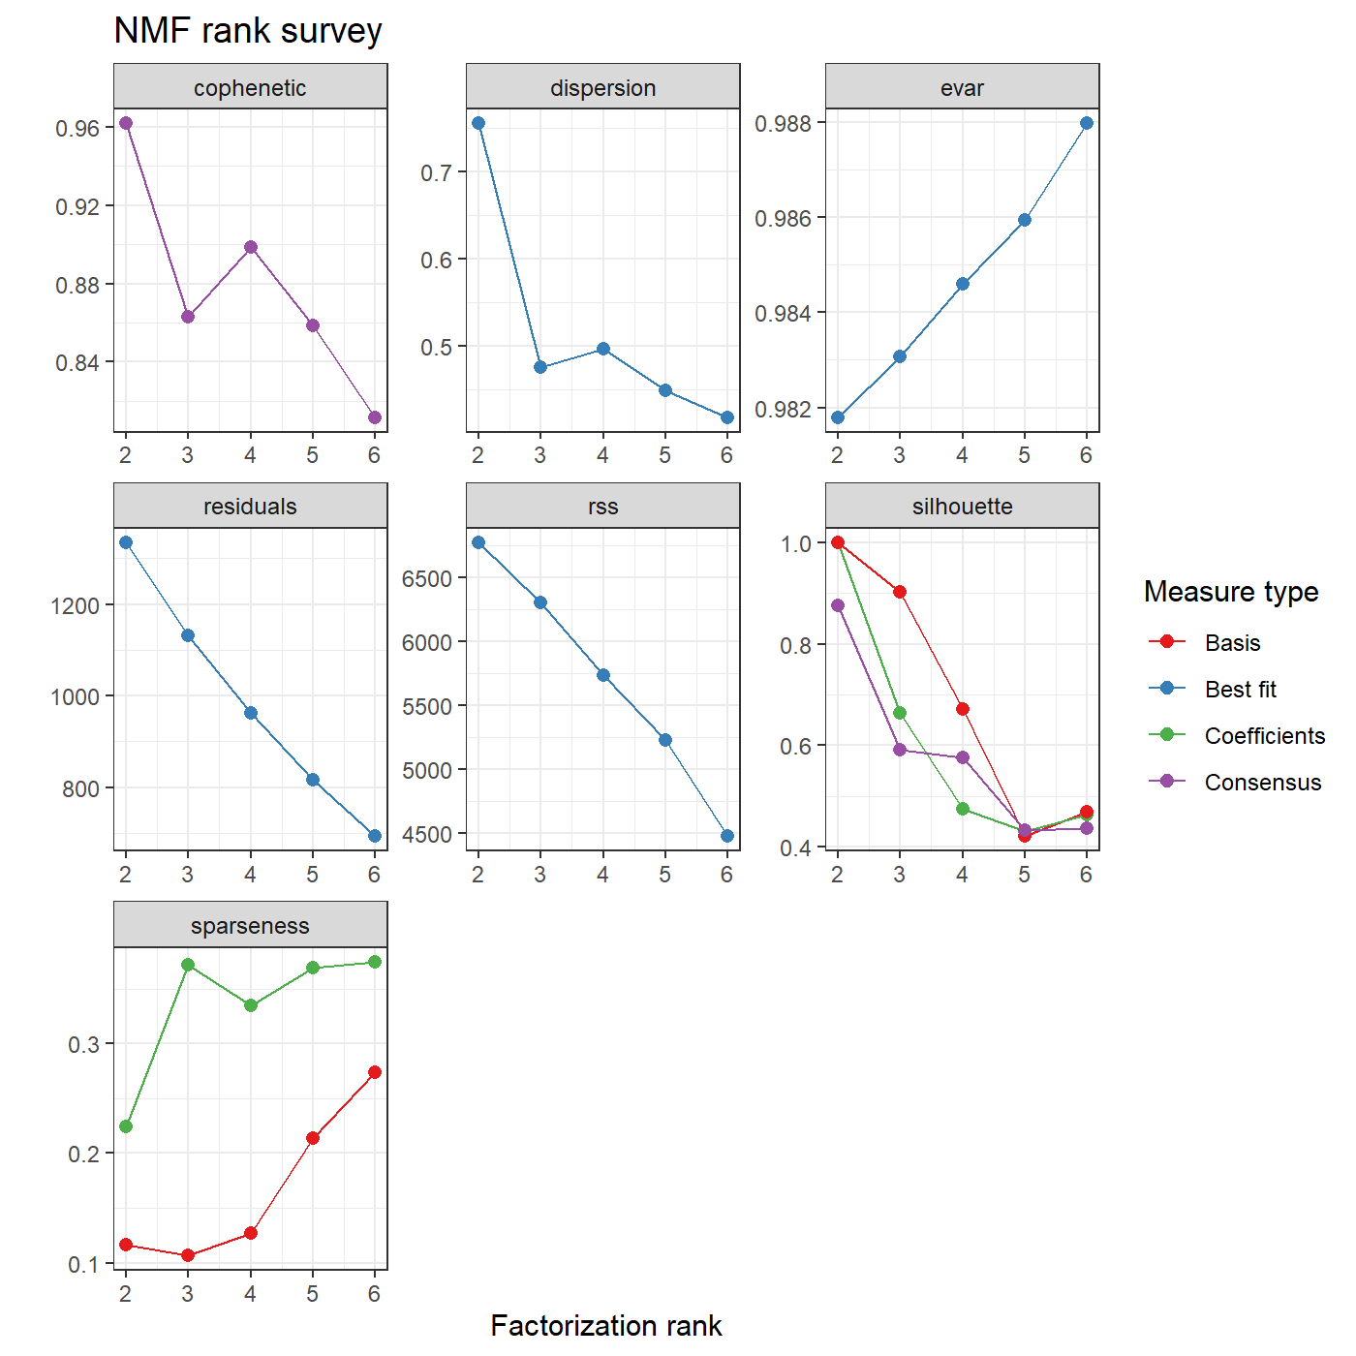
Figure S1 NMF rank survey based on ferroptosis-related genes.
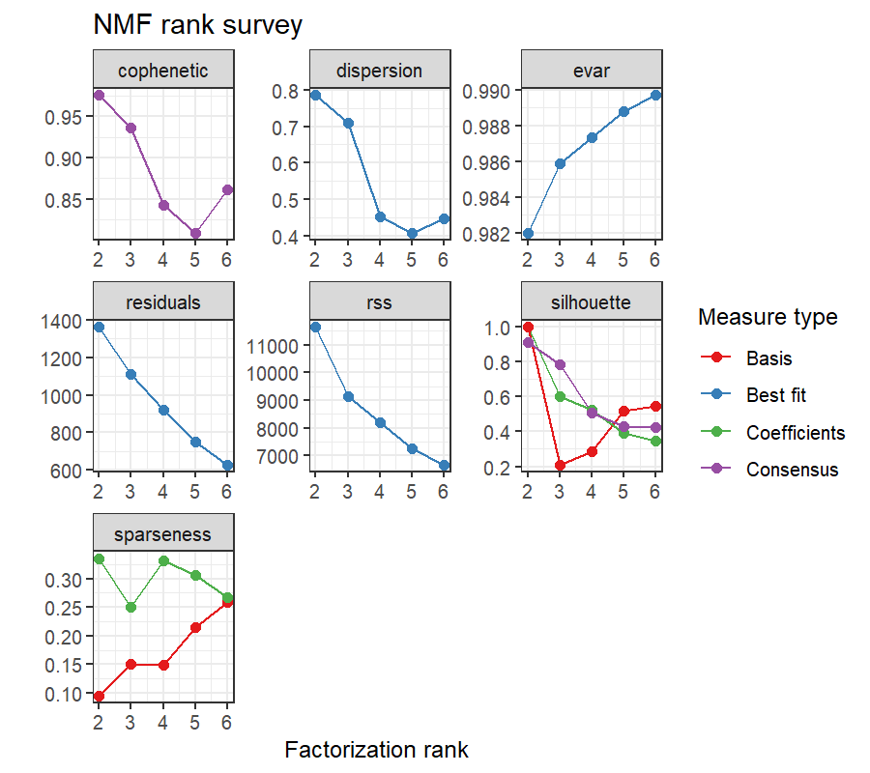
Figure S2 NMF rank survey based on angiogenesis-related genes.

Figure S3 The correlation analysis results between risk scores and clinical features.

