Supplementary Information

Targeted Liposomal Co-delivery Dopamine with 3-n-Butylphthalide for Effective Against Parkinson’s disease in Mice Model
Yi Liang^{1,2}, Liping Feng1, Yue Zheng1, Yunzhen Gao2, Rongying Shi2, Zhirong Zhang2, Xue Ying1, Yingchun Zeng1

¹ School of pharmacy, Chengdu Medical College, Chengdu 610500, China; ² Key Laboratory of Drug-Targeting and Drug Delivery System, Ministry of Education, West China School of Pharmacy, Sichuan University, Chengdu 610041, China

Correspondence: Xue Ying, Yingchun Zeng
School of pharmacy, Chengdu Medical College
No. 783, Xindu avenue, Chengdu 610500, People’s Republic of China
Tel: +86-28-62739516 (Yingchun Zeng); +86-28-62739552 (Xue Ying)
Email: zych19900119@163.com (Yingchun Zeng)；Yingxueshzu@163.com (Xue Ying)

Supplementary Information

Methods
Quantification of NBP and DA by HPLC
The concentration of NBP and DA was determined by HPLC system (Agilent technologies 1260 series) and an AQ-C18 column (150 mm × 4.6 mm, i.d 5 µm) operating at 30 °C. The mobile phase for NBP was composed of methanol-0.1% formic acid solution (85/15, v/v). As for DA, the mobile phase consisted of acetonitrile-0.1% formic acid solution (20/80, v/v). The flow rate was 1 mL/min. The detection wavelength was set at 229 nm for NBP and 280 nm for DA, and the injected volume of the sample was 10 µL. NBP and DA were eluted at 4.61 and 2.21 min, respectively.”

Quantification of NBP and DA by LC-MS/MS
The HPLC system consisted of a rapid resolution liquid chromatography system (1200 series, Agilent Technologies, Santa Clara, CA, USA) equipped with an SL binary pump, SL autosampler and degasser. The chromatographic separation was performed on an Agilent HC-C18 column (4.6 mm × 150 mm, i.d 5 µm). The mobile phase for NBP was composed of methanol-0.1% formic acid solution (70/30, v/v). As for DA, the mobile phase consisted of acetonitrile-0.1% formic acid solution (20/80, v/v). The flow rate was set at 0.3 mL/min for NBP and 0.4 mL/min for DA. Column temperature was maintained at 30 °C, and the injection volume was 1 μL.
An Agilent 6140 triple-quadrupole mass spectrometer equipped with an electrospray ionization (ESI) interface was used for mass spectrometric analysis. All quantifications were carried out in the positive ionization mode. The capillary voltage was 4 kV. Nitrogen was used as the collision gas at 350 °C. Other optimal MS/MS parameters were shown in Table S1. The retention time of NBP and DA was 1.51 and 0.87 min, respectively.

Table S1. MS/MS parameters of NBP and DA
Compounds | Ion  mode | Precursor ion (m/z) | Product ion (m/z) | Fragmentor energy (eV) | Collision energy (eV) | Gas flow rate (L/min) | Atomizer pressure (psi)
NBP | SIM | 213.1 | - | 135 | - | 12 | 35
DA | MRM | 154.1 | 137 | 45 | 4 | 10 | 30
SIM: single ion monitoring; MRM: multiple reaction monitoring

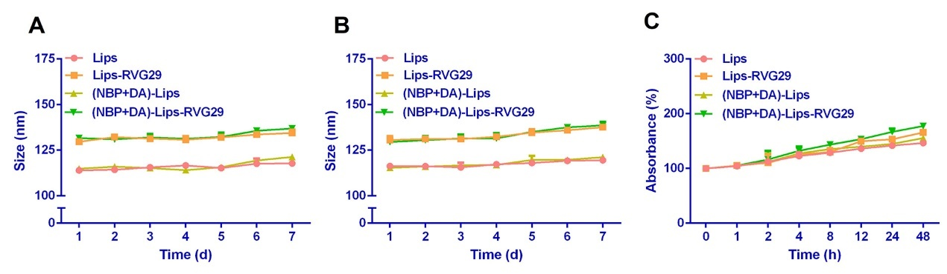
Figure S1 The particle size variation of liposomes in PBS at (A) 4 ℃ and (B) 25 ℃ for 7 days. (C) absorbance variation of liposomes in FBS for 48 h (n = 3, mean ± SD).

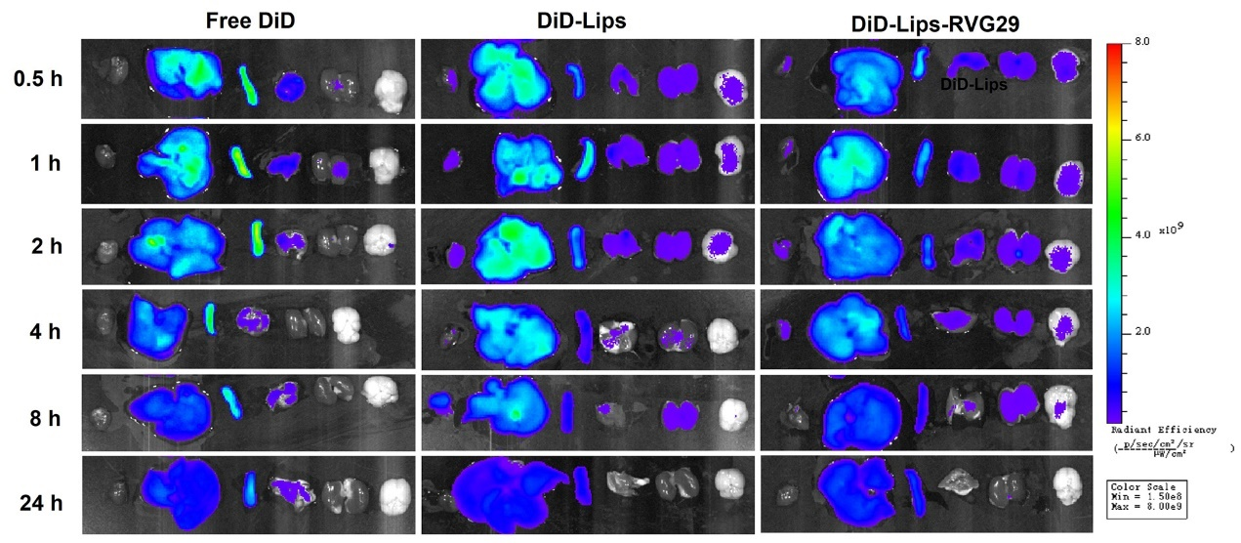
Figure S2 Ex vivo fluorescence images of isolated organs at 0.5 h to 24 h post-injection of free DiD, DiD-Lips and DiD-Lips-RVG29.

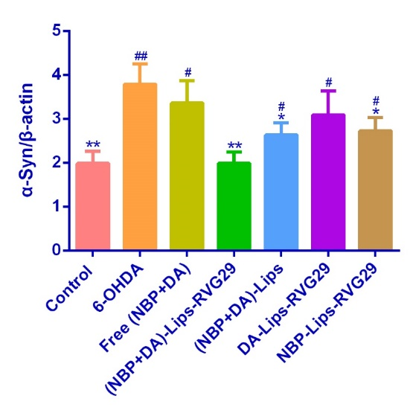
Figure S3 The semi-quantitative analysis of α-Syn protein levels in the lesioned striatum (mean ± SD, n = 3).

Table S2. The main pharmacokinetic parameters of NBP in rats (n = 5, mean ± SD)
Parameters | Free NBP | (NBP+DA)-Lips | (NBP+DA)-Lips-RVG29
AUC_{0-t} (μg/L*h) | 7.72 ± 1.0 | 116 ± 19.2 | 118 ± 17.2
AUC_{0-∞} (μg/L*h) | 7.76 ± 1.02 | 120 ± 20.9 | 121 ± 18.7
MRT_{0-t} (h) | 0.432 ± 0.0397 | 1.01 ± 0.18 | 1.09 ± 0.182
MRT_{0-∞} (h) | 0.683 ± 0.216 | 2.43 ± 1.63 | 2.56 ± 1.20
C_{max} (μg/L) | 19.6 ± 2.70 | 256 ± 30.2 | 253 ± 29.4
T_{1/2z} (h) | 0.177 ± 0.0570 | 12.7 ± 6.90 | 12.2 ± 8.66
CLz (L/h/kg) | 4.18 ± 0.551 | 0.274 ± 0.0570 | 0.269 ± 0.0463

Table S3. The main pharmacokinetic parameters of DA in rats (n = 5, mean ± SD)
Parameters | Free DA | (NBP+DA)-Lips | (NBP+DA)-Lips-  RVG29
AUC_{0-t} (μg/L*h) | 5.60 ± 1.58 | 104 ± 28.4 | 106 ± 23.4
AUC_{0-∞} (μg/L*h) | 5.63 ± 1.61 | 108 ± 31.6 | 110 ± 26.5
MRT_{0-t} (h) | 0.384 ± 0.0554 | 0.866 ± 0.216 | 0.898 ± 0.0420
MRT_{0-∞} (h) | 0.592 ± 0.0656 | 3.05 ± 1.84 | 3.10 ± 1.21
C_{max} (μg/L) | 15.3 ± 4.40 | 244 ± 79.7 | 247 ± 45.7
T_{1/2z} (h) | 0.181 ± 0.0609 | 11.5 ± 6.13 | 11.6 ± 7.17
CLz (L/h/kg) | 6.08 ± 1.75 | 0.326 ± 0.136 | 0.304 ± 0.0787

