SERS analysis platform based on aptamer recognition-release strategy for efficient and sensitive diagnosis of colorectal precancerous lesions
Fengsong Chen^{1†}, Yanhua Huang^{1†}, Yongxia Liu², Yanwen Zhuang³, Xiaowei Cao³, Xiaogang Qin²*
¹Department of Gastroenterology, Nantong Haimen People’s Hospital, Nantong 226100, Jiangsu, China
²Department of gastroenterology, Traditional Chinese Medicine Hospital of Tongzhou District, Nantong 226300, Jiangsu, China
³Institute of Translational Medicine, Medical College, Yangzhou University, Yangzhou 225001, Jiangsu, China

*Correspondence:
Xiaogang Qin， Email: tzqinxiaogang@163.com

Fengsong Chen and Yanhua Huang contributed equally to this work.

Information Classification: General
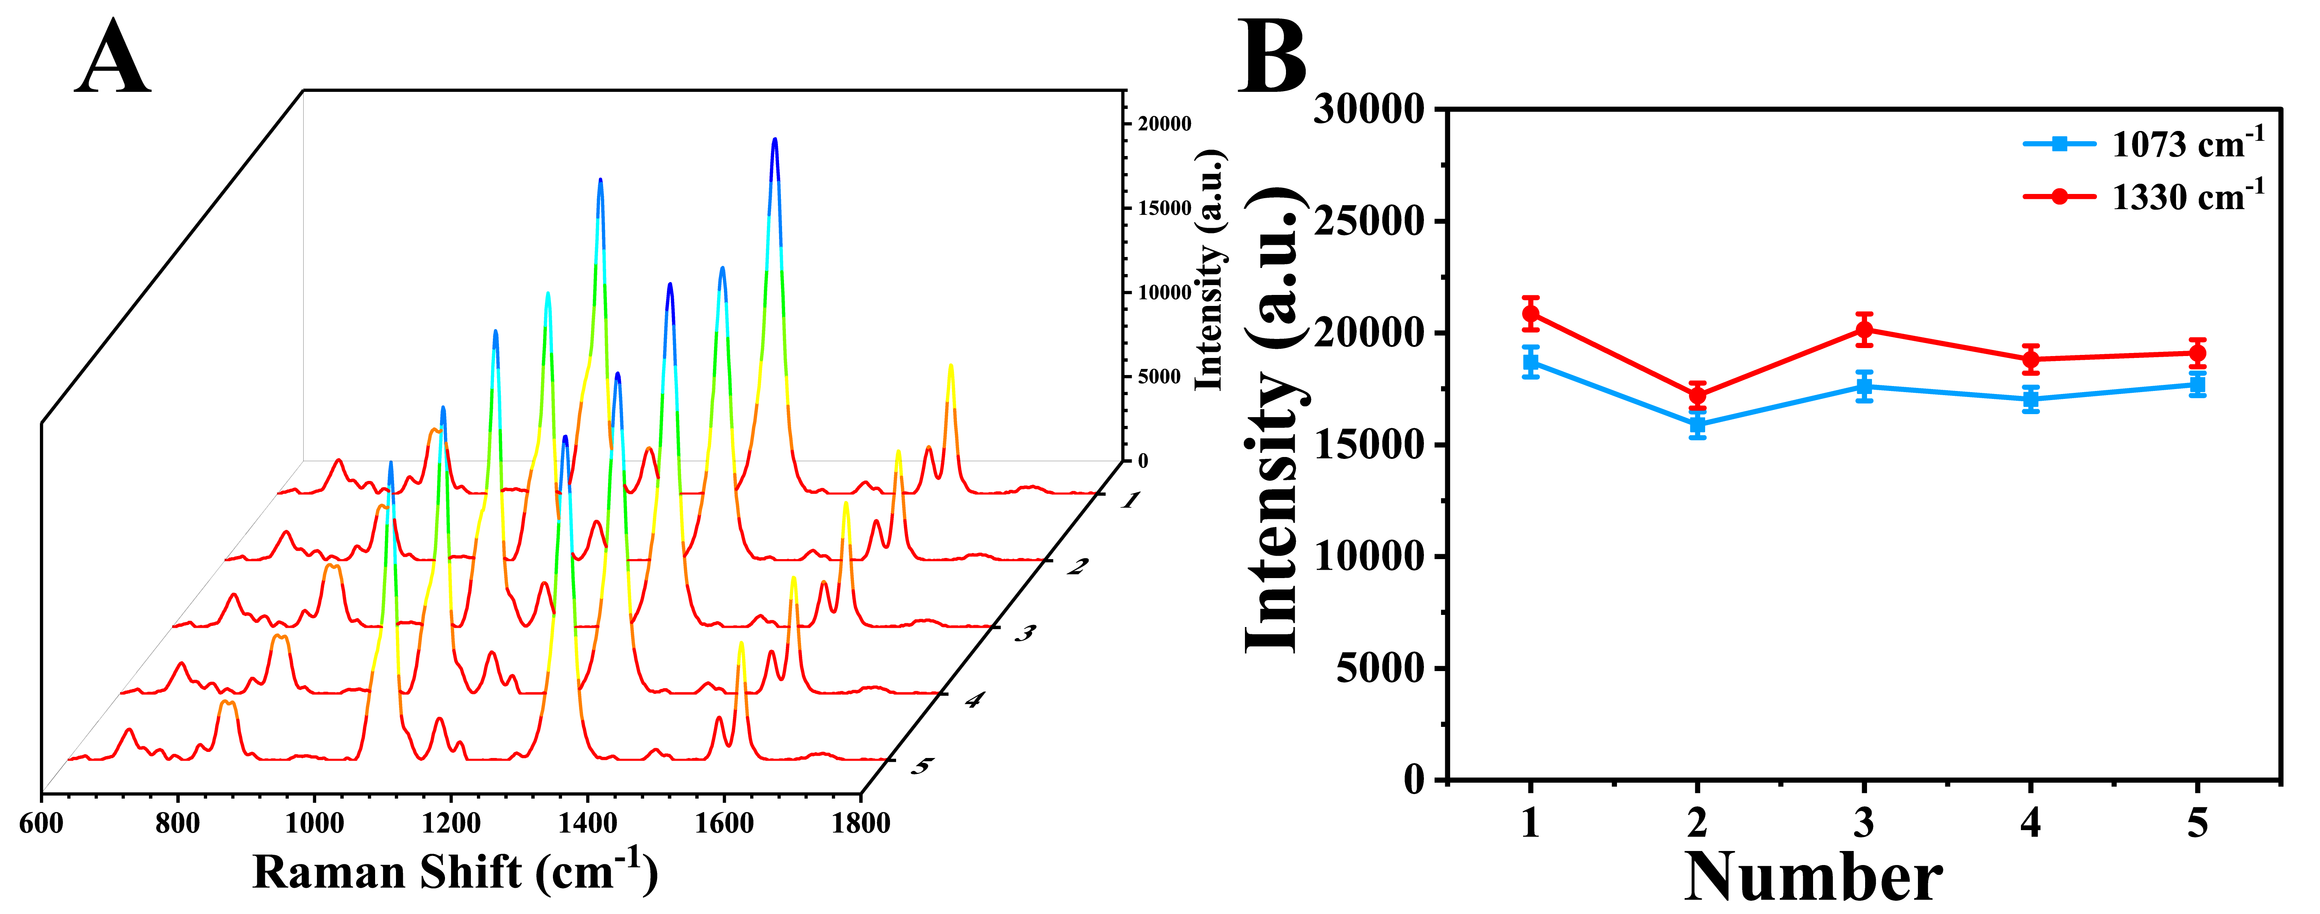
Fig. S1 Microarray chip as the SERS analysis platform for performance evaluation: (A) repeatability assessment and (B) line graph corresponding to SERS intensity at 1073 cm-1 and 1330 cm-1.
Table S1 Basic characteristics of the participants in this study.
Groups | Health | Precancer | CRC | F/X² | P
Average age | 51±1.86 | 55±1.43 | 59±4.93 | 51.67 | p<0.0001
Gender |  |  |  | 0.6183 | 0.2636
Male | 16 | 18 | 15
Female | 14 | 12 | 15
number | 30 | 30 | 30
Table S2. The hnRNP A1 and S100P concentration detected by SERS using the proposed platform and ELISA in healthy people
Samples | SERS (ng/mL) |  | ELISA (ng/mL)
Samples | hnRNP A1 | S100P | hnRNP A1 | S100P
1 | 36.82 | 15.97 | 37.04 | 16.61
2 | 42.91 | 17.92 | 39.77 | 18.04
3 | 35.55 | 14.46 | 39.07 | 15.37
4 | 37.15 | 15.91 | 40.42 | 17.16
5 | 38.39 | 15.87 | 39.71 | 16.31
6 | 37.51 | 17.92 | 39.57 | 18.48
7 | 42.05 | 16.31 | 44.92 | 18.81
8 | 41.25 | 15.17 | 39.09 | 17.08
9 | 42.19 | 14.79 | 45.20 | 16.05
10 | 37.58 | 15.51 | 39.77 | 16.01
11 | 42.41 | 15.75 | 45.50 | 14.72
12 | 37.94 | 15.74 | 39.45 | 15.20
13 | 41.09 | 15.91 | 39.87 | 16.03
14 | 37.55 | 14.79 | 40.71 | 14.03
15 | 42.06 | 16.02 | 39.17 | 15.34
16 | 38.24 | 16.17 | 41.27 | 15.87
17 | 36.42 | 15.04 | 39.26 | 17.20
18 | 42.75 | 17.76 | 44.81 | 18.08
19 | 40.51 | 16.04 | 38.79 | 17.14
20 | 37.48 | 15.34 | 42.12 | 17.89
21 | 38.24 | 16.07 | 41.04 | 17.17
22 | 38.16 | 15.67 | 39.92 | 16.93
23 | 36.72 | 15.05 | 39.91 | 16.15
24 | 36.97 | 17.91 | 40.04 | 19.23
25 | 38.71 | 15.50 | 40.21 | 16.78
26 | 41.75 | 15.07 | 42.31 | 17.28
27 | 40.73 | 15.60 | 43.02 | 17.94
28 | 36.72 | 18.17 | 39.17 | 19.09
29 | 37.28 | 16.95 | 41.04 | 17.75
30 | 39.75 | 17.15 | 40.91 | 18.35

Table S3. The hnRNP A1 and S100P concentration detected by SERS using the proposed platform and ELISA in CRC patients with precancerous lesions
Samples | SERS (ng/mL) |  | ELISA (ng/mL)
Samples | hnRNP A1 | S100P | hnRNP A1 | S100P
1 | 61.92 | 41.62 | 64.07 | 42.09
2 | 58.37 | 37.71 | 61.05 | 41.02
3 | 62.19 | 41.06 | 65.72 | 42.79
4 | 63.05 | 42.03 | 64.74 | 44.27
5 | 59.71 | 39.74 | 62.82 | 39.97
6 | 55.97 | 41.06 | 56.79 | 42.19
7 | 59.29 | 39.51 | 64.01 | 41.49
8 | 62.32 | 41.07 | 65.17 | 43.68
9 | 58.74 | 38.75 | 64.28 | 40.79
10 | 65.08 | 38.75 | 68.09 | 41.44
11 | 56.75 | 40.72 | 62.43 | 42.07
12 | 63.28 | 38.84 | 65.91 | 41.19
13 | 59.79 | 37.92 | 64.55 | 39.93
14 | 60.28 | 42.72 | 65.02 | 44.49
15 | 60.02 | 37.91 | 64.29 | 39.47
16 | 61.37 | 36.16 | 60.77 | 39.09
17 | 55.92 | 41.04 | 60.58 | 43.45
18 | 61.82 | 41.78 | 58.87 | 42.47
19 | 57.39 | 39.57 | 59.92 | 42.19
20 | 61.72 | 42.14 | 64.76 | 44.59
21 | 58.53 | 36.96 | 61.50 | 38.27
22 | 61.97 | 41.72 | 65.07 | 42.59
23 | 57.99 | 40.50 | 60.73 | 42.72
24 | 65.07 | 39.72 | 67.03 | 41.49
25 | 59.60 | 42.05 | 64.03 | 43.83
26 | 62.57 | 36.79 | 65.08 | 39.49
27 | 62.81 | 41.21 | 64.24 | 42.29
28 | 55.02 | 37.29 | 60.29 | 38.75
29 | 61.22 | 36.97 | 64.05 | 39.07
30 | 57.93 | 38.76 | 60.04 | 40.50

Table S4. The hnRNP A1 and S100P concentration detected by SERS using the proposed platform and ELISA in colorectal cancer patients
Samples | SERS (ng/mL) |  | ELISA (ng/mL)
Samples | hnRNP A1 | S100P | hnRNP A1 | S100P
1 | 115.42 | 61.19 | 113.19 | 59.27
2 | 118.34 | 57.50 | 129.07 | 64.94
3 | 122.19 | 60.83 | 118.19 | 55.16
4 | 103.75 | 62.75 | 109.72 | 64.38
5 | 114.29 | 55.93 | 124.37 | 59.28
6 | 109.70 | 64.17 | 124.34 | 69.42
7 | 107.76 | 59.49 | 116.86 | 61.94
8 | 112.75 | 61.72 | 120.40 | 65.25
9 | 118.49 | 56.04 | 116.53 | 58.48
10 | 105.04 | 58.67 | 114.04 | 62.67
11 | 116.17 | 60.27 | 124.19 | 64.72
12 | 123.57 | 58.73 | 119.36 | 62.70
13 | 107.81 | 59.91 | 114.19 | 62.42
14 | 110.07 | 63.47 | 117.10 | 67.41
15 | 120.27 | 57.49 | 127.45 | 61.61
16 | 111.75 | 55.66 | 114.43 | 59.56
17 | 115.09 | 61.09 | 118.34 | 65.28
18 | 110.71 | 61.80 | 118.49 | 65.79
19 | 107.59 | 59.46 | 109.69 | 62.49
20 | 111.68 | 62.94 | 117.50 | 67.66
21 | 128.09 | 57.37 | 134.72 | 61.02
22 | 121.57 | 61.50 | 124.51 | 65.46
23 | 107.49 | 62.44 | 115.72 | 65.17
24 | 105.88 | 59.73 | 111.49 | 64.42
25 | 109.14 | 62.72 | 115.94 | 65.10
26 | 112.40 | 66.19 | 115.94 | 68.95
27 | 102.73 | 66.17 | 114.46 | 70.19
28 | 105.83 | 57.29 | 114.74 | 60.07
29 | 111.29 | 55.79 | 119.73 | 58.71
30 | 105.27 | 59.73 | 107.41 | 64.49

