Supplementary materials
Supplementary table 1. The results of blood routine and biochemical test associated with infection.
Patient | WBC (10⁹/L)  (3.5~9.5) | NEUT (%)  (40~75) | Mo (%)  (3~10) | ESR (mm/h) | CRP (mg/L) | Culture results
P01 | 12.4 | 82.9 | 9.8 | 9 | 107.8 | Staphylococcus aureus
P02 | 3.6 | 58.8 | 7.5 | 16 | 6.58 | G+ coccus
P03 | 8.28 | 69.75 | 5.41 | 10 | 4.93 | -
P04 | 15.1 | 92.12 | 2.57 | 80 | 15 | Staphylococcus aureus
P05 | 5.6 | 57 | 10.2 | 23 | 4.6 | Staphylococcus haemolyticus
P06 | 6.6 | 59.6 | 11.1 | 2 | 1.9 | Staphylococcus aureus
P07 | 7.84 | 73.77 | 4.18 | 48 | 50 | -
P08 | 7.9 | 78.7 | 9.5 | 48 | 167 | Staphylococcus aureus
P09 | 4.85 | 57.1 | 9.1 | 52 | 5.57 | Staphylococcus epidermidis
P10 | 6.4 | 60.1 | 9.2 | 72 | 3.18 | Staphylococcus aureus
P11 | 3.7 | 56.3 | 6.8 | 67 | 1.2 | Staphylococcus aureus
P12 | 8.37 | 78.6 | 5.2 | 21 | 10 | -
P13 | 8.97 | 65.2 | 11.7 | 56 | 68.22 | Staphylococcus aureus
P14 | 7 | 57.3 | 8.2 | 120 | 51.5 | Escherichia coli
P15 | 4.8 | 70.6 | 10.1 | 120 | 12.3 | Pseudomonas aeruginosa
P16 | 5.1 | 65.1 | 7.7 | 6 | 0.8 | -
P17 | 7.6 | 72.6 | 5.2 | 58 | 69.2 | -
P18 | 4.9 | 50.7 | 10.9 | 55 | 128.4 | -
P19 | 4.28 | 67.92 | 5.91 | 17 | 7.03 | -
P20 | 6.83 | 65.9 | 6.45 | 83 | 89.79 | -
P21 | 8.78 | 79.9 | 5.3 | 96 | 36.5 | -
P22 | 5.6 | 53.6 | 9.8 | 12 | 3.14 | Staphylococcus aureus
P23 | 10.8 | 86.75 | 4.89 | 60 | 184 | Staphylococcus aureus
P25 | 8.2 | 63.8 | 7.9 | 118 | 89.6 | -
P26 | 6.3 | 60.5 | 8.2 | 35 | 40.7 | -
P27 | 4.81 | 41.6 | 10.8 | 4 | 0.52 | -
P28 | 7.2 | 51.1 | 8.2 | 5 | 1.25 | G+ bacilli
P30 | 17.54 | 89.87 | 4.06 | 86 | 363 | Staphylococcus aureus
P31 | 7.8 | 74.5 | 8.1 | 120 | 60 | Streptococcus agalactiae
P32 | 8.3 | 71.2 | 8.4 | 110 | 105 | Staphylococcus epidermidis, Pseudomonas aeruginosa

Supplementary Figure 1. Correlation between bacterial culture, metagenomics detection, and blood test results. The circles represent the strength of correlation between the factors, with the size and color of the circle indicating the strength and direction of the correlation. A cross on the circle indicates no significant correlation (P ≥ 0.05).
A) Correlation analysis based on blood tests, the positivity or negativity of culture results, and whether a dominant pathogen was detected by metagenomics.
B) Correlation analysis using the categorization of blood tests as normal or abnormal, the positivity or negativity of culture results, and whether a dominant pathogen was detected by metagenomics.
A)
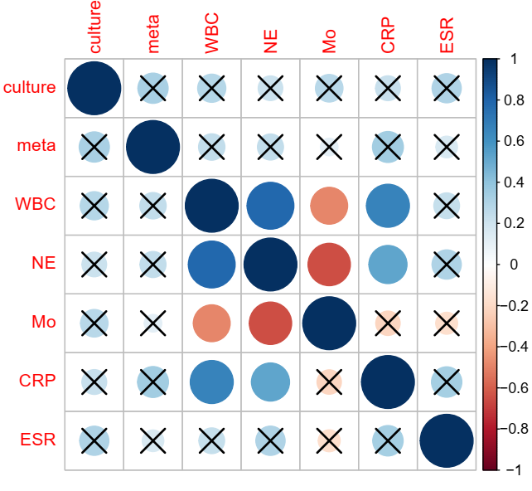
B)
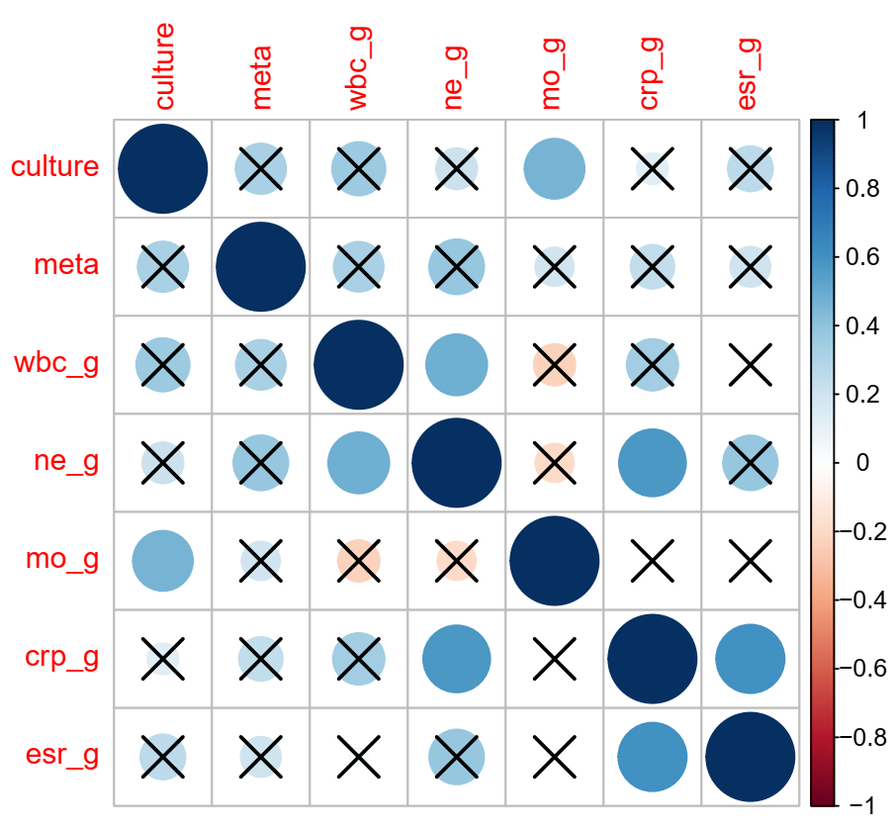

Supplementary table 2. The results with16S sequencing result.

No | ID | Age | Sex | Sample source | Surgery* | Sampling time since surgery | Culture results | Part of analyzed 16S sequencing result | WBC | NE | Mo | ESR | CRP
1 | P01 | 80 | M | Hip | THA | 8 years | Staphylococcus aureus | g__Staphylococcus (35.81), g__Staphylococcus..s__aureus (27.48) | 12.4 | 82.9 | 9.8 | 9 | 107.8
2 | P02 | 75 | F | Knee | TKA | 1 years | G+ coccus | g__Finegoldia (56.25), g__Corynebacterium (21.99), g__Anaerococcus (6.48), g__Staphylococcus (4.93) | 3.6 | 58.8 | 7.5 | 16 | 6.58
3 | P03 | 60 | F | Knee | ORIF | 1 week | - | g__Agrobacterium (63.96), g__Comamonas (9.01), g__Sphingomonas (6.85) | 8.28 | 69.75 | 5.41 | 10 | 4.93
4 | P04 | 28 | F | Knee | ORIF | 3 days | Staphylococcus aureus | g__Staphylococcus..s__aureus (8.20), g__Staphylococcus (7.88) | 15.10 | 92.12 | 2.57 | 80 | 15
5 | P05 | 75 | M | Tibia | ORIF | 4 days | Staphylococcus haemolyticus | g__Staphylococcus (53.80), f__Comamonadaceae (13.34), g__Burkholderia (8.21), g__Agrobacterium (7.33), g__Comamonas (6.62) | 5.60 | 57 | 10.2 | 23 | 4.6
6 | P06 | 61 | M | Tibia | ORIF | 7 days | Staphylococcus aureus | g__Staphylococcus (39.16), g__Staphylococcus..s__aureus (30.25) | 6.6 | 59.6 | 11.1 | 2 | 1.9
7 | P07 | 47 | F | Knee | TKA | 2 years | - | g__Finegoldia (43.50), g__Peptoniphilus (28.57), g__Anaerococcus (23.70) | 7.84 | 73.77 | 4.18 | 48 | 50
8 | P08 | 51 | M | Knee | TKA | 10 months | Staphylococcus aureus | g__Staphylococcus (9.07), g__Staphylococcus..s__aureus (7.56) | 7.9 | 78.7 | 9.5 | 48 | 167
9 | P09 | 67 | M | Knee | TKA | 10 years | Staphylococcus epidermidis | g__Staphylococcus..s__aureus (10.65), g__Staphylococcus (10.64) | 4.85 | 57.1 | 9.1 | 52 | 5.57
10 | P10 | 66 | F | Calcaneus | ORIF | 5 days | Staphylococcus aureus | g__Staphylococcus..s__aureus (24.75), g__Staphylococcus (24.27) | 6.4 | 60.1 | 9.2 | 72 | 3.18
11 | P11 | 71 | F | Knee | arthroscope | 4 days | Staphylococcus aureus | g__Staphylococcus (3.34), g__Staphylococcus..s__aureus (2.64) | 3.7 | 56.3 | 6.8 | 67 | 1.2
12 | P12 | 33 | M | Ankle | Achilles Tendon suture | 5 days | - | g__Fusobacterium (44.79), f__Tissierellaceae..g__WAL_1855D (10.69), g__Prevotella (10.33), g__Porphyromonas (8.76), g__Streptococcus (2.25) | 8.37 | 78.6 | 5.2 | 21 | 10
13 | P13 | 59 | M | Buttock | cystectomy | 6 days | Staphylococcus aureus | g__Staphylococcus (30.59), g__Staphylococcus..s__aureus (24.89) | 8.97 | 65.2 | 11.7 | 56 | 68.22
14 | P14 | 63 | M | Spine# | ORIF | 6 days | Escherichia coli | g__Anaerococcus (91.16) | 7.00 | 57.3 | 8.2 | 120 | 51.5
15 | P15 | 82 | F | Hip | ORIF | 1 week | Pseudomonas aeruginosa | g__Burkholderia (36.11), f__Comamonadaceae (34.78), g__Achromobacter (10.23), f__Microbacteriaceae (7.03) | 4.8 | 70.6 | 10.1 | 120 | 12.3
16 | P16 | 64 | M | Ankle | ORIF | 29 days | - | g__Porphyromonas (55.01), g__Peptoniphilus (19.11), g__Finegoldia (10.25), g__Anaerococcus (8.67) | 5.1 | 65.1 | 7.7 | 6 | 0.8
17 | P17 | 65 | F | Knee | TKA | 6 years | - | f__Comamonadaceae (31.42), g__Burkholderia (29.24), f__Sphingomonadaceae (21.29) | 7.60 | 72.6 | 5.2 | 58 | 69.2
18 | P18 | 58 | M | Spine# | ORIF | 5 days | - | f__Fusobacteriaceae..g__Fusobacterium (59.92), g__Parvimonas (14.64), g__Haemophilus..s__parainfluenzae (10.95), g__Streptococcus (4.74） | 4.9 | 50.7 | 10.9 | 55 | 128.4
19 | P19 | 68 | M | Knee | TKA | 3 months | - | f__Comamonadaceae (44.85), g__Burkholderia (41.65), g__Comamonas (5.01) | 4.28 | 67.92 | 5.91 | 17 | 7.03
20 | P20 | 69 | F | Hip | THA | 8 weeks | - | g__Prevotella..s__nanceiensis (25.25), g__Prevotella..s__melaninogenica (17.22), g__Parvimonas (13.52), g__Fusobacterium (13.28), g__Prevotella (13.03) | 6.83 | 65.9 | 6.45 | 83 | 89.79
21 | P21 | 62 | F | Knee | TKA | 2 years | - | f__Tissierellaceae..WAL_1855D (28.36), g__Porphyromonas (18.63), g__Fusobacterium (11.62), g__Prevotella (10.75), g__Porphyromonas (9.36), g__Peptoniphilus (6.26) | 8.78 | 79.9 | 5.3 | 96 | 36.5
22 | P22 | 49 | M | Tibia | ORIF | 35 days | Staphylococcus aureus | g__Staphylococcus (25.95), g__Staphylococcus..s__aureus (20.31), g__Anaerococcus (7.09), g__Agrobacterium (5.36) | 5.60 | 53.6 | 9.8 | 12 | 3.14
23 | P23 | 81 | F | Shoulder | TSA | 8 years | Staphylococcus aureus | g__Staphylococcus..s__aureus (13.16), g__Staphylococcus (12.98) | 10.8 | 86.75 | 4.89 | 60 | 184
24 | P25 | 56 | M | Spine# | ORIF | 7 days | - | f__Microbacteriaceae (25.33), f__Comamonadaceae (21.24), g__Burkholderia (13.39), g__Comamonas (11.42), g__Sphingomonas (7.05), g__Agrobacterium (6.00) | 8.2 | 63.8 | 7.9 | 118 | 89.6
25 | P26 | 70 | M | Hip | ORIF | 3 weeks | - | f__Rhizobiaceae (31.60), g__Agrobacterium (19.11), f__Rhizobiaceae (14.69), g__Comamonas (9.72), f__Bradyrhizobiaceae (6.52), g__Bradyrhizobium (6.17), g__Burkholderia (5.13) | 6.30 | 60.5 | 8.2 | 35 | 40.7
26 | P27 | 35 | M | Knee | MPFL Recon | 7days | - | g__Agrobacterium (35.29), g__Burkholderia (26.17), f__Comamonadaceae (16.75), g__Bradyrhizobium (7.00), g__Comamonas (6.72), g__Mesorhizobium (5.95) | 4.81 | 41.6 | 10.8 | 4 | 0.52
27 | P28 | 53 | M | Elbow | ORIF | 5 days | G+ bacilli | f__Comamonadaceae (23.71), g__Agrobacterium (20.59), g__Burkholderia (20.33), g__Comamonas (9.77), f__Rhizobiaceae (7.81), g__Mesorhizobium (5.94) | 7.2 | 51.1 | 8.2 | 5 | 1.25
28 | P30 | 66 | F | Tibia | ORIF | 28 days | Staphylococcus aureus | g__Staphylococcus (11.27), g__Staphylococcus..s__aureus (8.01) | 7.8 | 74.5 | 8.1 | 120 | 60
29 | P31 | 62 | F | Hip | THA | 19 years | Streptococcus agalactiae | g__Streptococcus (45.37), g__Streptococcus..s__agalactiae (43.15) | 17.54 | 89.87 | 4.06 | 86 | 363
30 | P32 | 72 | F | Hip | THA | 5 years | Staphylococcus epidermidis, Pseudomonas aeruginosa | g__Streptococcus (85.65) | 8.3 | 71.2 | 8.4 | 110 | 105
*THA: Total hip arthroplasty; TKA: Total knee arthroplasty; TSA: Total shoulder arthroplasty; ORIF: Open Reduction Internal Fixation;
#Spine sample source include：Thoracic intervertebral, Lumbar Vertebra, cervical spine

