Supplementary Figure Legends
Figure S1 IMP displayed no cytotoxicity on Light II cells. CCK-8 analysis of Light II cells administrated with various concentrations of IMP for 72 h.

Figure S2 (A) Gli-luciferase reporter activity in wild-type (shCtrl) and SUFU-knockdown (shSUFU) Light II cells. (B, C) qRT-PCR analysis of Gli1 expression in with overexpression of GLI1-Flag (B) or GLI2 detaN (C) treated with IMP (10 μM, 20 μM). All error bars represent mean ± s.d. All experiments were repeated at least three times. Statistical significance was calculated using Student t test, ∗∗P <0.01.

Figure S3 (A) JASPAR analysis of the putative STAT3 binding site on Gli1 promoter. (B) Gli-luciferase reporter activity in DAOY cells transfected with Gli-luciferase reporter and TK-Renilla followed with exposure to IL-6 (20 ng/mL) in the presence of IMP (10 μM, 20μM) for 36 h. All error bars represent mean ± s.d. All experiments were repeated at least three times. Statistical significance was calculated using Student t test, ∗P <0.05, ∗∗P <0.01.

Figure S4 Body weight of mice over the time period of treatments.

Supplementary Figures
Figure S1
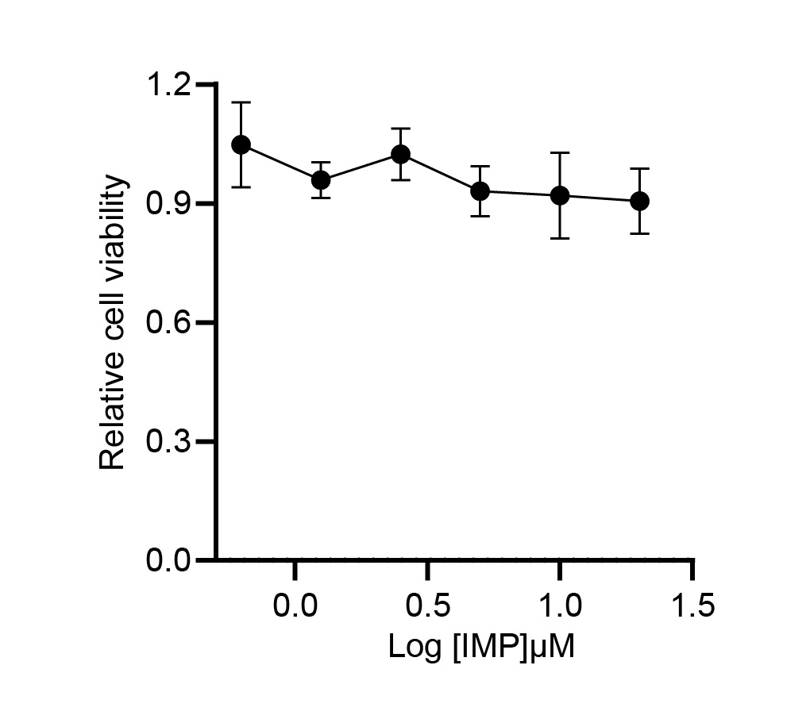
Figure S2
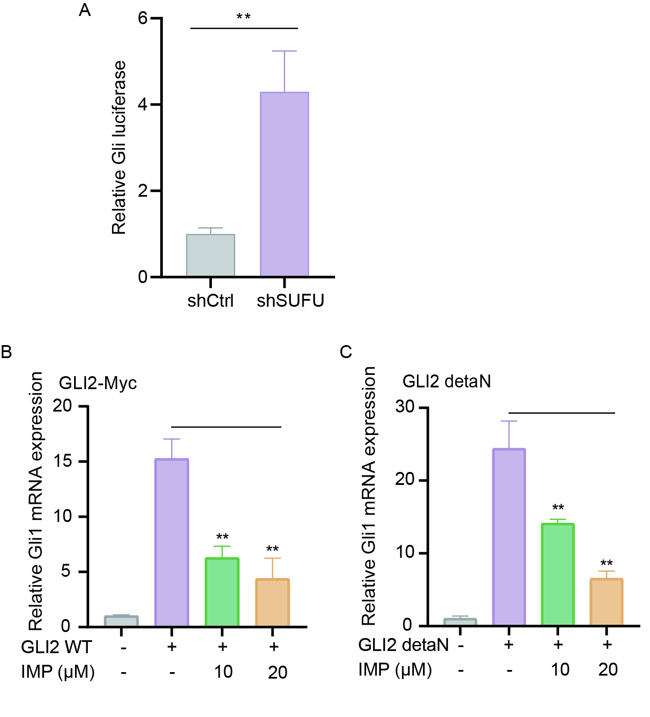
Figure S3
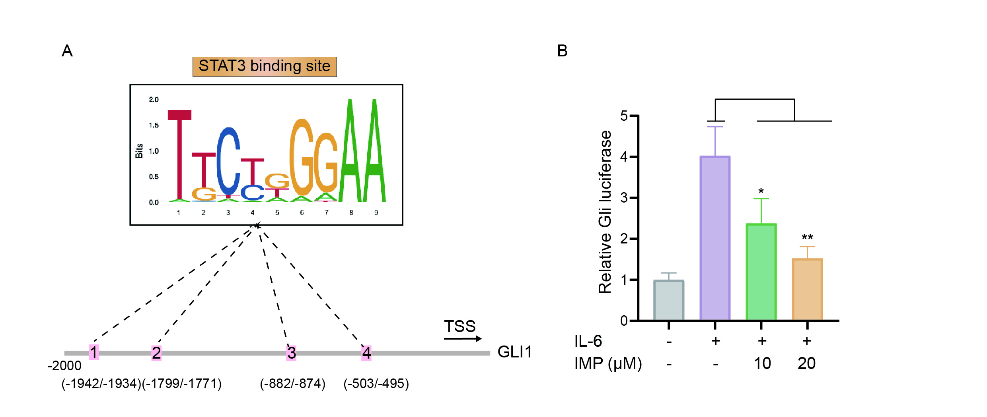

Figure S4
