Supplementary table 1: Inclusion and Exclusion criteria for this study
condition | content
Inclusion criteria | 01)It meets the diagnostic criteria for hepatocellular carcinoma in the "Primary Liver Cancer Diagnosis and Treatment Standards 2019 Edition".  02)The maximum diameter of a single tumor is ≤ 5 cm, or the number of tumors is ≤ 3 and the maximum diameter of the tumor is ≤ 3 cm  03)Imaging examination showed no macrovascular invasion, lymphatic metastases, or extrahepatic metastases  04)There is no history of other malignant tumors or serious other organ lesions in the past  05)Preoperative noncontract scan + dynamic contrast MRI examination  06)The patient profile was complete and the follow-up was complete  07)ECOG score ≤2  08)Child-Pugh (CTP) grade A or B  09)Radiofrequency or microwave after the first treatment of the technical assessment successful
Exclusion criteria | 01)The number of intrahepatic tumors was greater than 3  02)Accompanied by portal or venous cancer thrombosis or invasion of adjacent organs  03)CTP grade C, which cannot be improved by hepatoprotective therapy  04)Esophageal and gastric variceal bleeding within 4 weeks prior to treatment  05)Uncorrectable coagulation disorders and severe blood abnormalities, severe bleeding tendency  06)Refractory massive ascites, cachexia  07)There is an active infection, especially inflammation of the biliary system  08)Severe failure of major organs such as liver, kidney, heart, lungs, and brain  09)Patients who are unconscious or unable to cooperate with treatment  10) Contrast agents are hepatocyte-specific contrast agents  11)Prior to ablation, any of the following treatments: chemotherapy, targeted, immunotherapy  12)Patients lost to follow-up within 6 months after ablation treatment  13)Those who are not completely abled

Note: Definition of success by radiofrequency or ablation techniques: Repeat dynamic contrast MRI within 30 days after ablation, indicating that the target tumor is completely covered by the ablation area. Definition of incomplete ablation: the first repeat MRI after ablation, indicating that the target tumor is not completely covered by the ablation area.
Supplementary table 2: MRI equipment parameters in three hospitals
1.Upper abdominal dynamic enhancement MRI scanning equipment and parameters of Sun Yat-sen University Cancer Center
MR models and sequences | azimuth | TR（ms） | TE（ms） | FOV | Bandwidth (kHz) | thickness (mm) | Layer spacing | matrix | Number of excitations
GE 3.0 T
FSE T2WI | cross section | 10588 | 73 | 380×380 | 83 | 7 | 0.7 | 320×320 | 2
SSFSE T2WI | Coronal plane | 10600 | 100 | 400×400 | 42 | 5 | 0.5 | 288×224 | 2
T1WI pre-scan LAVA | cross section | 3.7 | 1.6 | 400×360 | 167 | 5 | -2 | 260×224 | 1
T1WI Enhanced LAVA | cross section | 2.8 | 1.3 | 400×360 | 167 | 5 | -2 | 260×224 | 1
Siemens 3.0 T
FSE T2WI | cross section | 2200 | 87 | 380×380 | 710 | 5 | 1.5 | 320×256 | 2
SSFSE T2WI | Coronal plane | 2200 | 92 | 380×380 | 710 | 6 | 0.6 | 320×225 | 2
T1WI pre-scan LAVA | cross section | 3.9 | 1.89 | 400×360 | 440 | 3 | 0.6 | 288×201 | 1
T1WI Enhanced LAVA | cross section | 3.9 | 1.89 | 400×360 | 440 | 3 | 0.3 | 288×201 | 1
United Imaging 3.0 T
T2WI FSE FS Trigger | cross section | 4000 | 78.1 | 380×300 | 330 | 7 | 0.7 | 288×216 | 3
T2WI FSE SPIR Trigger | Coronal plane | 4000 | 82.94 | 360×320 | 355 | 5 | 0.5 | 288×217 | 3
T1WIPre-scan quick 3D | cross section | 2.91 | 1.31 | 400×320 | 800 | 5 | -2 | 256×202 | 1
T1W Iintensifier quick 3D | cross section | 2.91 | 1.31 | 400×360 | 800 | 5 | -2 | 256×203 | 1
Philips 3.0 T
T2WI SPIR Trigger | cross section | 2103 | 76 | 400×400 | 1413.2 | 6 | 0.6 | 268×268 | 1
T2WI TSE FS Trigger | Coronal plane | 710 | 80 | 350×350 | 420.9 | 6 | 0.6 | 220×198 | 1
T1WI pre-scan THRIVE | cross section | 3.7 | 1.32 | 300×360 | 1260.6 | 4.5 | -2.5 | 268×236 | 1
T1WI intensifier THRIVE | cross section | 3.7 | 1.32 | 300×360 | 1260.6 | 4.5 | -2.5 | 268×236 | 1

2.Upper abdominal artery enhanced MRI scanning equipment and parameters in Henan Provincial Cancer Hospital
MR models and sequences | azimuth | TR（ms） | TE（ms） | FOV | Bandwidth (kHz) | thickness (mm) | Layer spacing | matrix | Number of excitations
GE 3.0 T
FSE T2WI | cross section | 10588 | 73 | 380×380 | 83 | 7 | 0.7 | 320×320 | 2
SSFSE T2WI | Coronal plane | 10600 | 100 | 400×400 | 42 | 5 | 0.5 | 288×224 | 2
T1WI pre-scan LAVA | cross section | 3.7 | 1.6 | 400×360 | 167 | 5 | -2 | 260×224 | 1
T1WI Enhanced LAVA | cross section | 2.8 | 1.3 | 400×360 | 167 | 5 | -2 | 260×224 | 1
Siemens 3.0 T
FSE T2WI | cross section | 2200 | 87 | 380×380 | 710 | 5 | 1.5 | 320×256 | 2
SSFSE T2WI | Coronal plane | 2200 | 92 | 380×380 | 710 | 6 | 0.6 | 320×225 | 2
T1WI pre-scan LAVA | cross section | 3.9 | 1.89 | 400×360 | 440 | 3 | 0.6 | 288×201 | 1
T1WI Enhanced LAVA | cross section | 3.9 | 1.89 | 400×360 | 440 | 3 | 0.3 | 288×201 | 1
United Imaging 3.0 T
T2WI FSE FS Trigger | cross section | 4000 | 78.1 | 380×300 | 330 | 7 | 0.7 | 288×216 | 3
T2WI FSE SPIR Trigger | Coronal plane | 4000 | 82.94 | 360×320 | 355 | 5 | 0.5 | 288×217 | 3
T1WI PRE-SCAN THRIVE | cross section | 2.91 | 1.31 | 400×320 | 800 | 5 | -2 | 256×202 | 1
T1WI INTENSIFIER THRIVE | cross section | 2.91 | 1.31 | 400×360 | 800 | 5 | -2 | 256×203 | 1

3.Upper abdomen dynamic enhancement MRI scanning equipment and parameters in Huaihe Hospital of Henan University
MR models and sequences | azimuth | TR（ms） | TE（ms） | FOV | Bandwidth (kHz) | thickness (mm) | Layer spacing | matrix | Number of excitations
GE 3.0 T
FSE T2WI | cross section | 10588 | 73 | 380×380 | 83 | 7 | 0.7 | 320×320 | 2
SSFSE T2WI | Coronal plane | 10600 | 100 | 400×400 | 42 | 5 | 0.5 | 288×224 | 2
T1WI pre-scan LAVA | cross section | 3.7 | 1.6 | 400×360 | 167 | 5 | -2 | 260×224 | 1
T1WI Enhanced LAVA | cross section | 2.8 | 1.3 | 400×360 | 167 | 5 | -2 | 260×224 | 1
Siemens 3.0 T
FSE T2WI | cross section | 2200 | 87 | 380×380 | 710 | 5 | 1.5 | 320×256 | 2
SSFSE T2WI | Coronal plane | 2200 | 92 | 380×380 | 710 | 6 | 0.6 | 320×225 | 2
T1WI pre-scan LAVA | cross section | 3.9 | 1.89 | 400×360 | 440 | 3 | 0.6 | 288×201 | 1
T1WI Enhanced LAVA | cross section | 3.9 | 1.89 | 400×360 | 440 | 3 | 0.3 | 288×201 | 1

Supplementary table 3: Ablation parameters for three hospitals
The name of the center | equipment | power | frequency
Sun Yat-sen University Cancer Center | Nanjing-Yigao (Microwave) | 50-60W | 2450MHz
Sun Yat-sen University Cancer Center | Nanjing-Minimally Invasive (Microwave) | 50-60W | 2450MHz
Sun Yat-sen University Cancer Center | Nanjing-The Great Wall (Microwave) | 50-60W | 2450MHz
Sun Yat-sen University Cancer Center | Cool-tip (RF) | 100-120W | 480kHz
Henan Provincial Cancer Hospital | Nanjing Yigao (microwave) | 50-60W | 2450MHz
 | Mianyang-Lide (RF) | 90-120W | 400kHz
 | Boston Scientific (RF) | 90-110W | 500kHz
Huaihe Hospital of Henan University | Nanjing Yigao(microwave). | 50-60W | 2450MHz
 | Boston Scientific (RF) | 90-110W | 500kHz
Supplementary Table 4: The selected features and their coefficients in different ROI of phases in the training set
Series | Features | Coefficient values
AC | log.sigma.1.0.mm.3D_glcm_InverseVariancer  wavelet.HLL_glcm_MCC  wavelet.LHL_glrlm_LongRunHighGrayLevelEmphasis | -7.961e-01  7.768e-01  1.596e-05
VC | log.sigma.4.0.mm.3D_glszm_SmallAreaLowGrayLevelEmphasis  wavelet.LHH_glszm_ZoneEntropy | 1.22472  0.07919
T2 | log.sigma.3.0.mm.3D_firstorder_Skewness  wavelet.LHH_firstorder_RootMeanSquared | -0.15957  0.07256
DC | wavelet.LLH_glszm_SmallAreaLowGrayLevelEmphasis | -0.51527
DC | wavelet.HLH_firstorder_Mean | 0.49291
DC | wavelet.HHH_glszm_SmallAreaLowGrayLevelEmphasis | 0.42068
DC | wavelet.HLL_firstorder_Skewness | -0.10567
FLEX | wavelet.HHH_glcm_Imc1  log.sigma.1.0.mm.3D_firstorder_Skewness  wavelet.HHL_firstorder_Mean  wavelet.LHH_firstorder_Median | 1.67641  -0.02772  0.29909  0.41206

Note: L represents low-pass filter, H represents low-pass filter. For example, HHL represents the intensity value resulting from directional filtering of X with a high-pass filter along x-direction, a high pass filter along y-direction and a low-pass filter along z-direction.

Supplementary Data 1: Five-Sequence Integrated Radiomics Score
Radiomics score =
(0.4225
+ (-0.7961) * log(sigma.1.0.mm.3D_glcm_InverseVariance)
+ 0.7768 * wavelet.HLL_glcm_MCC
+ 0.00001596 * wavelet.LHL_glrlm_LongRunHighGrayLevelEmphasis)
+ (0.55137
+ 1.67641 * wavelet.HHH_glcm_Imc1
+ (-0.02772) * log(sigma.1.0.mm.3D_firstorder_Skewness)
+ 0.29909 * wavelet.HHL_firstorder_Mean
+ 0.41206 * wavelet.LHH_firstorder_Median)
+ (-72.08426
+ (-0.15957) * log(sigma.3.0.mm.3D_firstorder_Skewness)
+ 0.07256 * wavelet.LHH_firstorder_RootMeanSquared)
+ (0.27313
+ 1.22472 * log(sigma.4.0.mm.3D_glszm_SmallAreaLowGrayLevelEmphasis)
+ 0.07919 * wavelet.LHH_glszm_ZoneEntropy)
+ (0.46502
+ (-0.51527) * wavelet.LLH_glszm_SmallAreaLowGrayLevelEmphasis
+ 0.49291 * wavelet.HLH_firstorder_Mean
+ 0.42068 * wavelet.HHH_glszm_SmallAreaLowGrayLevelEmphasis
+ (-0.10567) * wavelet.HLL_firstorder_Skewness)

Supplementary Figure 1：The Process of Manual Segmentation of Five Sequences
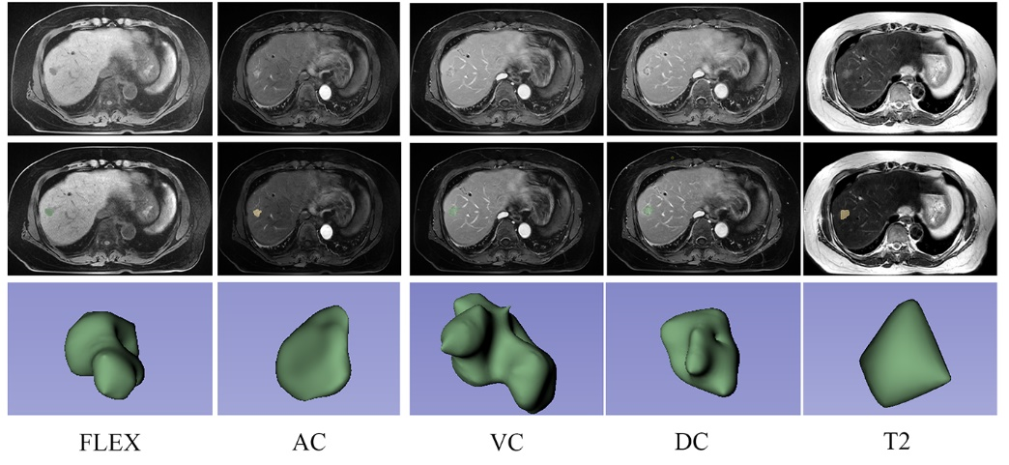
This image displays the manual delineation and 3D modeling of a hepatocellular carcinoma tumor from five MRI sequences:
FLEX: MRI plain scan.
AC: MRI arterial phase.
VC: MRI portal venous phase.
DC: MRI delayed phase.
T2: MRI T2-weighted imaging.
Each row shows 2D scans and their corresponding 3D tumor models, used for radiomic feature extraction and deep learning applications.

