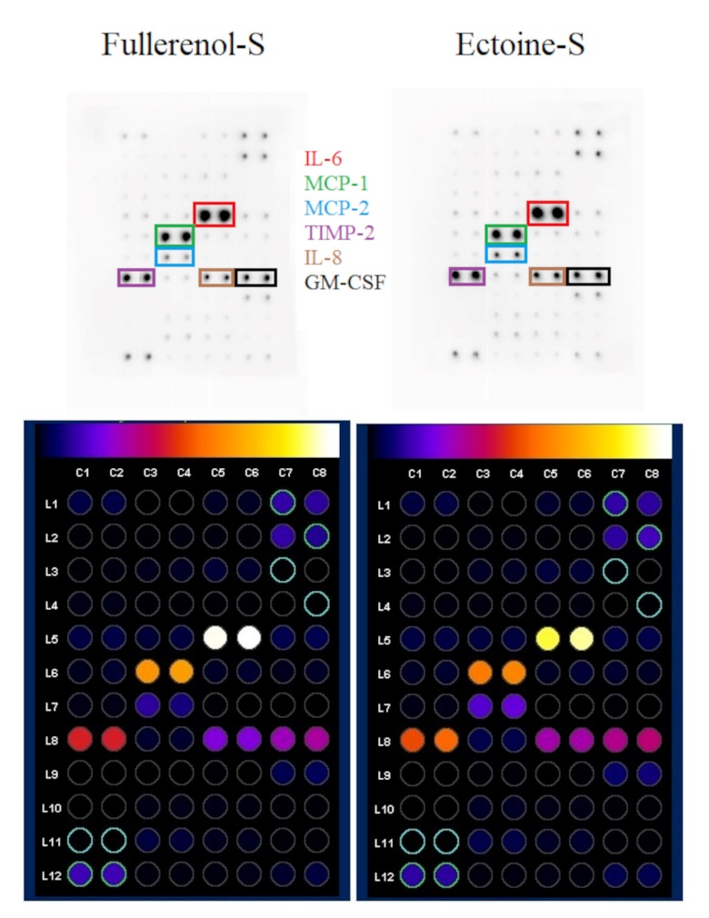
Figure S1 Analysis of cytokines secreted into the culture medium by HNEpCs pretreated for 1 h with 10 mg/L fullerenol (left side) or 0.2% ectoine (right side) and then incubated for 24 h with the S protein. The top row shows the output membranes and the bottom row shows the normalized results to control dots and background (blanks) using ImageJ 1.54d. The color of the frames corresponds to the color of the cytokines.
Abbreviations: IL; interleukin; MCP; monocyte chemotactic protein; TIMP; tissue inhibitor of metalloproteinases; GM-CSF; granulocyte macrophage colony stimulating factor.

