Appendix 1. Plastic Surgery Assessment Quiz. Twenty test questions administered to the residents rotating on the plastic surgery service to assess knowledge gained.

The purpose of this anonymous and confidential test is to help assess the quality of the clinical instruction while on the plastic surgery rotation. The last four digits of the social security number are for tracking and statistical analysis purposes only

Plastic Surgery Assessment Quiz

Dept.____________ __PGY_____ _Last four digits S.S.#_________Date_ _ _ _

Please read each of the following 20 items and select the single best answer. There is no penalty for guessing. These results will assist with curriculum reform. Thank you for your assistance
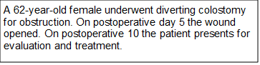

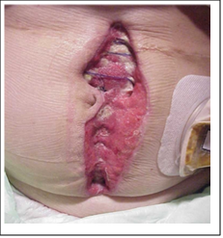
- For figure 1 what is the LEAST appropriate treatment for this wound?
- Application of VAC™ dressing
- Serial debridement
- Moist dressing changes
- Reclose the wound edges
- Skin graft
2. How long does it take to initiate irreversible skin changes marking the onset of a pressure ulcer?
  - 1 hour
  - 4 hours
  - 12 hours
  - 24 hours
3. What does Moh’s micrographic surgery refer to?
  - Closure technique of face wounds.
  - Excision technique for basal cell carcinoma.
  - Margin identification for facial melanoma in situ.

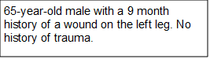

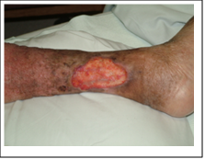
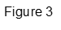
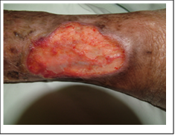
4. For figures 2 & 3, what is the LEAST likely etiology of this type of chronic wound?
- Arterial insufficiency
- Post-surgical/iatrogenic
- Sickle cell disease
- Venous insufficiency
5. For figures 2 & 3, what is the single most effective treatment for this type of wound?
- Compression dressing
- Serial debridement
- Arterial revascularization
- Skin graft / flap
6. A facial laceration is repaired with 5-0 Vicryl® deep dermal stitches and 5-0 Prolene® simple interrupted stitches in the skin. To maximize aesthetic results and minimize dehiscence, when should the Prolene® stitches be removed?
  - 1-3 days
  - 4-6 days
  - 7-14 days
7. Which is the most appropriate suture for repairing a 3.0 cm longitudinal laceration of the dorsum of the hand? There is no involvement of the tendon.
- 2-0 Prolene®
- 3-0 Vicryl®
- 4-0 fast-absorbing gut
- 5-0 Nylon
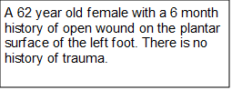
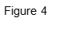
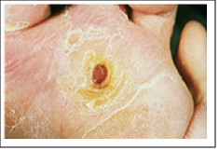
8. For figure 4, what is the most common etiology for this type of chronic wound?
  - Arterial insufficiency
  - Charcot arthropathy
  - Diabetic neuropathy
  - Venous insufficiency
9. Which statement best describes treatment for the wound in figure 4?
- Aggressive wide debridement with removal of abnormal tissue and infection will allow for spontaneous healing.
- Foot elevation, antibiotic ointment and nutritional supplementation will stimulate healing.
- Moist dressing and modification of footwear will support healing by secondary intention.
- Expedient surgical closure with skin graft or flap will prevent infection of the wound.
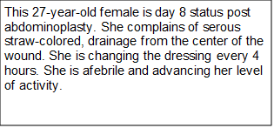
10. For figure 5, what is the single best intervention?
- Inpatient admission, bedrest and parenteral antibiotics.
- Opening of part of the incision.
- Oral antibiotics.
- Placement of a drain and suture repair of the drainage site.

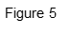
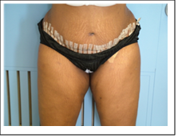
11. For figure 5 which of the following diagnoses is NOT considered a risk factor for this healing problem?
- Diabetes
- Hypertension
- Sickle cell anemia
- Cancer
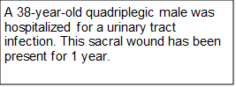
12. For figure 6 what is the single most effective treatment for this type of chronic wound?
- Frequent dressing changes
- Pressure relief
- Surgical closure
- Topical and/or parenteral antibiotics

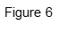
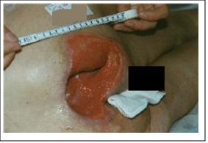
13. For figure 6 which is the LEAST appropriate dressing for this wound?
- Santyl® collagenase
- Negative pressure wound therapy (VAC®)
- Silvadene®
- Solosite® hygrogel
14. What is the published recurrence rate for surgically repaired chronic pressure ulcers?
- >80%
- 50%
- 10%
- <1%
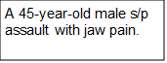
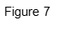
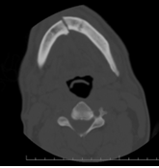
Figure 8
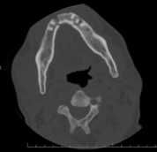

15. What type of fracture is present in figures 7 & 8?
- Alveolar fracture
- Body fracture
- Condylar fracture
- Parasymphyseal fracture
16. Which complication is associated with intermaxillary arch bar fixation (IMF)?
- Ankylosis of the tempromandibular joint.
- Loss of teeth
- Malocclusion
- Wound infection
17. Initially in the emergency department, how should uncontrolled arterial bleeding from a wrist laceration best be managed?
- Clamping of all vessels in the open wound.
- Compression dressing and tourniquet.
- Cutdown procedure proximal to the laceration and tying off the artery.
- Rapid watertight repair of the laceration with large permanent stitches.
18. Which statement best describes an abnormal scar?
- Hypertrophic scar and scar contracture are synonyms.
- Keloid scar grows beyond their original boundaries.
- Keloid and hypertrophic scar are synonyms.
- Tension is the likely etiology of a keloid scar
19. What is the most appropriate treatment for a closed nondisplaced first metacarpal long oblique fracture?
- Ace wrap and antibiotics.
- Closed reduction and hand-based splint.
- Hand-based thumb spica cast.
- Short arm radial gutter splint.
20. Which statement is most correct regarding problem wounds?
- Silver impregnated dressings have proven anti-microbial benefits.
- Wet to dry dressings can stimulate proliferative phase of healing.
- Wound healing deficits secondary to radiation improve once the erythema and pain resolve, approximately 3 months.
- Wounds that dry out (scab or eschar) heal faster than most wounds.

*Use of tradename ® is for convenience and clarity of what is used at our hospital. It is not an endorsement or preference.

Appendix 2. Plastic Surgery Goals and Objectives. The rotation curriculum provided to rotating residents in accordance with institutional policy.
General Surgery Residency
Plastic Surgery Goals and Objectives
Rotation Name: Plastic Surgery
PGY level that will be taking rotation: PGY 1 and PGY 3
Overall Objective of Rotation:
Understand and develop the basic skills needed to diagnose and manage patients treated by the plastic surgery service.
ACGME Competency and Level Based Goals & Objectives:
The Plastic Surgery Division is composed of board certified plastic surgeons managing patients at multiple sites in the health system. Our rotating residents (PGY 1 -3) can expect to see a wide range of elective hand and general plastic surgery problems. In addition, residents will treat trauma of the face, hand and soft tissue injuries in our ER on call where we rotate with Orthopedics and Otolaryngology. Wound healing problems are routinely seen in our inpatient consultations. Residents will rotate in the satellites (as time allows) in order to obtain more elective hand and cosmetic cases. The Plastic Surgery team consists of attending plastic surgeons, plastic surgery fellows, rotating residents, Physician extenders and medical students,
These goals will be obtained by active participation in the clinical activities of the Plastic Surgery Division with time being split between inpatient rounds, clinic, inpatient care and the operating room. Residents will work under the guidance and supervision of the senior staff. All residents will be involved in the teaching activities of the Plastic Surgery Division and the Department of Surgery including divisional lectures, hand anatomy dissections, videotape presentations, scheduled courses, Grand Rounds and morbidity / mortality conferences. All residents are expected to read on current and upcoming cases to get the most out of their participation.
All residents will maintain current patient care charting in EPIC the electronic medical record system.

PGY-1 Curriculum
Professionalism:
- Residents must demonstrate a commitment to professionalism and an adherence to ethical principles.
- Participate in the resident on call schedule covering new consults from the emergency department and inpatient night calls
- Coordinate call to conform to 80-hour work week

Patient Care and Procedural Skills
- Residents must be able to provide patient care that is compassionate, appropriate, and effective for the treatment of health problems and the promotion of health. Fellows must be able to perform all medical, diagnostic, and surgical procedures considered essential for the area of practice.
- Learn basic plastic surgery techniques
- Learn basic wound closure and subcuticular sutures
- Learn basic hand and finger fracture care
- Learn basic principles of grafts and flaps
- Become proficient in local anesthesia and nerve blocks of the finger, wrist and face assessments
- Become proficient in the functional assessment of facial, hand and skin injuries and tumors
- Demonstrate proficiency in the functional assessment of chronic wounds and pressure injuries
- Cooperate in the assessment of chest wall dehiscence and other major wounds
- Demonstrate decision making involved with repair of Mohs micrographic surgery defects
- Acquire knowledge in Emergency Department wound evaluation and management
- Gain experience with expeditious management of facial and hand soft tissue injuries, fractures and dislocations encountered in the Detroit Campus Emergency Department
- Learn to prioritize cases to determine the need for immediate care
- Understand pre and post-operative management
- Learn which cases can be done in an outpatient setting
- Become proficient in the postoperative orders and follow-up care for facial, hand and reconstruction cases, and chronic wound care
- Apply knowledge acquired on other rotations to patients on our service
- Apply wound healing principles to chronic wounds of pressure sores, diabetic ulcers, vascular impaired limbs and infections
- Be familiar with at least two techniques of chronic wound care
- Gain knowledge in the following technical skills:
  - Fine tissue handling and suturing techniques
  - Assessing and reconstructing traumatic skin wounds
  - Assessing and repairing extensor tendon wounds
  - Assessing and performing biopsies of skin nevi and cysts
- Gain knowledge of basic finger and hand fracture care in the following:
  - Applying an effective Double Kerlix method dressing
  - Applying off-the-shelf splints
  - Applying apply hand and wrist plaster splints
- Document surgical procedures in the ACGME data base

Medical Knowledge:
- Residents must demonstrate knowledge of established and evolving biomedical, clinical, epidemiological and social-behavioral sciences, as well as the application of this knowledge to patient care.
Residents will acquire knowledge of the following anatomical structures
- Face, hand and skin
- Common reconstructive procedures such as deep inferior epigastric perforator flaps, other common free flaps, myocutaneous flaps, chest wall reconstructions
- Understand the physiology of acute wound healing chronic wounds
- Become knowledgeable about benign and malignant skin tumors
- Learn about common syndromes encountered in plastic and hand surgery such as carpal tunnel, DeQuervain’s disease, trigger finger, Dupuytrens Contracture.

Practice-based Learning and Improvement:
- Residents must demonstrate the ability to investigate and evaluate their care of patients, to appraise and assimilate scientific evidence, and to continuously improve patient care based on constant self-evaluation and lifelong learning.
- Lead informal discussions of medical topics related to patients on our service
Interpersonal and Communication Skills:
- Residents must demonstrate interpersonal and communication skills that result in the effective exchange of information and collaboration with patients, their families, and health professionals.
- Learn to communicate with supervising staff, support staff, patients, families and referring services
System-based Practice:
- Residents must demonstrate an awareness of and responsiveness to the larger context and system of health care, including the social determinants of health, as well as the ability to call effectively on other resources to provide optimal health care.
- Participate in discharge planning. Understand the disease specific requirements, patient specific restrictions and impact of the social determinants of health.
- Collaborate with social workers to coordinate patient discharge process.
Supervision:
Supervisor and oversight will be tiered with graded authority and responsibility. Residents may perform history and physical examinations, and consultations under indirect supervision with direct supervision available. Residents may perform pre-operative evaluation work up and formulation of a plan of treatment under indirect supervision with direct supervision available. Residents may perform management of routine post-operative issues such as fluid management, decisions of venous thromboembolism prophylaxis etc. under indirect supervision with direct supervision available. Minor procedures performed at other locations (i.e. ward, clinic, emergency room, intensive care unit) may be performed by the appropriate level resident under indirect supervision with direct supervision immediately available or direct supervision available along with the attending physicians knowledge and approval. Senior residents may supervise PGY I and intermediate level residents that are not yet qualified in a given procedure.
Didactics/Educational Conferences
Many plastic surgery didactic activities conflict with required general surgery didactic activities. Attendance at weekly plastic surgery didactics and monthly journal club are voluntary.
Evaluation Method:
Each resident is evaluated by all attendings with which he or she has had contact at the end of every rotation. The evaluation includes criteria based on the General Competencies, as well as rotation-specific objectives. The resident is allowed and encouraged to view these reports. In addition, evaluations are completed by nurses, midlevels, administrative staff. These evaluations are reviewed by the Program Director. If there are significant deficiencies, a conference is arranged with the Program Director.

PGY-3 Curriculum
Professionalism:
- Residents must demonstrate a commitment to professionalism and an adherence to ethical principles.
- Assume senior resident responsibility for organization and care of inpatients on service and consults
- Coordinate call of residents assigned to service to conform to 80-hour work week

Patient Care and Procedural Skills:
- Residents must be able to provide patient care that is compassionate, appropriate, and effective for the treatment of health problems and the promotion of health. Fellows must be able to perform all medical, diagnostic, and surgical procedures considered essential for the area of practice.
Residents will:
- Management of patients before, during and after operations: Be able to accurately evaluate and correct problems preoperatively, request appropriate anesthesia, place patients in position for operations on various body locations, efficiently and accurately
- Assist in operations, apply effective dressings and splints, write general and specific postoperative orders
- Follow patients with identification of potential complications
- Assume the role of operating surgeon under supervision
- Refine fine tissue handling skills
- Remain current in-patient care electronic charting

Practice-based Learning and Improvement:
- Residents must demonstrate the ability to investigate and evaluate their care of patients, to appraise and assimilate scientific evidence, and to continuously improve patient care based on constant self-evaluation and lifelong learning.
- Participate in the teaching of junior residents and medical students on the service.
- Lead informal discussions of medical topics related to patients on our service.

Interpersonal and Communication Skills:
- Residents must demonstrate interpersonal and communication skills that result in the effective exchange of information and collaboration with patients, their families, and health professionals.
- Residents must develop skills in communicating with patients, families and ancillary staff in an effective, yet respectful manner
- Residents must demonstrate clear and concise patient notes

System-based Practice:
- Residents must demonstrate an awareness of and responsiveness to the larger context and system of health care, including the social determinants of health, as well as the ability to call effectively on other resources to provide optimal health care.
- Participate in discharge planning. Understand the disease specific requirements, patient specific restrictions and impact of the social determinants of health.
- Collaborate with social workers to coordinate patient discharge process.
Supervision:
Supervisor and oversight will be tiered with graded authority and responsibility. Residents may perform history and physical examinations, and consultations under indirect supervision with direct supervision available. Residents may perform pre-operative evaluation work up and formulation of a plan of treatment under indirect supervision with direct supervision available. Residents may perform management of routine post-operative issues such as fluid management, decisions of venous thromboembolism prophylaxis etc. under indirect supervision with direct supervision available. Minor procedures performed at other locations (i.e. ward, clinic, emergency room, intensive care unit) may be performed by the appropriate level resident under indirect supervision with direct supervision immediately available or direct supervision available along with the attending physicians knowledge and approval. Senior residents may supervise PGY I and intermediate level residents that are not yet qualified in a given procedure.
Senior level residents are expected to lead inpatient daily rounds including assessment and planning with direct supervision. Senior level residents are expected to function as lead surgeon for routine uncomplicated operations with direct supervision.

Didactics/Educational Conferences
Many plastic surgery didactic activities conflict with required general surgery didactic activities. Attendance at weekly plastic surgery didactics and monthly journal club are voluntary.
Evaluation Method:
Each resident is evaluated by all attendings with which he or she has had contact at the end of every rotation. The evaluation includes criteria based on the General Competencies, as well as rotation-specific objectives. The resident is allowed and encouraged to view these reports. In addition, evaluations are completed by nurses, midlevel’s, administrative staff. These evaluations are reviewed by the Program Director. If there are significant deficiencies, a conference is arranged with the Program Director.

