Tumor-Stroma Ratio is a Critical Indicator of Peritoneal Metastasis in Gastric Cancer
Lin Zhong ^{a †}, Hongyun Huang ^{b †}, Dong Hou^{a†}, Shihai Zhou^{c}, Yu Lin^{d}, Yue Yu^{d}, Jinhao Yuª, FanghaiHan ^{e}*, Lang Xie ^{f}*

ª Department of Gastrointestinal Surgery, Sun Yat-sen Memorial Hospital, Sun Yat-sen University, Guangzhou, Guangdong, China, 510120;
^{b} Department of General Surgery, Peking Union Medical College Hospital, Chinese Academy of Medical Science and Peking Union Medical College, Beijing, China, 100010;
^{c} Department of Tumor Surgery, Zhongshan City People’s Hospital, Zhongshan, Guangdong, China, 528403;
^{d} Department of Pathology, Zhujiang Hospital, Southern Medical University, Guangzhou, Guangdong, China, 510282;
^{e} Department of Gastrointestinal Surgery, Guangdong Second Provincial General Hospital, Guangzhou, Guangdong, China, 5181025;
^{f} Department of General surgery, Zhujiang Hospital, Southern Medical University, Guangzhou, Guangdong, China, 510282.

*Corresponding author
langxiezj@hotmail.com (Lang Xie); fh_han@163.com (Fanghai Han)

† These authors made equal contributions to this work.
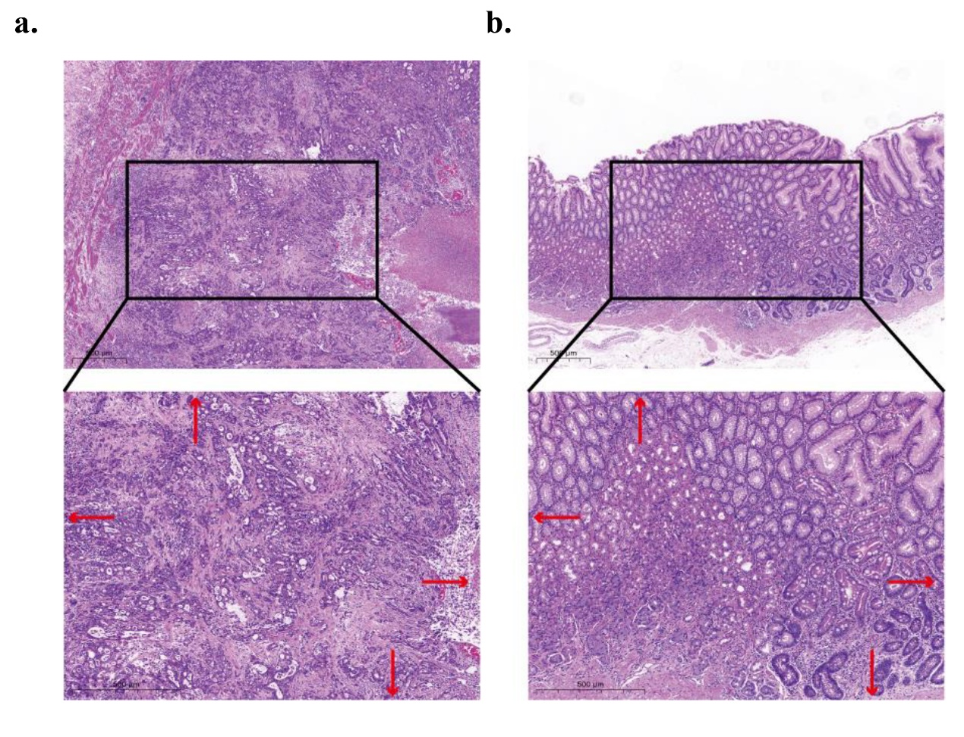
Supplemental Fig. 1. Schematic diagram of the TSR score. The target area was determined under 5 × field of view, and the TSR score was performed under 10 × field of view. The visual field area for scoring needs to ensure that the tumor cells are distributed around. Tumor cells present at all borders of the image field (north–east–south–west, red arrows).The samples were divided into high TSR group (a) and low TSR group (b) with a 50 % threshold as the cut-off value.

