Supplementary Material
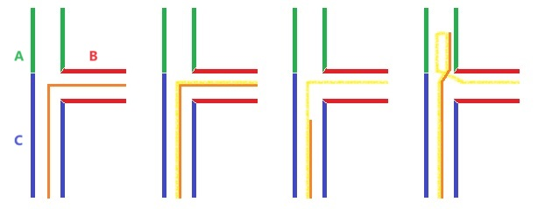
Supplementary Figure 1. Detailed steps of the loop technique in cardiac resynchronization therapy. (a) the guidewire (orange) was placed into the target vessel ([B] red) through the coronary sinus; (b) the left ventricular lead (yellow) was sent to the suitable position of the target vessel; (c) the guidewire retreated to the [C] blue vessel; (d) the guidewire in the left ventricular lead advanced to the [A] green vessel.

