Supplementary Materials

Supplementary Material 1 The search strategies of electronic databases 2
Supplementary Material 2 The list of excluded articles at the stage of full-text review 4
Supplementary Material 3 Subgroup analysis results of VAS scores 6
Supplementary Material 4 Meta-analysis results of cervical function 7
Supplementary Material 5 Meta-analysis results of cervical curvature 9

Supplementary Material 1 The search strategies of electronic databases
- Pubmed: A total of 6 literatures were retrieved.
#1: ((((Neck Pain[MeSH Terms]) OR (Spondylosis[MeSH Terms])) OR (Radiculopathy[MeSH Terms])) OR ((((cervical spondylotic radiculopathy[Title/Abstract]) OR (cervical radiculopathy[Title/Abstract])) OR (cervical spondylosis[Title/Abstract])) OR (nerve-root type cervical spondylosis[Title/Abstract])))
#2: ((Rotation-Traction Manipulation[Title/Abstract]) OR (Rotation Traction Manipulation[Title/Abstract])) OR (Cervical Rotation-Traction Manipulation[Title/Abstract])
#3: #1 AND #2
- EMbase: A total of 4 literatures were retrieved.
#1 'neck pain'/exp
#2 'spondylosis'/exp
#3 'radiculopathy'/exp
#4 'cervical spondylosis'/exp
#5 'cervical spondylotic radiculopathy'/exp
#6 'cervical spondylotic radiculopathy':ab,ti OR 'cervical radiculopathy':ab,ti OR 'nerve-root type cervical spondylosis':ab,ti
#7 'Rotation-Traction Manipulation':ab,ti OR 'Rotation Traction Manipulation':ab,ti OR 'Cervical Rotation-Traction Manipulation':ab,ti
#8 #1OR #2 OR #3 OR #4 OR #5 OR #6
#9 #7 AND #8
*exp=expand search; ab,ti=abstract, title
- The Cochrane Library: A total of 8 literatures were retrieved.
#1 MeSH descriptor: [Neck pain] explode all trees
#2 MeSH descriptor: [spondylosis] explode all trees
#3 MeSH descriptor: [radiculopathy] explode all trees
#4 (cervical spondylotic radiculopathy):ti,ab,kw OR (cervical radiculopathy):ti,ab,kw OR (nerve-root type cervical spondylosis):ti,ab,kw(Word variations have been searched)
#5 (Rotation-Traction Manipulation):ti,ab,kw OR (Rotation Traction Manipulation):ti,ab,kw OR (Cervical Rotation-Traction Manipulation):ti,ab,kw(Word variations have been searched)
#6 #1 OR #2 OR #3 OR #4
#7 #5 AND #6
*ti,ab,kw=title, abstract, keywords
- Web of Science: A total of 15 literatures were retrieved.
TS=(cervical spondylotic radiculopathy OR cervical radiculopathy OR nerve-root type cervical spondylosis OR neck pain OR spondylosis OR radiculopathy) AND TS=(Rotation-Traction Manipulation OR Rotation Traction Manipulation OR Cervical Rotation-Traction Manipulation)
*TS=Topic
- China National Knowledge Infrastructure (CNKI): A total of 115 literatures were retrieved.
(SU='Cervical Rotation-Traction Manipulation') AND (SU='cervical spondylotic radiculopathy' OR SU='cervical radiculopathy' OR SU='cervical spondylosis' OR SU='neck pain')
*SU=Subject
- WanFang Data: A total of 125 literatures were retrieved.
(Topic:(Cervical Rotation-Traction Manipulation)) and (Topic:(cervical spondylotic radiculopathy) or Topic:(cervical radiculopathy) or Topic:(cervical spondylosis) or Topic:(neck pain))
- VIP: A total of 75 literatures were retrieved.
Topic=(Cervical Rotation-Traction Manipulation) AND Topic=(cervical spondylotic radiculopathy OR cervical radiculopathy OR cervical spondylosis OR neck pain)
- SinoMed: A total of 89 literatures were retrieved.
"Cervical Rotation-Traction Manipulation"[unweighted: expanded] AND ("cervical spondylotic radiculopathy"[unweighted: expanded] OR "cervical radiculopathy"[unweighted: expanded] OR "cervical spondylosis"[unweighted: expanded] OR "neck pain"[unweighted: expanded])

Supplementary Material 2 The list of excluded articles at the stage of full-text review
Number | References | Reason
1 | Zhu LG, Yu J, Gao JH, Zhang Q, Li JJ, Fang JG. Clinical study on VAS score for pain of cervical radiculopathy treated by rotatory manipulation. Beijing Journal of Traditional Chinese Medicine. 2005;24(5):297-298. | Not CRTM
2 | Zhu LG, Zhang Q, Gao JH, Li JX, Luo J, Yang KX, Wang SQ, Yu J, Zhao GD, Zhang W. Clinical observation on rotation-traction manipulation for treatment of the cervical spondylotic of the neuro-radicular type. China Journal of Orthopaedics and Traumatology. 2005;18(8):489-490. | Not CRTM
3 | Yu J, Xie YM, Zhu LG, Yu J, Zhang Q. Cost-effectiveness analysis of rotational manipulation in treatment of cervical radiculopathy. Chinese Journal of Information on Traditional Chinese Medicine. 2008;15(4):7-8. | Not CRTM
4 | Zhang JX. Clinical Observation of the Sun's Rotatory Manipulation about the Treatment of the Spondylotic Radiculopathy. Guangzhou University of Chinese Medicine, 2008. | Not CRTM
5 | Qin Y, Li ZY, Lu Y, Qin J, Jiang JM. Randomized Controlled Clinical Study of the Clinical Efficacy of the Sun Manipulation of Rotating Treatment to Cervical Spondylotic Radiculopathy. Chinese Journal of Traditional Medical Traumatology & Orthopedics. 2012;20(7):3-5. | Not CRTM
6 | Lin X, Zheng MJ, Chen B, Zhang M, Pang J, Zhang MC, Zhan HS. Analysis of Quality of Life in Rotating and Reconstructive Manipulative Therapy for Treating Nerve Root Type Cervical Spondylopathy. Chinese Journal of Traditional Medical Traumatology & Orthopedics. 2015;23(5):5-8. | Not CRTM
7 | Chu FM, Zhang Z, Liu JW, Yuan RX. Comparative Analysis of Rotation Manipulation and Conventional Manipulation in Treating Nerve Root Cervical Spondylosis. Chinese Journal of Traditional Medical Traumatology & Orthopedics. 2009;17(3):36-37. | Not CRTM
8 | Shen GX. Observation on the clinical effect of rotational manipulation on cervical radiculopathy. The Journal of Medical Theory and Practice. 2014;(9):1180-1181. | Not CRTM
9 | Yu J, Zhu LG, Li JJ, Hong Y, Wang P, Fang M, Lin DK. Clinical research of TCM comprehensive therapy on recurrence rate of shoulder-arm pain after nerve root type cervical spondylosis. Beijing Journal of Traditional Chinese Medicine. 2013;32(12):885-888. | Inappropriate comparison
10 | Wu JL. Clinical Effects And Safety of TCM Combination Therapy On Cervical Spondylopathy of The Nerve Root Type. Guangzhou University of Chinese Medicine, 2009. | Inappropriate comparison
11 | Zhen PC, Zhu LG, Gao JH, Yu J, Feng MS, Wei X, Wang SQ. Clinical observation on improvement of motion range of cervical spine of patients with cervical spondylotic radiculopathy treated with rotation-traction manipulation and neck pain particles and cervical neck pain rehabilitation exercises. China Journal of Orthopaedics and Traumatology. 2010;23(10):750-753. | Inappropriate comparison
12 | Wu JL, Lin DK, Chen BL, Su HT, Ning FP, Zhao BD. Clinical observation on treatment of cervical radiculopathy by manipulation combined with acupuncture at Jingtong point. Journal of New Chinese Medicine. 2012;44(5):107-109. | Inappropriate comparison
13 | Zhao C, Bai Y. Clinical Observation on the Treatment of Cervical Spondylotic Radiculopathy with Optimized Scheme of Comprehensive Non-operative Therapy. Rheumatism and Arthritis. 2014;(11):27-29,44. | Inappropriate comparison
14 | Chen X, Zhu LG, Yu J, Li JJ, Hong Y. Influence of traditional Chinese medicine combined therapy on the cervical curvature of cervical radiculopathy. Beijing Journal of Traditional Chinese Medicine. 2014,33(4):280-282. | Inappropriate comparison
15 | Li JG, Shen HD. To investigate the curative effect of non-operative comprehensive therapy for cervical spondylotic radiculopathy. World Latest Medicine Information. 2016;16(76):76-77. | Inappropriate comparison
16 | Xie YX. Clinical effect observation of non-surgical comprehensive therapy in treating nerve root-type cervical spondylosis. Clinical Journal of Chinese Medicine. 2018;10(27):13-14. | Inappropriate comparison
17 | Wang WM, Li YD, Liu YF, Zhang JT, Jin ZF. Clinical study on the treatment of cervical radiculopathy with dynamic traction and underlift manipulation. Jilin Journal of Traditional Chinese Medicine. 2013;33(8):839-840. | Inappropriate outcomes
18 | Liu LY, Zhao BL, Wang HD. Effect and Safety of Rotation-traction Manipulation on Cervical Spondylotic Radiculopathy. Food and Drug. 2012;14(6):436-439. | Inappropriate outcomes
19 | Yang B, Shi XF. Clinical observation of 80 cases of cervical radiculopathy treated by manipulation and acupuncture. World Health Digest. 2012;9(3):253-254. | Inappropriate outcomes
20 | Shi F, Huang CL. 52 Cases of Cervical Spondylotic Radiculopathy Treated by Warm Acupuncture Combined with Rotating-Lifting Manipulation. Liaoning Journal of Traditional Chinese Medicine. 2022;49(6):189-192. | Not RCTs
21 | Xia LL. Clinical efficacy observation of pulse radiofrequency combined with rotation-traction manipulation in treatment of cervical radiculopathy. Tianjin University of Traditional Chinese Medicine, 2021. | Not RCTs
22 | Zhen PC, Zhu LG, Gao JH, Yu J, Feng MS, Wei X, Wang SQ. Clinical observation on improvement of motion range of cervical spine of patients with cervical spondylotic radiculopathy treated with rotation-traction manipulation and neck pain particles and cervical neck pain rehabilitation exercises. China Journal of Orthopaedics and Traumatology. 2010;23(10):750-753. | Duplicate publication

Supplementary Material 3 Subgroup analysis results of VAS scores
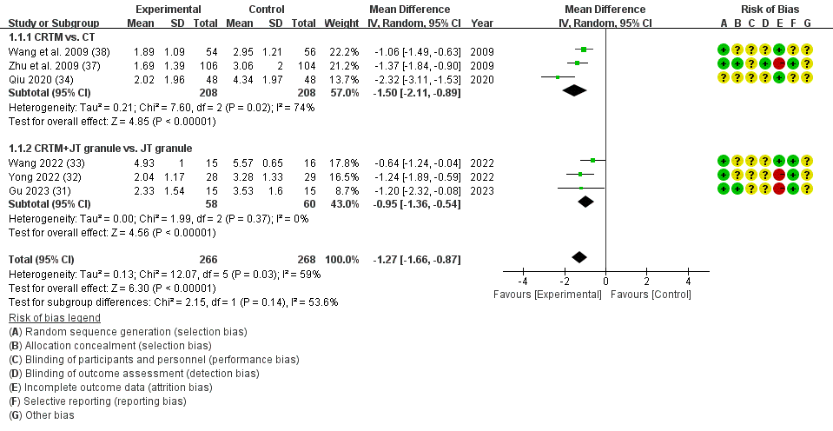
Supplementary Figure 1 Subgroup analysis results of VAS scores based on control group categories
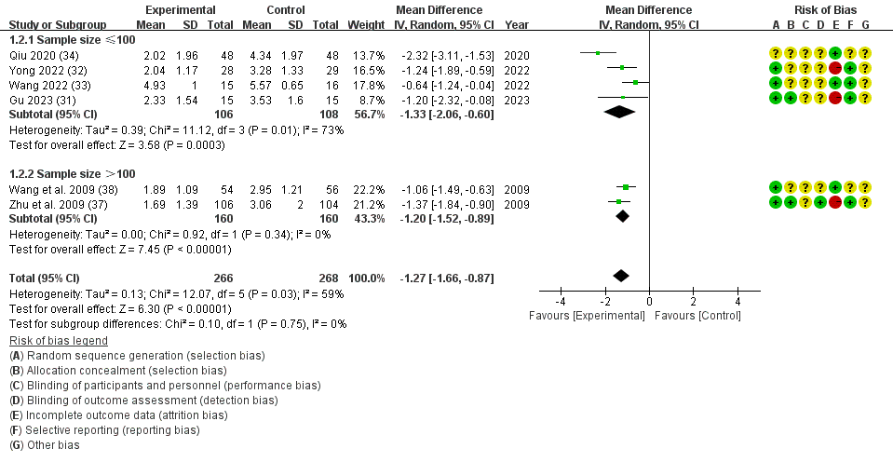 Supplementary Figure 2 Subgroup analysis results of VAS scores based on sample sizes
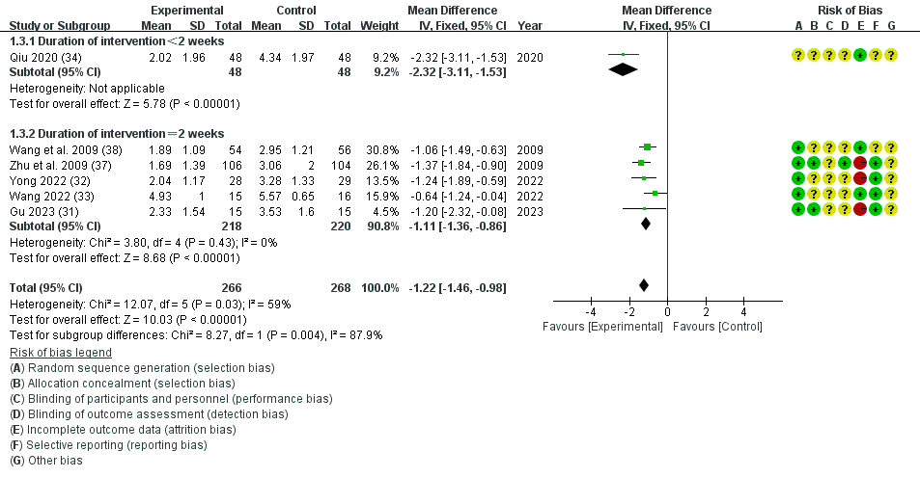
Supplementary Figure 3 Subgroup analysis results of VAS scores based on durations of intervention

Supplementary Material 4 Meta-analysis results of cervical function
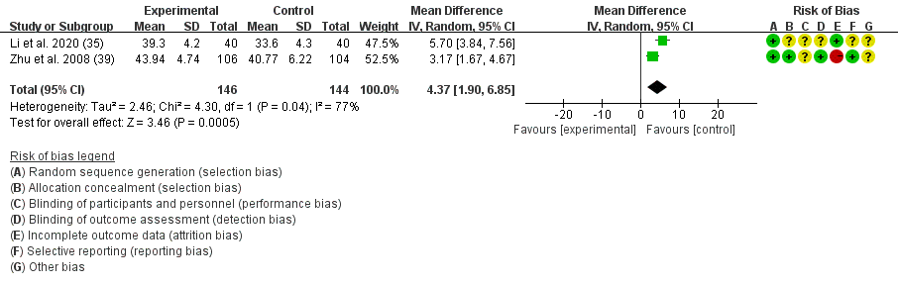 Supplementary Figure 4 The forest plot of cervical range of motion of left flexion
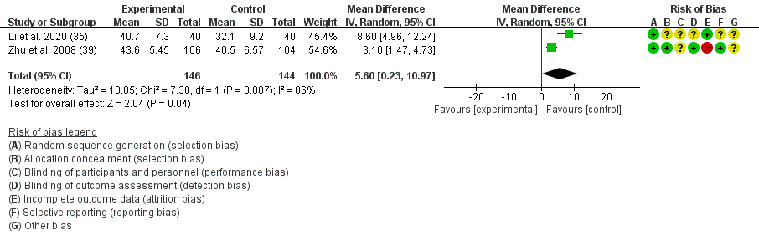
Supplementary Figure 5 The forest plot of cervical range of motion of right flexion
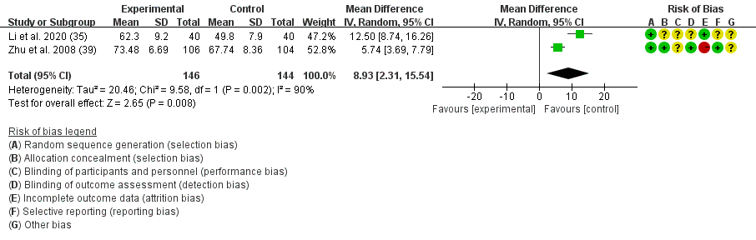
Supplementary Figure 6 The forest plot of cervical range of motion of left rotation
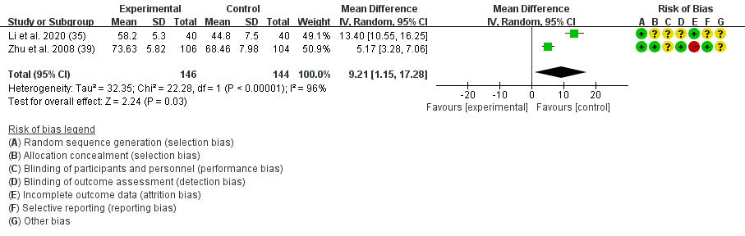
Supplementary Figure 7 The forest plot of cervical range of motion of right rotation
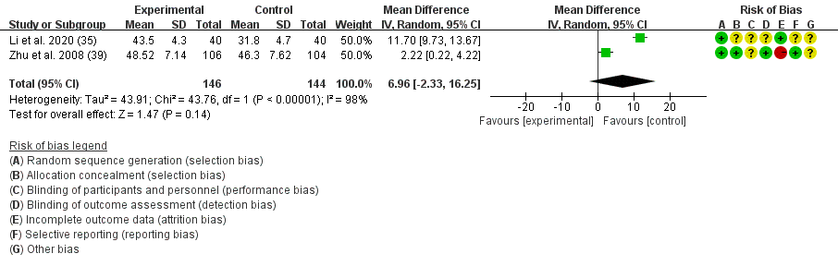
Supplementary Figure 8 The forest plot of cervical range of motion of flexion
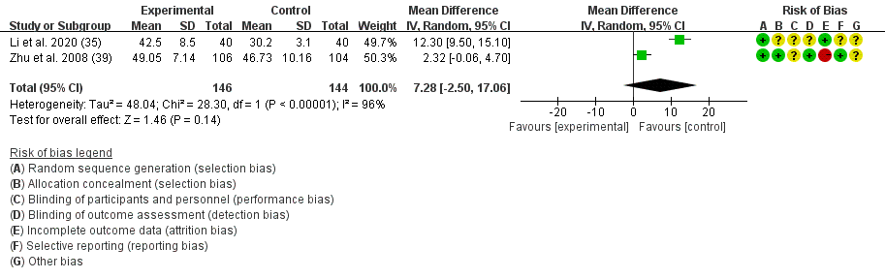
Supplementary Figure 9 The forest plot of cervical range of motion of extension
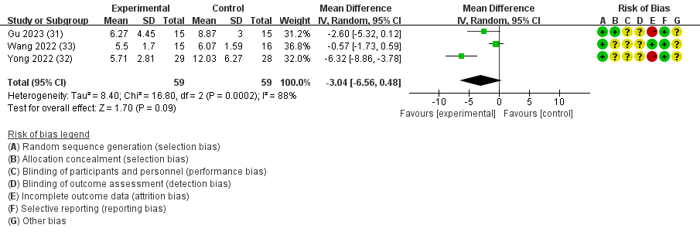
Supplementary Figure 10 The forest plot of NDI scores
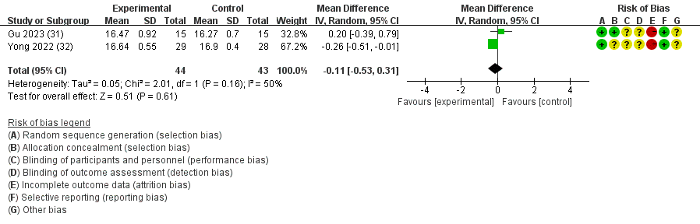
Supplementary Figure 11 The forest plot of JOA scores

Supplementary Material 5 Meta-analysis results of cervical curvature
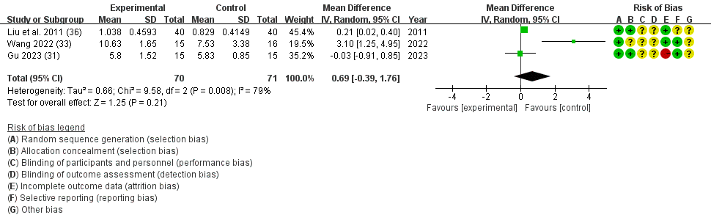
Supplementary Figure 12 The forest plot of cervical curvature

