Supplemental Digital Content
Supplementary Table S1 1
Supplementary Figure S1 2

SupplementaryTable S1. Comparison of the efficacy with sTREM-1 of each marker for septic cardiomyopathy events
Variable | Area | Standard error | p value | Z-statistic
sTREM-1(pg/ml) | 0.824 | 0.03388 | - | -
MYO(ng/ml) | 0.545 | 0.04871 | < 0.0001 | 4.6955
CK-MB(ng/ml) | 0.556 | 0.04915 | < 0.0001 | 4.4844
TNT-HS(ng/ml) | 0.547 | 0.04824 | < 0.0001 | 4.7058
NT-proBNP(pg/ml) | 0.514 | 0.04850 | < 0.0001 | 5.2416
PCT(ng/ml) | 0.630 | 0.04723 | 0.0009 | 3.3325
IL-1β(pg/ml) | 0.647 | 0.04572 | 0.0019 | 3.1069
IL-18(pg/ml) | 0.573 | 0.04884 | < 0.0001 | 4.2261
MYO: myoglobin;NT-proBNP: N-Terminal pronatriuretic peptide; CK-MB: creatine kinase isoenzyme; TNT-HS: highly sensitive troponin; PCT: Procalcitonin; IL-1β: Interleukin-1β; IL-18: Interleukin18; sTREM-1: soluble myeloid cells trigger receptor-1; P<0.05 means statistically significant.

Supplementary Fig. S1
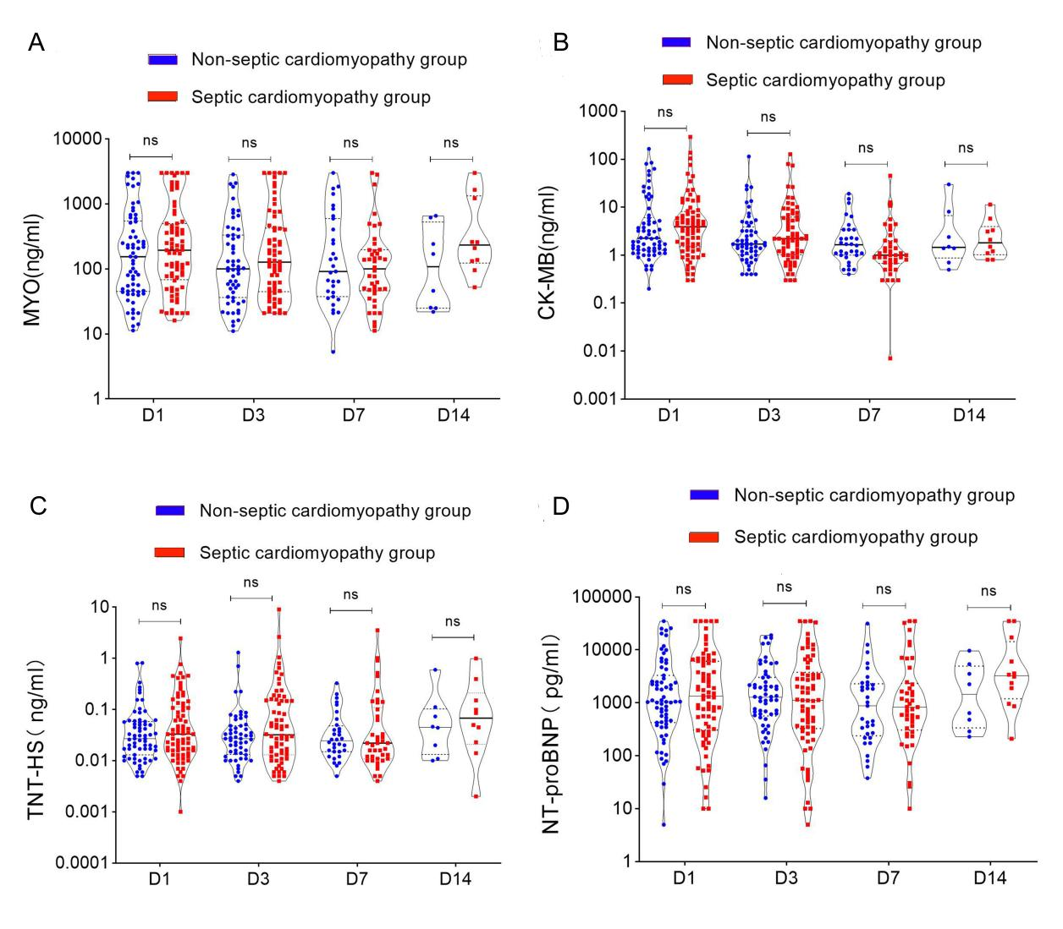
Fig. S1 Changes in markers of cardiac dysfunction in patients with Non-SCM and SCM after admission to ICU. A, MYO. B, CK-MB. C, TNT-HS. D,NT-proBNP. MYO, myoglobin; CK-MB, creatine kinase isoenzyme; TNT-HS, highly sensitive troponin. NT-proBNP, N-Terminal pronatriuretic peptide; ns means no statistically significant.

