Table S1. The Sleep Questionnaire
Clinical comorbidities in children | Answer “Yes/No”
- Does your child have enlarged tonsils?
- Does your child have enlarged adenoids?
- Has your child been tested for allergens and diagnosed with allergic rhinitis?
- Has your child been tested for allergens and diagnosed with non-allergic rhinitis?
- Have your child diagnosed with bronchial asthma?
- Have your child been diagnosed with a neuromuscular disease?
PSQ-term
- Did your child stop growing at a normal rate at any time since birth?
- Is your child overweight?
- While sleeping, does your child snore loudly?
- Does your child tend to breath through the mouth during the day
- While sleeping, does your child snore more than half the time?
- While sleeping, does your child always snore?
- Have you ever seen your child stop breathing during the night?
- While sleeping, does your child have trouble breathing, or struggle to breath
- While sleeping, does your child have "heavy" or loud breathing?
- Does your child have a dry mouth on waking up in the morning?
- This child often interrupts or intrudes on others?
- Does your child occasionally wet the bed?
- This child often is "on the go" or often acts as if " driven by a motor"
- This child often fidgets with hands or feets or squirms in seat?
- Does your child wake up feeling unrefreshed in the morning?
- This child often does not seem to listen when spoken to directly?
- Has a teacher or other supervisor commented that your child appears?
- it hard to wake your child up in the morning?
- This child often is easily distracted by extraneous stimuli？
- Does your child wake up with headaches in the morning?
- This child often has difficulty organizing task and activities？
- Does your child have a problem with sleepiness during the day?

Table S2. Comparison of POSA and NPOSA data before PSM
Variables, | NPOSA  (n=750) | POSA  (n=158) | p. value
*Age, y | 5.49± (2.71) | 5.84± (2.78) | 0.151
**Male, n (%) | 473 (63.1) | 97 (61.4) | 0.763
*BMI, kg/m² | 16.8± (3.41) | 18.0± (4.18) | 0.001
*means±(SD), ** N (%)
Table S3. Chi-square test for POSA and NPOSA among bronchial asthma groups after PSM
 | NPOSA | POSA | $$x^{2}$$ | P-value
Bronchial asthma |  |  | <0.001 | 1
Yes, n (%) | 17 (5.6) | 8 (5.2) | <0.001 | 1
No, n (%) | 289(94.4) | 145 (94.8) | <0.001 | 1

Abbreviations: PSM, propensity score matching; BMI, body mass index.

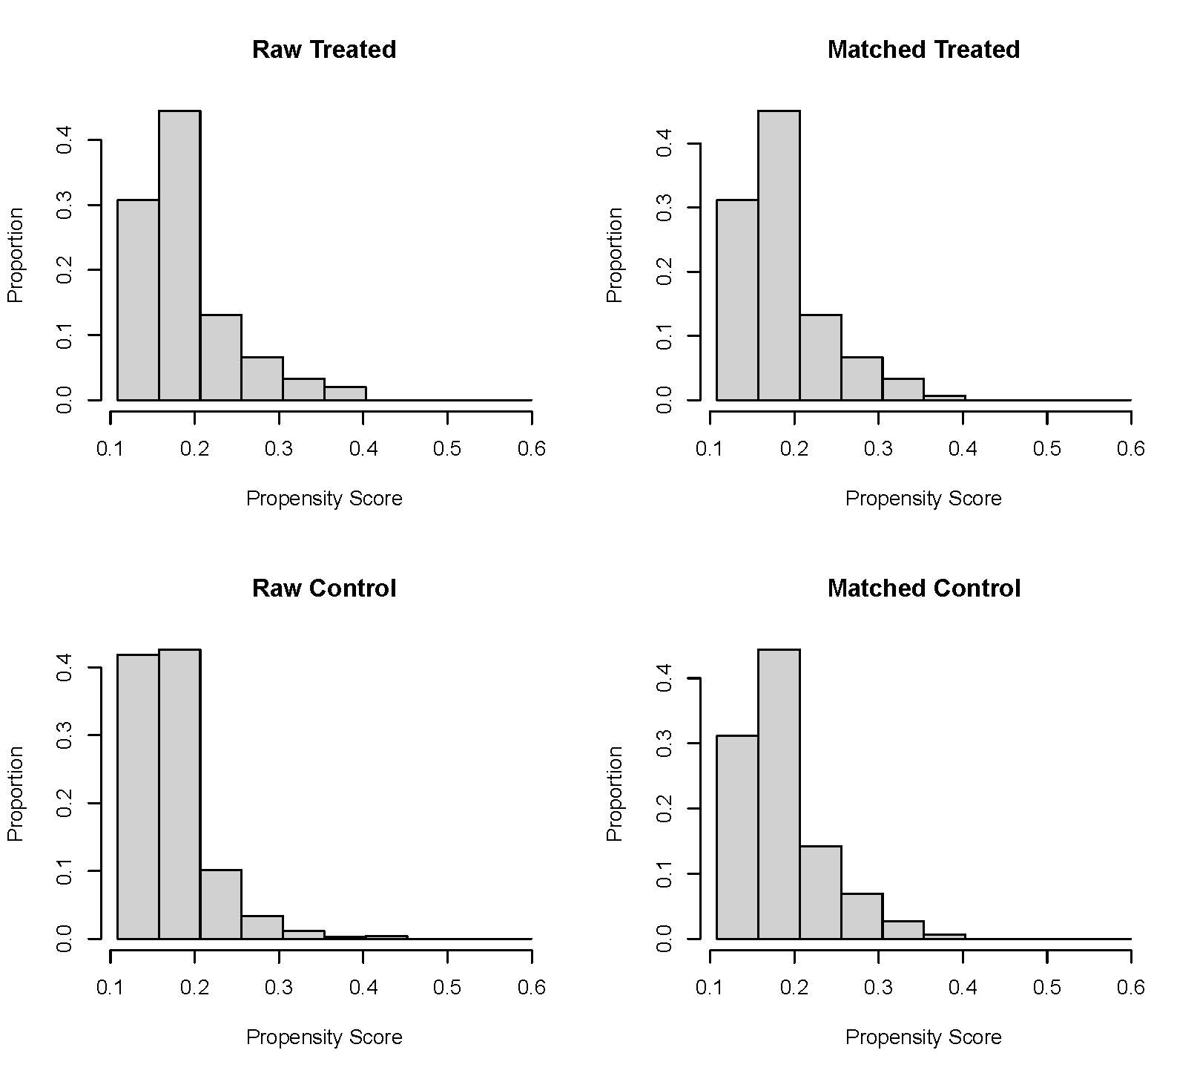
Figure S1 Balance Plot for Propensity Score Matching

