Supplementary Table 1 The variance inflation factor (VIF) assessed multicollinearity. A value > 5 indicates potential multicollinearity.
Variable | VIF
NEU | 7.8786
RBC | 3.0056
MON | 10.073
RDWSD | 1.153
PLT | 3.0774
HGB | 3.0616
HDLC | 1.0769
LYM | 8.1835
LMR | 11.495
NMR | 11.173
SII | 9.5827

Supplementary Table 2 Calibration degree evaluated by the Hosmer–Lemeshow test. P < 0.05: difference between the predicted and observed values, average calibration. P > 0.05: no significant difference, good fit.
Goodness of Fit Test | Chi-square | degrees of freedom | P-value
Training set | 14.324 | 8 | 0.074
Validation set | 10.955 | 8 | 0.204

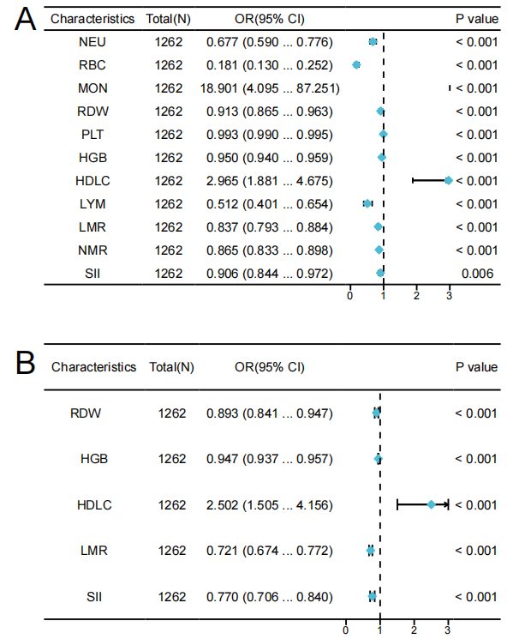
Supplementary Figure 1 Forest plots of risk factors for MS with single factor independent prognosis (A) and multifactor independent prognosis (B).
Abbreviations: NEU, neutrophil; RBC, red blood cell; MON, monocyte; RDW, red blood cell distribution width; PLT, platelet; HGB, hemoglobin; HDLC, high-density lipoprotein cholesterol; LYM, monocyte-to lymphocyte ratio; LMR, lymphocyte-to-monocyte ratio NMR, neutrophil-to-monocyte ratio; SII, systemic immune‐inflammation index; OR, odds ratio.

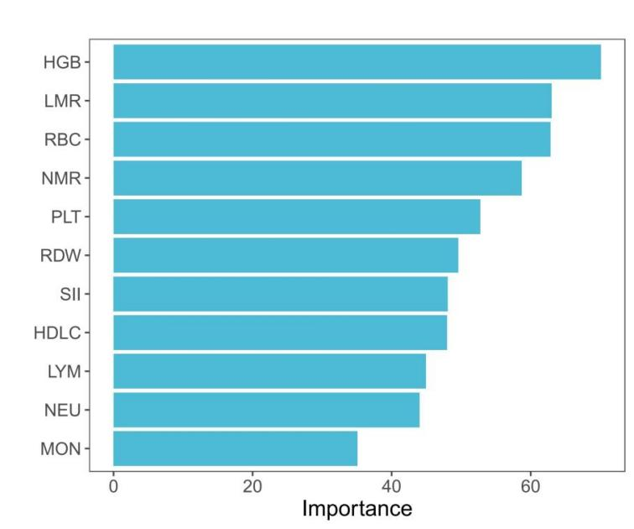
Supplementary Figure 2 Importance of features from the random forest model.
Abbreviations: HGB, hemoglobin; LMR, lymphocyte-to-monocyte ratio; RBC, red blood cell; NMR, neutrophil-to-monocyte ratio; PLT, platelet; RDW, red blood cell distribution width; SII, systemic immune‐inflammation index; HDLC, high-density lipoprotein cholesterol; LYM, monocyte-to lymphocyte ratio; NEU, neutrophil; MON, monocyte.

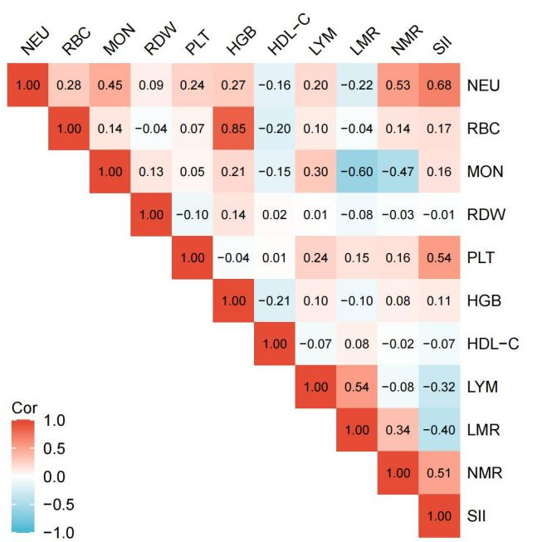
Supplementary Figure 3 Heatmap of pairwise correlation coefficients among variables in the dataset.
Abbreviations: NEU, neutrophil; RBC, red blood cell; MON, monocyte; RDW, red blood cell distribution width; PLT, platelet; HGB, hemoglobin; HDLC, high-density lipoprotein cholesterol; LYM, monocyte-to lymphocyte ratio; LMR, lymphocyte-to-monocyte ratio; NMR, neutrophil-to-monocyte ratio; SII, systemic immune‐inflammation index.

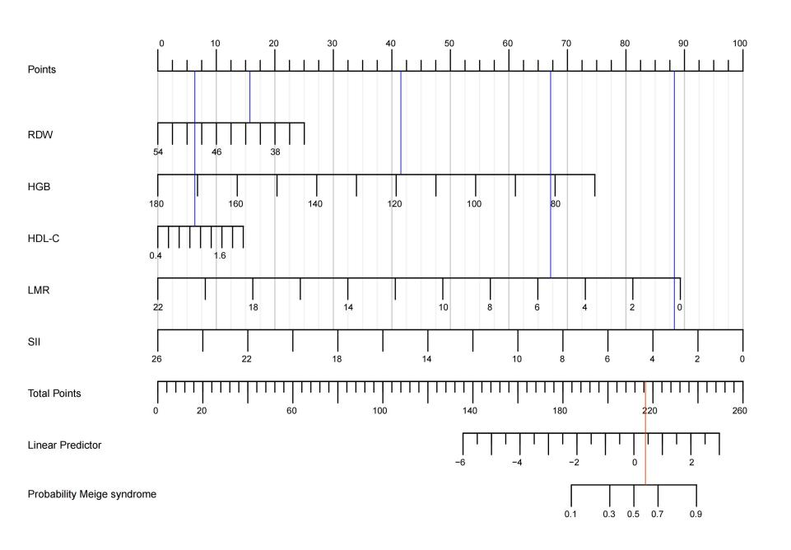
Supplementary Figure 4 Example of the MS disease risk prediction.
The blue lines represent values of a randomly selected patient from the development dataset who is RDW of 41.4 (15.75 points), with HGB of 119 g/L (41.59 point), HDL-C of 1.11 g/L (6.36points), LMR of 5.58 (66.71 points) and SII of 3.22 (87.62 points). These values when plotted, correspond to the points scale and points are then summed to give a total point score. The presented patient has a total point’s score of 218.03.
Abbreviations: RDW, red blood cell distribution width; HGB, hemoglobin; HDL-C, high-density lipoprotein cholesterol; LMR, lymphocyte-to-monocyte2 ratio; SII, systemic immune‐inflammation index.

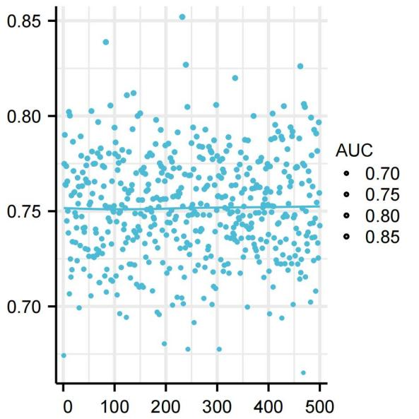

Supplementary Figure 5 Model validation was conducted via Five-fold cross-validation, with the average AUC serving as the metric for assessment.
Abbreviations: AUC, Area Under Curve.

