Supplemental material
Table S1 RT-qPCR system
Reagent | Volume
TB Green® Premix Ex Taq™ II | 5 μL
DNA | 1 μL
ddH₂O | 3 μL
Primer R | 0.4 μL
Primer F | 0.4 μL
ROX | 0.2 μL

Table S2 The primer sequences for RT-qPCR
Gene | Sequence（5'-3'）
16S rRNA-F | TACACACCGCCCGTCACACC
16S rRNA-R | CGGCTACCTTGTTACGACTTCACC
H2297-q-F | TTTTGCACACCGCTTTACCG
H2297-q-R | ACGAGCCCGACAAAAGGAAT
H1126-q-F | TTACTGTGGTGGCCTTTGCT
H1126-q-R | GGCTCCTGATCCATCGAGTT
H1233-q-F | AAACCGTACTAGCGGGCTTC
H1233-q-R | ACCAAACTTTTCTGGCGTGC
pgaA-q-F | CGTATGGCACTGTTCGAGGT
pgaA-q-R | CCCGCTTCAAAATGCTGCTT
H2313-q-F | ATCCGATTGATCCGCTTGCT
H2313-q-R | CGTTGAAGCGGCAATACCTG
H2766-q-F | CGCGCCAACATAAATTGCCT
H2766-q-R | GGTACACTTCACCCTGCACT
H3691-q-F | TTTGCAGCAGACTTGGAAGC
H3691-q-R | CACAAGCTGCTGTTTAGCGT
CspG-q-F | TGACAGCTCGTGAACAAGGC
CspG-q-R | CGATTGCACGGAAGTGAACG
GspG-q-F | GTGCCTCAGGCTTTACCCTT
GspG-q-R | CCCATGACGTTCGGTACGAT
PaaH-q-F | TAAGCCACCGTCATGTAGGC
PaaH-q-R | GCGCGTGTAAACATCACGAG
Note: H is an abbreviation for HMPREF0010_0.

Table S3 Primers for biofilm-associated genes
Gene | Sequence（5'-3'） | Function
CsuE-q-F | TTGTGGGAATCGGGGTGTTCTTTG | Pilus tip adhesin subunit CsuE^{[1]}
CsuE-q-R | GAGAGTGAACCAAGCGAGTCTGC | Pilus tip adhesin subunit CsuE^{[1]}
BfmR-q-F | GTCGTGAAGTTCGCCCACACTATC | Two-component signal transduction system response regulator BfmR^{[2]}
BfmR-q-R | GCACCCATTTCCAGACCAAGTACC
BfmS-q-F | GCAGAGCGTCGTTACCTTCACC | Two-component signal transduction system sensor kinase BfmS^{[2]}
BfmS-q-R | ATACCGCCCGTAATCCGAACTTTG
Pgm-q-F | AGTGCCCACCACTATTTCCG | Phosphoglucomutase PGM^{[3]}
Pgm-q-R | TCGTAGTTTGCGTATCGGCT | Phosphoglucomutase PGM^{[3]}

Table S4 Data quality table before and after quality control
Sample | Before filtering Q30（%） | After filtering Q30（%）
Con1 | 92.92 | 93.13
Con2 | 93.08 | 93.27
Con3 | 92.76 | 92.96
Con4 | 92.19 | 92.44
ABF1 | 90.72 | 91.24
ABF2 | 89.54 | 90.59
ABF3 | 92.66 | 92.94
ABF4 | 92.13 | 92.41

Table S5 Comparison results of each sample after sequencing data quantification
Sample | Total reads  (clean data) | Total mapped | Multiple mapped | Uniquely mapped
Con1 | 6433510 | 82.48% | 0.04% | 79.5%
Con2 | 7889632 | 89.98% | 0.03% | 87.07%
Con3 | 7918885 | 83.89% | 0.04% | 80.98%
Con4 | 6432234 | 86.75% | 0.02% | 83.8%
ABF1 | 7623586 | 72.44% | 0.02% | 69.41%
ABF2 | 9294046 | 79.93% | 0.02% | 76.58%
ABF3 | 7540588 | 73.56% | 0.01% | 70.94%
ABF4 | 8581624 | 78.64% | 0.01% | 75.77%

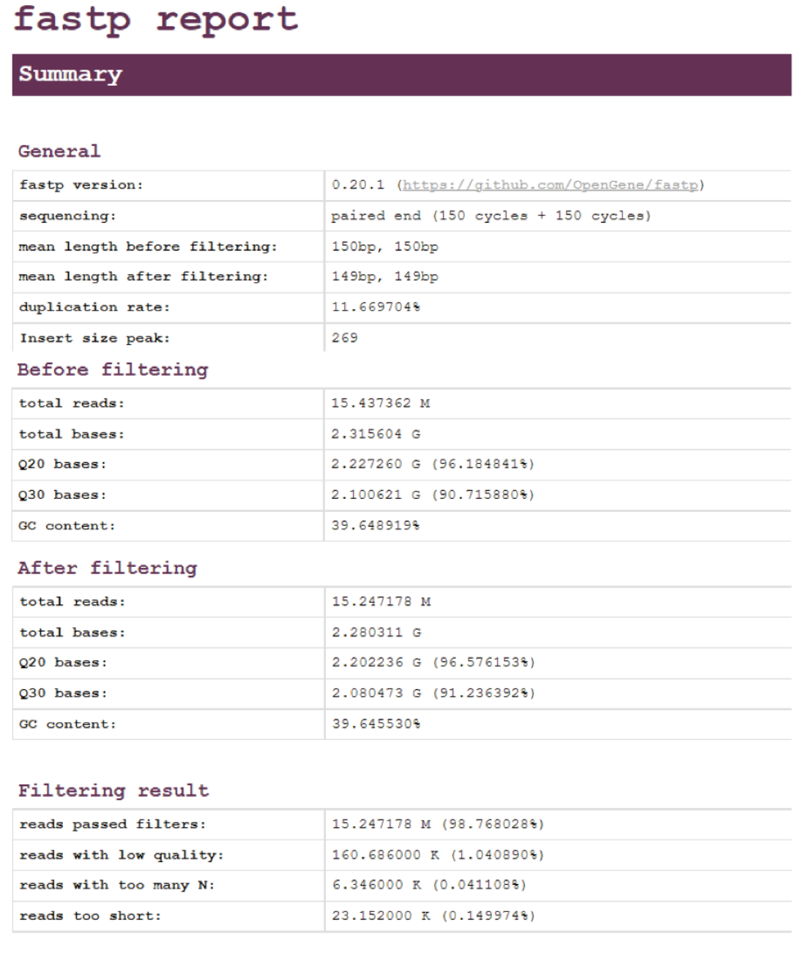
Figure S1 Report of the filtered fastp software for ABF1 samples.
Note: The report contains the total number of bases before and after filtering and the quality of bases before and after filtering.

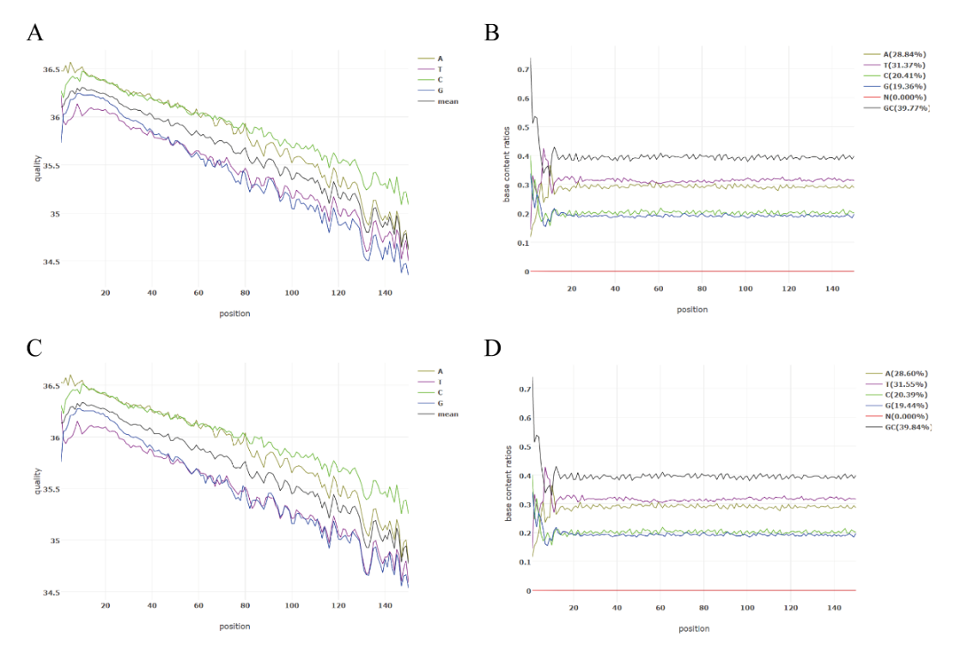
Figure S2 Quality control results of transcriptome data of ABF1 samples. A-B are base masses and GC contents of ABF1 samples before QC filtration; C-D are base masses and GC contents of ABF1 samples after QC filtration.

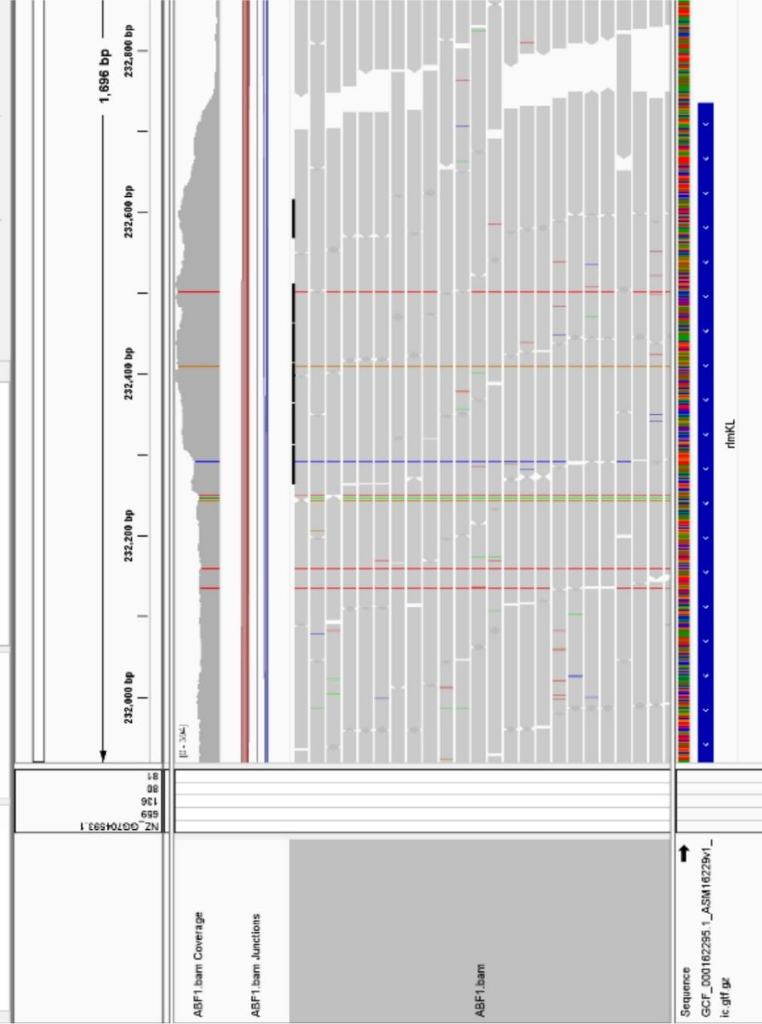
Figure S3 Results of alignment of transcriptome sequencing data with the reference genome of strain ATCC19606. The figure shows the results of ABF1 comparison with the reference genome of A. baumannii ATCC19606 strain, the upper peaked shaded portion is the corresponding sequencing depth of ABF1, the lower bar is the comparison of reads, the color portion is the different types of mutations, the bottom blue portion is the amino acid sequences corresponding to the reference sequences, and the color bar above the blue color bar is indicated by the different colors of the different bases.
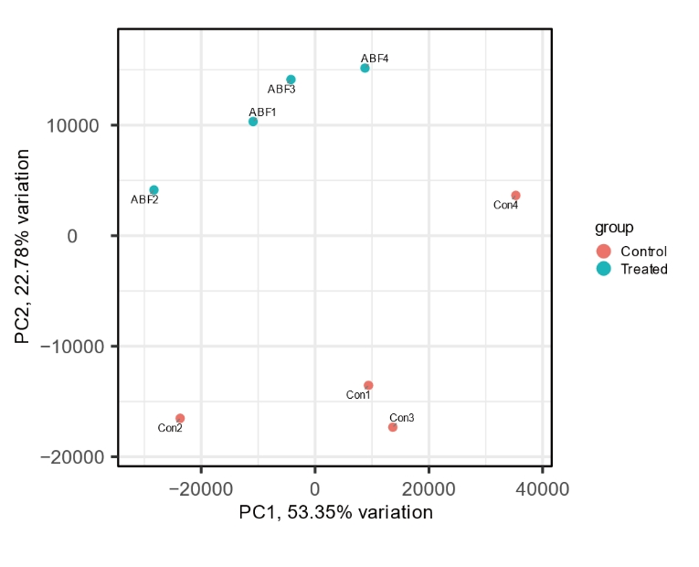
Figure S4 PCA principal component analysis between samples.

Figure S5 RT-qPCR validation of transcriptome results. The red line in the graph is the threshold for a Fold Change of 1. Greater than 1 is considered an upward adjustment, and less than 1 is considered a downward adjustment.

Figure S6 Predicted physicochemical properties of OmpH. (A) The signal peptide region of H354 predicted by SignalP (5.0). (B) The molecular weight of OmpH predicted by ProtParam with positive and negatively charged amino acids. (C) The transmembrane region predicted by TMHMM. (D) The hydrophilic region predicted by ProtScale.
Figure S7 Construction of knockout and complemented strains of OmpH gene. (A) The pSGAb plasmid map. (B) The pCasAb plasmid map. (C) The knockdown result. (D) The result of sequence comparison after knockdown. (E) The PYMAb2 plasmid map. (F) The result of backfill and sequencing results.

Figure S8 Expression level of genes related to biofilm formation. (A) RT-qPCR was used to detect OmpH gene expression in ATCC 17978 wild strains, knockout strains and overexpressed strains. (B) The result of MIC against Cec4 before and after OmpH knockdown. (C) The staining of capsule before and after OmpH knockdown. (D) The expression of genes related to biofilm before and after OmpH knockdown detected by RT-qPCR.
Reference：
1. Pakharukova N, Tuittila M, Paavilainen S, Zavialov A. Methylation, crystallization and SAD phasing of the Csu pilus CsuC-CsuE chaperone-adhesin subunit pre-assembly complex from Acinetobacter baumannii. Acta Crystallogr F Struct Biol Commun. 2017;73(Pt 8):450-454.
2. Krasauskas R, Skerniškytė J, Armalytė J, Sužiedėlienė E. The role of Acinetobacter baumannii response regulator BfmR in pellicle formation and competitiveness via contact-dependent inhibition system. BMC Microbiol. 2019;19(1):241.
3. Upmanyu K, Haq QMR, Singh R. Factors mediating Acinetobacter baumannii biofilm formation: Opportunities for developing therapeutics. Curr Res Microb Sci. 2022;3:100131.

