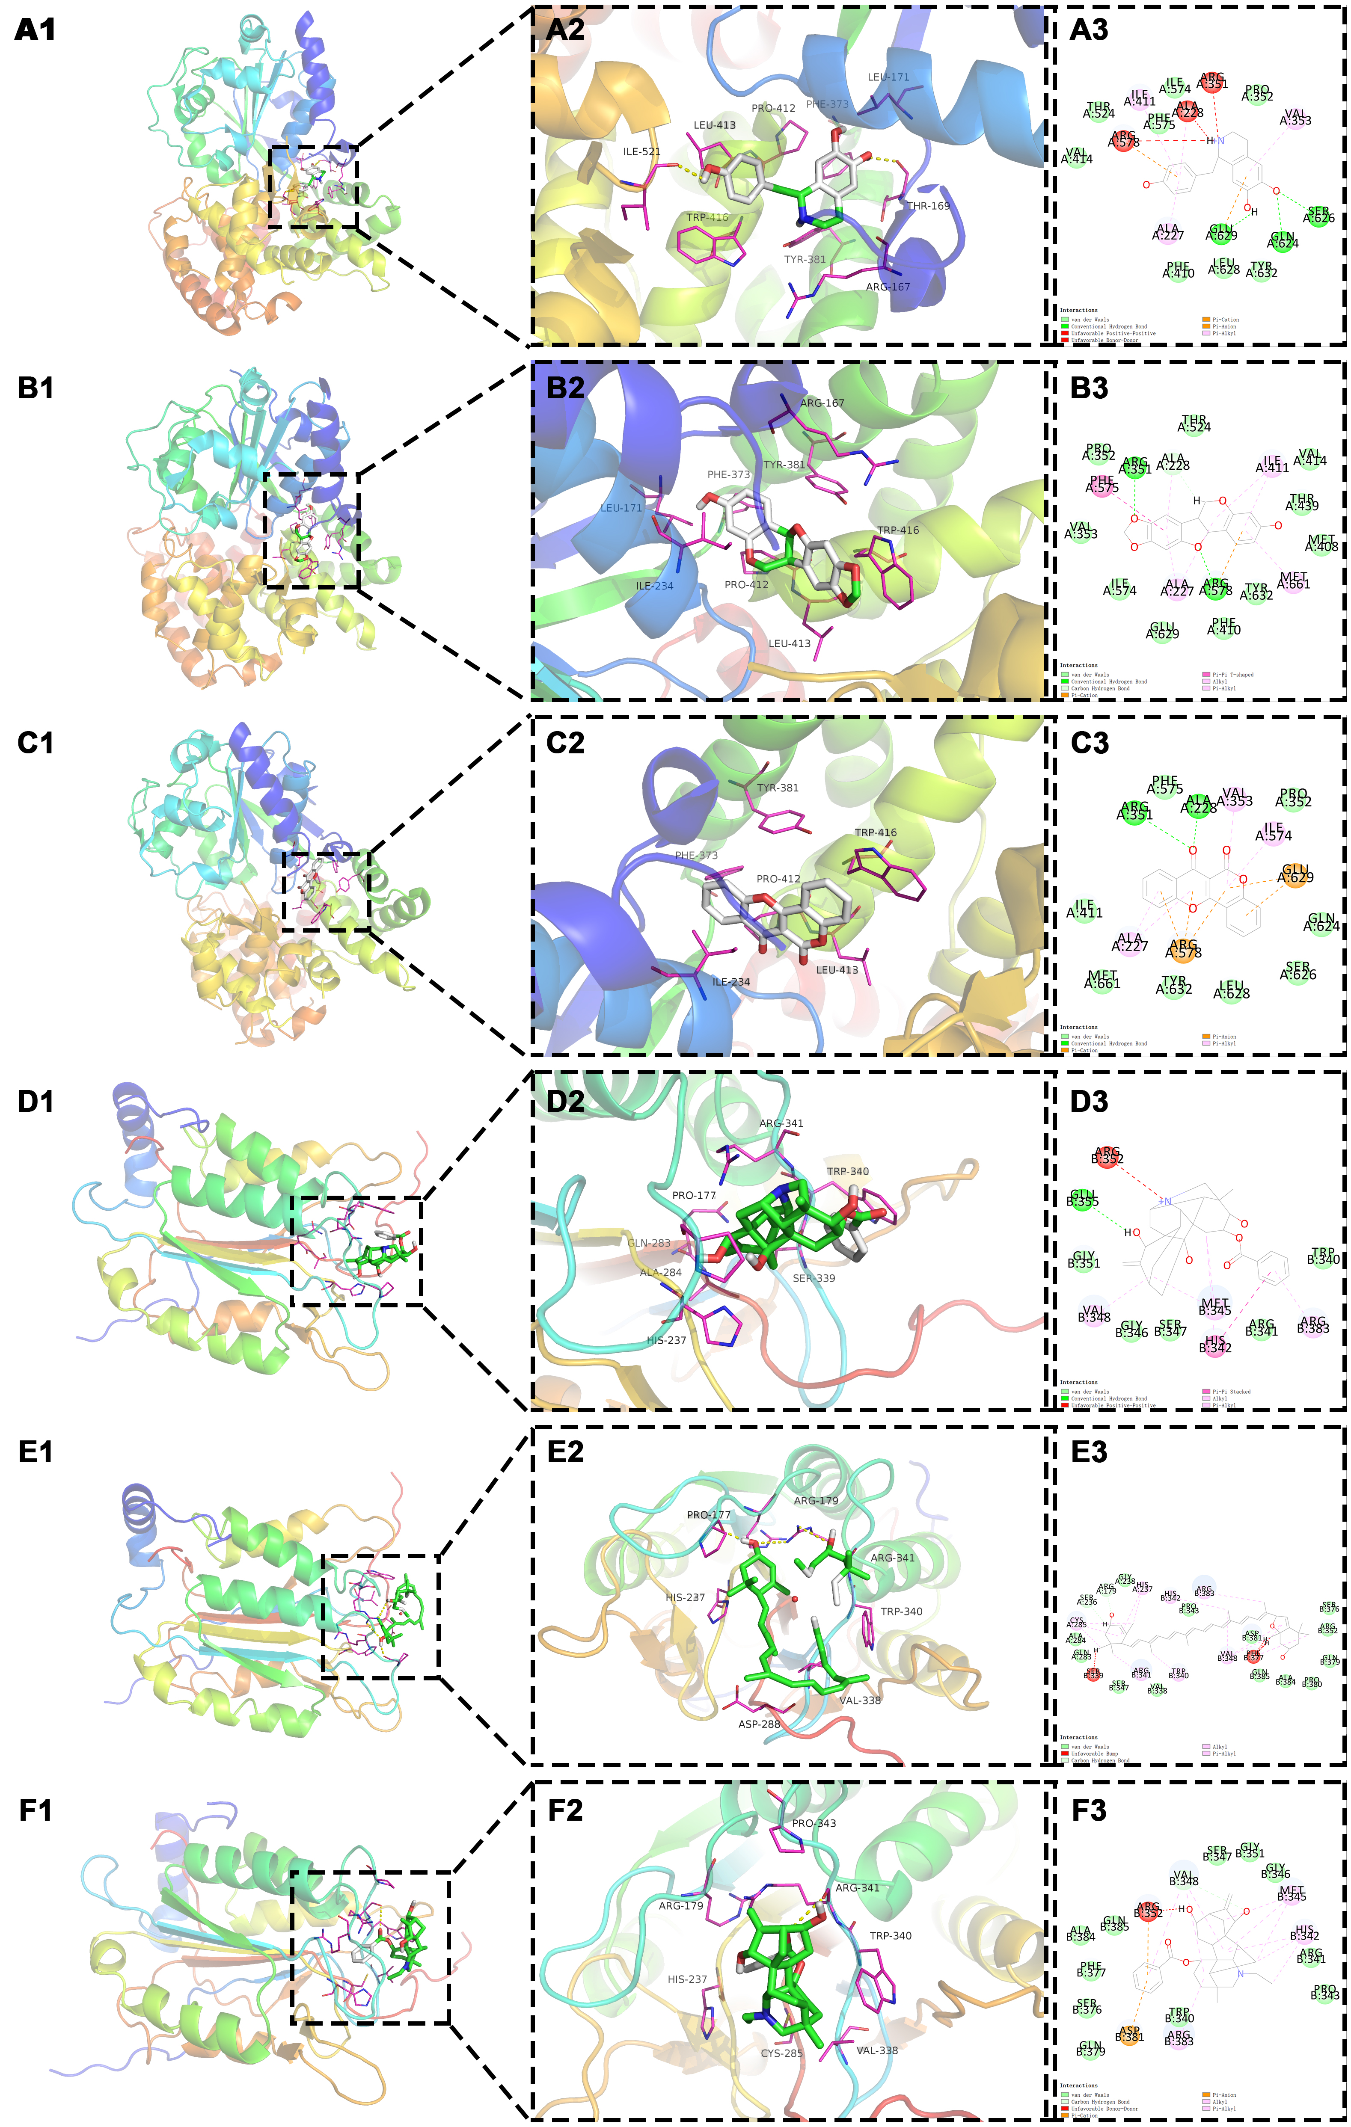
Supplemental Figure 1. Molecular docking model.
(A1) NLRP3-MOL002419-3D (macroscopic). (A2) NLRP3-MOL002419-3D (microscopic). (A3) NLRP3-MOL002419-2D.
(B1) NLRP3-MOL003648-3D (macroscopic). (B2) NLRP3-MOL003648-3D (microscopic). (B3) NLRP3-MOL003648-2D.
(C1) NLRP3-MOL005321-3D (macroscopic). (C2) NLRP3-MOL005321-3D (microscopic). (C3) NLRP3-MOL005321-2D.
(D1) Caspase-1-MOL002421-3D (macroscopic). (D2) Caspase-1-MOL002421-3D (microscopic). (D3) Caspase-1-MOL002421-2D.
(E1) Caspase-1-MOL004492-3D (macroscopic). (E2) Caspase-1-MOL004492-3D (microscopic). (E3) Caspase-1-MOL004492-2D.
(F1) Caspase-1-MOL002410-3D (macroscopic). (F2) Caspase-1-MOL002410-3D (microscopic). (F3) Caspase-1-MOL002410-2D.
D, Dimensions.

