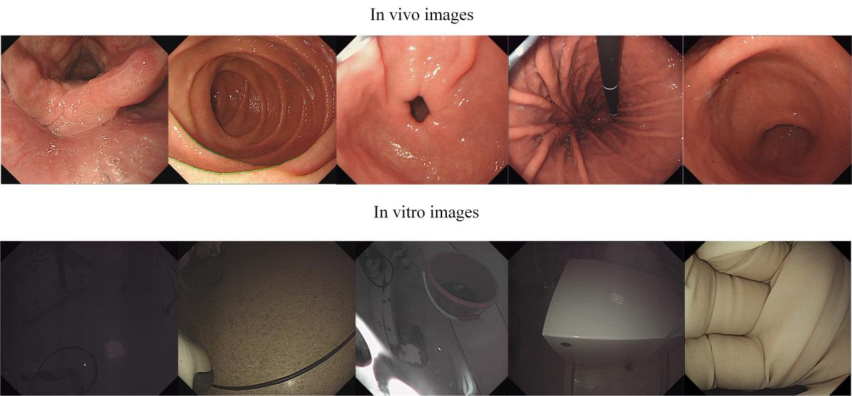
Supplementary figure S1. Representative images of in vivo and in vitro.

