Supporting Information
Toxicity and Oxidative Stress Biomarkers in the Organs of Mice Treated with Mesoporous Polydopamine Nanoparticles Modified with Iron and Coated with Cancer Cell Membrane
Marta Szukalska¹, Bartosz F. Grześkowiak², Magdalena J. Bigaj-Józefowska², Marta Witkowska^{3,7}, Emilia Cicha⁴, Patrycja Sujka-Kordowska⁵, Izabela Miechowicz⁶, Michał Nowicki⁵, Radosław Mrówczyński^{3,7}, Ewa Florek¹

¹Laboratory of Environmental Research, Department of Toxicology, Poznan University of Medical Sciences, Poznań, Poland
²NanoBioMedical Centre, Adam Mickiewicz University, Poznań, Poland
³Faculty of Chemistry, Adam Mickiewicz University, Poznań, Poland
⁴Laboratory of Experimental Animals, Poznan University of Medical Sciences, Poznań, Poland
⁵Department of Histology and Embryology, Poznan University of Medical Sciences, Poznań, Poland
⁶Department of Computer Science and Statistics, Poznan University of Medical Sciences, Poznań, Poland
⁷Centre for Advanced Technologies, Adam Mickiewicz University, Poznań, Poland

Correspondence: Marta Szukalska, Ph.D.
Laboratory of Environmental Research, Department of Toxicology, Poznan University of Medical Sciences, Rokietnicka 3 Street, 60-806 Poznan, Poland
Email: martan@ump.edu.pl

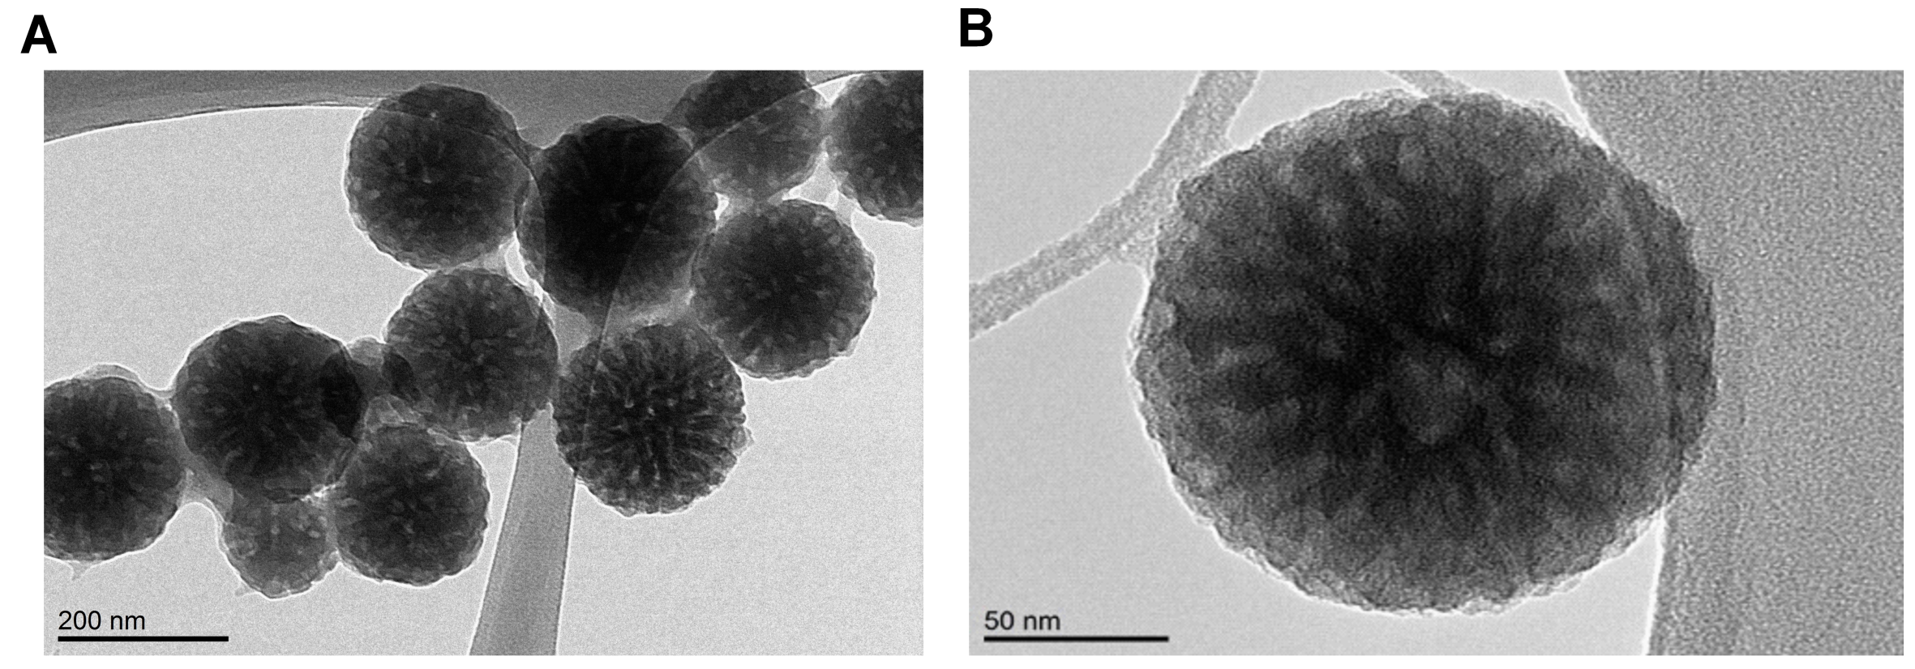
Figure S1. TEM images of MPDAFe NPs.

Table S1. Z-avarege, PDI and Zeta potential values of MPDAFe NPs
Sample | Z-average/(d.nm)​ ​ | PDI​ | Zeta potential/(mV)​
MPDAFe | 251.0 ± 13.4 | 0.13 | -22.7 ± 4.3
Vesicles | 312.4 ± 98.4 | 0.40 | -43.9 ± 5.7
MPDAFe@Mem | 263.2 ± 5.2 | 0.11 | -41.2 ± 1.5

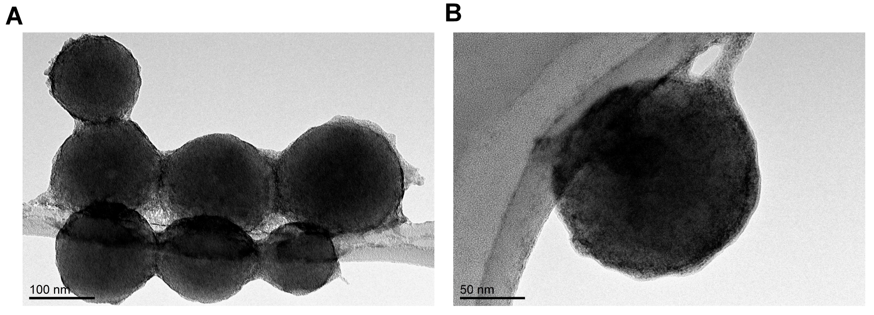
Figure S2. TEM images of MPDAFe@Mem NPs.

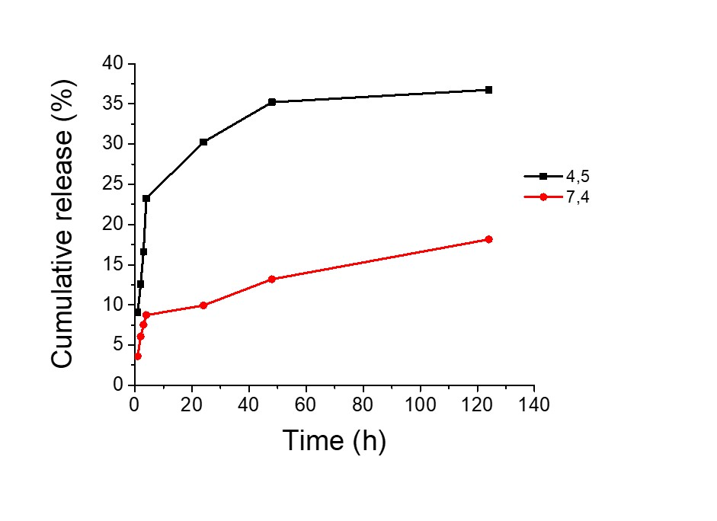
Figure S3. Release profile of DOX from MPDAFe@DOX NPs for 124 h at different pH.

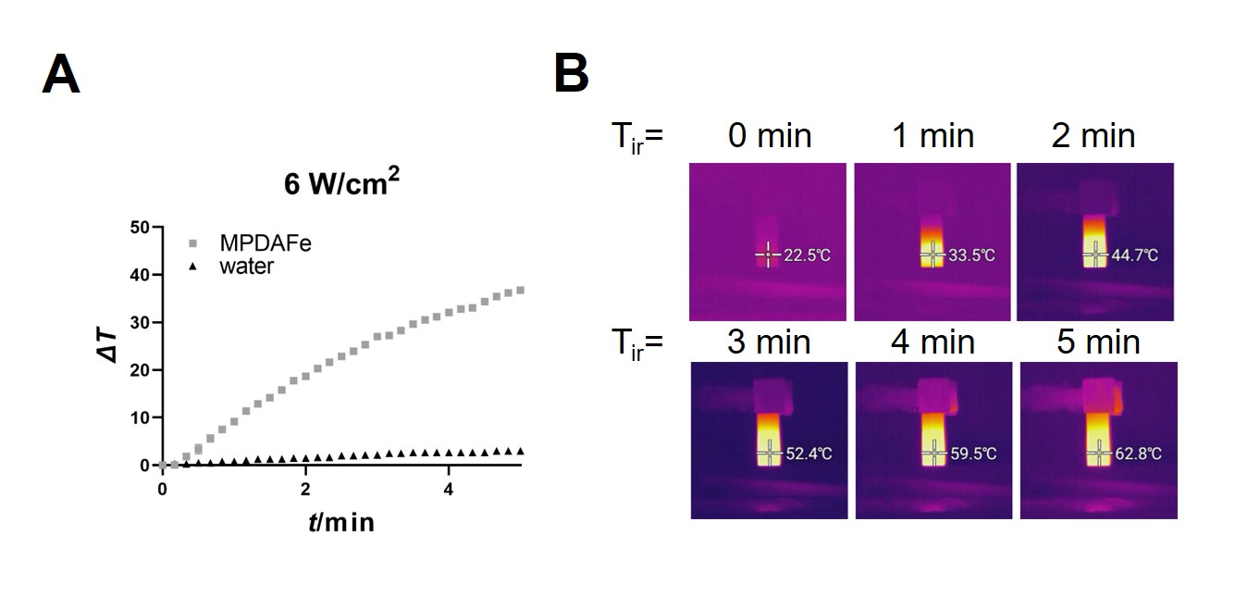
Figure S4. Temperature increase (A), and thermographic camera images (B) of the MPDAFe NPs solution after irradiation with 808 nm laser.

