Interrelationships between inflammatory score, delayed cerebral ischemia and unfavorable outcome in patients with aSAH: A four-way decomposition

Supplementary Materials
1. Supplementary Methods
Appendix E1. Inclusion and exclusion criteria for patients with aSAH
Appendix E2. Patient management
Appendix E3. Biomarkers selection and inflammatory score construction
Appendix E4. DCI definition
Appendix E5. Four-way decomposition analysis
2. Supplementary Tables
Table S1. 22 inflammatory markers used for developing a biomarker risk score
Table S2. The parameters of four machine learning classifiers
Table S3. Comparisons of baseline characteristics and outcomes between the low and high inflammatory score groups in the primary cohort
Table S4. Comparisons of baseline characteristics and outcomes between the low and high inflammatory score groups in the PSM cohort
Table S5. Comparisons of baseline characteristics and outcomes between the low and high inflammatory score groups in the IPTW cohort
Table S6. Multivariable logistic regression models evaluating the association of inflammatory score with DCI in aSAH patients
Table S7. Multivariable logistic regression models evaluating the association of inflammatory score with poor outcome in aSAH patients
Table S8. Four-way decomposition assessing the effect of high inflammatory score on poor functional outcome due to mediation and interaction with DCI
Table S9. Incremental predictive value of inflammatory score for poor functional outcome in patients with aSAH
3. Supplementary Figures
Figure S1. Flow diagram of the patient enrollment in this study
Figure S2. The day of DCI onset after ictus in aSAH patients
Figure S3. A correlation matrix of 22 inflammatory markers
Figure S4. Feature selection using the least absolute shrinkage and selection operator (LASSO) regression model
Figure S5. The standard mean differences of baseline characteristics before matching and after matching
Figure S6. Boxplot of inflammatory score between aSAH patients with and without DCI, and poor outcome
Figure S7. Calibration curves analysis of the model with or without inflammatory score
Figure S8. Decision curve analysis of the model with or without inflammatory score
Figure S9. A nomogram based on inflammatory score for predicting poor outcome in aSAH patients
Figure S10. A web-based interactive calculator interface based on a nomogram for predicting the risk of poor outcome in aSAH patients (https://min115. shinyapps.io/dynnomapp/)

Appendix E1
Inclusion and exclusion criteria for patients with aSAH
Inclusion criteria were listed as follows: 1) adult patients (age >18 years); 2) time interval of symptom onset to hospital admission < 72 hours; 3) rupture of the aneurysm as the cause of SAH confirmed by three-dimensional computed tomographic angiography (CTA), magnetic resonance angiography (MRA), or digital subtraction angiography (DSA); and 4) patients who underwent specialized endovascular coil embolization. Exclusion criteria were listed as follows: 1) patients those with additional aneurysms (e.g., blood bubble, dissection, fusiform, infectious, cerebrovascular or Moyamoya malformation); 2) patients with preoperative unexpected events that could affect the outcome; 3) functional or neurological deficit of the extremities due to any previous disease; 4) history of tumor or neurological impairment, inflammatory diseases, autoimmune diseases; 5) missing critical information (e.g., imaging data, clinical data and biochemical parameters).
Appendix E2
Patient management
All patients were treated homogeneously according to the (inter)national guidelines.^{1,2} Specifically, after presentation at the emergency department, patients were either admitted to the brain care unit or the intensive care unit. Ruptured aneurysms were treated endovascular (preferably) or surgically as early as feasible, preferably within 24 hours after ictus. Patients received oral nimodipine, 60 mg, six times daily for 21 days. If patients had raised intracranial pressure or (suspected) hydrocephalus, an external ventricular drain, or an external lumbar drain, was placed. Patients suspected of DCI were treated with noradrenalin-induced normovolemic hypertension induction. Moreover, anti-diabetic, anti-hypertensive, lipid-lowering and antiplatelet medications were taken based on the past medical history and stents.
Appendix E3
Biomarkers selection and inflammatory score construction
To select parsimonious sets of predictors, we devised a procedure for reducing dimensions and selecting robust inflammatory biomarkers by the following steps, respectively: 1) all biomarkers were standardized to Z-scores; 2) pearson’s correlation analysis was applied to filter out co-linear features with a threshold value of pearson’s correlation coefficient (PCC) > 0.90; 3) receiver operating characteristic (ROC) curve and Kruskal-Wallis test were performed to choose candidate features; 4) least absolute shrinkage and selection operator (LASSO) regression was adopted to select the discriminant features. Thereafter, the selected features were entered into the following machine learning (ML) classifiers to construct radiomics signatures. These included logistic regression (LR), support vector machine (SVM), Gaussian naïve Bayes (NB), and linear discriminant analysis (LDA). Logistic regression (LR) is a commonly used binary linear classifier, which uses the sigmoid function for non-linear transformation and the log maximum likelihood estimation function for learning the posterior probability of a single sample.³ LR was included for its proficiency in providing probabilistic outputs and for ease of interpretation in a clinical context. The support vector machine (SVM) algorithm can be used for linear or non-linear classification, which aims to find the optimal segmentation hyperplane to make the points closer to the hyperplane have a larger distance.⁴ The effectiveness in high-dimensional spaces made it an ideal choice for handling the complex feature sets typical of clinical data. The naive Bayes (NB) algorithm is based on applying Bayes’ theorem with the “naive” assumption of conditional independence between every pair of features.⁵ It’s particularly effective for categorical data and is commonly used for classification tasks. The linear discriminant analysis (LDA) algorithm projects the data on the low dimension, and its purpose is to select the projection direction with the best classification performance.⁶ LDA was chosen for its strength in dimensionality reduction and classification tasks, particularly in datasets where linear combinations of features are meaningful. Each classifier was chosen for its unique approach to learning and pattern recognition, ensuring that the model captured various aspects of the data. More importantly, these are commonly used classifiers in previous ML related studies. The inclusion of different ML classifiers allows us to compare and construct the optimal prediction model for our specific application. The accuracy score, precision score, recall score, F1 score, and area under the receiver operating characteristic curve (AUC) were used to evaluate the performance of the ML model.⁷ The SVM model demonstrated the best performance with the highest AUC. Therefore, we chose the SVM algorithm to develop the model and calculate the inflammatory score for each observation.
Appendix E4
DCI definition
DCI status was ascertained using an established definition.⁸ DCI was recorded as a dichotomous value (present or absent) and was defined as“the occurrence of focal neurological impairment or a decrease of ≥ 2 points on the GCS lasting > 2 hours, which is not immediately apparent after aneurysm occlusion and cannot be attributed to other causes” and/or “the presence of cerebral infarction on CT or MR scan, which was not present after early aneurysm occlusion and which cannot be attributed to other causes such as surgical interventions”. The adjudication of DCI (based on the above definition) was performed by consensus of at least two neurointensivists.
Appendix E5
Four-way decomposition analysis
Recent work has shown how a total effect of an exposure on an outcome, in the context of a mediator with which the exposure might interact, could be decomposed into four components: that due to just mediation, that due to just interaction, that due to both mediation and interaction, and that due to neither mediation nor interaction.^{9,10} This approach allowed us to decompose the total effect of inflammatory score on the risk of poor functional outcome into four distinct components: 1) Controlled direct effect: representing the effect solely attributable to high inflammatory score, independent of any interaction or mediation effect with DCI; (2) Reference interaction: arising from the interaction between inflammatory score and DCI; (3) Mediated interaction: arising from both interaction and mediation effect with DCI; (4) Pure indirect effect: representing the effect of inflammatory score that is solely mediated through the occurrence of DCI. The total interaction effect is the sum of the reference interaction and mediated interaction. The total mediation effect is the sum of mediated interaction and pure indirect effect. By decomposing the total effect into these four components, we were able to assess the specific contributions of inflammatory score, DCI, their interaction and mediation effects to the risk of poor outcome.

Reference
1. Hoh BL, Ko NU, Amin-Hanjani S, et al. 2023 Guideline for the Management of Patients With Aneurysmal Subarachnoid Hemorrhage: A Guideline From the American Heart Association/American Stroke Association. Stroke. 2023;54(7):e314-e70. doi: 10.1161/str.0000000000000436.
2. Fraser JF, Heit JJ, Mascitelli JR, et al. Decoding the data: a comment on the American Heart Association/American Stroke Association (AHA/ASA) 2023 Guideline for the Management of patients with Aneurysmal Subarachnoid Hemorrhage. J Neurointerv Surg. 2023;15(9):835-7. doi: 10.1136/jnis-2023-020675.
3. LaValley MP. Logistic regression. Circulation. 2008;117(18):2395-9. doi: 10.1161/circulationaha.106.682658.
4. Luts J, Ojeda F, Van de Plas R, et al. A tutorial on support vector machine-based methods for classification problems in chemometrics. Anal Chim Acta. 2010;665(2):129-45. doi: 10.1016/j.aca.2010.03.030.
5. Ahmed MS, Shahjaman M, Rana MM, et al. Robustification of Naïve Bayes Classifier and Its Application for Microarray Gene Expression Data Analysis. Biomed Res Int. 2017;2017:3020627. doi: 10.1155/2017/3020627.
6. Gardner-Lubbe S. Linear discriminant analysis for multiple functional data analysis. J Appl Stat. 2021;48(11):1917-33. doi: 10.1080/02664763.2020.1780569.
7. Yang F, Wang X, Ma H, et al. Transformers-sklearn: a toolkit for medical language understanding with transformer-based models. BMC Med Inform Decis Mak. 2021;21(Suppl 2):90. doi: 10.1186/s12911-021-01459-0.
8. Vergouwen MD, Vermeulen M, van Gijn J, et al. Definition of delayed cerebral ischemia after aneurysmal subarachnoid hemorrhage as an outcome event in clinical trials and observational studies: proposal of a multidisciplinary research group. Stroke. 2010;41(10):2391-5. doi: 10.1161/strokeaha.110.589275.
9. VanderWeele TJ. A unification of mediation and interaction: a 4-way decomposition. Epidemiology. 2014;25(5):749-61. doi: 10.1097/ede.0000000000000121.
10. VanderWeele TJ, Shrier I. Sufficient Cause Representation of the Four-way Decomposition for Mediation and Interaction. Epidemiology. 2016;27(5):e32-3. doi: 10.1097/ede.0000000000000521.

Table S1. 22 inflammatory markers used for developing a biomarker risk score
Domain | Markers | Abbreviations | Definition
Blood cell  counts^{1,2} | White blood cell count | WBC | -
Blood cell  counts^{1,2} | Neutrophil count | N | -
Blood cell  counts^{1,2} | Lymphocyte count | L | -
Blood cell  counts^{1,2} | Monocyte count | M | -
Blood cell  counts^{1,2} | Platelet count | Plt | -
Blood cell  counts^{1,2} | Albumin | Alb | -
Blood cell  counts^{1,2} | Hemoglobin | Hb | -
Blood cell  counts^{1,2} | Red blood cell distribution width | RDW | -
Blood cell  counts^{1,2} | Mean platelet volume | MPV | -
Direct markers² | C-reactive protein | CRP | -
Direct markers² | Lactate dehydrogenase | LDH | -
Derived parameters^{2,4-7} | Neutrophil-to-lymphocyte ratio | NLR | neutrophil count/lymphocyte count
Derived parameters^{2,4-7} | Derived neutrophil-to-lymphocyte ratio | dNLR | (WBC count – neutrophil count)/lymphocyte count
Derived parameters^{2,4-7} | Platelet-to-lymphocyte ratio | PLR | platelet count/lymphocyte count
Derived parameters^{2,4-7} | Monocyte-to-lymphocyte ratio | MLR | monocyte count/lymphocyte count
Derived parameters^{2,4-7} | Prognostic nutritional index | PNI | albumin count [g/L] + lymphocyte count × 5
Derived parameters^{2,4-7} | Systemic inflammatory response index | SIRI | neutrophil count × monocyte count/lymphocyte count
Derived parameters^{2,4-7} | Systemic immune-inflammation index | SII | neutrophil count × platelet count/lymphocyte count
Derived parameters^{2,4-7} | Pan-immune-inflammation value | PIV | (neutrophil count × platelet count × monocyte count)/lymphocyte count
Derived parameters^{2,4-7} | Mean platelet volume to platelet ratio | MPR | mean platelet volume/platelet ratio
Derived parameters^{2,4-7} | Hemoglobin-to-red blood cell distribution width ratio | HRR | Hemoglobin/red blood cell distribution width ratio
Derived parameters^{2,4-7} | C-reactive protein to albumin ratio | CAR | C-reactive protein/albumin ratio
Reference
1. Qiang YX, Deng YT, Zhang YR, et al. Associations of blood cell indices and anemia with risk of incident dementia: A prospective cohort study of 313,448 participants. Alzheimers Dement. 2023;19(9):3965-76. doi: 10.1002/alz.13088.
2. Feng J, Zhao X, Huang B, et al. Incorporating inflammatory biomarkers into a prognostic risk score in patients with non-ischemic heart failure: a machine learning approach. Front Immunol. 2023;14:1228018. doi: 10.3389/fimmu.2023.1228018.
3. Chu H, Huang C, Zhou Z, et al. Inflammatory score predicts early hematoma expansion and poor outcomes in patients with intracerebral hemorrhage. Int J Surg. 2023;109(3):266-76. doi: 10.1097/js9.0000000000000191.
4. Guven DC, Sahin TK, Erul E, et al. The Association between the Pan-Immune-Inflammation Value and Cancer Prognosis: A Systematic Review and Meta-Analysis. Cancers (Basel). 2022;14(11). doi: 10.3390/cancers14112675.
5. Zhang P, Li Y, Zhang H, et al. Prognostic value of the systemic inflammation response index in patients with aneurismal subarachnoid hemorrhage and a Nomogram model construction. Br J Neurosurg. 2023;37(6):1560-6. doi: 10.1080/02688697.2020.1831438.
6. Ösken A, Hacı R, Dinç Asarcıklı L, et al. Mean platelet volume/platelet count ratio as a predictor of stent thrombosis in patients with ST-segment-elevation myocardial infarction. Ir J Med Sci. 2021;190(3):1095-102. doi: 10.1007/s11845-021-02626-y.
7. Chi G, Lee JJ, Montazerin SM, et al. Prognostic value of hemoglobin-to-red cell distribution width ratio in cancer: a systematic review and meta-analysis. Biomark Med. 2022;16(6):473-82. doi: 10.2217/bmm-2021-0577.

Table S2. The parameters of four machine learning classifiers
Characteristics | logistic regression (LR) | support vector machine (SVM) | Gaussian naïve Bayes (NB) | linear discriminant analysis (LDA)
Cutoff | 0.240 | 0.046 | 0.066 | 0.231
AUC | 0.708 | 0.747 | 0.667 | 0.701
AUC.SE | 0.031 | 0.032 | 0.031 | 0.031
AUC.low | 0.647 | 0.686 | 0.605 | 0.639
AUC.up | 0.769 | 0.809 | 0.729 | 0.762
P value | < 0.001 | < 0.001 | < 0.001 | < 0.001
ACC | 0.668 | 0.745 | 0.590 | 0.652
ACC.low | 0.667 | 0.744 | 0.588 | 0.651
ACC.up | 0.670 | 0.746 | 0.591 | 0.653
SEN | 0.688 | 0.677 | 0.771 | 0.708
SEN.low | 0.595 | 0.584 | 0.687 | 0.617
SEN.up | 0.780 | 0.771 | 0.855 | 0.799
SPE | 0.662 | 0.768 | 0.526 | 0.632
SPE.low | 0.606 | 0.718 | 0.466 | 0.575
SPE.up | 0.718 | 0.819 | 0.585 | 0.690
PLR | 2.033 | 2.923 | 1.625 | 1.927
PLR.low | 1.641 | 2.261 | 1.377 | 1.574
PLR.up | 2.518 | 3.779 | 1.919 | 2.358
NLR | 0.472 | 0.420 | 0.436 | 0.461
NLR.low | 0.347 | 0.312 | 0.297 | 0.333
NLR.up | 0.643 | 0.566 | 0.640 | 0.638
PPV | 0.418 | 0.508 | 0.365 | 0.405
PPV.low | 0.341 | 0.421 | 0.298 | 0.331
PPV.up | 0.495 | 0.594 | 0.431 | 0.479
NPV | 0.857 | 0.871 | 0.867 | 0.860
NPV.low | 0.810 | 0.828 | 0.815 | 0.812
NPV.up | 0.904 | 0.913 | 0.919 | 0.908
PPA | 0.688 | 0.677 | 0.771 | 0.708
PPA.low | 0.595 | 0.584 | 0.687 | 0.617
PPA.up | 0.780 | 0.771 | 0.855 | 0.799
NPA | 0.662 | 0.768 | 0.526 | 0.632
NPA.low | 0.606 | 0.718 | 0.466 | 0.575
NPA.up | 0.718 | 0.819 | 0.585 | 0.690
TPA | 0.668 | 0.745 | 0.590 | 0.652
TPA.low | 0.620 | 0.700 | 0.539 | 0.604
TPA.up | 0.717 | 0.789 | 0.640 | 0.701
KAPPA | 0.289 | 0.402 | 0.218 | 0.274
KAPPA.low | 0.195 | 0.303 | 0.137 | 0.183
KAPPA.up | 0.383 | 0.501 | 0.299 | 0.366
Notes: As indicated by the bold font, the p value reached statistical significance.
Abbreviations: AUC, area under curve; SE, standard error; ACC, accuracy; SEN, sensitivity; SPE, specificity; PLR, positive Ilkellhood ratio; NLR, negative likelihood ratio; PPV, positive predictive value; NPV, negative predictive value; PPA, positive accordance; NPA, negative accordance; TPA, total accordance.

Table S3. Comparisons of baseline characteristics and outcomes between the low and high inflammatory score groups in the primary cohort
Characteristics | Primary cohort
Characteristics | Low inflammatory score | High inflammatory score | P value
No. of patients | 241 | 127
Age | 55.00 [45.00, 66.00] | 57.00 [48.00, 68.00] | 0.044
Age > 65 years | 61 (25.3) | 43 (33.9) | 0.523
Gender
Male | 94 (39.0) | 56 (44.1) | 0.345
Female | 147 (61.0) | 71 (55.9)
Medical history
Smoking | 75 (31.1) | 47 (37.0) | 0.254
Alcohol | 82 (34.0) | 52 (40.9) | 0.190
Hypertension | 45 (18.7) | 24 (18.9) | 0.958
Diabetes | 48 (19.9) | 26 (20.5) | 0.899
Heart disease | 9 (3.7) | 8 (6.3) | 0.265
Previous stroke | 21 (8.7) | 12 (9.4) | 0.814
Hyperlipidemia | 12 (5.0) | 13 (10.2) | 0.057
Admission clinical grade
GCS score | 14.00 [13.00, 15.00] | 13.00 [11.00, 14.00] | <0.001
9-15 point | 216 (89.6) | 84 (66.1) | <0.001
< 9 point | 25 (10.4) | 43 (33.9)
WFNS grade | 2.00 [1.00, 3.00] | 3.00 [2.00, 4.00] | <0.001
I–III | 216 (89.6) | 84 (66.1) | <0.001
IV–V | 25 (10.4) | 43 (33.9)
HH grade | 2.00 [1.00, 2.00] | 2.00 [2.00, 3.00] | <0.001
I–III | 232 (96.3) | 105 (82.7) | <0.001
IV–V | 9 (3.7) | 22 (17.3)
mFS grade | 3.00 [2.00, 4.00] | 3.00 [2.00, 4.00] | 0.001
I-II | 169 (70.1) | 65 (51.2) | <0.001
III-IV | 72 (29.9) | 62 (48.8)
Acute hydrocephalus
No | 223 (92.5) | 108 (85.0) | 0.023
Yes | 18 (7.5) | 19 (15.0)
Aneurysm characteristics
Maximum size (mm) | 5.23 [3.87, 6.80] | 5.49 [4.20, 7.03] | 0.177
< 3 mm | 19 (7.9) | 7 (5.5) | 0.688
3-10 mm | 206 (85.5) | 112 (88.2)
> 10 mm | 16 (6.6) | 8 (6.3)
Neck width (mm) | 3.43 [1.56, 4.40] | 3.57 [1.70, 4.46] | 0.212
≥ 4 mm | 81 (33.6) | 48 (37.8) | 0.424
AR ratio | 1.82 [1.51, 2.60] | 1.84 [1.53, 2.55] | 0.817
≤ 2 | 133 (55.2) | 73 (57.5) | 0.673
Location
Anterior | 216 (89.6) | 103 (81.1) | 0.022
Posterior | 25 (10.4) | 24 (18.9)
Shape
Regular | 161 (66.8) | 84 (66.1) | 0.898
Irregular | 80 (33.2) | 43 (33.9)
Wide neck
No | 106 (44.0) | 51 (40.2) | 0.481
Yes | 135 (56.0) | 76 (59.8)
Timing of treatment
≤ 24h | 137 (56.8) | 57 (44.9) | 0.037
24-72h | 74 (30.7) | 56 (44.1)
>72h | 30 (12.4) | 14 (11.0)
Stents assist coiling
No | 126 (52.3) | 54 (42.5) | 0.075
Yes | 115 (47.7) | 73 (57.5)
Occlusion level
class I | 209 (86.7) | 107 (84.3) | 0.518
class II-III | 32 (13.3) | 20 (15.7)
DCI
No | 210 (87.1) | 82 (64.6) | <0.001
Yes | 31 (12.9) | 45 (35.4)
Poor outcome
No | 209 (86.7) | 63 (49.6) | <0.001
Yes | 32 (13.3) | 64 (50.4)
Notes: Data are expressed as n (%), mean ± standard deviation, or median (interquartile range), as appropriate. As indicated by the bold font, the p value reached statistical significance.
Abbreviations: GCS, Glasgow Coma Scale; WFNS, World Federation of Neurosurgical Societies; HH, Hunt Hess; mFS, modified Fisher Scale; AR, aneurysm maximum height to neck diameter ratio; DCI, delayed cerebral ischemia.

Table S4. Comparisons of baseline characteristics and outcomes between the low and high inflammatory score groups in the PSM cohort
Characteristics | PSM cohort
Characteristics | Low inflammatory score | High inflammatory score | P value
No. of patients | 123 | 123
Age | 58.00 [48.50, 68.50] | 57.00 [47.50, 68.00] | 0.897
Age > 65 years | 40 (32.5) | 42 (34.1) | 0.689
Gender
Male | 55 (44.7) | 56 (45.5) | 0.898
Female | 68 (55.3) | 67 (54.5)
Medical history
Smoking | 44 (35.8) | 45 (36.6) | 0.894
Alcohol | 49 (39.8) | 51 (41.5) | 0.795
Hypertension | 18 (14.6) | 24 (19.5) | 0.309
Diabetes | 24 (19.5) | 23 (18.7) | 0.871
Heart disease | 6 (4.9) | 8 (6.5) | 0.582
Previous stroke | 13 (10.6) | 12 (9.8) | 0.833
Hyperlipidemia | 9 (7.3) | 12 (9.8) | 0.494
Admission clinical grade
GCS score | 13.00 [13.00, 14.00] | 13.00 [11.00, 14.00] | 0.196
9-15 point | 99 (80.5) | 84 (68.3) | 0.028
< 9 point | 24 (19.5) | 39 (31.7)
WFNS grade | 3.00 [2.00, 3.00] | 3.00 [2.00, 4.00] | 0.093
I–III | 99 (80.5) | 84 (68.3) | 0.028
IV–V | 24 (19.5) | 39 (31.7)
HH grade | 2.00 [2.00, 3.00] | 2.00 [2.00, 3.00] | 0.149
I–III | 114 (92.7) | 104 (84.6) | 0.045
IV–V | 9 (7.3) | 19 (15.4)
mFS grade | 3.00 [2.00, 4.00] | 3.00 [2.00, 4.00] | 0.168
I-II | 76 (61.8) | 65 (52.8) | 0.156
III-IV | 47 (38.2) | 58 (47.2)
Acute hydrocephalus
No | 112 (91.1) | 104 (84.6) | 0.119
Yes | 11 (8.9) | 19 (15.4)
Aneurysm characteristics
Maximum size (mm) | 5.26 [3.80, 6.84] | 5.49 [4.24, 7.03] | 0.208
< 3 mm | 10 (8.1) | 4 (3.3) | 0.210
3-10 mm | 104 (84.6) | 112 (91.1)
> 10 mm | 9 (7.3) | 7 (5.7)
Neck width (mm) | 3.66 [1.49, 4.42] | 3.60 [1.73, 4.46] | 0.232
≥ 4 mm | 42 (34.1) | 47 (38.2) | 0.507
AR ratio | 1.80 [1.50, 2.64] | 1.79 [1.52, 2.54] | 0.954
≤ 2 | 66 (53.7) | 72 (58.5) | 0.441
Location
Anterior | 103 (83.7) | 101 (82.1) | 0.735
Posterior | 20 (16.3) | 22 (17.9)
Shape
Regular | 89 (72.4) | 82 (66.7) | 0.332
Irregular | 34 (27.6) | 41 (33.3)
Wide neck
No | 56 (45.5) | 49 (39.8) | 0.367
Yes | 67 (54.5) | 74 (60.2)
Timing of treatment
≤ 24h | 64 (52.0) | 56 (45.5) | 0.032
24-72h | 36 (29.3) | 54 (43.9)
>72h | 23 (18.7) | 13 (10.6)
Stents assist coiling
No | 60 (48.8) | 53 (43.1) | 0.370
Yes | 63 (51.2) | 70 (56.9)
Occlusion level
class I | 102 (82.9) | 103 (83.7) | 0.864
class II-III | 21 (17.1) | 20 (16.3)
DCI
No | 108 (87.8) | 80 (65.0) | <0.001
Yes | 15 (12.2) | 43 (35.0)
Poor outcome
No | 103 (83.1) | 62 (50.0) | <0.001
Yes | 21 (16.9) | 62 (50.0)
Notes: Data are expressed as n (%), mean ± standard deviation, or median (interquartile range), as appropriate. As indicated by the bold font, the p value reached statistical significance.
Abbreviations: GCS, Glasgow Coma Scale; WFNS, World Federation of Neurosurgical Societies; HH, Hunt Hess; mFS, modified Fisher Scale; AR, aneurysm maximum height to neck diameter ratio; DCI, delayed cerebral ischemia.

Table S5. Comparisons of baseline characteristics and outcomes between the low and high inflammatory score groups in the IPTW cohort
Characteristics | IPTW cohort
Characteristics | Low inflammatory score | High inflammatory score | P value
No. of patients | 368.3 | 364.7
Age | 54.91 (13.71) | 55.04 (11.55) | 0.933
Age > 65 years | 99.1 (26.9) | 97.1 (26.6) | 0.957
Gender
Male | 150.0 (40.7) | 156.6 (42.9) | 0.724
Female | 218.3 (59.3) | 208.2 (57.1)
Medical history
Smoking | 124.1 (33.7) | 117.2 (32.1) | 0.791
Alcohol | 136.8 (37.1) | 127.9 (35.1) | 0.730
Hypertension | 67.5 (18.3) | 70.8 (19.4) | 0.826
Diabetes | 66.8 (18.1) | 63.7 (17.5) | 0.881
Heart disease | 13.4 (3.6) | 12.3 (3.4) | 0.883
Previous stroke | 33.1 (9.0) | 37.5 (10.3) | 0.743
Hyperlipidemia | 20.8 (5.6) | 21.1 (5.8) | 0.956
Admission clinical grade
GCS score | 13.16 (2.11) | 13.11 (2.37) | 0.840
9-15 point | 301.2 (81.8) | 297.6 (81.6) | 0.964
< 9 point | 67.0 (18.2) | 67.2 (18.4)
WFNS grade | 2.43 (1.13) | 2.43 (1.17) | 0.991
I–III | 301.2 (81.8) | 297.6 (81.6) | 0.964
IV–V | 67.0 (18.2) | 67.2 (18.4)
HH grade | 2.10 (0.93) | 2.10 (1.02) | 0.963
I–III | 343.9 (93.4) | 334.5 (91.7) | 0.580
IV–V | 24.4 (6.6) | 30.2 (8.3)
mFS grade | 3.03 (1.10) | 3.01 (1.15) | 0.900
I-II | 235.7 (64.0) | 234.9 (64.4) | 0.947
III-IV | 132.5 (36.0) | 129.8 (35.6)
Acute hydrocephalus
No | 335.6 (91.1) | 327.6 (89.8) | 0.714
Yes | 32.7 (8.9) | 37.2 (10.2)
Aneurysm characteristics
Maximum size (mm) | 5.64 (2.40) | 5.74 (2.41) | 0.718
< 3 mm | 31.6 (8.6) | 20.2 (5.5) | 0.683
3-10 mm | 314.0 (85.3) | 321.9 (88.2)
> 10 mm | 22.7 (6.2) | 22.7 (6.2)
Neck width (mm) | 3.14 (1.80) | 3.23 (1.83) | 0.686
≥ 4 mm | 121.0 (32.9) | 126.4 (34.6) | 0.761
AR ratio | 2.14 (0.86) | 2.07 (0.63) | 0.573
≤ 2 | 198.6 (53.9) | 202.1 (55.4) | 0.817
Location
Anterior | 325.4 (88.3) | 316.0 (86.6) | 0.657
Posterior | 42.9 (11.7) | 48.7 (13.4)
Shape
Regular | 242.2 (65.8) | 236.1 (64.7) | 0.868
Irregular | 126.1 (34.2) | 128.7 (35.3)
Wide neck
No | 167.0 (45.3) | 159.0 (43.6) | 0.785
Yes | 201.3 (54.7) | 205.7 (56.4)
Timing of treatment
≤ 24h | 188.7 (51.3) | 187.8 (51.5) | 0.997
24-72h | 137.1 (37.2) | 134.2 (36.8)
>72h | 42.4 (11.5) | 42.7 (11.7)
Stents assist coiling
No | 176.7 (48.0) | 171.5 (47.0) | 0.881
Yes | 191.5 (52.0) | 193.2 (53.0)
Occlusion level
class I | 317.6 (86.2) | 310.1 (85.0) | 0.778
class II-III | 50.7 (13.8) | 54.7 (15.0)
DCI
No | 321.1 (87.2) | 253.8 (69.6) | <0.001
Yes | 47.2 (12.8) | 110.9 (30.4)
Poor outcome
No | 307.1 (83.4) | 203.0 (55.7) | <0.001
Yes | 61.2 (16.6) | 161.7 (44.3)
Notes: As indicated by the bold font, the p value reached statistical significance.
Abbreviations: GCS, Glasgow Coma Scale; WFNS, World Federation of Neurosurgical Societies; HH, Hunt Hess; mFS, modified Fisher Scale; AR, aneurysm maximum height to neck diameter ratio; DCI, delayed cerebral ischemia.

Table S6. Multivariable logistic regression models evaluating the association of inflammatory score with DCI in aSAH patients
Characteristics | Univariable analysis of DCI |  |  | Multivariable analysis of DCI |  |  | Multivariable analysis of DCI
Characteristics | OR | 95% CI | P value | OR | 95% CI | P value | OR | 95% CI | P value
Age | 1.13 | 0.65-1.96 | 0.664
Gender | 0.93 | 0.56-1.56 | 0.789
Smoking | 1.23 | 0.73-2.08 | 0.443
Alcohol | 0.89 | 0.52-1.51 | 0.654
Hypertension | 1.47 | 0.80-2.70 | 0.218
Diabetes | 1.57 | 0.87-2.84 | 0.132
Heart disease | 1.19 | 0.38-3.77 | 0.764
Previous stroke | 1.26 | 0.54-2.91 | 0.594
Hyperlipidemia | 1.54 | 0.62-3.84 | 0.350
WFNS grade | 3.10 | 1.74-5.50 | <0.001 | 1.98 | 1.00-3.93 | 0.050 | 2.38 | 1.20-4.72 | 0.013
Acute hydrocephalus | 2.30 | 1.11-4.77 | 0.025 | 1.30 | 0.55-3.09 | 0.544 | 1.21 | 0.50-2.97 | 0.670
Location | 1.47 | 0.73-2.93 | 0.277
Shape | 1.13 | 0.66-1.91 | 0.663
Size group | 1.30 | 0.50-3.41 | 0.587
Wide neck | 0.79 | 0.47-1.31 | 0.352
Timing of treatment | 0.72 | 0.43-1.20 | 0.204
Stents assist coiling | 0.95 | 0.57-1.57 | 0.831
Occlusion level | 1.51 | 0.77-2.96 | 0.230
Inflammatory score¹ | 1.93 | 1.48-2.51 | <0.001 |  |  |  | 1.84 | 1.41-2.39 | <0.001
High inflammatory score | 3.72 | 2.20-6.28 | <0.001 | 3.12 | 1.81-5.39 | <0.001
Notes: ¹Per unit change in regressor. As indicated by the bold font, the p value reached statistical significance.
Abbreviations: aSAH, aneurysmal subarachnoid hemorrhage; WFNS, World Federation of Neurosurgical Societies; DCI, delayed cerebral ischemia; OR, odds ratio; CI, confidence intervals.
Table S7. Multivariable logistic regression models evaluating the association of inflammatory score with poor outcome in aSAH patients
Characteristics | Univariable analysis of outcome |  |  | Multivariable analysis of outcome |  |  | Multivariable Analysis of outcome
Characteristics | OR | 95% CI | P value | OR | 95% CI | P value | OR | 95% CI | P value
Age | 2.47 | 1.51-4.05 | <0.001 | 2.94 | 1.60-5.37 | <0.001 | 2.87 | 1.57-5.23 | 0.001
Gender | 1.28 | 0.79-2.06 | 0.319
Smoking | 1.08 | 0.66-1.76 | 0.767
Alcohol | 1.43 | 0.89-2.31 | 0.137
Hypertension | 2.32 | 1.34-4.03 | 0.003 | 2.72 | 1.38-5.37 | 0.004 | 2.13 | 1.07-4.21 | 0.031
Diabetes | 1.16 | 0.65-2.04 | 0.616
Heart disease | 0.59 | 0.17-2.12 | 0.422
Previous stroke | 2.27 | 1.09-4.74 | 0.028 | 2.38 | 0.96-5.91 | 0.062 | 2.01 | 0.82-4.93 | 0.128
Hyperlipidemia | 1.11 | 0.45-2.75 | 0.822
WFNS grade | 5.29 | 3.03-9.23 | <0.001 | 2.49 | 1.18-5.24 | 0.016 | 3.33 | 1.60-6.95 | 0.001
Acute hydrocephalus | 3.07 | 1.54-6.14 | 0.001 | 1.40 | 0.53-3.69 | 0.502 | 1.27 | 0.48-3.35 | 0.626
Location | 1.99 | 1.06-3.73 | 0.032 | 1.45 | 0.67-3.13 | 0.341 | 1.51 | 0.69-3.32 | 0.301
Shape | 1.20 | 0.74-1.95 | 0.464
Size group | 0.94 | 0.36-2.44 | 0.900
Wide neck | 1.06 | 0.66-1.69 | 0.818
Timing of treatment | 1.10 | 0.69-1.74 | 0.702
Stents assist coiling | 1.25 | 0.78-2.00 | 0.348
Occlusion level | 0.73 | 0.36-1.48 | 0.383
DCI | 5.88 | 3.42-10.11 | <0.001 | 4.22 | 2.24-7.92 | <0.001 | 3.61 | 1.88-6.93 | <0.001
Inflammatory score¹ | 3.50 | 2.19-5.62 | <0.001 |  |  |  | 2.68 | 1.67-4.28 | <0.001
High inflammatory score | 6.63 | 3.99-11.04 | <0.001 | 4.87 | 2.71-8.75 | <0.001
Notes: ¹Per unit change in regressor. As indicated by the bold font, the p value reached statistical significance.
Abbreviations: aSAH, aneurysmal subarachnoid hemorrhage; WFNS, World Federation of Neurosurgical Societies; DCI, delayed cerebral ischemia; OR, odds ratio; CI, confidence intervals.

Table S8. Four-way decomposition assessing the effect of high inflammatory score on poor functional outcome due to mediation and interaction with DCI
Characteristics | Unadjusted model |  |  | Adjusted modelª
Characteristics | Excess relative risk (95% CI) | Proportion attributed (%) | P value | Excess relative risk (95% CI) | Proportion attributed (%) | P value
Controlled direct effect (CDE) | 2.66 (0.61-4.71) | 29.11 | 0.011 | 2.24 (0.29-4.19) | 30.86 | 0.024
Reference interaction (INT_{ref}) | 2.24 (-0.09-4.56) | 24.48 | 0.059 | 1.93 (-0.25-4.12) | 26.64 | 0.083
Mediated interaction (INT_{med}) | 3.93 (-0.38-8.23) | 42.95 | 0.074 | 2.82 (-0.62-6.27) | 38.89 | 0.108
Pure indirect effect (PIE) | 0.31 (-0.08-0.71) | 3.44 | 0.122 | 0.26 (-0.09-0.62) | 3.60 | 0.150
Total excess relative risk (TE) | 9.14 (2.10-16.17) |  | 0.011 | 7.26 (1.21-13.31) |  | 0.019
Notes: ªMultivariable regression model adjusted for the confounders (age, hypertension, previous stroke, WFNS grade, acute hydrocephalus and aneurysm location) which were statistically significant in univariate analysis (p ≤ 0.10). As indicated by the bold font, the p value reached statistical significance.
Abbreviations: DCI, delayed cerebral ischemia; CI, confidence intervals.

Table S9. Incremental predictive value of inflammatory score for poor functional outcome in patients with aSAH
Characteristics | ROC |  | IDI |  | NRI (Categorical) |  | NRI (Continuous)
Characteristics | AUC (95% CI) | p  value | Value (95% CI) | p  value | Value (95% CI) | p  value | Value (95% CI) | p  value
Conventional model | 0.772  (0.716-0.829) |  | Refence |  | Refence |  | Refence
Hybrid model | 0.822  (0.772-0.872) | 0.009 | 0.069  (0.040 - 0.098) | <0.001 | 0.05338  (-0.065 - 0.172) | 0.379 | 0.870  (0.657 - 1.083) | <0.001
Notes: As indicated by the bold font, the p value reached statistical significance.
Abbreviations: aSAH, aneurysmal subarachnoid hemorrhage; ROC, receiver operating characteristic; IDI, integrated discrimination improvement; NRI, net reclassification improvement; AUC, area Under curve; CI, confidence intervals
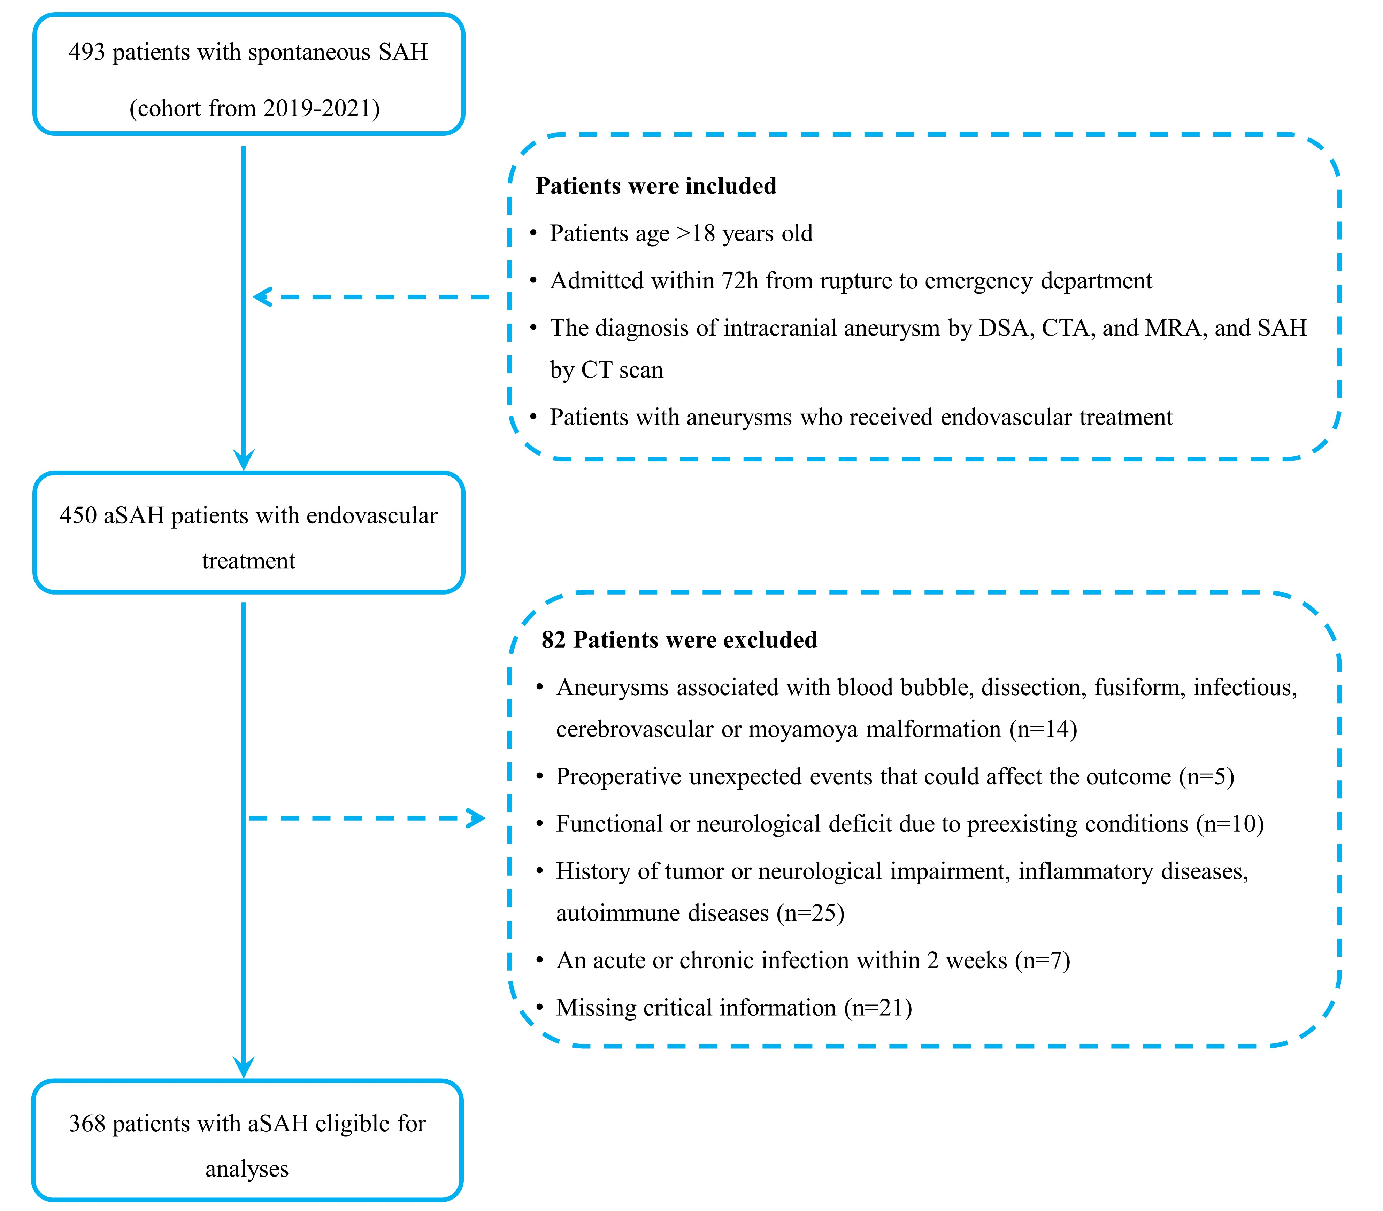
Figure S1. Flow diagram of the patient enrollment in this study
Abbreviations: SAH, subarachnoid hemorrhage; DSA, digital subtraction angiography; CTA, computed tomographic angiography; MRA, magnetic resonance angiography; CT, computed tomography; aSAH, aneurysmal subarachnoid hemorrhage.

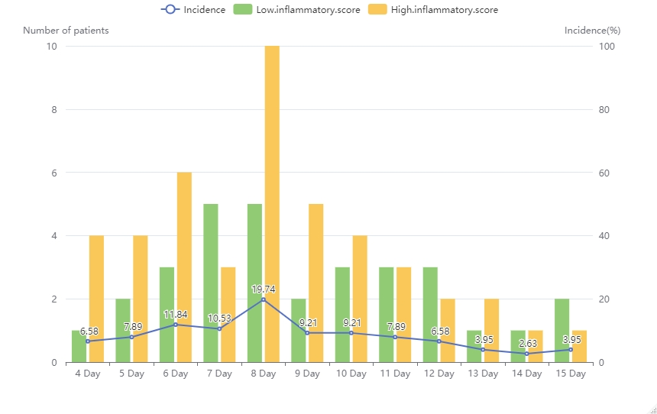
Figure S2. The day of DCI onset after ictus in aSAH patients
Abbreviations: DCI, delayed cerebral ischemia; aSAH, aneurysmal subarachnoid hemorrhage.

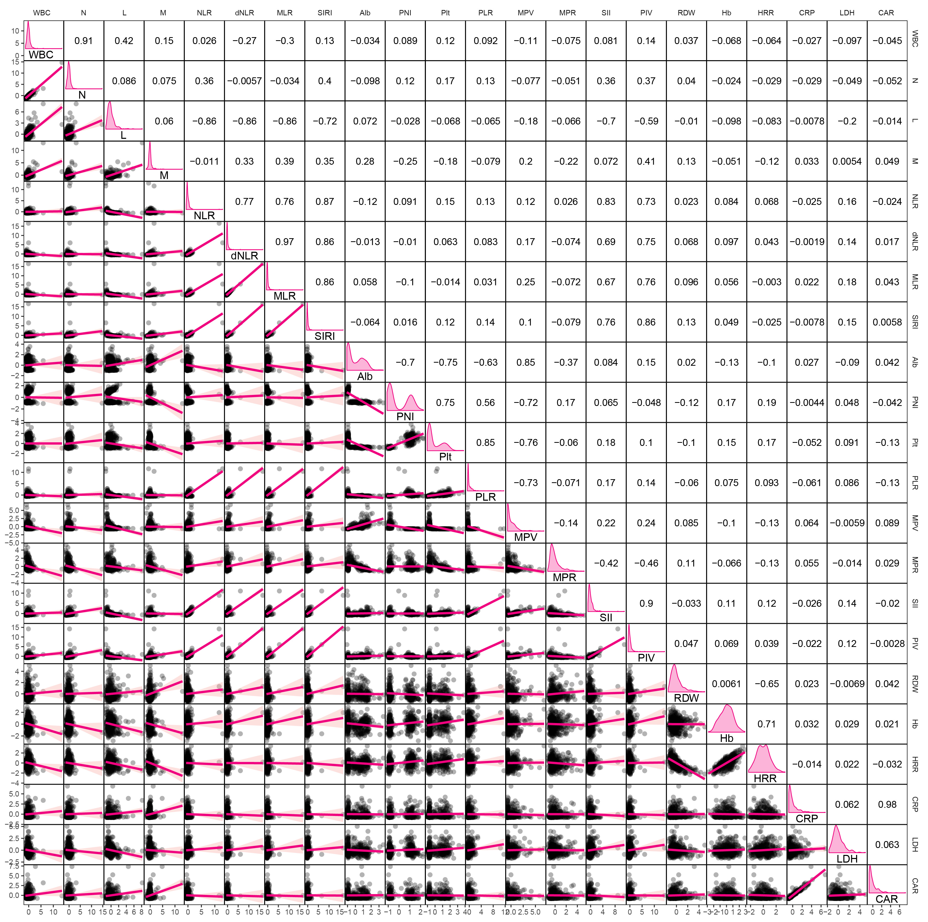
Figure S3. A correlation matrix of 22 inflammatory markers
Abbreviations: WBC, White blood cell count; N, Neutrophil count; L, Lymphocyte count; M, Monocyte count; Plt, Platelet count; Alb, Albumin; Hb, Hemoglobin; RDW, Red blood cell distribution width; MPV, Mean platelet volume; CRP, C-reactive protein; LDH, Lactate dehydrogenase; NLR, Neutrophil-to-lymphocyte ratio; dNLR, Derived neutrophil-to-lymphocyte ratio; PLR, Platelet-to-lymphocyte ratio; MLR, Monocyte-to-lymphocyte ratio; PNI, Prognostic nutritional index; SIRI, Systemic inflammatory response index; SII, Systemic immune-inflammation index; PIV, Pan-immune-inflammation value; MPR, Mean platelet volume to platelet ratio; HRR, Hemoglobin-to-red blood cell distribution width ratio; CAR, C-reactive protein to albumin ratio.

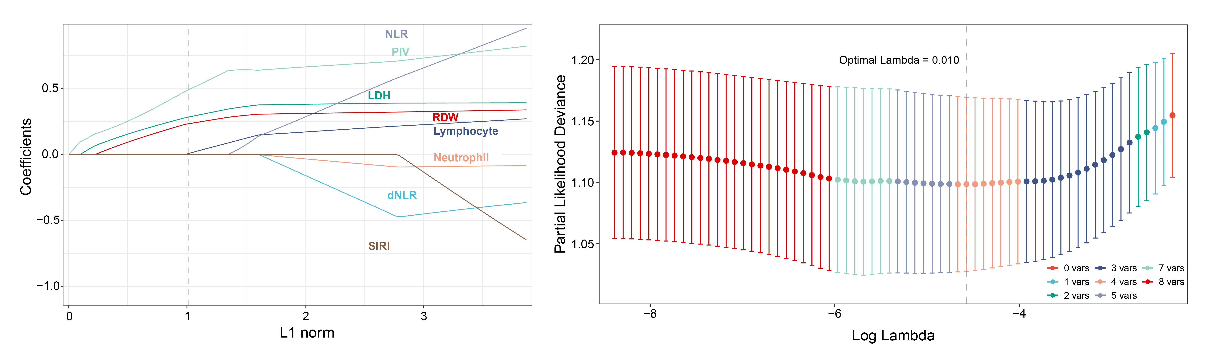
Figure S4. Feature selection using the least absolute shrinkage and selection operator (LASSO) regression model.
Abbreviations: RDW, Red blood cell distribution width; LDH, Lactate dehydrogenase; NLR, Neutrophil-to-lymphocyte ratio; dNLR, Derived neutrophil-to-lymphocyte ratio; SIRI, Systemic inflammatory response index; PIV, Pan-immune-inflammation value.

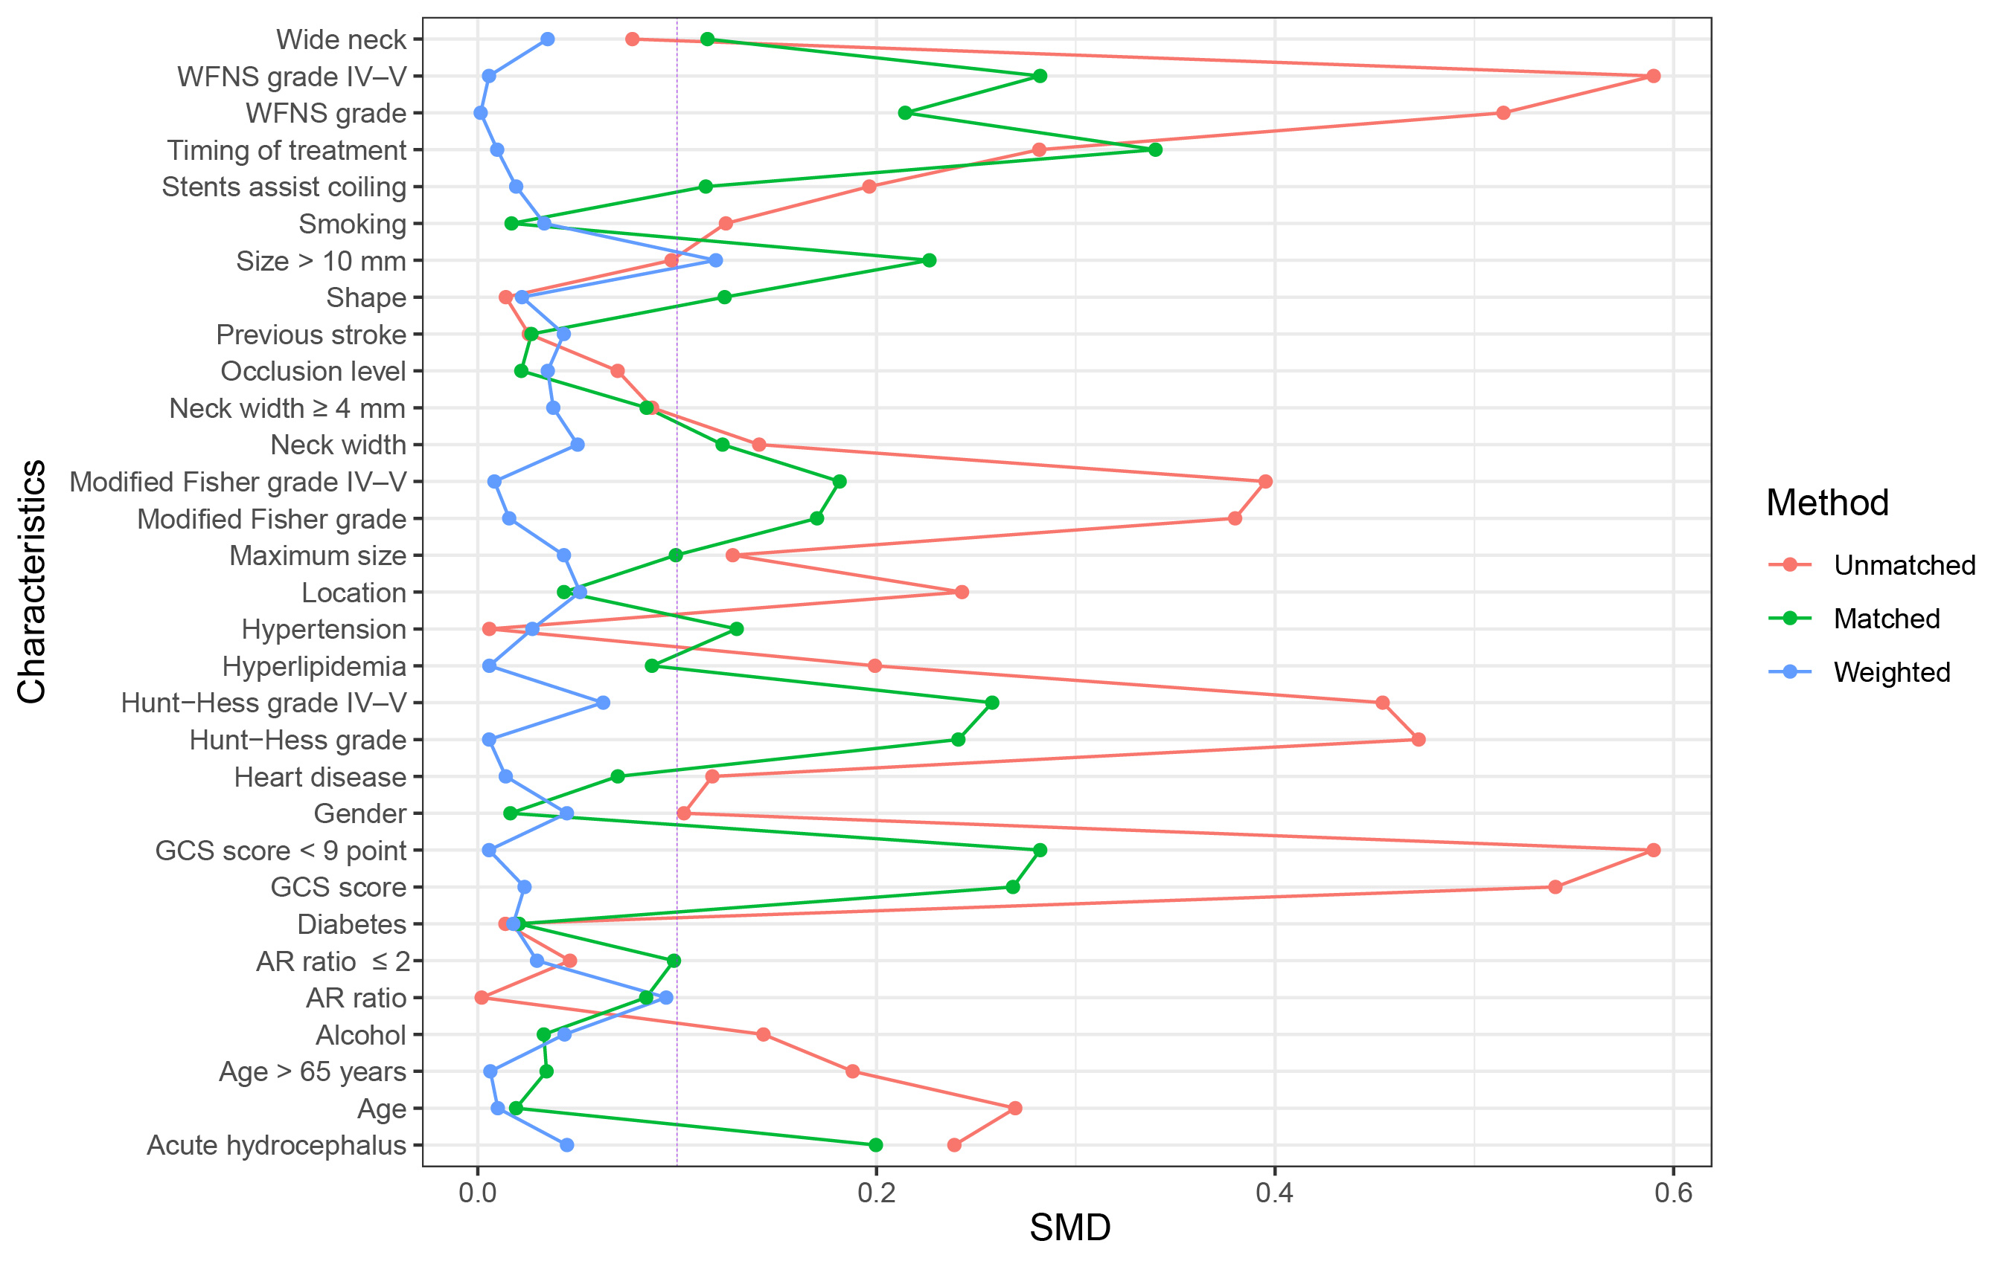
Figure S5. The standard mean differences of baseline characteristics before matching and after matching.
Abbreviations: GCS, Glasgow Coma Scale; WFNS, World Federation of Neurosurgical Societies; HH, Hunt Hess; mFS, modified Fisher Scale; AR, aneurysm maximum height to neck diameter ratio; DCI, delayed cerebral ischemia.

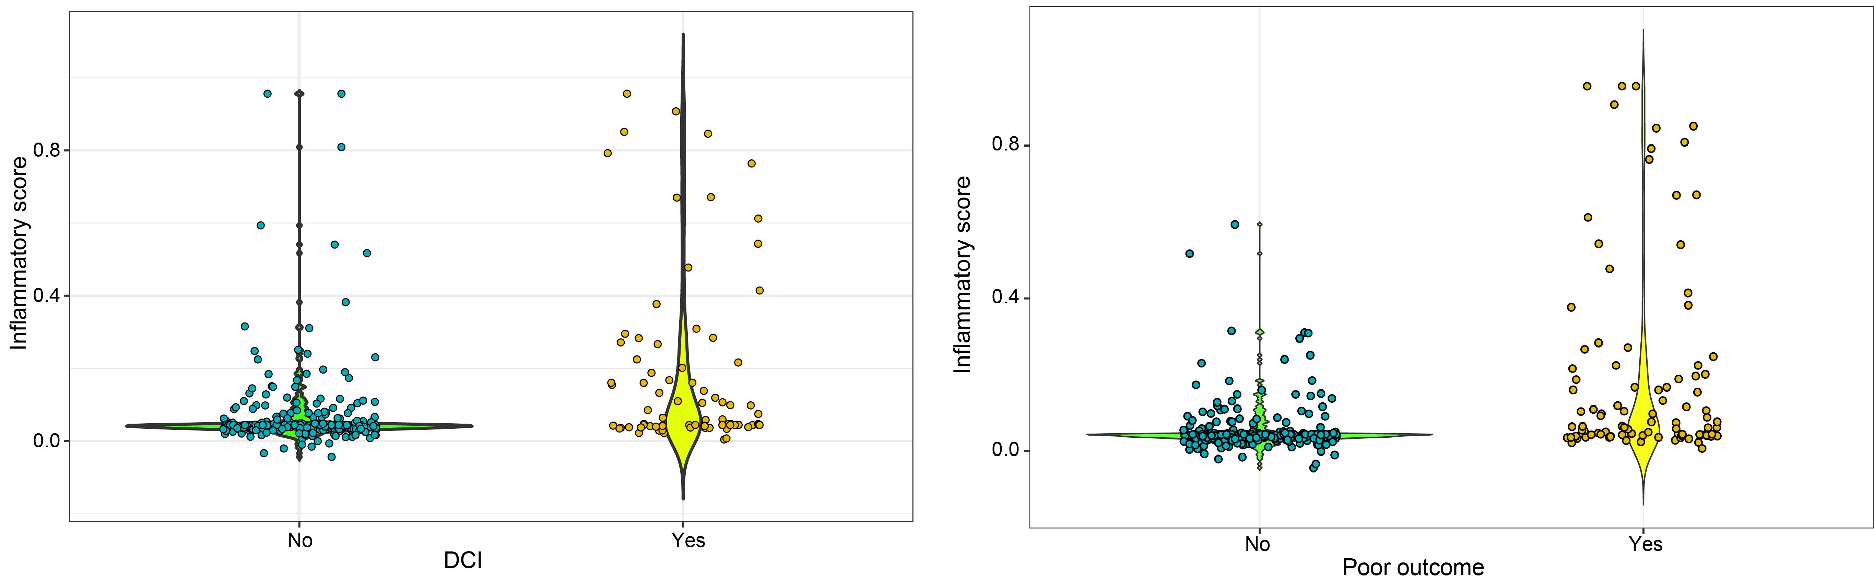
Figure S6. Boxplot of inflammatory score between aSAH patients with and without DCI, and poor outcome.
Abbreviations: DCI, delayed cerebral ischemia; aSAH: aneurysmal subarachnoid hemorrhage.

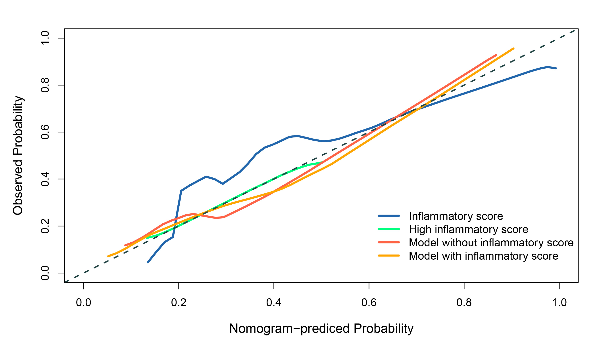 Figure S7. Calibration curves analysis of the model with or without inflammatory score.

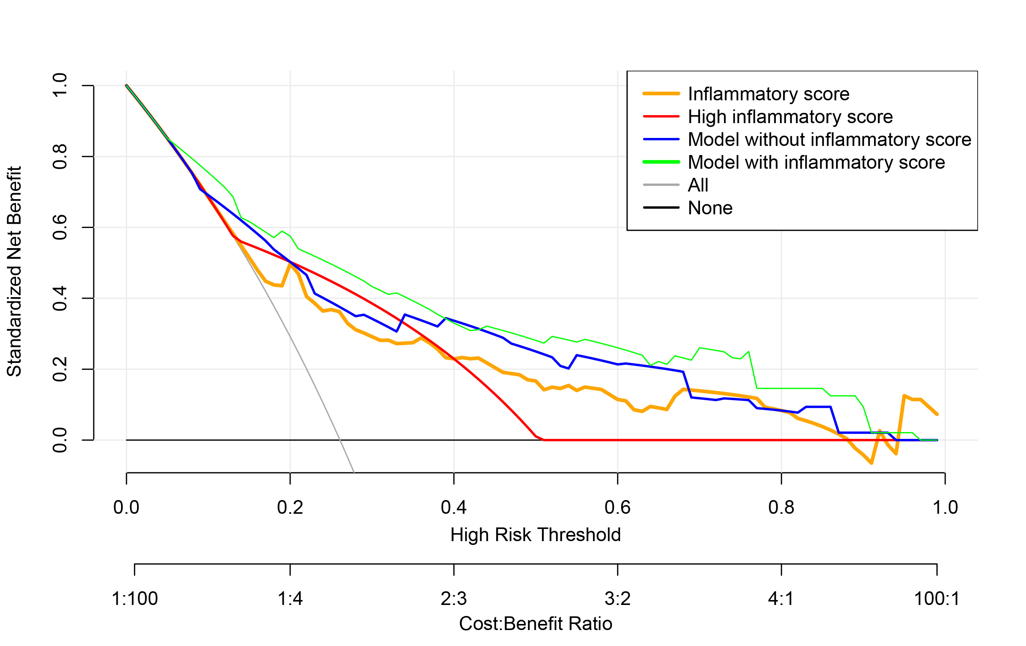 Figure S8. Decision curve analysis of the model with or without inflammatory score.

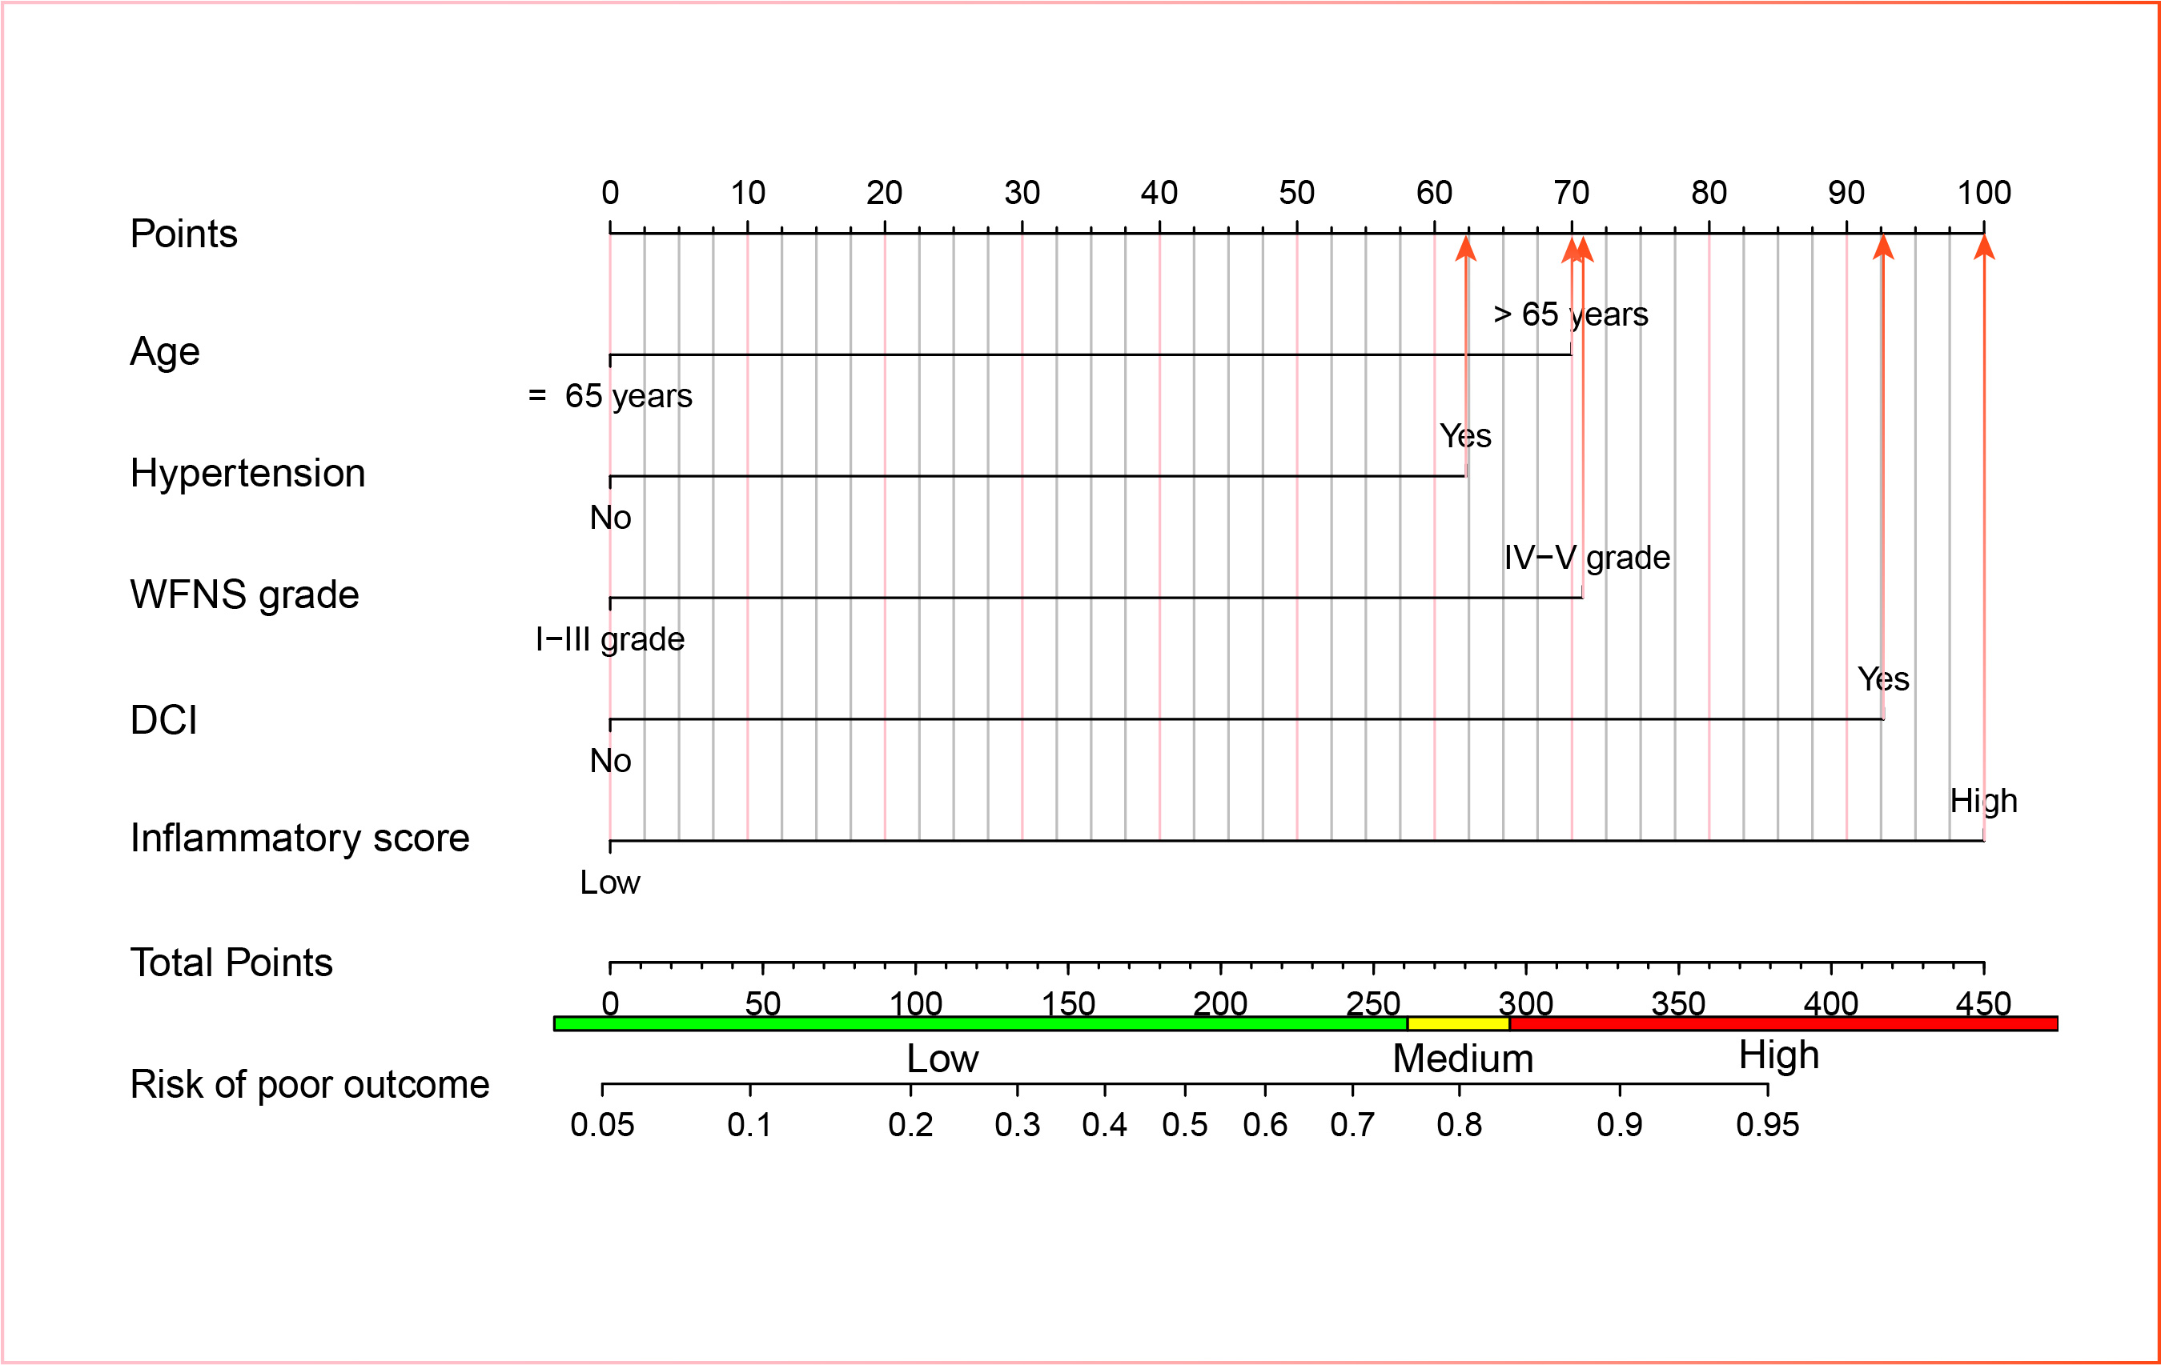
Figure S9. A nomogram based on inflammatory score for predicting poor outcome in aSAH patients.
Abbreviations: WFNS, World Federation of Neurosurgical Societies; DCI, delayed cerebral ischemia; aSAH: aneurysmal subarachnoid hemorrhage.

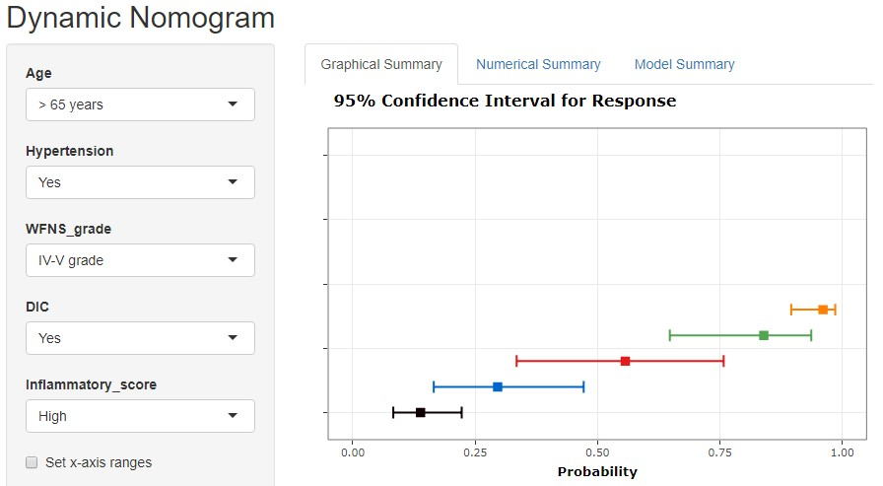
Figure S10. A web-based interactive calculator interface based on a nomogram for predicting the risk of poor outcome in aSAH patients (https://min115. shinyapps.io/dynnomapp/).
Abbreviations: WFNS, World Federation of Neurosurgical Societies; DCI, delayed cerebral ischemia; aSAH: aneurysmal subarachnoid hemorrhage.

