Graphene Oxide Quantum Dots-Preactivated Dental Pulp Stem Cells/GelMA Facilitates Mitophagy-Driven Bone Regeneration

Xiaoyuan Yan¹, Na An², Zeying Zhang¹, Qiujing Qiu¹, Di Yang¹, Penggong Wei¹, Xiyue Zhang¹, Lihong Qiu^{1, *}, Jiajie Guo^{1, *}

¹ Department of Endodontics, School and Hospital of Stomatology, China Medical University, Liaoning Provincial Key Laboratory of Oral Diseases, Shenyang 110002, China
² Department of Orthodontics, School and Hospital of Stomatology, China Medical University, Liaoning Provincial Key Laboratory of Oral Diseases, Shenyang 110002, China

*Correspondence to:
Professor Lihong Qiu, DDS, PhD
Department of Endodontics, School and Hospital of Stomatology, China Medical University, Liaoning Provincial Key Laboratory of Oral Diseases, Shenyang 110002, China.
No. 117 Nanjing North Street, Heping District, Shenyang, Liaoning Province, China
Email: lhqiu@cmu.edu.cn
and
Professor Jiajie Guo, DDS, PhD
Department of Endodontics, School and Hospital of Stomatology, China Medical University, Liaoning Provincial Key Laboratory of Oral Diseases, Shenyang 110002, China.
No. 117 Nanjing North Street, Heping District, Shenyang, Liaoning Province, China
Email: guojiajie@cmu.edu.cn

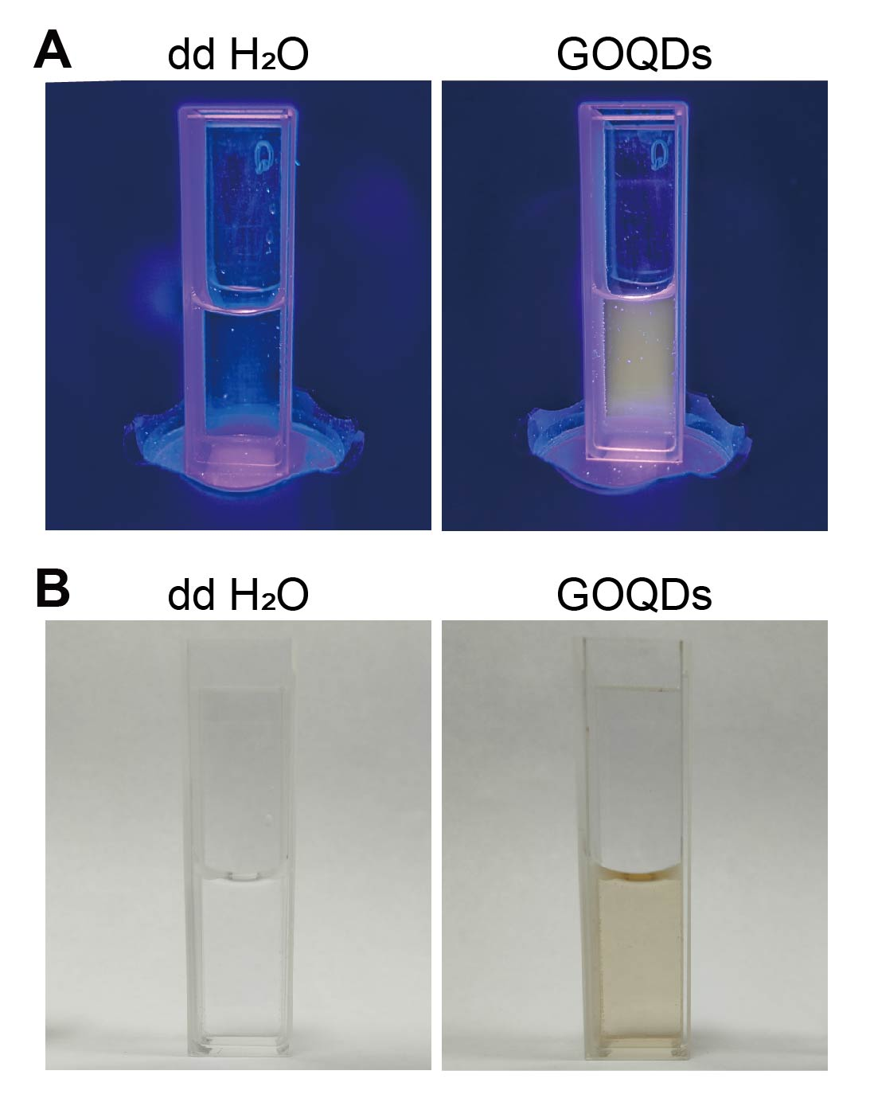
Figure S1. Dispersibility and fluorescence of GOQDs aqueous solution. Digital photographs of GOQDs aqueous solution (50 μg/mL) under (A) 405-nm UV light and (B) daylight with deionized water as the control group.

Figure S2. Images of DPSCs treated with different concentrations of GOQDs for 7 days taken with a microscope (scale bar of the upper panel = 500 μm; scale bar of the lower panel = 200 μm).
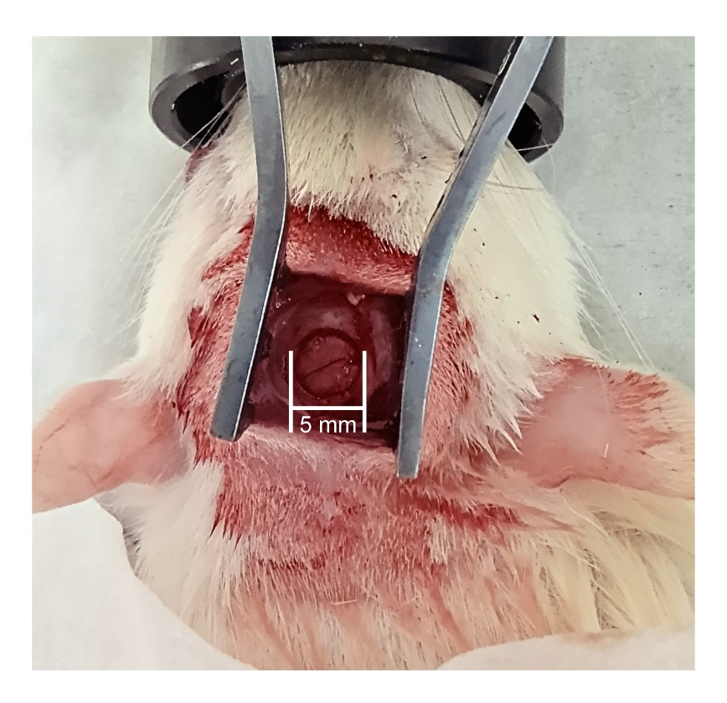
Figure S3. Creation of the calvarial bone defect in a rat (diameter = 5 mm).

