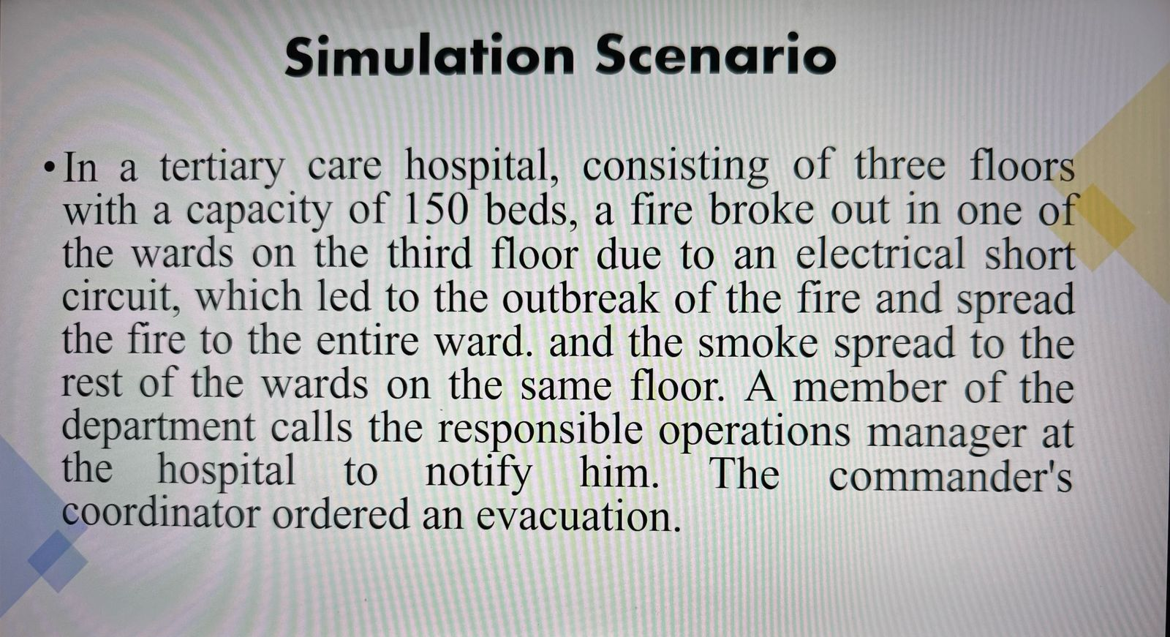
Supplementary Figure 1: The scenario

A scenario was developed by the researcher and presented to the students using a projector. The scenario described a situation where 220 “In a tertiary care hospital with three floors and a capacity of 150 beds, a fire broke out in one of the wards on the third floor due to an electrical short circuit. The fire quickly spread throughout the ward, and smoke began to fill the other wards on the same floor. A staff member notified the hospital’s operations manager, who then ordered an evacuation as AQ2 directed by the commander’s coordinator.”) Figure 1(

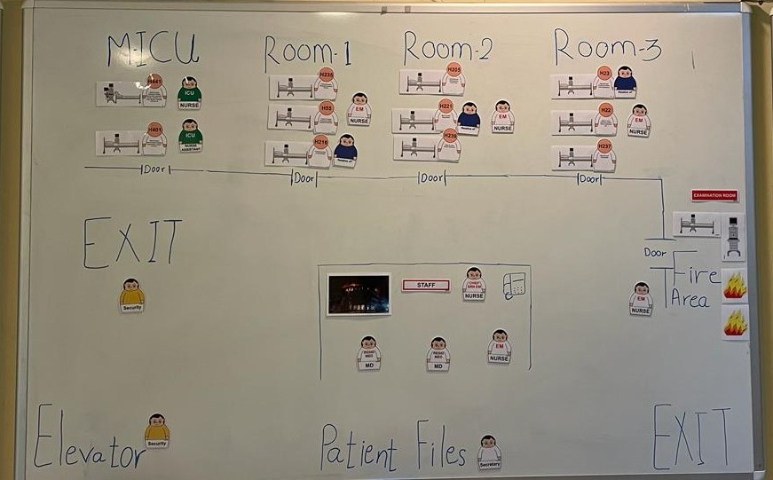
Supplementary Figure 2: The simulation lab board

The simulation lab board (Supplementary Figure 2) was prepared to represent the evacuation area. The layout included an inpatient department with three rooms, each containing three beds, 225 a Medium-Intensive Care Unit (MICU) with two beds, a diagnostic room, a storage room, and a nursing station, as well as two emergency exits.

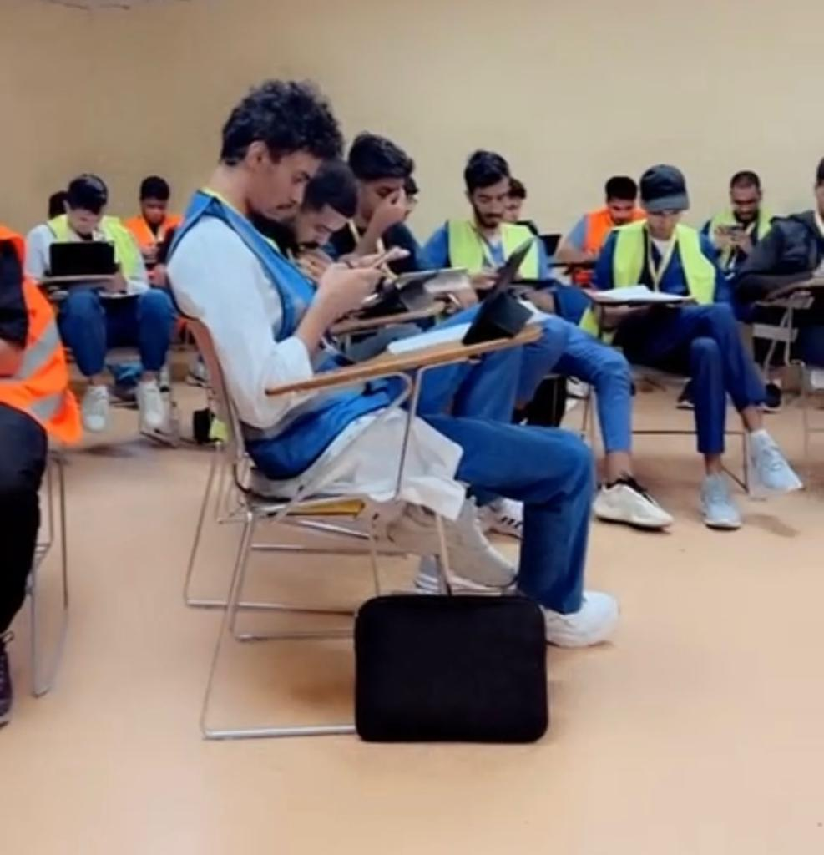
Supplementary Figure 3: Students were divided into two groups

Students were divided into two groups over two days—male students on the first day and female students on the second. Each day was split into two sessions: the first session from 8:00 a.m. to 12:00 p.m., and the second from 12:00 p.m. to 4:00 p.m. Upon arrival, students registered and received cards with a unique code. They were then directed 230 to the lecture hall

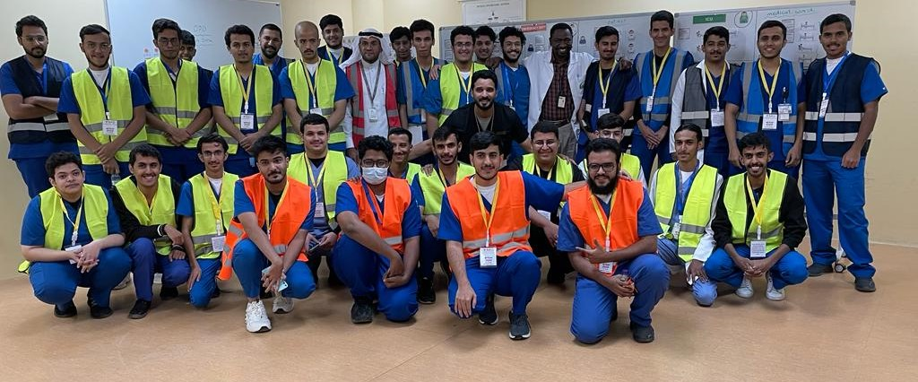
Supplementary Figure 4: one group of participants after finishing the project

