Supplementary Figure 1. Study design and procedures of animal experiments.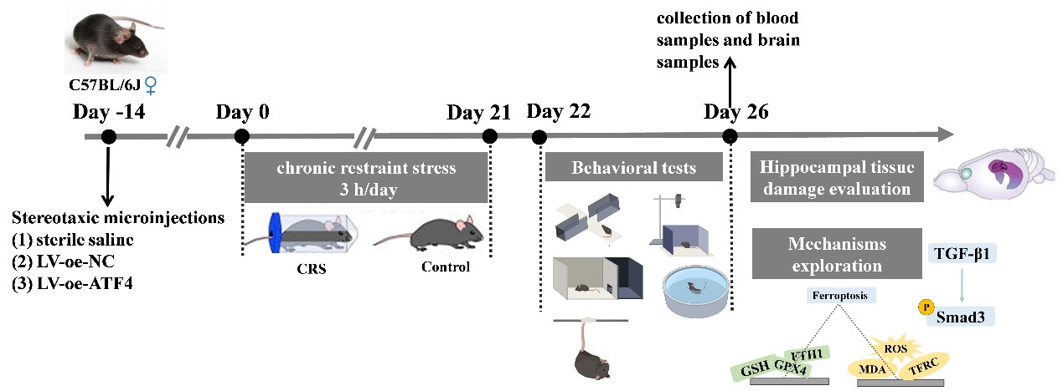
Supplementary Figure 2. The protein-protein interaction (PPI) network analysis. (A) The PPI network of FDEGs. (B) A gene cluster of FDEGs identified by the plug-in Molecular Complex Detection. (C) Degrees of genes were calculated by the degree algorithms of CytoHubba.
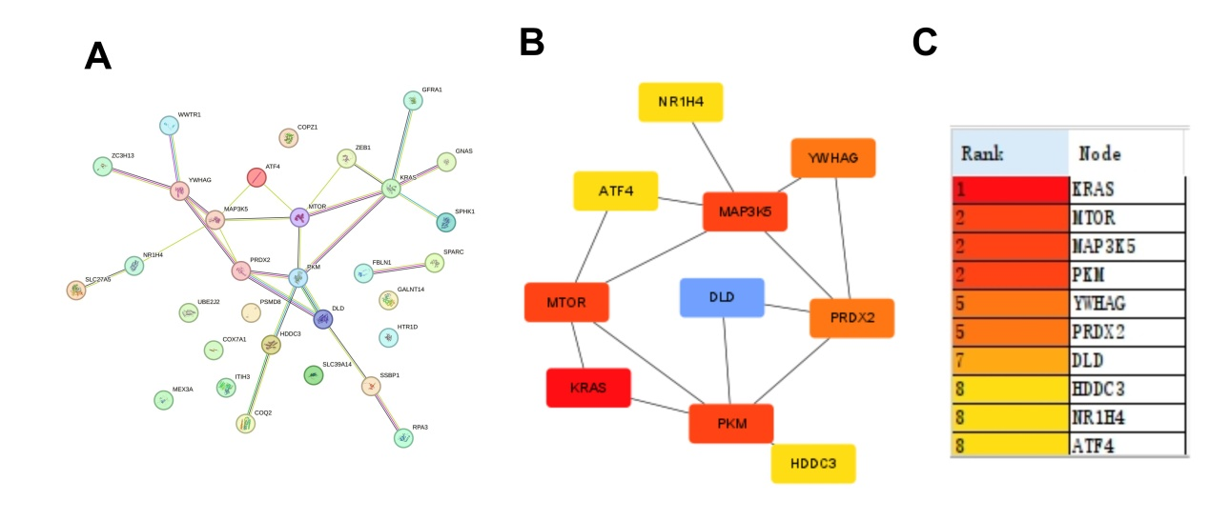
Supplementary Figure 3. Receiver operating characteristic curves of hub genes. The horizontal coordinate was the false positive rate, and the vertical coordinate was the true positive rate.
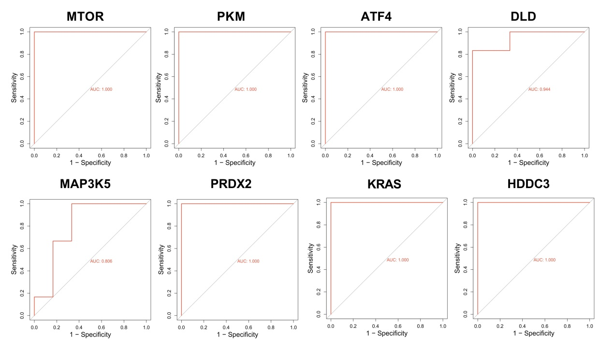
Supplementary Figure 4. ATF4 validation in the GSE100085 dataset. (A) A box line plot showed the expression difference of ATF4 between the Control group and the Anxiety group in GSE100085. (B) The receiver operating characteristic curve of ATF4. The horizontal coordinate was the false positive rate, and the vertical coordinate was the true positive rate.
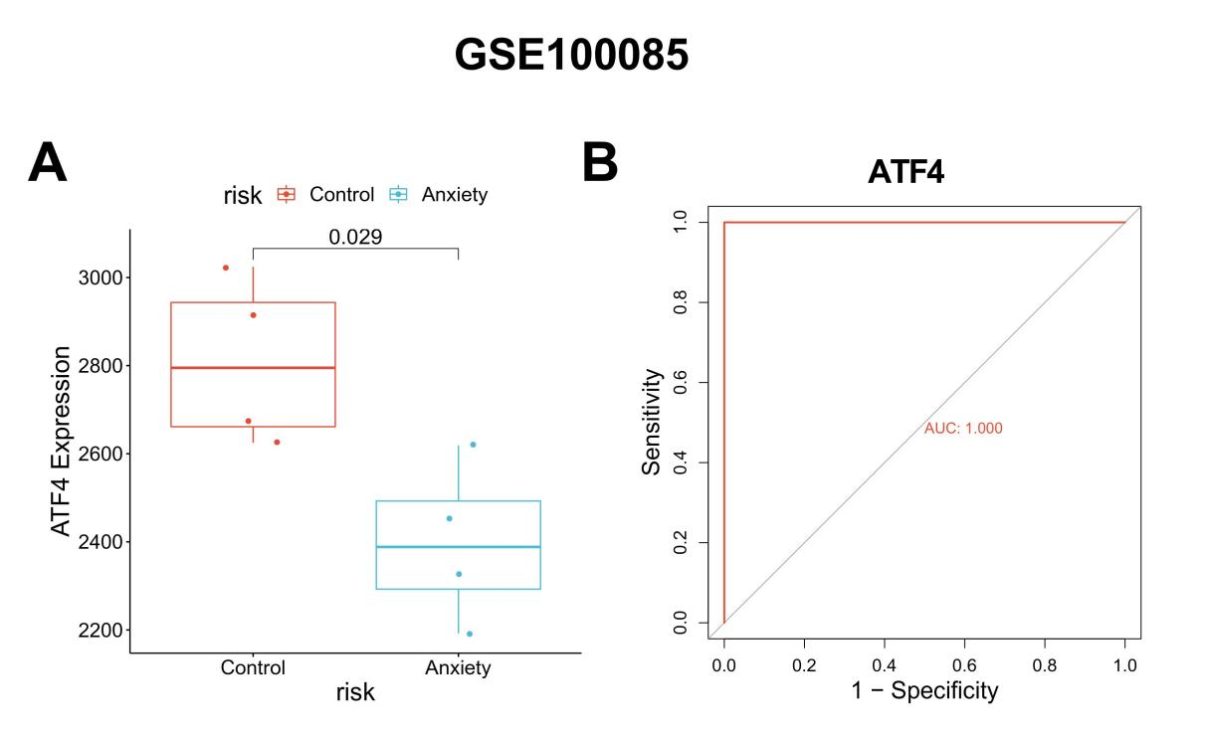

Supplementary Table 1. The sequences of primers
Name | Sequence（5’-3’）
M-GAPDH-F | CTCATGACCACAGTCCATGC
M-GAPDH-R | TTCAGCTCTGGGATGACCTT
M-MTOR-F | AATGCTATGGAGGTTACGGGTCTG
M-MTOR-R | CGCTTATTGCCTTTGGTATTTGTG
M-PKM-F | GGTGACGGAGGTGGAGAATGGTGG
M-PKM-R | CGATTTTGCTGATGATCTTGATGT
M-ATF4-F | CTGACTCTGCTGCTTACATTACTC
M-ATF4-R | TGTCTTGTTTTGCTCCATCTTTTT
M-DLD-F | CTACAAAAGCCGATGGCAGCACTC
M-DLD-R | TCCACCCACATGACCCAAAAATTC
M-MAP3K5-F | AGAAAAGGACGGGAAAGGGATACG
M-MAP3K5-R | GCTCGAGATGAGGGTTGTGATGTG
M-PRDX2-F | ATTACGGCGTGTTGAAAAATGATG
M-PRDX2-R | AAAGGCCTGGACTAGGCGGAGAGC
M-KRAS-F | GGGGAGGGCTTTCTTTGTGTATTT
M-KRAS-R | CCCATCTTTGCTCATCTTTTCTTT
M-HDDC3-F | CTGGTGAAGCTGGCAGACAAGCTA
M-HDDC3-R | TTTTGGGGAGGACTGTGGAAGGAC

Supplementary Table 2. The top 15 up-regulated and down-regulated DEGs
Name | Description | log2FoldChange | pval | up/down
Hbb-b2 | hemoglobin, beta adult minor chain | 6.5064503 | 9.86E-15 | up
Glo1 | glyoxalase 1 | 1.7245354 | 4.45E-10 | up
Sox11 | SRY (sex determining region Y)-box 11 | 2.0983425 | 5.78E-10 | up
Mvb12b | multivesicular body subunit 12B | 2.0568936 | 1.12E-09 | up
Hddc3 | HD domain containing 3 | 2.5710878 | 1.22E-09 | up
Ssbp2 | single-stranded DNA binding protein 2 | 3.5623226 | 1.51E-09 | up
Gadd45gip1 | growth arrest and DNA-damage-inducible, gamma interacting protein 1 | 1.9927148 | 5.87E-09 | up
Kras | Kirsten rat sarcoma viral oncogene homolog | 1.5703301 | 7.33E-09 | up
Wdfy1 | WD repeat and FYVE domain containing 1 | 2.0720929 | 7.35E-09 | up
Zfp775 | zinc finger protein 775 | 2.3807197 | 1.02E-08 | up
Dbpht2 | DNA binding protein with his-thr domain | 2.5578083 | 1.16E-08 | up
Lrp6 | low density lipoprotein receptor-related protein 6 | 2.8709523 | 1.22E-08 | up
Ppfibp1 | PTPRF interacting protein, binding protein 1 (liprin beta 1) | 1.8352535 | 1.59E-08 | up
Zbtb46 | zinc finger and BTB domain containing 46 | 2.1879842 | 1.63E-08 | up
Cuedc1 | CUE domain containing 1 | 2.6435527 | 1.75E-08 | up
Prdx2 | peroxiredoxin 2 | -4.9428957 | 1.67E-13 | down
Prrt4 | proline-rich transmembrane protein 4 | -5.5438662 | 9.76E-13 | down
B3galt6 | UDP-Gal:betaGal beta 1,3-galactosyltransferase, polypeptide 6 | -3.3115053 | 1.49E-12 | down
Ooep | oocyte expressed protein | -3.1647661 | 2.47E-12 | down
Abhd16a | abhydrolase domain containing 16A | -6.0527516 | 4.13E-12 | down
Chchd4 | coiled-coil-helix-coiled-coil-helix domain containing 4 | -4.0467373 | 1.47E-11 | down
Mboat2 | membrane bound O-acyltransferase domain containing 2 | -2.0354458 | 1.07E-10 | down
Coq2 | coenzyme Q2 4-hydroxybenzoate polyprenyltransferase | -5.3730939 | 1.47E-10 | down
Srp9 | signal recognition particle 9 | -2.449183 | 2.66E-10 | down
Prcp | prolylcarboxypeptidase (angiotensinase C) | -2.6773358 | 2.82E-10 | down
Rpl29 | ribosomal protein L29 | -4.3150285 | 2.96E-10 | down
Psmd8 | proteasome (prosome, macropain) 26S subunit, non-ATPase, 8 | -2.0850849 | 3.29E-10 | down
Arl5a | ADP-ribosylation factor-like 5A | -3.9056038 | 3.36E-10 | down
Ndufb10 | NADH dehydrogenase (ubiquinone) 1 beta subcomplex, 10 | -2.7155257 | 3.98E-10 | down
Runx1t1 | runt-related transcription factor 1; translocated to, 1 (cyclin D-related) | -3.6874671 | 4.97E-10 | down

Supplementary Table 3. GO terms for FDEGs
GOTERM | Term | PValue | Fold enrichment | Count | GeneRatio | Genes
GOTERM_BP_DIRECT | GO:0032869~cellular response to insulin stimulus | 4.67E-04 | 25.31 | 4 | 12.90 | PKM, SLC39A14, MTOR, YWHAG
GOTERM_BP_DIRECT | GO:0034198~cellular response to amino acid starvation | 0.002163212 | 41.92 | 3 | 9.68 | MTOR, ATF4, MAP3K5
GOTERM_BP_DIRECT | GO:0031667~response to nutrient levels | 0.002630935 | 37.97 | 3 | 9.68 | ZEB1, MTOR, ATF4
GOTERM_BP_DIRECT | GO:1990253~cellular response to leucine starvation | 0.018556693 | 103.20 | 2 | 6.45 | MTOR, ATF4
GOTERM_BP_DIRECT | GO:0030857~negative regulation of epithelial cell differentiation | 0.025605092 | 74.53 | 2 | 6.45 | ZEB1, KRAS
GOTERM_BP_DIRECT | GO:0033554~cellular response to stress | 0.029810675 | 63.89 | 2 | 6.45 | PRDX2, MAP3K5
GOTERM_CC_DIRECT | GO:0005829~cytosol | 0.03163316 | 1.71 | 14 | 45.16 | WWTR1, SPHK1, UBE2J2, COPZ1, MTOR, PSMD8, PRDX2, PKM, ZEB1, MEX3A, GNAS, KRAS, YWHAG, MAP3K5
GOTERM_CC_DIRECT | GO:0070062~extracellular exosome | 0.032095494 | 2.46 | 8 | 25.81 | PRDX2, ITIH3, PKM, GNAS, FBLN1, GFRA1, SSBP1, YWHAG
GOTERM_MF_DIRECT | GO:0005159~insulin-like growth factor receptor binding | 0.024194462 | 79.03 | 2 | 6.45 | GNAS, YWHAG
GOTERM_MF_DIRECT | GO:0005524~ATP binding | 0.026576086 | 2.88 | 7 | 22.58 | PKM, SPHK1, KRAS, UBE2J2, SLC27A5, MTOR, MAP3K5

Supplementary Table 4. KEGG Pathways for FDEGs
KEGG_PATHWAY | Term | PValue | Fold enrichment | Count | GeneRatio | Genes
KEGG_PATHWAY | Alzheimer disease | 3.95297E-05 | 9.89 | 7 | 22.58 | PSMD8, GNAS, UBE2J2, COX7A1, SLC39A14, ATF4, MAP3K5
KEGG_PATHWAY | Pathways of neurodegeneration - multiple diseases | 0.000300659 | 6.85 | 7 | 22.58 | PSMD8, KRAS, COX7A1, SLC39A14, MTOR, ATF4, MAP3K5
KEGG_PATHWAY | Prostate cancer | 0.000945736 | 5.53 | 7 | 22.58 | PSMD8, KRAS, UBE2J2, COX7A1, MTOR, ATF4, MAP3K5
KEGG_PATHWAY | Thermogenesis | 0.001807081 | 15.50 | 4 | 12.90 | ZEB1, KRAS, MTOR, ATF4
KEGG_PATHWAY | Growth hormone synthesis, secretion and action | 0.00252759 | 8.10 | 5 | 16.13 | GNAS, KRAS, COX7A1, MTOR, MAP3K5
KEGG_PATHWAY | Phospholipase D signaling pathway | 0.003314151 | 12.53 | 4 | 12.90 | GNAS, KRAS, MTOR, ATF4
KEGG_PATHWAY | Amyotrophic lateral sclerosis | 0.005965993 | 10.16 | 4 | 12.90 | SPHK1, GNAS, KRAS, MTOR
KEGG_PATHWAY | Central carbon metabolism in cancer | 0.012390047 | 5.16 | 5 | 16.13 | PSMD8, COX7A1, MTOR, ATF4, MAP3K5
KEGG_PATHWAY | Viral carcinogenesis | 0.013450796 | 16.11 | 3 | 9.68 | PKM, KRAS, MTOR
KEGG_PATHWAY | Chemical carcinogenesis - receptor activation | 0.014330314 | 7.37 | 4 | 12.90 | PKM, KRAS, YWHAG, ATF4

