Supplementary Material
Supplementary Figures
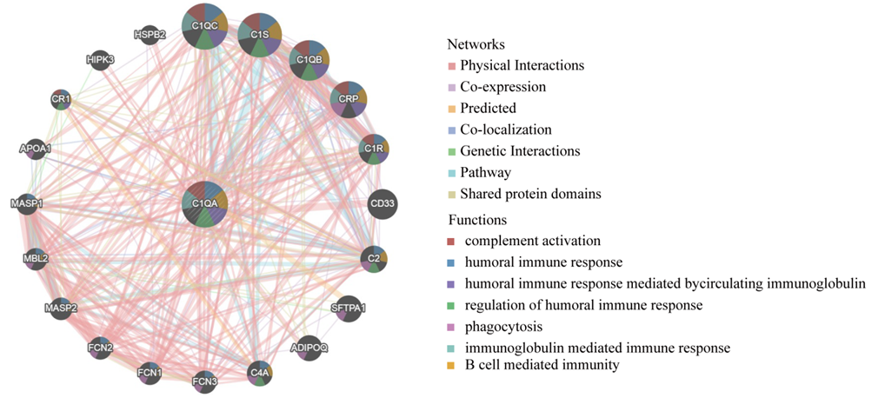
Figure S1A. The PPI network of C1QA and its functional analysis come from GeneMANIA.
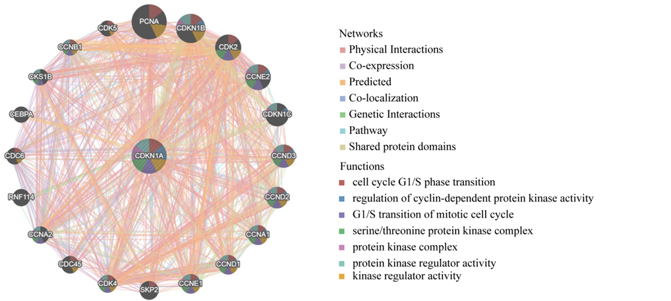Figure S1B. The PPI network of CDKN1A and its functional analysis come from GeneMANIA.

