Supplementary materials
Supplementary Figure 1 Distribution of bispectral index with the remimazolam effect-site concentration.
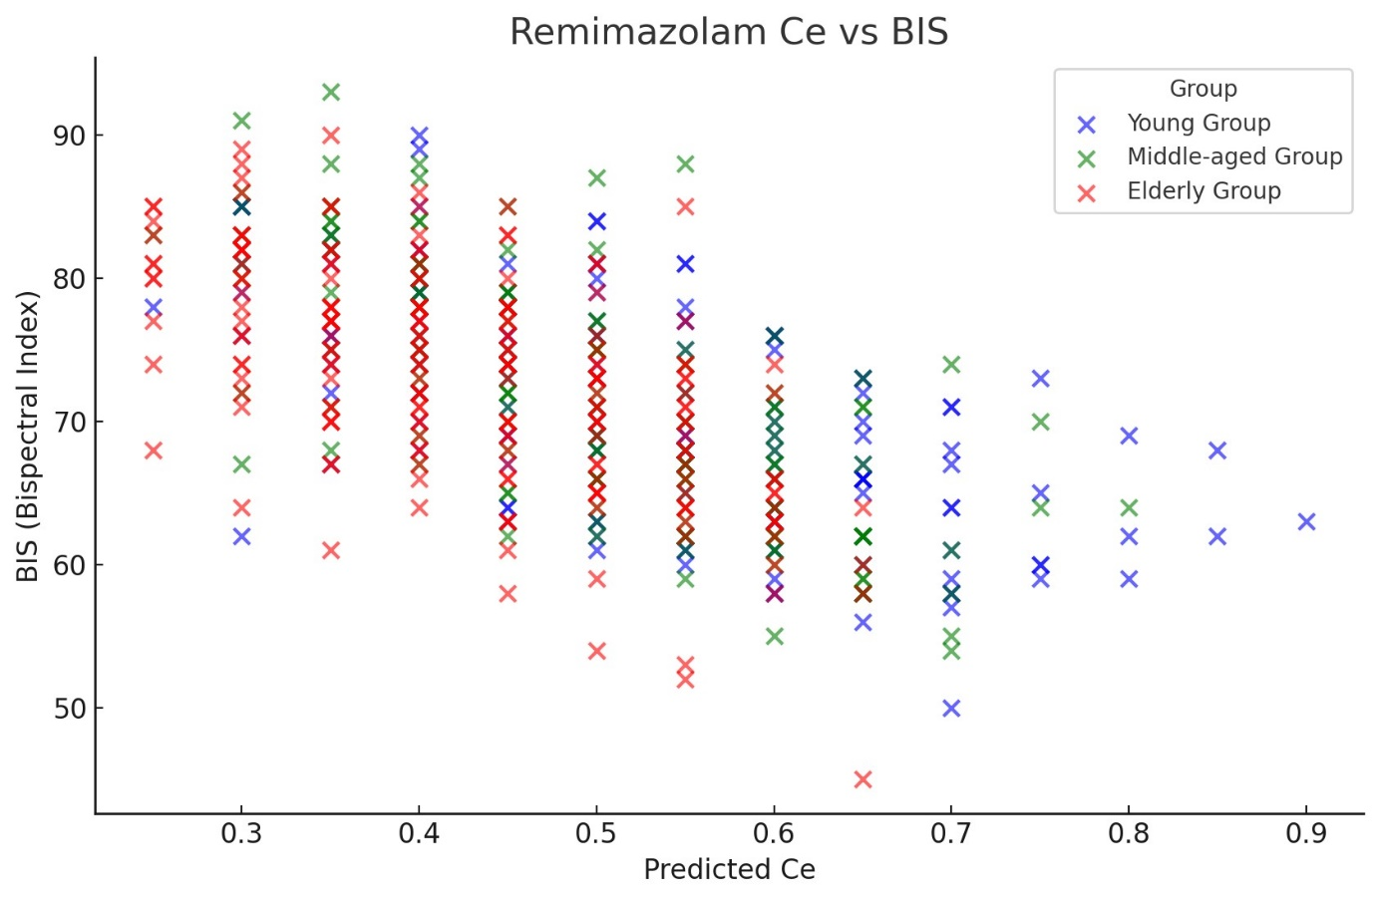
The x marks represent the raw data observed from all patients. Ce, effect-site concentration of remimazolam.
Supplementary Figure 2 Relationship between the remimazolam effect-site concentration and sedation level.
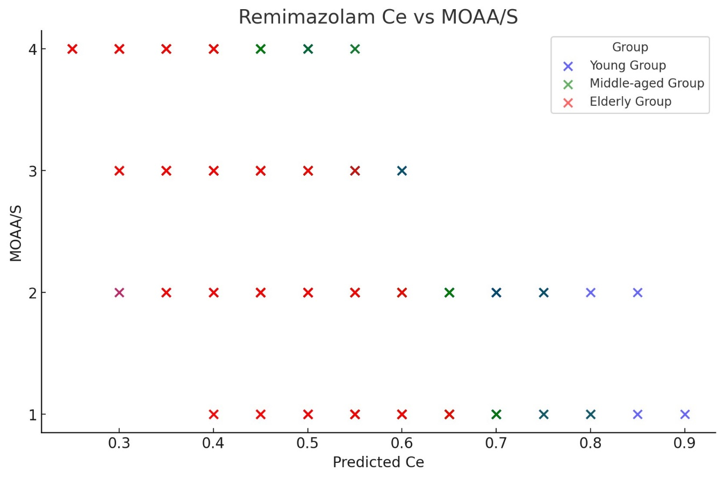
The x marks represent the raw data observed from all patients. Ce, effect-site concentration of remimazolam; MOAA/S: Modified Observer’s Assessment of Alertness/Sedation scale.

