Quercetin attenuates MRGPRX2-mediated mast cell degranulation via the MyD88/IKK/NF-κB and PI3K/AKT/ Rac1/Cdc42 pathway

Chenrui Zhao ^{1, 2,#}, Yuanyuan Ding ^{2,#}, Yihan Huang ², Chao Wang ², Bin Guo ^{1,}*, Tao Zhang ².

¹ Department of Anesthesiology, Xi’an Honghui Hospital, Xi’an Jiaotong University, Xi’an 710054, China
² College of Pharmacy, Xi’an Jiaotong University, Xi’an 710061, China

#1 These authors contributed equally.

* Corresponding author
Bin Guo, Department of Anesthesiology, Xi’an Honghui Hospital, Xi’an Jiaotong University, Xi’an 710054, China
E-mail address: xuan_310755@sina.com

Supplementary
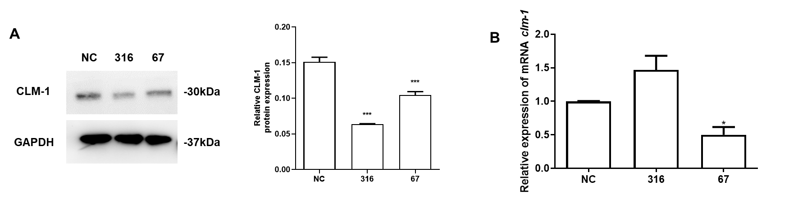
Figure S1. CLM-1 down-regulated cells in LAD2 were successfully constructed by siRNA technology.
(A) Western blot was used to analyze the down-regulation efficiency of CLM-1 protein level in LAD2 cells and its gray value quantitative analysis. (B) The down-regulation efficiency of CLM-1 gene expression in LAD2 cells was analyzed by RT-PCR. The data were expressed as mean ± SEM, and the two-tailed unpaired student T test was used for statistical analysis. *P < 0.05, ***P < 0.001 were considered statistically significant.

