Supporting information
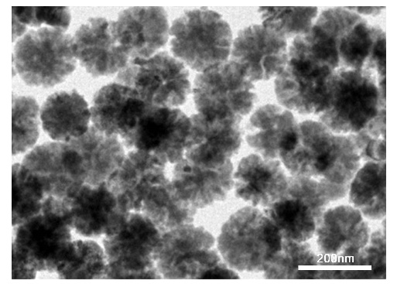
Figure S1: Transmission electron microscopy image of mFe NPs.

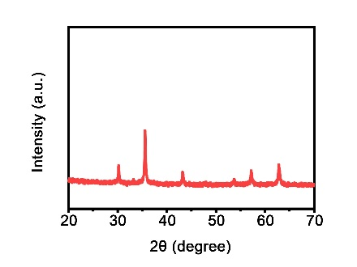
Figure S2: XRD pattern of the mFe NPs.

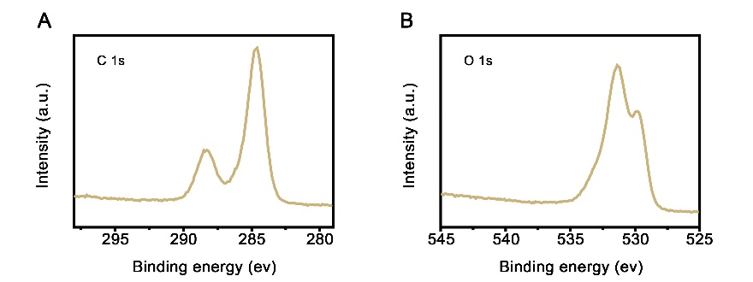
Figure S3: XPS high resolution (A) C 1s and (B) O 1s spectrum of mFe NPs.

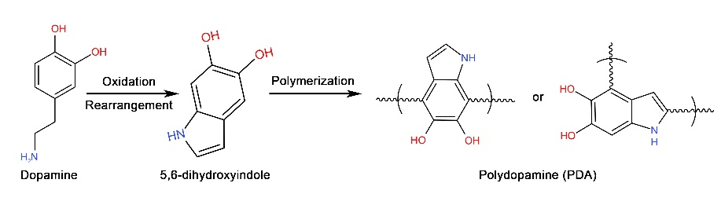
Figure S4: Schematic illustration of the preparation of PDA shell through oxidative polymerization and Michael addition reaction.

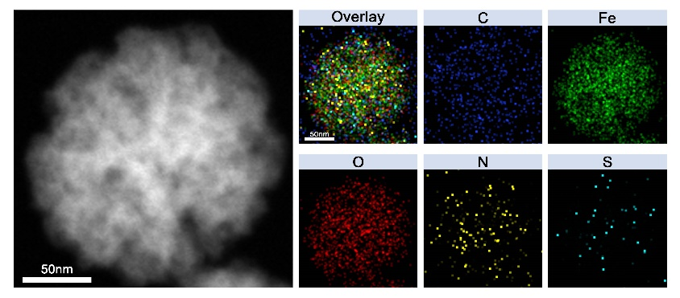
Figure S5: Elemental mapping of mFeB@PDA-FA NPs.

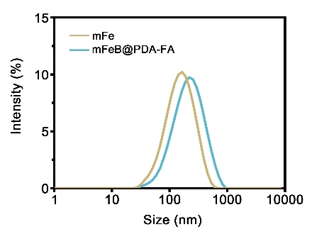
Figure S6 Particle size distribution of mFe NPs and mFeB@PDA NPs.

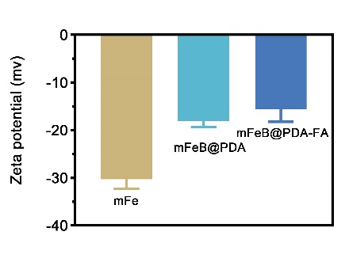
Figure S7: Zeta potential of mFe, mFeB@PDA and mFeB@PDA-FA NPs.

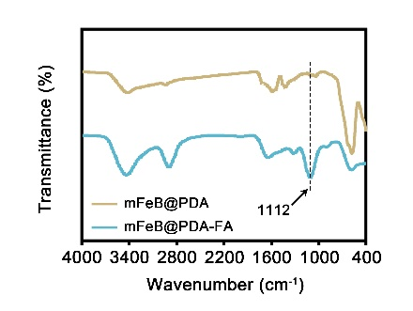
Fugure S8: FTIR spectra of mFeB@PDA and mFeB@PDA-FA NPs.

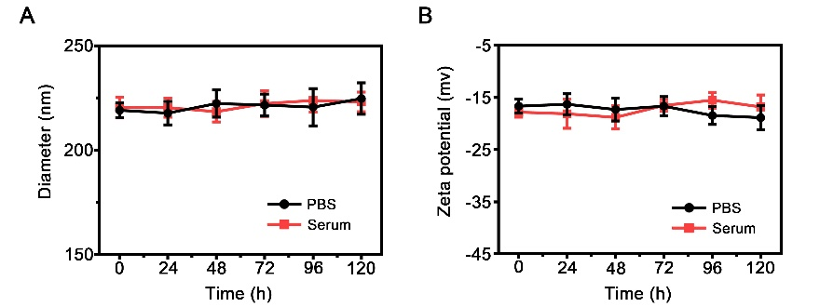
Figure S9: (A) Hydrodynamic diameter and (B) zeta potential changes of mFeB@PDA-FA NPs in PBS and serum for 5 days.

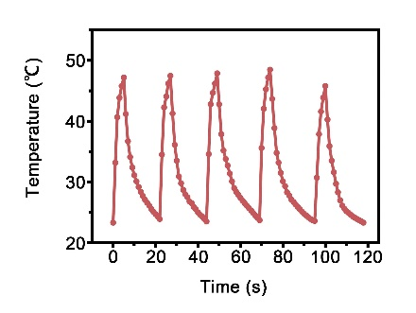
Figure S10: Photothermal stability of mFeB@PDA-FA NPs during 5 heating-cooling cycles.

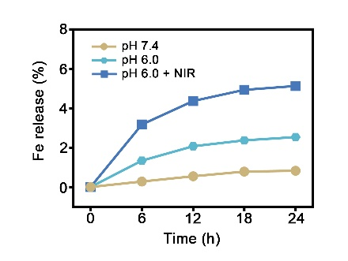
Figure S11: In vitro Fe ion release behavior at different pH levels with or without NIR

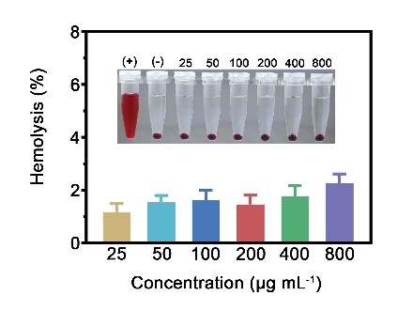
Figure S12: Hemolysis analysis of mFeB@PDA-FA suspension at various concentrations (mean ± SD, n = 3).
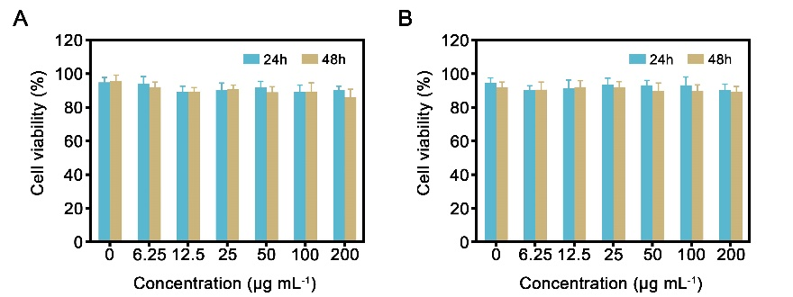
Figure S13: Cell viabilities of (A) BMSCs and (B) HUVECs after co-incubation with mFeB@PDA-FA NPs at various concentrations for 24 h and 48 h.

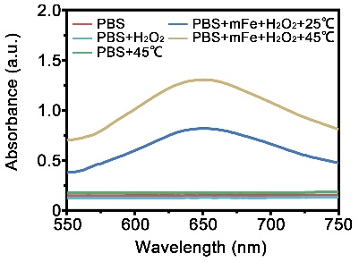
Figure S14: UV-vis absorption spectra of TMB aqueous solution treated with: (1) PBS, (2) PBS + H₂O₂, (3) PBS + 45 ℃, (4) PBS + mFe + H₂O₂ + 25 ℃ and (5) PBS + mFe + H₂O₂ + 45 ℃.

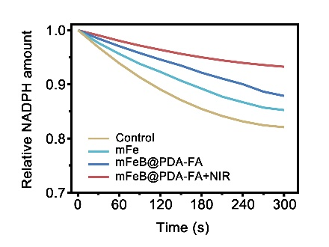
Figure S15: Intracellular GPX4 activity of MNNG/HOS cells after different treatments.

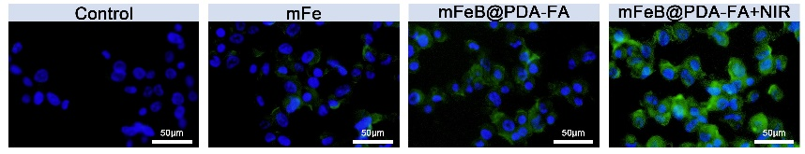
Figure S16: Fluorescence images of lipid peroxides stained with C11-BODIPY^{581/591} after different treatments.

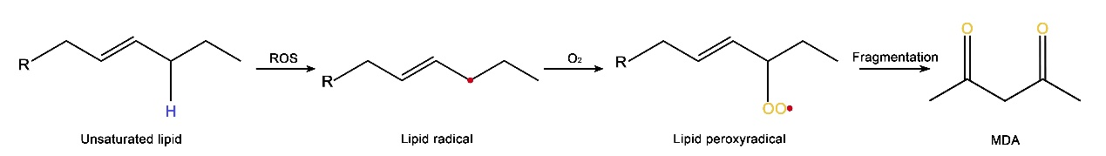
Figure S17: Schematic illustration of lipid peroxidation process.

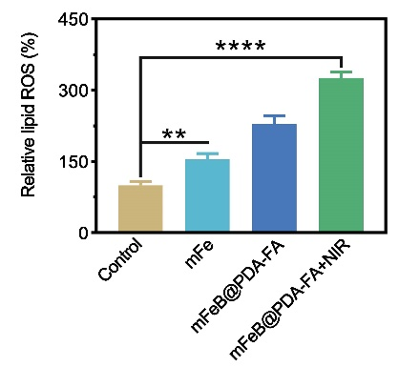
Figure S18: Lipid peroxidation levels of MNNG/HOS cells after corresponding treatments (**P < 0.01, ****P < 0.0001).

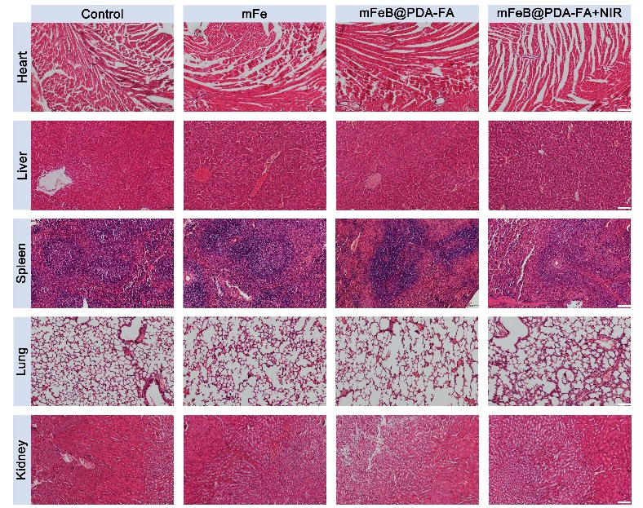
Figure S19: H&E staining images of major organs (heart, liver, spleen, lung, kidney) of tumor-bearing mice after various treatments. Scale bar: 100 μm.

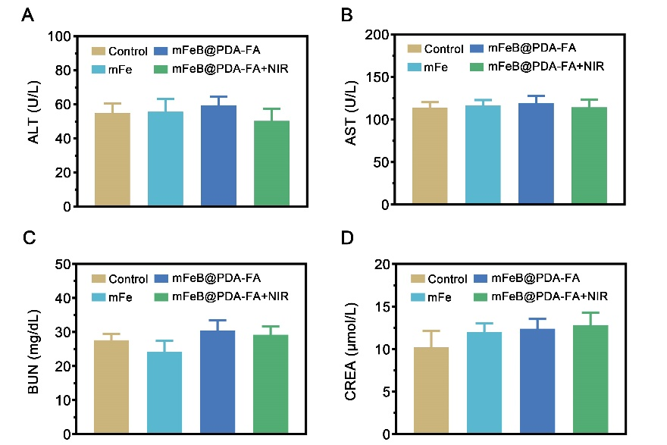
Figure S20: Biosafety evaluation of blood biochemistry test of mice after different treatments. Serum levels of (A) ALT and (B) AST reflect the liver function of mice, while the serum levels of (C) BUN and (D) CREA reflect the kidney function of mice.

