Supplemental Materials
Supplemental Tables
Table S1. Input parameters utilized in PBPK modeling of anlotinib as a victim drug.
Parameters | Value | Source
Physicochemical
Molecular weight (g/mol) | 480.360 | Ref ¹
LogP_{o:w}ª | 3.700 | Ref ¹
Compound type | Diprotic base | Ref ¹
pKa 1 | 14.000 | Ref ¹
pKa 2 | 9.390 | Ref ¹
B/P^{b} | 0.790 | Ref ²
f_{u}^{c} | 0.070 | Ref ¹
Absorption | ADAM
P_{Caco-2}(x10⁻⁶ cm/s)^{d} | 3.500 | Ref ¹
Solubility (mg/mL)
Entry 1 pH | 1.700 | Ref ¹
Entry 1 Solubility | 500.000 | Ref ¹
Entry 2 pH | 4.600 | Ref ¹
Entry 2 Solubility | 0.114 | Ref ¹
Entry 3 pH | 6.500 | Ref ¹
Entry 3 Solubility | 0.00089 | Ref ¹
Distribution | Full PBPK Model
K_{p(Adipose)}^{e} | 22.230 | Ref ¹
K_{p(Bone)} | 38.860 | Ref ¹
K_{p(Brain)} | 1.370 | Predicted by Simcyp®
K_{p(Gut)} | 135.060 | Ref ¹
K_{p(Heart)} | 56.490 | Ref ¹
K_{p(Kidney)} | 77.840 | Ref ¹
K_{p(Liver)} | 55.780 | Ref ¹
K_{p(Lung)} | 251.880 | Ref ¹
K_{p(Muscle)} | 14.260 | Ref ¹
K_{p(Skin)} | 3.603 | Predicted by Simcyp®
K_{p(Spleen)} | 123.390 | Ref ¹
K_{p(Pancreas)} | 96.280 | Ref ¹
Elimination | Enzyme Kinetics
CL_{int, CYP1A2}^{f}  ISEF_{CYP1A2}^{g} | 0.23  0.69 | In house
CL_{int, CYP3A4}  ISEF_{CYP3A4} | 0.32  0.49 | In house
CL_{int, CYP3A5}  ISEF_{CYP3A5} | 0.31  0.43 | In house
ªLog P_{o:w}: the partition coefficient in oil and water.
^{b}B/P: blood to plasma ratio.
^{c}f_{u}: unbound fraction of the drug in plasma.
^{d}PCaco-2: the apparent permeability through the Caco-2 cells.
^{e}K_{p}: tissue to plasma partition coefficient.
^{f}CL_{int}: intrinsic clearance (µL/min/pmol)
^{g}ISEF, intersystem extrapolation factor

Table S2. The built-in DDI parameters of perpetrators included in the PBPK-DDI model.
Parameters | Strong CYP3A inhibitor |  |  | Moderate CYP3A inhibitor |  |  | Strong CYP1A2 inhibitor |  | strong CYP3A and moderate CYP1A2 inducer
Parameters | Itraconazole | Ketoconazole | Clarithromycin | Diltiazem | Erythromycin | Fluconazole | Fluvoxamine | Ciprofloxacin | Rifampicin
CYP1A2 Ki | - | - | - | - | - | - | 0.002 | 2 | -
CYP3A4 Ki | 0.0013 | 0.015 | 10 | 36.1 | 82 | 10.7 | 0.789 | 1.5 | 15
CYP3A5 Ki | - | 0.109 | - | 36.1 | - | 86.4 | 5.82 | - | -
CYP3A4 K_{app}  K_{inact} | - | - | 12  2.13 | 4.75  0.702 | 23.2  2.25 | - | - | - | -
CYP3A5 K_{app}  K_{inact} | - | - | - | 4.75  0.702 | 7.14  0.66 | - | - | - | -
CYP3A4/5 Ind_{max}^  IndC₅₀^ | - | - | - | - | - | - | - | - | 16  0.32
CYP1A/2  Ind_{max}^ IndC₅₀^ |  |  |  |  |  |  |  |  | 2.7  0.1
Note: K_{i} (μM): concentration of inhibitor that supports half maximal inhibition;
K_{app} (μM): concentration of mechanism-based inhibitor associated with half maximal inactivation rate;
K_{inact} (1/h): inactivation rate of the enzyme
Ind_{max}^: maximal fold induction over vehicle
IndC₅₀^(μM): test compound concentration that supports half maximal induction
“-” represented that no corresponding value was entered
Table S3. Observed and predicted pharmacokinetic parameters of anlotinib in cancer patients under varying single dosing regimens.
Dose (mg) |  | C_{max} (ng/mL) | AUC_{0-120h} (ng·h/mL)
5 mg  (n = 1) | Obs | 5.8 | 411
5 mg  (n = 1) | Pred-by in vivo | 5.7±1.0 | 304.0±70.9
5 mg  (n = 1) | Pred-by rhCYP | 5.7±1.1 | 288.7±82.7
5 mg  (n = 1) | Pred-by retrograde | 5.5±1.1 | 255.7±80.7
5 mg  (n = 1) | FE | 1.02 | 1.42
10 mg  (n = 4) | Obs | 5.8±2.8 | 318±133
10 mg  (n = 4) | Pred-by in vivo | 11.4±2.0 | 607.0±142.4
10 mg  (n = 4) | Pred-by rhCYP | 11.3±2.1 | 576.3±165.3
10 mg  (n = 4) | Pred-by retrograde | 10.9±2.1 | 510.4±161.3
10 mg  (n = 4) | FE | 1.95 | 1.81
12 mg  (n = 11) | Obs | 10.5±2.9 | 617±194
12 mg  (n = 11) | Pred-by in vivo | 13.7±2.4 | 727.9±171.4
12 mg  (n = 11) | Pred-by rhCYP | 13.5±2.6 | 691.0±198.1
12 mg  (n = 11) | Pred-by retrograde | 13.1±2.5 | 612.0±193.4
12 mg  (n = 11) | FE | 1.29 | 1.11
16 mg  (n = 4) | Obs | 15.8±3.2 | 894±305
16 mg  (n = 4) | Pred-by in vivo | 18.3±3.2 | 969.4±228.8
16 mg  (n = 4) | Pred-by rhCYP | 18.0±3.4 | 919.9±263.7
16 mg  (n = 4) | Pred-by retrograde | 17.5±3.3 | 814.9±257.7
16 mg  (n = 4) | FE | 1.14 | 1.02

Table S4. Pharmacokinetics of anlotinib with and without coadministration of perpetrators using rhCYPs-approach in cancer patients (default K_{i} values vs. experimentally obtained K_{i} predictions).

Group | Using default K_{i} values in Simcyp |  | Using in-house K_{i} values
Group | C_{max}(ng/mL) | AUC(ng*h/mL) | C_{max}(ng/mL) | AUC(ng*h/mL)
Anlotinib | 13.43 | 1054.09 | 13.43 | 1054.09
Ketoconazole+Anlotinib | 14.47 | 1486.93 | 13.96 | 1167.87
Ratio | 1.08 | 1.41 | 1.03 | 1.11
Clarithromycin+Anlotinib | 14.08 | 1415.48 | 14.10 | 1425.26
Ratio | 1.05 | 1.34 | 1.05 | 1.35

Supplemental Figures
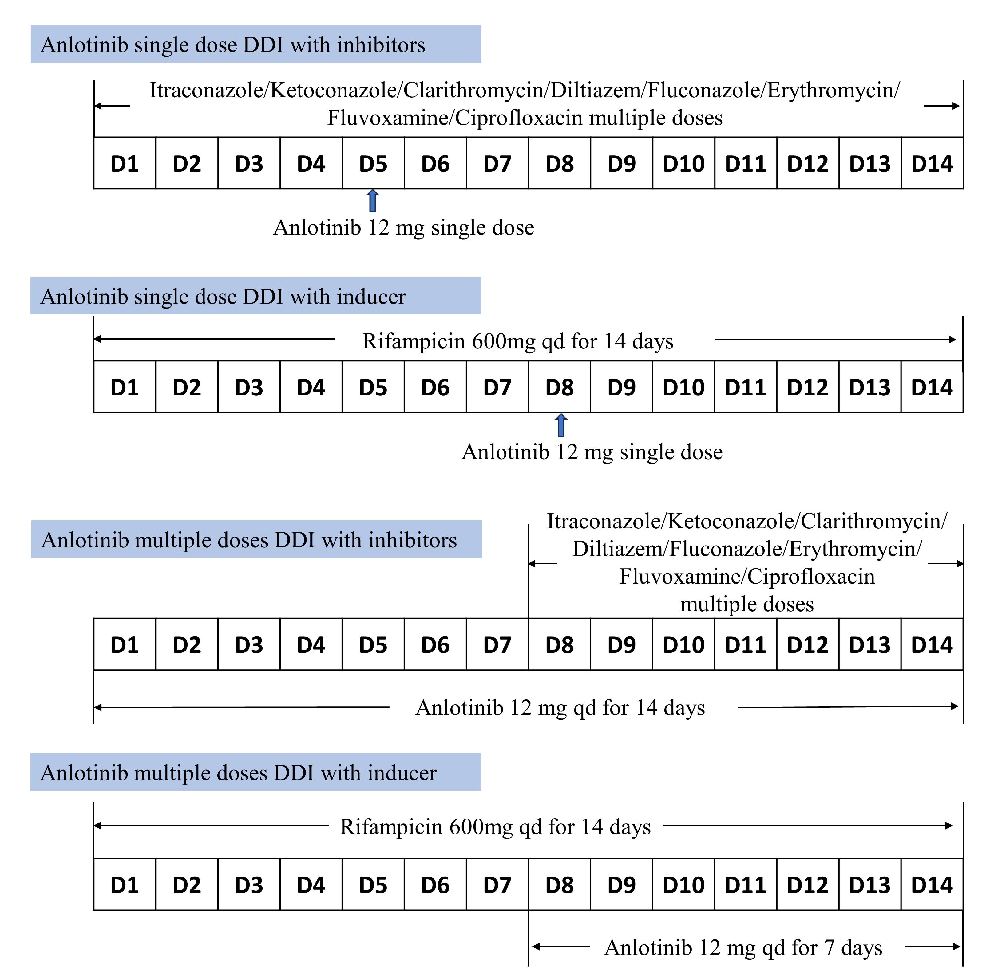
Figure S1. Co-administration regimens employed for predicting DDI between anlotinib and perpetrators.
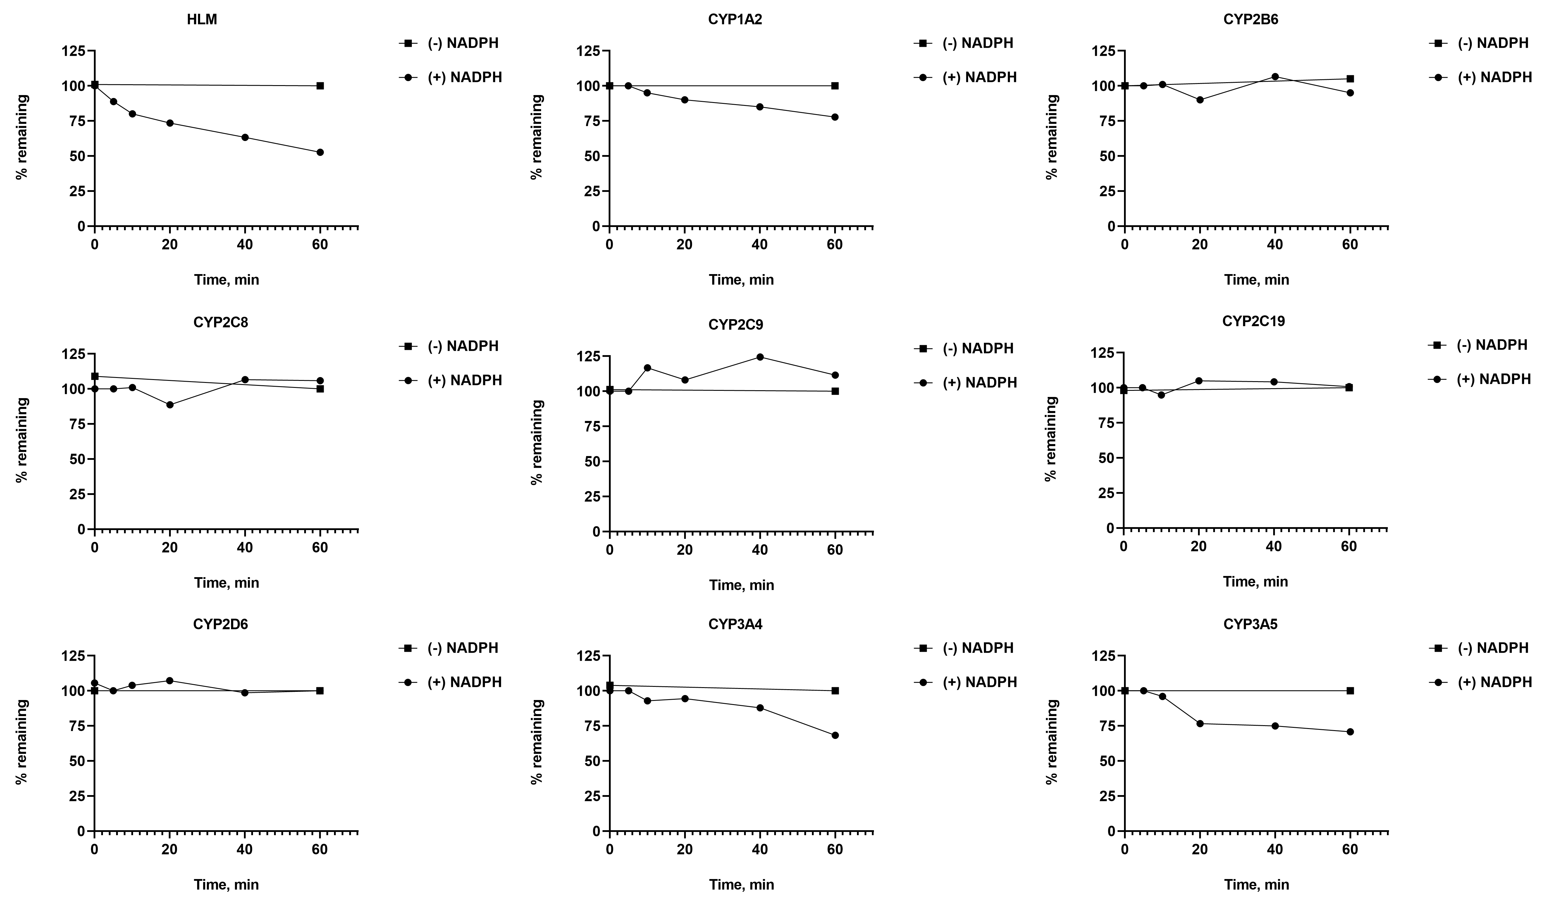
Figure S2. The metabolic stability of anlotinib in HLM and rhCYPs.

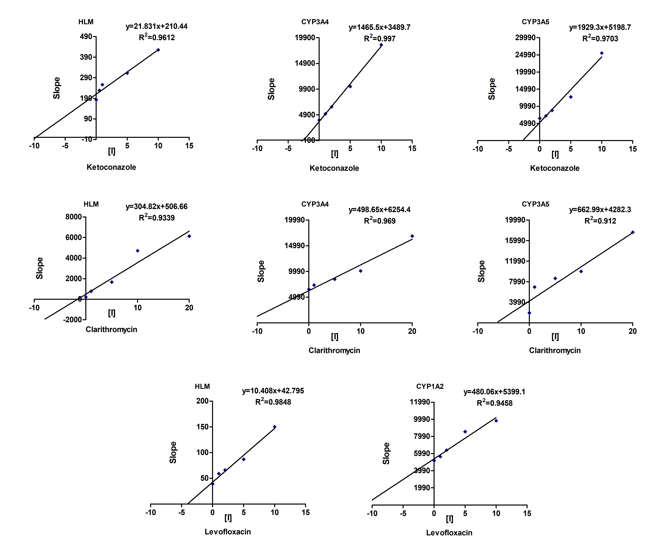
Figure S3. The linear regression analysis of the slope against the inhibitor concentration

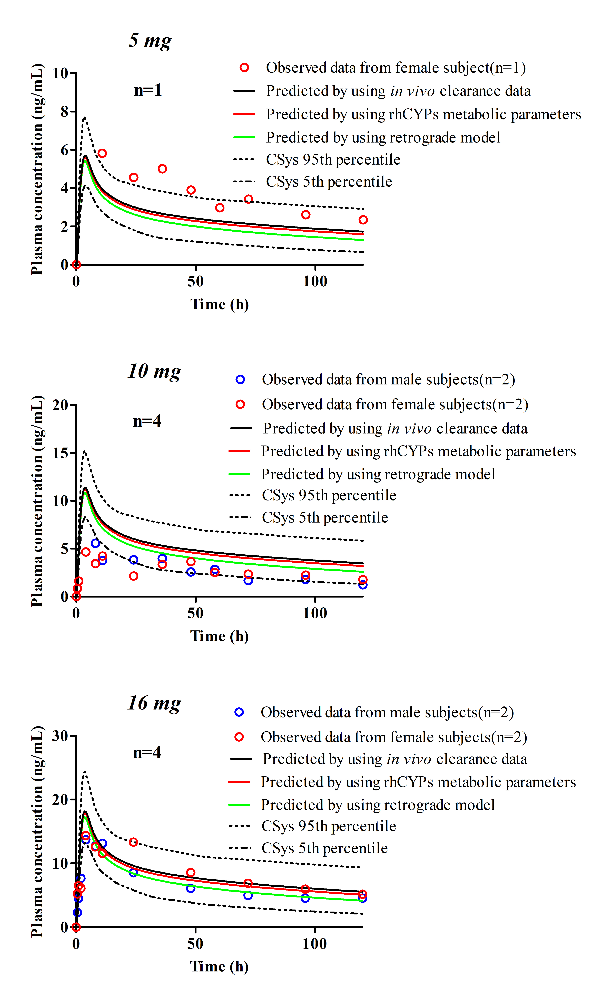
Figure S4. The validation of the anlotinib PBPK model was compared using three different methods, including in vivo, rhCYPs and retrograde techniques after 5mg, 10mg or 16mg single dose.

Figure S5. PBPK model-predicted plasma concentrations of anlotinib with and without (black lines) coadministration of strong CYP3A inhibitors in cancer patients using ISEF-approach. The PK profile of anlotinib coadministration with inhibitors with default K_{i} values (red line) and experimentally obtained K_{i} (blue line).

Reference
- Zhong CC, Chen F, Yang JL, et al. Pharmacokinetics and disposition of anlotinib, an oral tyrosine kinase inhibitor, in experimental animal species. Acta Pharmacol Sin. 2018;39(6):1048-1063. doi: 10.1038/aps.2017.199
- Jin Z, He Q, Zhu X, Zhu M, et al. Application of physiologically based pharmacokinetic modelling for the prediction of drug-drug interactions involving anlotinib as a perpetrator of cytochrome P450 enzymes. Basic Clin Pharmacol Toxicol. 2022;130(5):592-605. doi: 10.1111/bcpt.13721

