Deciphering the Prognostic and Therapeutic Value of a Gene Model Associated with Two Aggressive Hepatocellular Carcinoma Phenotypes Using Machine Learning

Junhan Pan^{1*}, Cong Zhang^{1, 2, 3*}, Huizhen Huang¹, Yanyan Zhu¹, Yuhao Zhang⁴, Shuzhen Wu¹, Yan-Ci Zhao¹, Feng Chen¹
- Department of Radiology, The First Affiliated Hospital, Zhejiang University School of Medicine, Hangzhou, China
- Hepatobiliary and Pancreatic Interventional Treatment Center, Division of Hepatobiliary and Pancreatic Surgery, The First Affiliated Hospital, Zhejiang University School of Medicine, Hangzhou, China.
- Zhejiang Provincial Key Laboratory of Pancreatic Disease, The First Affiliated Hospital, Zhejiang University School of Medicine, Hangzhou, China
- Department of Pathology, The First Affiliated Hospital, Zhejiang University School of Medicine, Hangzhou, China
*These authors contributed equally to this work.
Corresponding author: Feng Chen, Email: chenfenghz@zju.edu.cn.

Figure S1 Comparison of recurrence free survival between low-risk and high-risk patient groups in GSE14520 cohort.
Figure S2 Comparison of overall survival between low-risk and high-risk patient groups in the TCGA cohort, stratified by (A, E) age, (B, I) child-pugh grade, (C, G) tumor grade, (D, K) vascular invasion, (F, J) alpha-fetoprotein, and (H, L) clinical stage.
Figure S3 Comparison of disease-free interval between low-risk and high-risk patient groups in the TCGA cohort, stratified by (A, E) age, (B, I) child-pugh grade, (C, G) tumor grade, (D, K) vascular invasion, (F, J) alpha-fetoprotein, and (H, L) clinical stage.
Figure S4 Comparison of disease-specific survival between low-risk and high-risk patient groups in the TCGA cohort, stratified by (A, E) age, (B, I) child-pugh grade, (C, G) tumor grade, (D, K) vascular invasion, (F, J) alpha-fetoprotein, and (H, L) clinical stage.
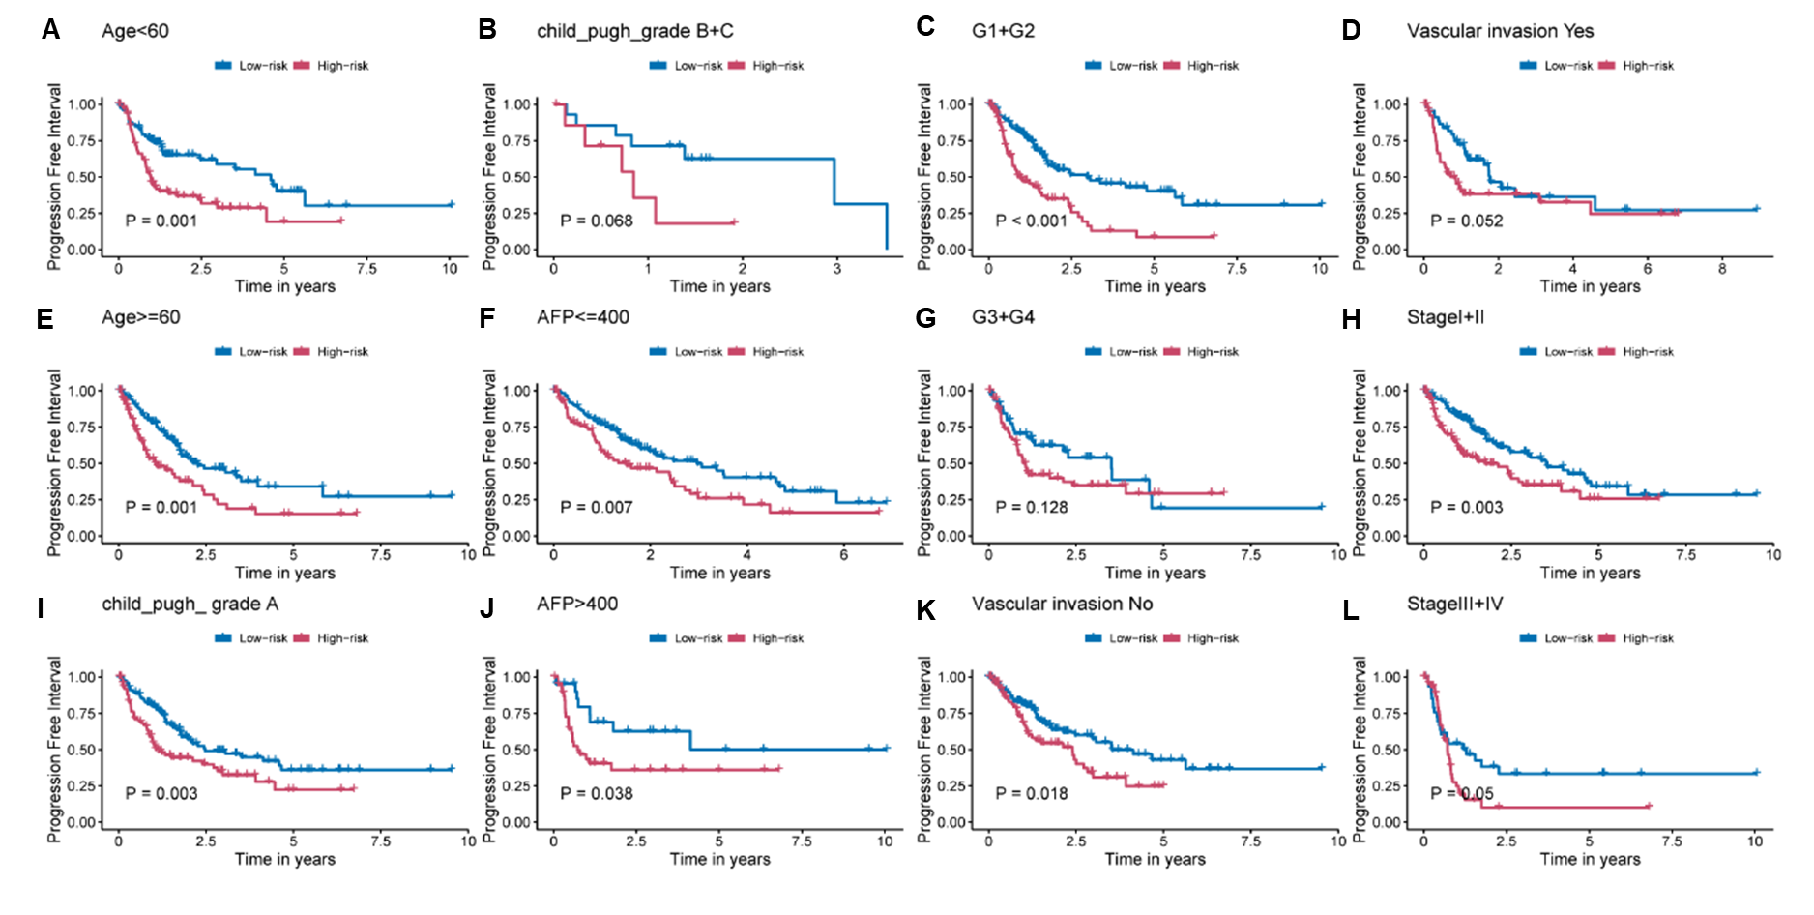

Figure S5 Comparison of progression-free interval between low-risk and high-risk patient group in the TCGA cohort, stratified by (A, E) age, (B, I) child-pugh grade, (C, G) tumor grade, (D, K) vascular invasion, (F, J) alpha-fetoprotein, and (H, L) clinical stage.

Figure S6 Comparison of overall survival between low-risk and high-risk patient groups in the ICGC-LIRI-JP cohort, stratified by (A, D) age, (B, E) gender, and (C, F) clinical stage.

Figure S7 Comparison of overall survival between low-risk and high-risk patient groups in the TCGA cohort, stratified by (A, E) age, (B, I) gender, (C, G) multinodular, (D, K) clinical stage, (F, J) main tumor size, and (H, L) BCLC staging.
Figure S8 Comparison of recurrence-free survival between low-risk and high-risk patient groups, stratified by (A, E) age, (B, I) gender, (C, G) multinodular, (D, K) clinical stage, (F, J) main tumor size, and (H, L) BCLC staging.

Table S1 Sample sizes of the six cohorts included in this study
Cohort name | Number of patients
TCGA-LIHC cohort | 363
ICGC-LIRI-JP cohort | 240
GSE14520 cohort | 242
GSE104580 cohort | 147
GSE109211 cohort | 67
FAHZU In-house cohort | 25

Table S2 Summary of coefficients, HR, 95% CI, and P value for model genes
Gene name | Coefficient | Hazard ratio (95% CI) | P-value
SLC41A3 | 0.46 | 1.6 (1.1-2.2) | 0.006
FNDC4 | 0.21 | 1.2 (1.1-1.4) | 0.002
NDRG1 | 0.11 | 1.1 (0.96-1.3) | 0.140
NOP56 | 0.31 | 1.4 (1-1.8) | 0.025

Table S3 Univariate and multivariate Cox analysis of overall survival in the TCGA-LIHC cohort

Variables | Univariate analysis |  |  | Multivariate analysis
Variables | HR (95% CI) | P-value |  | HR (95% CI) | P-value
Age (≥60 years vs. <60 years) | 1.21 (0.86, 1.72) | 0.281 |  | / | /
Child-Pugh grade (B-C vs. A) | 1.62 (0.80, 3.28) | 0.183 |  | / | /
AFP (>400 ng/ml vs. ≤400 ng/ml) | 1.06 (0.65, 1.73) | 0.832 |  | / | /
Grade (G3-G4 vs. G1-G2) | 1.12 (0.78, 1.61) | 0.540 |  | / | /
Vascular invasion (Yes vs. No) | 1.35 (0.89, 2.05) | 0.162 |  | / | /
Stage (Stage III-IV vs. Stage I-II) | 2.49 (1.71-3.61) | < 0.001 |  | 2.43 (1.67, 3.54) | < 0.001
Risk group (High vs. Low) | 3.00 (2.06-4.37) | < 0.001 |  | 2.94 (1.97, 4.38) | < 0.001
Abbreviations: AFP, Alpha-fetoprotein.

Table S4 Univariate and multivariate Cox analysis of overall survival in the GSE14520 cohort

Variables | Univariate analysis |  |  | Multivariate analysis
Variables | HR (95% CI) | P-value |  | HR (95% CI) | P-value
Gender (Male vs. Female) | 1.86 (0.90, 3.83) | 0.093 |  | / | /
Age (≥60 years vs. <60 years) | 0.84 (0.50, 1.41) | 0.512 |  | / | /
Main tumor size (>5cm vs. ≤5cm) | 1.96 (1.31, 2.93) | 0.001 |  | 1.04 (0.59, 1.84) | 0.893
Multinodular (Yes vs. No) | 1.65 (1.06, 2.93) | 0.025 |  | 0.50 (0.27, 0.94) | 0.032
Stage (Stage III vs. Stage I-II) | 3.64 (2.34, 5.65) | < 0.001 |  | 1.83 (0.87, 3.82) | 0.110
BCLC staging (B-C vs. 0-A) | 3.69 (2.38, 5.73) | < 0.001 |  | 3.47 (1.60, 7.51) | 0.002
Risk group (High vs. Low) | 1.94 (1.29, 2.92) | 0.002 |  | 1.64 (1.06, 2.55) | 0.027
Abbreviations: BCLC, Barcelona Clinic Liver Cancer.

Table S5 Univariate and multivariate Cox analysis of overall survival in the ICGC-LIRI-JP cohort
Variables | Univariate analysis |  |  | Multivariate analysis
Variables | HR (95% CI) | P-value |  | HR (95% CI) | P-value
Age (≥ 60 years vs. <60 years) | 0.87 (0.42, 1.81) | 0.711 |  | / | /
Gender (Male vs. Female) | 0.49 (0.26, 0.91) | 0.023 |  | 0.38 (0.20, 0.72) | 0.003
Stage (Stage III-IV vs. Stage I-II) | 2.26 (1.23, 4.12) | 0.008 |  | 2.45 (1.31, 4.58) | 0.005
Risk group (High vs. Low) | 2.18 (1.16, 4.09) | 0.015 |  | 2.03 (1.07, 3.86) | 0.029

Table S6 Comparison of clinical and pathological characteristics between the high-risk and low-risk groups in the in-house cohort
Characteristics | High-risk group  (n=12) | Low-risk group  (n=13) | P-value
Clinical characteristics
Age (years) | 60 (41-77) | 63 (37-81) | 0.413 *
Gender |  |  | 0.220
Male | 10 (83.3 %) | 13 (100 %)
Female | 2 (16.7 %) | 0 (0 %)
Hepatitis B virus infection |  |  | 0.645
Presence | 10 (83.3 %) | 9 (69.2 %)
Absent | 2 (16.7 %) | 4 (30.8 %)
Child-Pugh class |  |  | >0.999
A | 10 (83.3 %) | 11 (84.6 %)
B | 2 (16.7 %) | 2 (15.4 %)
BCLC stage |  |  | 0.593
0-A | 10 (83.3 %) | 12 (92.3 %)
B-C | 2 (16.7 %) | 1 (7.7 %)
Serum AFP (ng/ml) |  |  | < 0.001
≤ 400 | 3 (25 %) | 12 (92.3 %)
> 400 | 9 (75 %) | 1 (7.7 %)
Pathological characteristics
Edmondson grade |  |  | 0.066 #
I-II | 3 (25%) | 8 (61.5%)
III-IV | 9 (75%) | 5 (38.5%)
Cirrhosis |  |  | 0.320 #
Presence | 7 (58.3%) | 5 (38.5%)
Absent | 5 (41.7%) | 8 (61.5%)
Fibrosis capsule |  |  | 0.561 #
Presence | 6 (50%) | 8 (61.5%)
Absent | 6 (50%) | 5 (38.5%)
Microvascular invasion |  |  | 0.041
Presence | 10 (83.3%) | 5 (38.5%)
Absent | 2 (16.7%) | 8 (61.5%)
Satellite nodule |  |  | >0.999
Presence | 2 (16.7%) | 3 (23.1%)
Absent | 10 (83.3%) | 10 (76.9%)
Notes: *P-values are from the U test for continuous variables, #P-values from X² test, and other P-values from the Fisher's exact test for categorical variables.
Abbreviations: BCLC, Barcelona Clinic Liver Cancer; AFP, Alpha-fetoprotein.

Table S7 Comparison of imaging features between the high-risk and low-risk groups in the in-house cohort
Characteristics | High-risk group  (n=12) | Low-risk group  (n=13) | P-value
Lesion size >5.0 cm |  |  | 0.165#
Presence | 7 (58.3%) | 4 (30.8%)
Absent | 5 (41.7%) | 9 (69.2%)
Multifocal lesions |  |  | 0.593
Presence | 2 (16.7%) | 1 (7.7%)
Absent | 10 (83.3%) | 12 (92.3%)
Nonsmooth tumor margin |  |  | 0.041
Presence | 10 (83.3%) | 5 (38.5%)
Absent | 2 (16.7%) | 8 (61.5%)
Rim arterial phase hyperenhancement |  |  | 0.428
Presence | 6 (50.0%) | 4 (30.8%)
Absent | 6 (50.0%) | 9 (69.2%)
Intratumoral artery |  |  | 0.202
Presence | 10 (83.3%) | 7 (53.8%)
Absent | 2 (16.7%) | 6 (46.2%)
Corona enhancement |  |  | <0.001#
Presence | 10 (83.3%) | 2 (15.4%)
Absent | 2 (16.7%) | 11 (84.6%)
Mosaic architecture |  |  | 0.028 #
Presence | 8 (66.7%) | 3 (23.1%)
Absent | 4 (33.3%) | 10 (76.9%)
Incomplete “capsule” appearance |  |  | >0.999
Presence | 10 (83.3%) | 11 (84.6%)
Absent | 2 (16.7%) | 2 (15.4%)
Necrosis or serve ischemia |  |  | 0.073
Presence | 11 (91.7%) | 7 (53.8%)
Absent | 1 (8.3%) | 6 (46.2%)
Marked diffusion restriction |  |  | 0.688
Presence | 8 (66.7%) | 7 (53.8%)
Absent | 4 (33.3%) | 6 (46.2%)
Notes: #P-values from X² test, and other P-values from the Fisher's exact test for categorical variables.

