ORIGINAL RESEARCH
Jiayan Huang et al

An Injectable Hydrogel Bioimplant Loaded with Engineered Exosomes and Triple Anti-tuberculosis Drugs with Potential for Treating Bone and Joint Tuberculosis
Jiayan Huang^{1*}
Han Li^{2*}
Yuting Mei¹
Pengcheng Yi ¹
Yunyao Ren¹
Yunjuan Wang³
Limei Han¹
Qiusha Tang³
Dongfang Liu³
Wei Chen⁴
Yanli An⁵
Chunmei Hu¹

¹ Department of Tuberculosis, the Second Hospital of Nanjing, Affiliated to Nanjing University of Chinese Medicine, Nanjing, China; ² Central Hospital of Guangdong nongken, Zhanjiang, China; ³ Medical School of Southeast University, Nanjing, China; ⁴ Department of Clinical Research Center, The Second Hospital of Nanjing, Nanjing University of Chinese Medicine, Nanjing, China; ⁵ Jiangsu Key Laboratory of Molecular and Functional Imaging, Department of Radiology, Zhongda Hospital, Medical School of Southeast University, 87 Dingjiaqiao Road, Nanjing, China.
Jiayan Huang¹*
Han Li²*
*These authors contributed equally to this work

Correspondence: Chunmei Hu, Zhongfu Road 1-1, Yijiangmen Street, Nanjing, Jiangsu Province, 210009.
Email njyy003@njucm.edu.cn

Table S1 Primer sequences of each gene
Gene | Primer Sequence, 5’–3’
Gene | Forward | Reverse
OPN  Runx2  COL1A1  GAPDH  VEGF  ANG-1  HIF-1α | CGATGATGACGACGACGATGAC  TCGTCAGCGTCCTATCAGTTCC  CGAGTATGGAAGCGAAGGTT  ACAACTTTGGTATCGTGGAAGG  AGGGCAGAATCATCACGAAGT  AGCGCCGAAGTCCAGAAAAC  GAACGTCGAAAAGAAAAGTCTCG | CTTGTGTGCTGGCAGTGAAGG  CTTCCATCAGCGTCAACACCATC  CTTGAGGTTGCCAGTCTGTT  GCCATCACGCCACAGTTTC  AGGGTCTCGATTGGATGGCA  TACTCTCACGACAGTTGCCAT  CCTTATCAAGATGCGAACTCACA

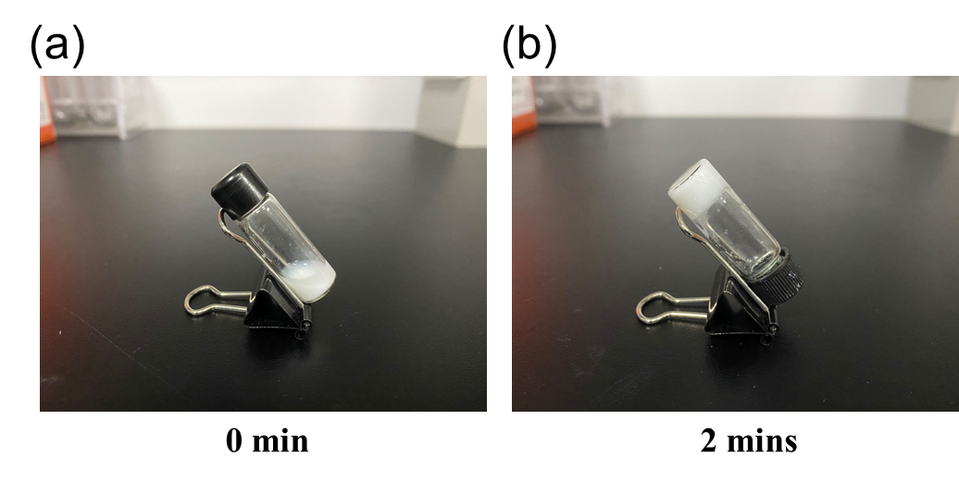
Figure S1. Inversion test of the hydrogels at different time points. (a) OHA₃/CMCS₃/HAP₈ mixture solution. (b) OHA₃/CMCS₃/HAP₈ hydrogel.

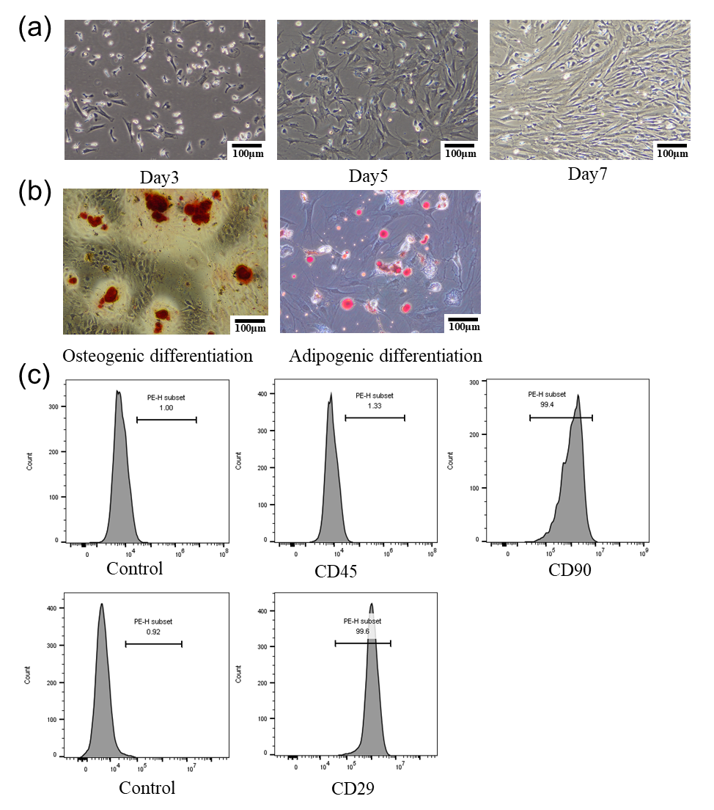

Figure S2. Identification of rBMSCs. (a) The morphology of BMSCs at 3days, 5days, 7days. (b) Adipogenic and osteogenic differentiation of rBMSCs. Osteogenic differentiation was shown by the left image. Adipogenic differentiation was shown by the right image. (c) The markers of rBMSCs were identified by flow cytometry.

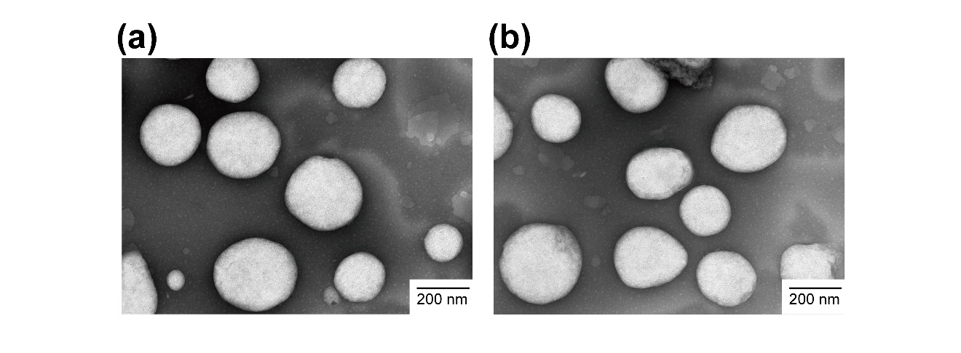
Figure S3 TEM images of liposomes. (a) INH-loaded liposomes; (b) PZA- loaded liposomes.

Table S2 AST and CK levels in serum of rat in each group
Project | Group | Time/Testing results |  |  |  |  | Reference ranges
 |  | 1w | 2w |  | 4w
AST (U/L) | Control | 108.54±15.09 |  |  |  |  | 41.47~195.65
AST (U/L) | Gel | 160.93±20.82 |  | 190.56±7.65 |  | 133.07±30.47 | 41.47~195.65
AST (U/L) | RFP/INH/PZA-Lipo Exo_{eng} Gel | 132.97±25.78 |  | 125.23±44.29 |  | 117.25±54.26 | 41.47~195.65
Cr  ($μmol/L$) | Control | 31.248±2.05 |  |  |  |  | 10.90~118.07
Cr  ($μmol/L$) | Gel | 30.06±0.51 |  | 36.37±2.99 |  | 36.05±3.69 | 10.90~118.07
Cr  ($μmol/L$) | RFP/INH/PZA-Lipo Exo_{eng} Gel | 33.09±0.69 |  | 34.49±2.35 |  | 39.74±4.58 | 10.90~118.07

