Supplemental Content
Title: Identifying the genetic associations between diabetes mellitus and the risk of vitiligo
Lingyun Zhao,^{1,2} Meng Hu³, Li Li^{1,2,3}
1. Supplemental Figure section
Figure S1. Forest plots for the associations of genetic susceptibility between DM and vitiligo using different Mendelian randomizations (The remaining negative results not shown in the text)
Figure S2. Visualization of the MR analysis of the effect of DM and its two subtypes on vitiligo.
Figure S3. Visualization of the MR analysis of the effect of vitiligo on DM and its two subtypes.
2. Supplemental Table section
Table S1. Detailed SNP information for the diabetes mellitus trait in vitiligo from UK Biobank.
Table S2. Detailed SNP information for the type 2 diabetes trait in vitiligo from UK Biobank.
Table S3. Detailed SNP information for the type 1 diabetes trait in vitiligo from UK Biobank.
Table S4. Detailed SNP information for the vitiligo trait in diabetes mellitus from GCST004785.
Table S5. Detailed SNP information for the vitiligo trait in type 1 diabetes from GCST004785.
Table S6. Detailed SNP information for the vitiligo trait in type 2 diabetes from GCST004785.

1. Supplemental Figure section
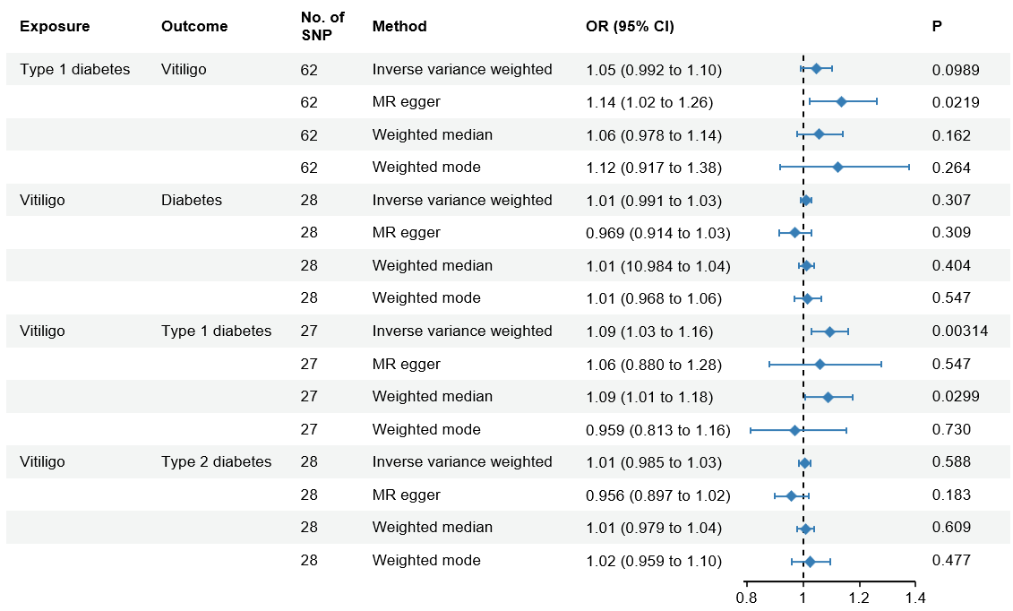
Figure S1. Forest plots for the associations of genetic susceptibility between DM and vitiligo using different MR. (The amounts of SNPs of type 1 diabetes are too small to complete the whole analyses as exposure, so we selected SNPs as IVs up to the genome-wide significance threshold (P < 5 × 10⁻⁵)). Abbreviations: SNPs, single nucleotide polymorphisms. DM, diabetes mellitus. MR, Mendelian randomization.
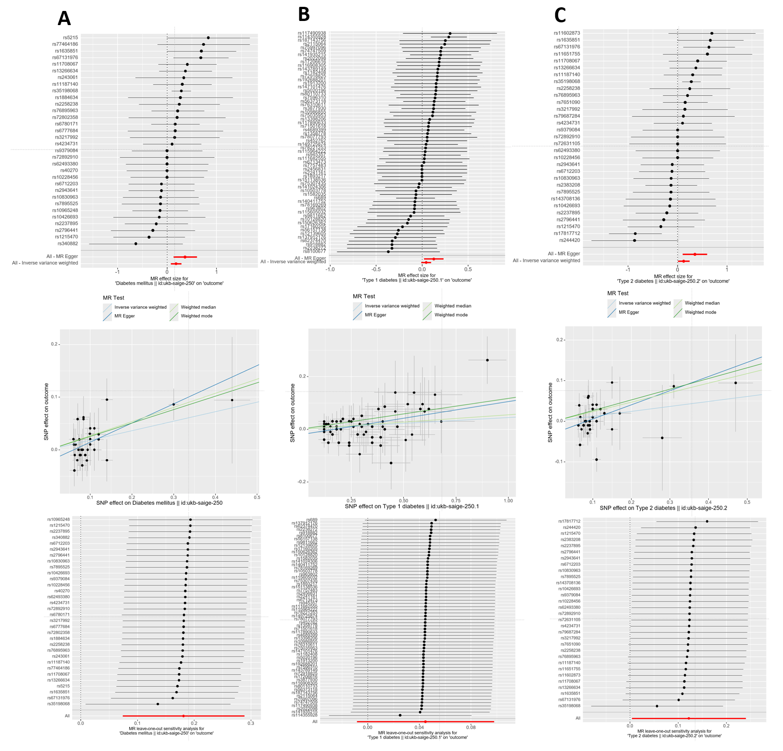
Figure S2. Visualization of the MR analysis of the effect of DM and its two subtypes on vitiligo. (A) Scatter plot of the primary MR analysis and leave-one-out sensitivity analysis of the effect of diabetes mellitus on vitiligo; (B) Scatter plot of the primary MR analysis and leave-one-out sensitivity analysis of the effect of type 1 diabetes on vitiligo. (C) Scatter plot of the primary MR analysis and leave-one-out sensitivity analysis of the effect of type 2 diabetes on vitiligo. Abbreviations: MR, Mendelian randomization. DM, diabetes mellitus. SNP, single- nucleotide polymorphism.
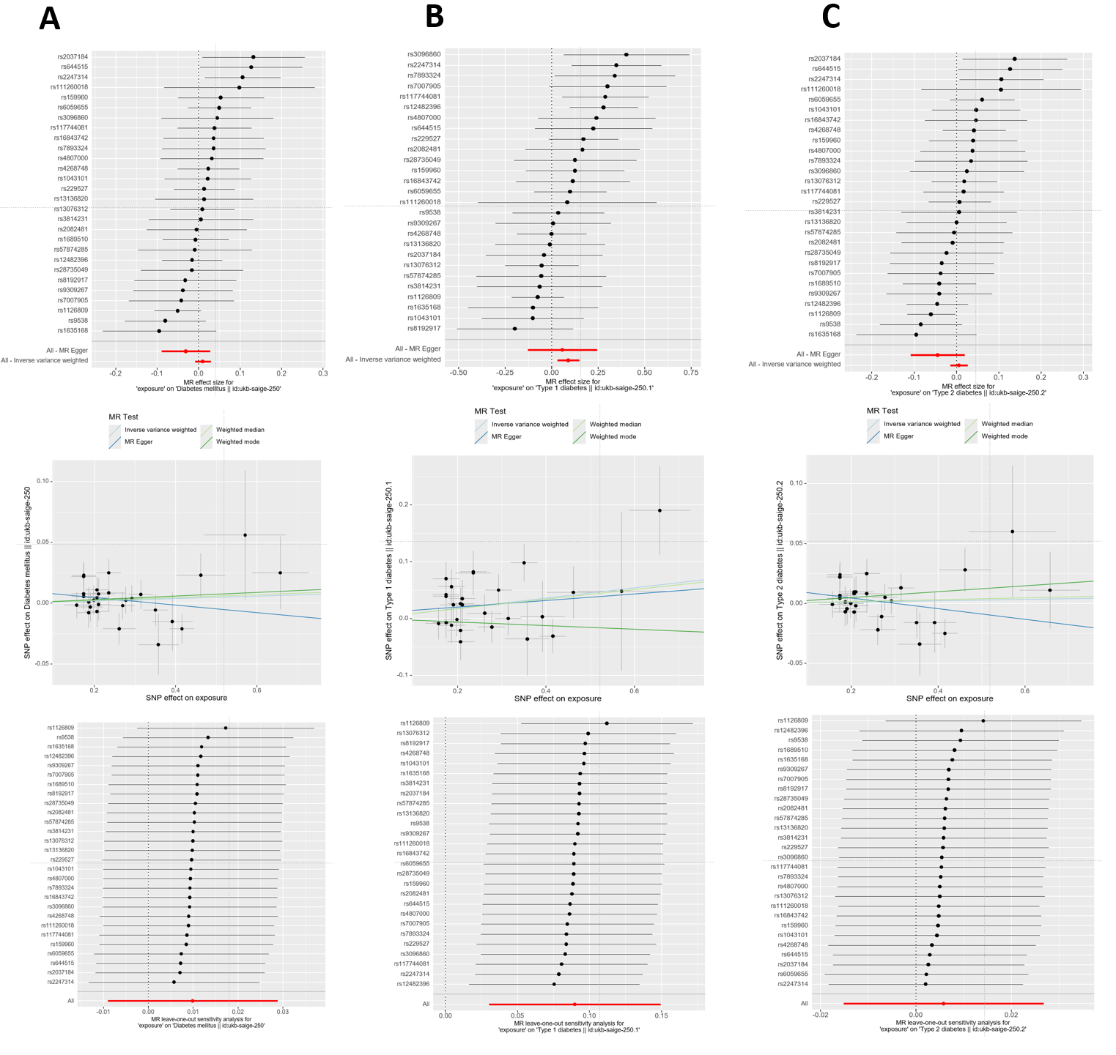
Figure S3. Visualization of the MR analysis of the effect of vitiligo on DM and its two subtypes. (A) Scatter plot of the primary MR analysis and leave-one-out sensitivity analysis of the effect of vitiligo on diabetes mellitus; (B) Scatter plot of the primary MR analysis and leave-one-out sensitivity analysis of the effect of vitiligo on type 1 diabetes. (C) Scatter plot of the primary MR analysis and leave-one-out sensitivity analysis of the effect of vitiligo on type 2 diabetes. Abbreviations: MR, Mendelian randomization. DM, diabetes mellitus. SNP, single- nucleotide polymorphism.

2. Supplemental Table section
Table S1. Detailed SNP information for the diabetes mellitus trait in vitiligo from UK Biobank.
SNP | Effect allele | Other allele | BETA | SE | EAF | Pval | F | Gene
rs10228456 | T | C | 0.079 | 0.011 | 0.55 | 4.10E-13 | 1267 | AGMO
rs10426693 | C | T | -0.063 | 0.011 | 0.44 | 8.70E-09 | 801 | EML2
rs10830963 | G | C | 0.077 | 0.012 | 0.28 | 1.40E-10 | 980 | MTNR1B
rs10965248 | C | T | -0.14 | 0.014 | 0.18 | 1.60E-23 | 2380 | DMRTA1
rs11187140 | A | G | -0.099 | 0.011 | 0.36 | 1.20E-18 | 1855 | Y_RNA,HHEX
rs11708067 | G | A | -0.1 | 0.013 | 0.25 | 6.30E-16 | 1539 | ADCY5
rs1215470 | C | T | -0.081 | 0.012 | 0.29 | 1.10E-11 | 1108 | SPRY2
rs13266634 | T | C | -0.11 | 0.012 | 0.31 | 3.10E-20 | 2128 | SLC30A8
rs1635851 | T | C | -0.084 | 0.011 | 0.58 | 1.60E-14 | 1411 | JAZF1
rs1884634 | T | G | 0.074 | 0.013 | 0.21 | 3.40E-08 | 744 | NA
rs2237895 | C | A | 0.092 | 0.011 | 0.42 | 2.40E-17 | 1693 | KCNQ1
rs2258238 | T | A | 0.12 | 0.018 | 0.11 | 6.60E-11 | 1156 | HMGA2
rs243061 | C | T | -0.06 | 0.011 | 0.41 | 4.00E-08 | 714 | NA
rs2796441 | A | G | -0.069 | 0.011 | 0.42 | 2.30E-10 | 951 | NA
rs2943641 | C | T | 0.088 | 0.011 | 0.65 | 6.80E-15 | 1446 | NYAP2
rs3217992 | T | C | 0.065 | 0.011 | 0.37 | 6.00E-09 | 807 | CDKN2B
rs340882 | G | C | 0.062 | 0.011 | 0.62 | 2.30E-08 | 742 | PROX1-AS1
rs35198068 | C | T | 0.3 | 0.012 | 0.29 | ＜1E-100 | 15740 | TCF7L2
rs40270 | C | A | 0.072 | 0.013 | 0.77 | 2.20E-08 | 752 | NA
rs4234731 | G | A | 0.1 | 0.011 | 0.59 | 1.60E-19 | 1988 | NA
rs5215 | T | C | -0.07 | 0.011 | 0.64 | 4.00E-10 | 925 | KCNJ11
rs62493380 | G | A | -0.094 | 0.016 | 0.13 | 8.00E-09 | 819 | NA
rs6712203 | T | C | -0.088 | 0.011 | 0.37 | 4.30E-15 | 1482 | COBLL1
rs67131976 | T | C | 0.14 | 0.014 | 0.17 | 1.60E-22 | 2275 | CDKAL1
rs6777684 | G | A | 0.061 | 0.011 | 0.61 | 3.70E-08 | 725 | NA
rs6780171 | A | T | 0.12 | 0.012 | 0.31 | 6.20E-26 | 2535 | IGF2BP2
rs72802358 | C | G | -0.1 | 0.018 | 0.1 | 4.70E-09 | 737 | CTRB1 CTRB2
rs72892910 | T | G | 0.082 | 0.014 | 0.17 | 1.00E-08 | 777 | TFAP2B
rs76895963 | G | T | -0.44 | 0.043 | 0.021 | 1.20E-23 | 3282 | CCND2
rs77464186 | C | A | -0.084 | 0.015 | 0.16 | 1.20E-08 | 777 | ARAP1
rs7895525 | C | T | 0.075 | 0.013 | 0.24 | 2.80E-09 | 841 | CDC123
rs9379084 | A | G | -0.11 | 0.017 | 0.12 | 3.30E-10 | 1048 | RREB1

Table S2. Detailed SNP information for the type 2 diabetes trait in vitiligo from UK Biobank.
SNP | Effect allele | Other_  allele | BETA | SE | EAF | Pval | F | Gene
rs10228456 | T | C | 0.082 | 0.011 | 0.55 | 3.20E-13 | 1362 | AGMO
rs10426693 | C | T | -0.063 | 0.011 | 0.44 | 1.90E-08 | 799 | EML2
rs10830963 | G | C | 0.077 | 0.012 | 0.28 | 7.00E-10 | 977 | MTNR1B
rs11187140 | A | G | -0.1 | 0.012 | 0.36 | 6.60E-19 | 1887 | Y_RNA,HHEX
rs11602873 | T | A | -0.089 | 0.015 | 0.16 | 5.40E-09 | 870 | ARAP1
rs11651755 | T | C | -0.065 | 0.011 | 0.51 | 6.90E-09 | 863 | HNF1B
rs11708067 | G | A | -0.1 | 0.013 | 0.25 | 3.80E-16 | 1535 | ADCY5
rs1215470 | C | T | -0.087 | 0.012 | 0.29 | 1.40E-12 | 1275 | SPRY2
rs13266634 | T | C | -0.11 | 0.012 | 0.31 | 9.10E-20 | 2121 | SLC30A8
rs143708136 | T | C | 0.28 | 0.051 | 0.013 | 2.30E-08 | 822 | SNX29
rs1635851 | T | C | -0.088 | 0.011 | 0.58 | 6.10E-15 | 1544 | JAZF1
rs17817712 | G | A | 0.11 | 0.011 | 0.39 | 9.60E-21 | 2361 | FTO
rs2237895 | C | A | 0.093 | 0.011 | 0.42 | 1.60E-16 | 1725 | KCNQ1
rs2258238 | T | A | 0.12 | 0.018 | 0.11 | 1.90E-10 | 1153 | HMGA2
rs2383208 | G | A | -0.15 | 0.015 | 0.18 | 4.40E-24 | 2726 | DMRTA1
rs244420 | G | T | -0.067 | 0.011 | 0.41 | 2.60E-09 | 887 | NFAT5
rs2796441 | A | G | -0.071 | 0.011 | 0.42 | 3.00E-10 | 1004 | NA
rs2943641 | C | T | 0.092 | 0.012 | 0.65 | 3.40E-15 | 1576 | NYAP2
rs3217992 | T | C | 0.068 | 0.012 | 0.37 | 4.50E-09 | 881 | CDKN2B
rs35198068 | C | T | 0.31 | 0.012 | 0.29 | ＜1E-100 | 16799 | TCF7L2
rs4234731 | G | A | 0.1 | 0.011 | 0.59 | 4.30E-19 | 1982 | NA
rs62493380 | G | A | -0.092 | 0.017 | 0.13 | 4.70E-08 | 782 | NA
rs6712203 | T | C | -0.088 | 0.012 | 0.37 | 2.90E-14 | 1477 | COBLL1
rs67131976 | T | C | 0.15 | 0.015 | 0.17 | 7.00E-25 | 2605 | CDKAL1
rs72631105 | A | G | 0.08 | 0.014 | 0.18 | 2.30E-08 | 772 | NA
rs72892910 | T | G | 0.083 | 0.015 | 0.17 | 1.90E-08 | 794 | TFAP2B
rs7651090 | G | A | 0.13 | 0.012 | 0.31 | 6.00E-28 | 2969 | IGF2BP2
rs76895963 | G | T | -0.47 | 0.045 | 0.021 | 3.90E-25 | 3737 | CCND2
rs7895525 | C | T | 0.076 | 0.013 | 0.24 | 6.20E-09 | 861 | CDC123
rs79687284 | C | G | 0.17 | 0.03 | 0.035 | 2.10E-08 | 797 | NA
rs9379084 | A | G | -0.11 | 0.018 | 0.12 | 1.40E-09 | 1045 | RREB1

Table S3. Detailed SNP information for the type 1 diabetes trait in vitiligo from UK Biobank.
SNP | Effect allele | Other allele | BETA | EAF | SE | Pval | F
rs10128820 | T | C | 0.35 | 0.035 | 0.077 | 6.40E-06 | 3266
rs10503778 | G | A | 0.31 | 0.047 | 0.067 | 4.40E-06 | 3399
rs10986855 | A | G | 0.25 | 0.067 | 0.056 | 1.20E-05 | 3083
rs111682555 | C | T | 0.4 | 0.022 | 0.096 | 3.60E-05 | 2714
rs114355928 | T | G | 0.9 | 0.029 | 0.091 | 5.10E-23 | 18709
rs115605032 | T | C | 0.35 | 0.032 | 0.08 | 1.20E-05 | 2993
rs115964222 | C | T | 0.3 | 0.04 | 0.072 | 3.10E-05 | 2724
rs116908305 | A | G | 0.52 | 0.014 | 0.12 | 2.10E-05 | 2944
rs117490938 | T | C | 0.46 | 0.022 | 0.1 | 7.00E-06 | 3597
rs117890633 | C | T | 0.4 | 0.021 | 0.099 | 4.80E-05 | 2592
rs1182408 | T | C | 0.12 | 0.49 | 0.028 | 9.00E-06 | 2837
rs12139605 | C | G | 0.19 | 0.11 | 0.045 | 3.30E-05 | 2786
rs13398206 | C | T | 0.12 | 0.31 | 0.03 | 3.80E-05 | 2426
rs1358778 | T | C | 0.33 | 0.035 | 0.077 | 2.30E-05 | 2901
rs137912176 | A | G | 0.44 | 0.026 | 0.092 | 1.50E-06 | 3876
rs140411752 | G | A | 0.39 | 0.025 | 0.095 | 5.00E-05 | 2924
rs141024306 | C | T | 0.54 | 0.017 | 0.11 | 1.50E-06 | 3852
rs141935215 | A | G | 0.65 | 0.014 | 0.13 | 6.80E-07 | 4619
rs143789149 | A | G | -0.3 | 0.05 | 0.066 | 4.90E-06 | 3375
rs147101476 | A | G | -0.2 | 0.1 | 0.046 | 8.40E-06 | 2839
rs149725874 | A | G | 0.68 | 0.0094 | 0.16 | 2.80E-05 | 3400
rs150626362 | T | C | 0.39 | 0.025 | 0.091 | 1.70E-05 | 2924
rs151138536 | A | G | 0.41 | 0.025 | 0.095 | 1.20E-05 | 3234
rs1582035 | C | A | -0.15 | 0.35 | 0.029 | 1.90E-07 | 4049
rs17160205 | A | G | 0.24 | 0.06 | 0.059 | 3.20E-05 | 2560
rs17206616 | C | G | 0.21 | 0.09 | 0.049 | 1.50E-05 | 2848
rs187143756 | A | G | -0.55 | 0.013 | 0.13 | 4.00E-05 | 3062
rs1893217 | G | A | 0.18 | 0.17 | 0.037 | 1.70E-06 | 3612
rs1913200 | G | A | -0.13 | 0.54 | 0.028 | 6.70E-06 | 3314
rs192688201 | A | T | 0.59 | 0.012 | 0.14 | 2.10E-05 | 3258
rs2022098 | C | A | -0.16 | 0.25 | 0.032 | 7.30E-07 | 3794
rs2115064 | A | G | -0.12 | 0.57 | 0.028 | 2.60E-05 | 2783
rs2238272 | T | G | 0.12 | 0.51 | 0.028 | 1.60E-05 | 2837
rs2241161 | A | C | -0.12 | 0.41 | 0.028 | 3.30E-05 | 2746
rs2456831 | G | A | 0.2 | 0.89 | 0.045 | 6.70E-06 | 3090
rs3877930 | G | A | 0.62 | 0.014 | 0.12 | 6.40E-07 | 4198
rs452762 | C | T | 0.18 | 0.13 | 0.042 | 1.50E-05 | 2890
rs4689399 | T | C | 0.15 | 0.52 | 0.028 | 1.10E-07 | 4446
rs5020196 | A | C | 0.26 | 0.055 | 0.061 | 1.80E-05 | 2770
rs56157138 | T | C | 0.24 | 0.061 | 0.058 | 2.90E-05 | 2600
rs56373118 | C | T | 0.58 | 0.011 | 0.14 | 4.70E-05 | 2886
rs62374470 | T | C | 0.29 | 0.049 | 0.066 | 9.90E-06 | 3092
rs6713473 | G | A | 0.47 | 0.017 | 0.11 | 2.40E-05 | 2911
rs689 | T | A | 0.28 | 0.71 | 0.031 | 8.10E-20 | 13058
rs71501618 | A | G | 0.29 | 0.042 | 0.07 | 3.00E-05 | 2667
rs72918825 | C | A | 0.18 | 0.12 | 0.043 | 1.50E-05 | 2697
rs74747509 | T | C | 0.38 | 0.029 | 0.084 | 5.10E-06 | 3209
rs75035953 | C | T | 0.6 | 0.013 | 0.13 | 5.30E-06 | 3650
rs75307435 | G | T | 0.32 | 0.042 | 0.071 | 8.70E-06 | 3252
rs7596310 | T | C | 0.14 | 0.23 | 0.033 | 1.90E-05 | 2736
rs75997096 | C | T | 0.41 | 0.024 | 0.094 | 1.30E-05 | 3107
rs76310611 | A | C | -0.24 | 0.065 | 0.057 | 3.00E-05 | 2760
rs7757483 | A | G | 0.12 | 0.49 | 0.028 | 2.80E-05 | 2837
rs78077793 | G | A | 0.18 | 0.14 | 0.04 | 7.20E-06 | 3078
rs78169269 | A | G | 0.51 | 0.023 | 0.097 | 2.10E-07 | 4630
rs78221253 | T | G | 0.26 | 0.055 | 0.062 | 3.80E-05 | 2770
rs80110733 | C | T | 0.46 | 0.02 | 0.1 | 6.00E-06 | 3274
rs8100677 | C | T | -0.14 | 0.8 | 0.035 | 4.30E-05 | 2470
rs918882 | T | C | -0.12 | 0.47 | 0.028 | 4.20E-05 | 2828
rs945357 | G | A | 0.35 | 0.032 | 0.082 | 2.10E-05 | 2993
rs963802 | C | T | -0.12 | 0.39 | 0.029 | 1.50E-05 | 2700
rs9811662 | A | G | -0.16 | 0.3 | 0.03 | 1.30E-07 | 4254

Table S4. Detailed SNP information for the vitiligo trait in diabetes mellitus from GCST004785.
SNP | Effect allele | Other allele | BETA | EAF | Pval | SE | F
rs1043101 | G | A | 0.207014 | 0.4 | 2.54E-13 | 0.03 | 930
rs111260018 | A | G | 0.57098 | 0.01 | 9.67E-09 | 0.1 | 288
rs1126809 | A | G | -0.41552 | 0.27 | 5.02E-32 | 0.03 | 3233
rs117744081 | G | A | 0.65752 | 0.03 | 1.62E-21 | 0.07 | 1143
rs12482396 | T | A | 0.350657 | 0.22 | 8.12E-29 | 0.03 | 1950
rs13076312 | T | C | 0.277632 | 0.46 | 4.63E-22 | 0.03 | 1762
rs13136820 | C | T | 0.198851 | 0.33 | 1.72E-11 | 0.03 | 788
rs159960 | A | G | 0.207014 | 0.48 | 8.08E-13 | 0.03 | 968
rs1635168 | A | C | 0.357674 | 0.07 | 6.97E-13 | 0.05 | 750
rs16843742 | C | T | -0.21072 | 0.23 | 6.11E-09 | 0.04 | 707
rs1689510 | C | G | 0.270027 | 0.33 | 5.68E-20 | 0.03 | 1475
rs2037184 | C | T | -0.17435 | 0.43 | 4.24E-09 | 0.03 | 670
rs2082481 | A | G | -0.21072 | 0.24 | 3.27E-09 | 0.03 | 729
rs2247314 | C | T | -0.23572 | 0.33 | 1.30E-13 | 0.03 | 1115
rs229527 | A | C | 0.29267 | 0.43 | 1.40E-24 | 0.03 | 1940
rs28735049 | A | T | 0.19062 | 0.26 | 7.45E-10 | 0.03 | 628
rs3096860 | C | T | 0.173953 | 0.32 | 1.02E-08 | 0.03 | 591
rs3814231 | T | C | -0.18633 | 0.26 | 1.71E-08 | 0.03 | 599
rs4268748 | C | T | -0.31471 | 0.27 | 1.23E-20 | 0.03 | 1798
rs4807000 | A | G | 0.173953 | 0.39 | 1.58E-09 | 0.03 | 647
rs57874285 | A | C | 0.157004 | 0.4 | 4.56E-08 | 0.03 | 530
rs6059655 | A | G | -0.46204 | 0.08 | 3.58E-13 | 0.06 | 1436
rs644515 | A | G | 0.173953 | 0.41 | 1.15E-09 | 0.03 | 658
rs7007905 | G | C | -0.18633 | 0.29 | 7.28E-09 | 0.03 | 642
rs7893324 | C | T | -0.23572 | 0.14 | 4.61E-08 | 0.04 | 600
rs8192917 | C | T | 0.207014 | 0.24 | 1.37E-10 | 0.03 | 703
rs9309267 | T | C | 0.392042 | 0.05 | 5.46E-13 | 0.05 | 656
rs9538 | T | G | -0.26136 | 0.22 | 7.81E-13 | 0.04 | 1063

Table S5. Detailed SNP information for the vitiligo trait in type 1 diabetes from GCST004785.
SNP | Effect allele | Other allele | BETA | EAF | Pval | SE | F
rs1043101 | G | A | 0.207014 | 0.4 | 2.54E-13 | 0.03 | 930
rs111260018 | A | G | 0.57098 | 0.01 | 9.67E-09 | 0.1 | 288
rs1126809 | A | G | -0.41552 | 0.27 | 5.02E-32 | 0.03 | 3233
rs117744081 | G | A | 0.65752 | 0.03 | 1.62E-21 | 0.07 | 1143
rs12482396 | T | A | 0.350657 | 0.22 | 8.12E-29 | 0.03 | 1950
rs13076312 | T | C | 0.277632 | 0.46 | 4.63E-22 | 0.03 | 1762
rs13136820 | C | T | 0.198851 | 0.33 | 1.72E-11 | 0.03 | 788
rs159960 | A | G | 0.207014 | 0.48 | 8.08E-13 | 0.03 | 968
rs1635168 | A | C | 0.357674 | 0.07 | 6.97E-13 | 0.05 | 750
rs16843742 | C | T | -0.21072 | 0.23 | 6.11E-09 | 0.04 | 707
rs2037184 | C | T | -0.17435 | 0.43 | 4.24E-09 | 0.03 | 670
rs2082481 | A | G | -0.21072 | 0.24 | 3.27E-09 | 0.03 | 729
rs2247314 | C | T | -0.23572 | 0.33 | 1.30E-13 | 0.03 | 1115
rs229527 | A | C | 0.29267 | 0.43 | 1.40E-24 | 0.03 | 1940
rs28735049 | A | T | 0.19062 | 0.26 | 7.45E-10 | 0.03 | 628
rs3096860 | C | T | 0.173953 | 0.32 | 1.02E-08 | 0.03 | 591
rs3814231 | T | C | -0.18633 | 0.26 | 1.71E-08 | 0.03 | 599
rs4268748 | C | T | -0.31471 | 0.27 | 1.23E-20 | 0.03 | 1798
rs4807000 | A | G | 0.173953 | 0.39 | 1.58E-09 | 0.03 | 647
rs57874285 | A | C | 0.157004 | 0.4 | 4.56E-08 | 0.03 | 530
rs6059655 | A | G | -0.46204 | 0.08 | 3.58E-13 | 0.06 | 1436
rs644515 | A | G | 0.173953 | 0.41 | 1.15E-09 | 0.03 | 658
rs7007905 | G | C | -0.18633 | 0.29 | 7.28E-09 | 0.03 | 642
rs7893324 | C | T | -0.23572 | 0.14 | 4.61E-08 | 0.04 | 600
rs8192917 | C | T | 0.207014 | 0.24 | 1.37E-10 | 0.03 | 703
rs9309267 | T | C | 0.392042 | 0.05 | 5.46E-13 | 0.05 | 656
rs9538 | T | G | -0.26136 | 0.22 | 7.81E-13 | 0.04 | 1063

Table S6. Detailed SNP information for the vitiligo trait in type 2 diabetes from GCST004785.
SNP | Effect allele | Other allele | BETA | EAF | Pval | SE | F
rs1043101 | G | A | 0.207014 | 0.4 | 2.54E-13 | 0.03 | 930
rs111260018 | A | G | 0.57098 | 0.01 | 9.67E-09 | 0.1 | 288
rs1126809 | A | G | -0.41552 | 0.27 | 5.02E-32 | 0.03 | 3233
rs117744081 | G | A | 0.65752 | 0.03 | 1.62E-21 | 0.07 | 1143
rs12482396 | T | A | 0.350657 | 0.22 | 8.12E-29 | 0.03 | 1950
rs13076312 | T | C | 0.277632 | 0.46 | 4.63E-22 | 0.03 | 1762
rs13136820 | C | T | 0.198851 | 0.33 | 1.72E-11 | 0.03 | 788
rs159960 | A | G | 0.207014 | 0.48 | 8.08E-13 | 0.03 | 968
rs1635168 | A | C | 0.357674 | 0.07 | 6.97E-13 | 0.05 | 750
rs16843742 | C | T | -0.21072 | 0.23 | 6.11E-09 | 0.04 | 707
rs1689510 | C | G | 0.270027 | 0.33 | 5.68E-20 | 0.03 | 1475
rs2037184 | C | T | -0.17435 | 0.43 | 4.24E-09 | 0.03 | 670
rs2082481 | A | G | -0.21072 | 0.24 | 3.27E-09 | 0.03 | 729
rs2247314 | C | T | -0.23572 | 0.33 | 1.30E-13 | 0.03 | 1115
rs229527 | A | C | 0.29267 | 0.43 | 1.40E-24 | 0.03 | 1940
rs28735049 | A | T | 0.19062 | 0.26 | 7.45E-10 | 0.03 | 628
rs3096860 | C | T | 0.173953 | 0.32 | 1.02E-08 | 0.03 | 591
rs3814231 | T | C | -0.18633 | 0.26 | 1.71E-08 | 0.03 | 599
rs4268748 | C | T | -0.31471 | 0.27 | 1.23E-20 | 0.03 | 1798
rs4807000 | A | G | 0.173953 | 0.39 | 1.58E-09 | 0.03 | 647
rs57874285 | A | C | 0.157004 | 0.4 | 4.56E-08 | 0.03 | 530
rs6059655 | A | G | -0.46204 | 0.08 | 3.58E-13 | 0.06 | 1436
rs644515 | A | G | 0.173953 | 0.41 | 1.15E-09 | 0.03 | 658
rs7007905 | G | C | -0.18633 | 0.29 | 7.28E-09 | 0.03 | 642
rs7893324 | C | T | -0.23572 | 0.14 | 4.61E-08 | 0.04 | 600
rs8192917 | C | T | 0.207014 | 0.24 | 1.37E-10 | 0.03 | 703
rs9309267 | T | C | 0.392042 | 0.05 | 5.46E-13 | 0.05 | 656
rs9538 | T | G | -0.26136 | 0.22 | 7.81E-13 | 0.04 | 1063

