Supplementary Information

Hybrid Biosilica Nanoparticles for In-vivo Targeted Inhibition of Colorectal Cancer Growth and Label-free Imaging

Donatella Delle Cave 1‡, Maria Mangini 2‡, Chiara Tramontano 3†‡, Luca De Stefano 3, Marco Corona 1, Ilaria Rea 3*, Anna Chiara De Luca 2*, Enza Lonardo 1#

1 National Research Council, Institute of Genetics and Biophysics, Naples 80131, Italy
2 National Research Council, Institute for Experimental Endocrinology and Oncology “G. Salvatore”, Second Unit, Naples 80131, Italy
3 National Research Council, Institute of Applied Sciences and Intelligent Systems, Unit of Naples, Naples 80131, Italy

‡These authors contributed equally to the work.
# Last author

†Current address: Internal Medicine Department, Radboud University Medical Center, The Netherlands

Corresponding Authors
*Ilaria Rea - ilaria.rea@na.isasi.cnr.it; https://orcid.org/0000-0003-0568-9911
*Anna Chiara De Luca - annachiara.deluca@cnr.it; https://orcid.org/0000-0002-3696-8465

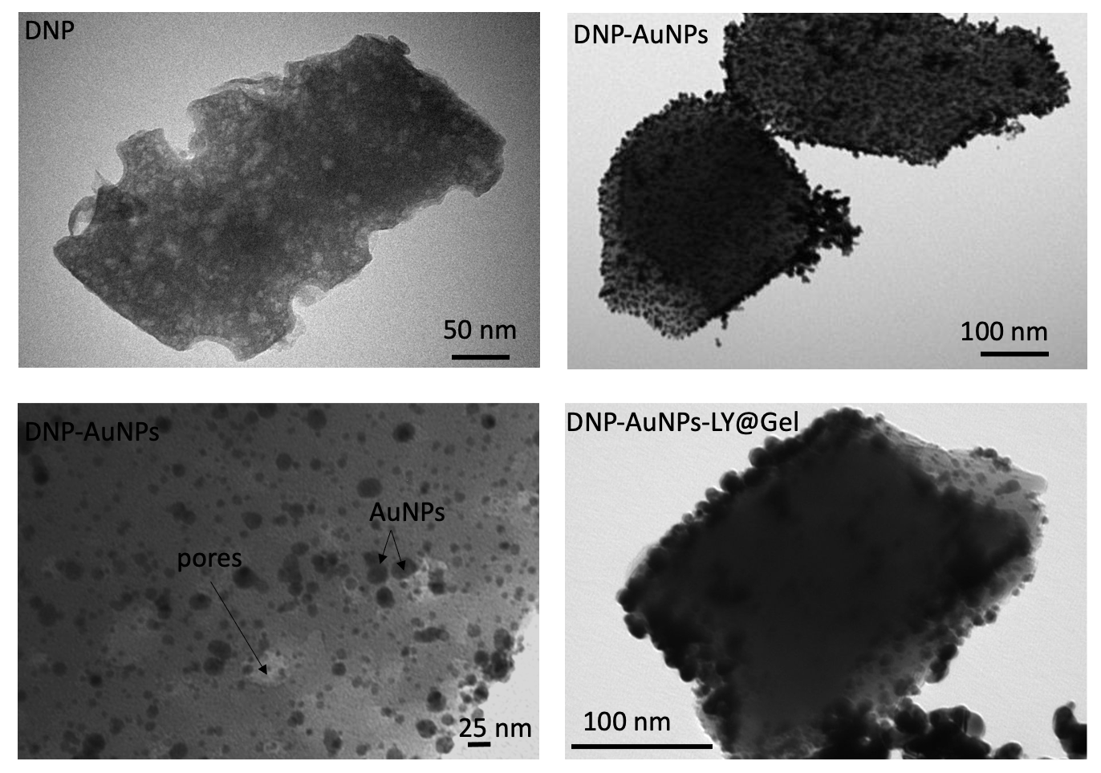

Figure S1. TEM images of the bare DNPs, DNPs-AuNPs, and DNPs-AuNPs-LY@Gel.

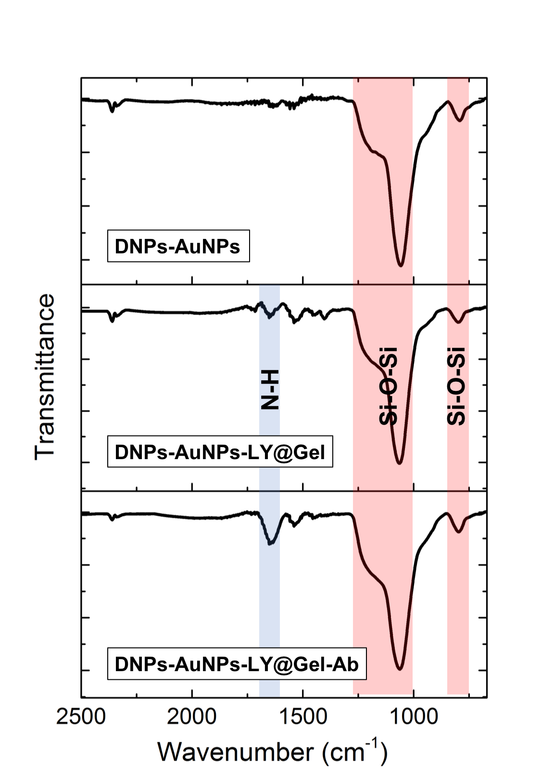
Figure S2. FTIR spectra of DNPs-AuNPs, DNPs-AuNPs-LY@Gel, and DNPs-AuNPs-LY@Gel-Ab.
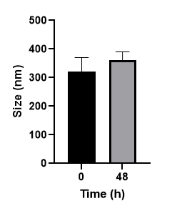
Figure S3. Size of DNPs-AuNPs-LY@Gel in DMEM at time 0 h and after 48 h. In a multiwell (24 wells), 20 µg/mL of DNPs-AuNPs-LY@Gel were added to 1 mL of DMEM. The DLS measurements were performed at time 0 and after 48 hours (h) of incubation in a sterile cell incubator at 37°C without stirring, to simulate the in-cell conditions. Measurements are presented as mean ± SDs on 3 replicates for each condition and each replicate has been measured 9 times.

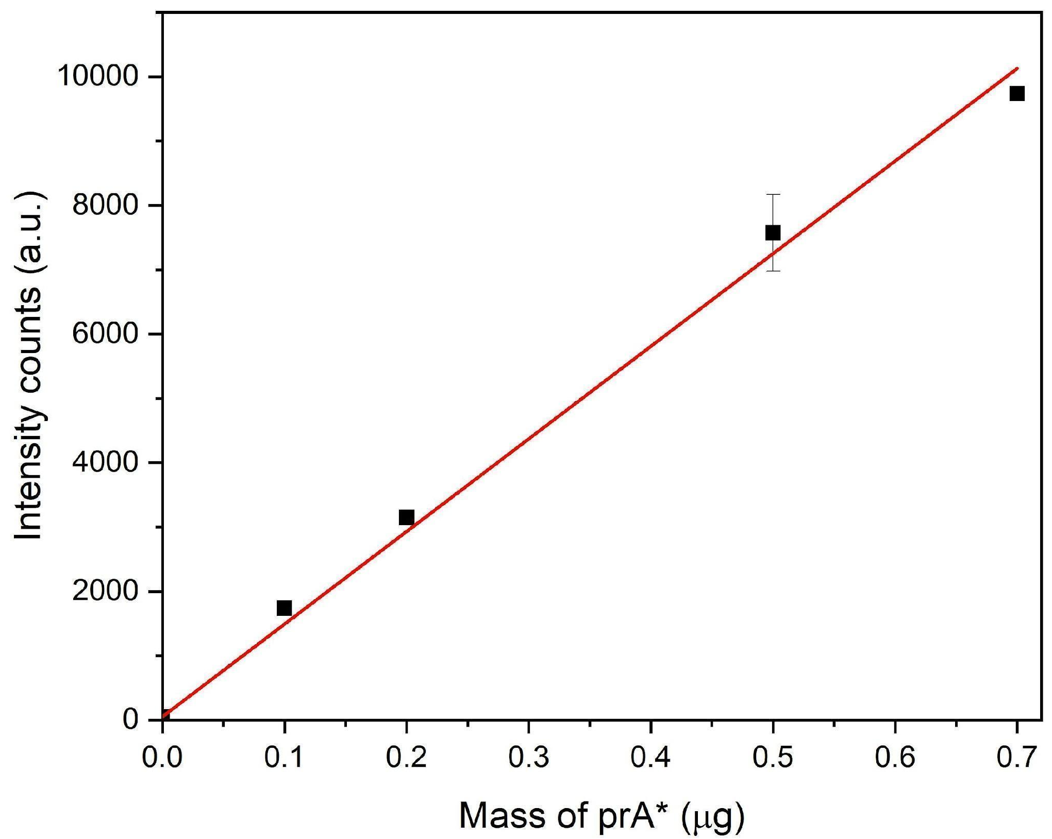

Figure S4. The FITC-labeled PrA (PrA*) titration curve was performed at 488 nm excitation wavelength in the range of PrA* mass included between 0 and 0.7 µg. The mass of PrA* (x-axis) is plotted against fluorescence emission (y-axis) and a direct proportionality is obtained. The R-square=0.995 was obtained from three independent experiments.

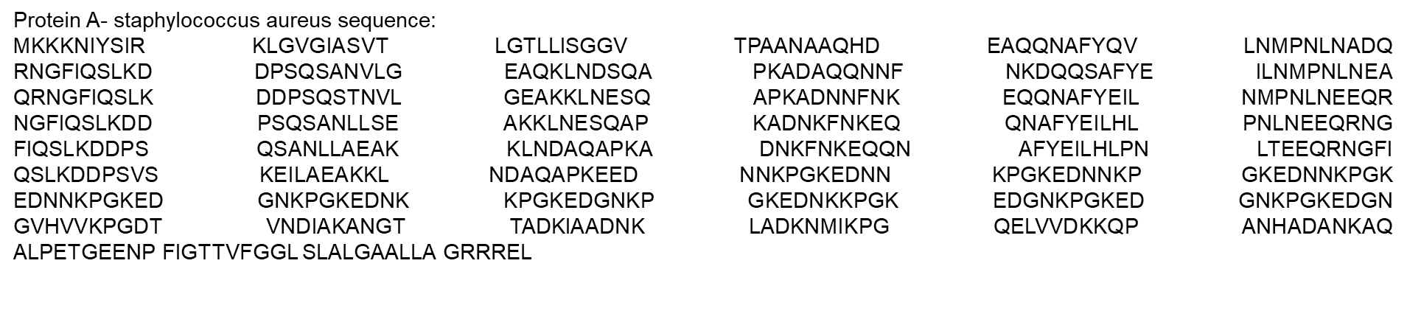

Figure S5. Sequence of the protein- a staphylococcus aureus conjugated to the gelatin shell on the DNPs-AuNPs-LY@Gel to enhance the antibody functionalization efficiency.

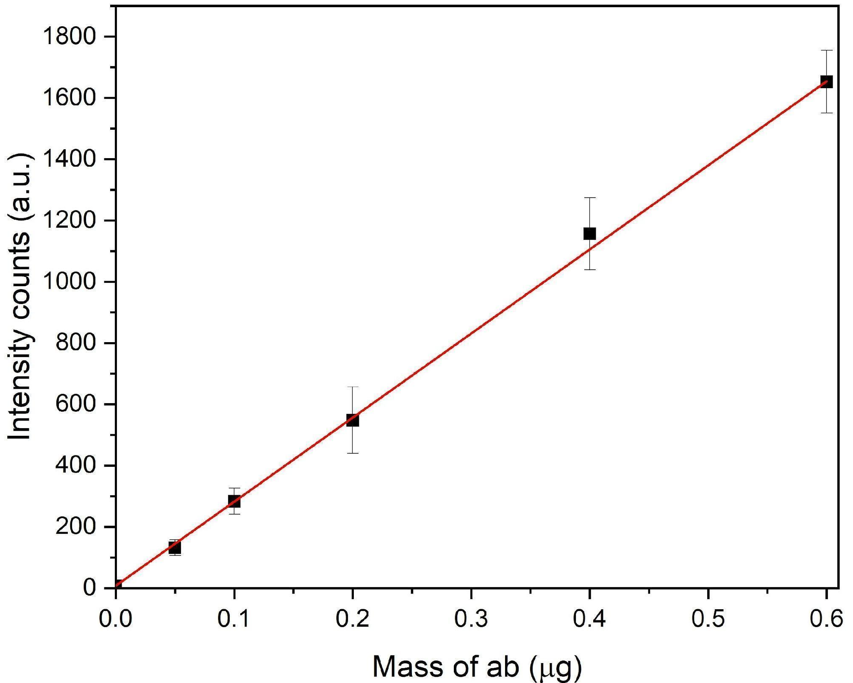

Figure S6. The titration curve of Texas Red-conjugated antibody (Ab*) was performed at 530 nm excitation wavelength in the range of Ab* mass included between 0 and 0.6 µg. The mass of Ab* (x-axis) is plotted against fluorescence emission (y- axis) and a direct proportionality is obtained. The R-square = 0.998 was obtained from three independent experiments.

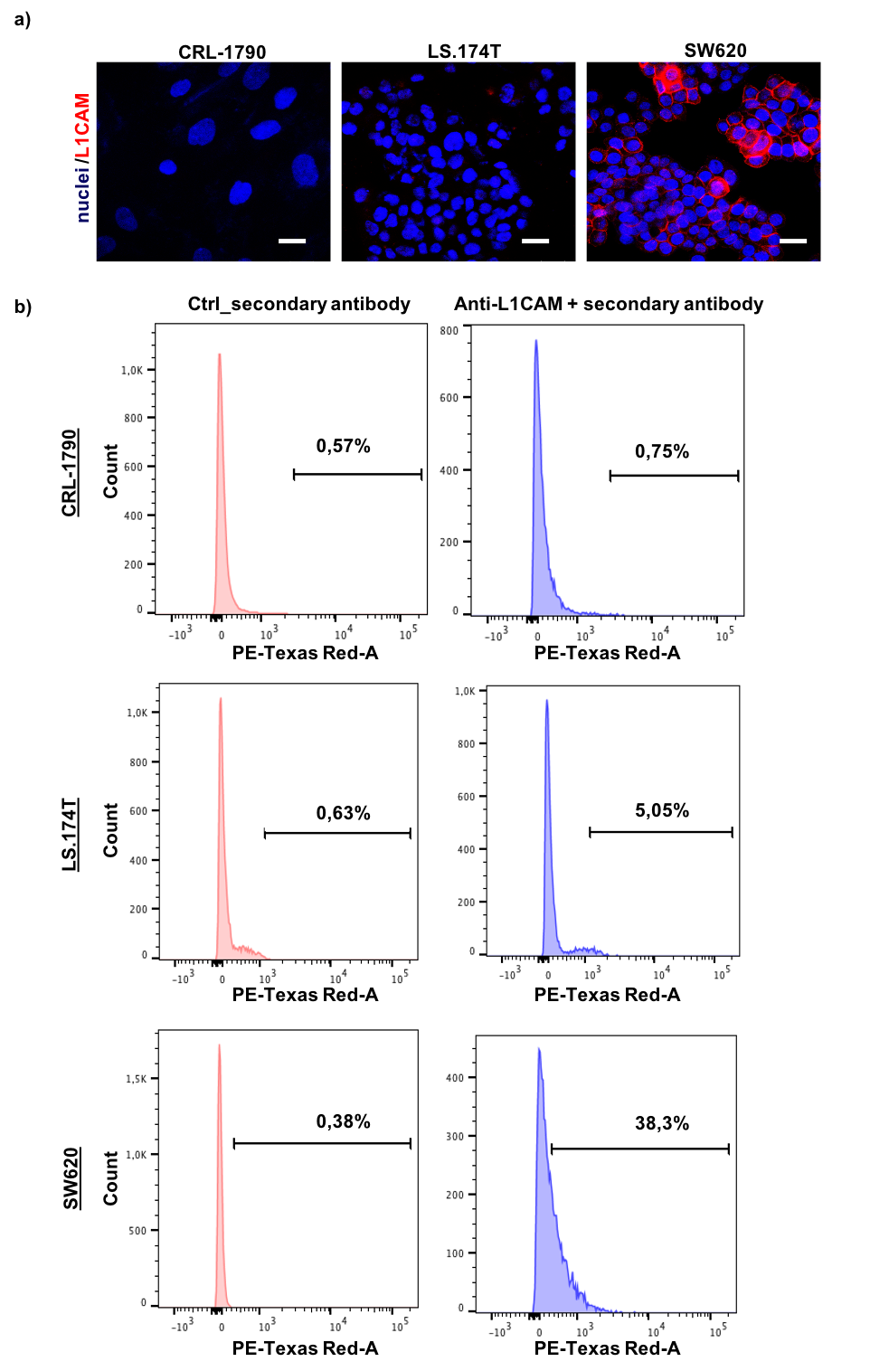
Figure S7. (a) Immunofluorescence analysis of L1CAM expression (red staining) in normal colon cells (CRL-1790, left panel), colon cancer cells LS.174T (middle panel) and SW620 (right panel). The cell nuclei are stained using Hoechst and are shown in blue. (b) Flow cytometry of CRL-1790, LS.174T, and SW620 cells. All cytometry gates were established based on control. The scale bars are 20 µm.

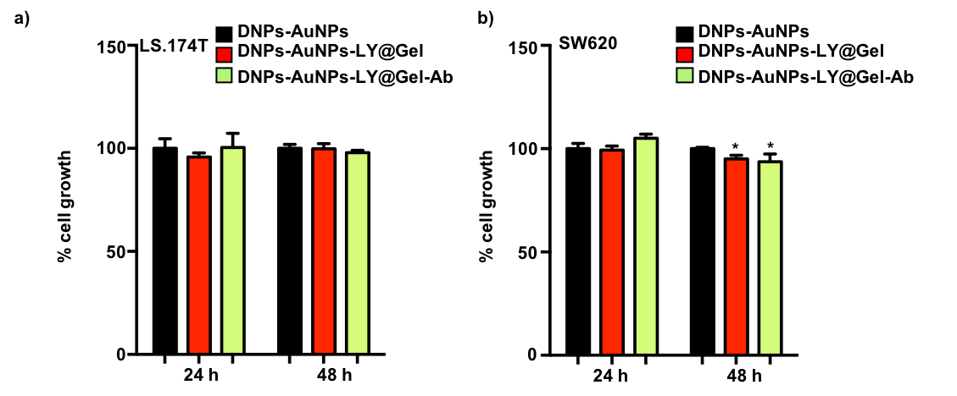
Figure S8. (a) Cell viability of LS-174T cells grew for 24 and 48 h in the presence of the indicated treatment. Cell viability was evaluated using CCK8, and absorbance was measured at 450 nm. (b) Cell viability of SW620 cells grew for 24 and 48 h in the presence of the indicated treatments. Cell viability was evaluated using CCK8, and absorbance was measured at 450 nm. *p < 0.05, n ≥ 6.

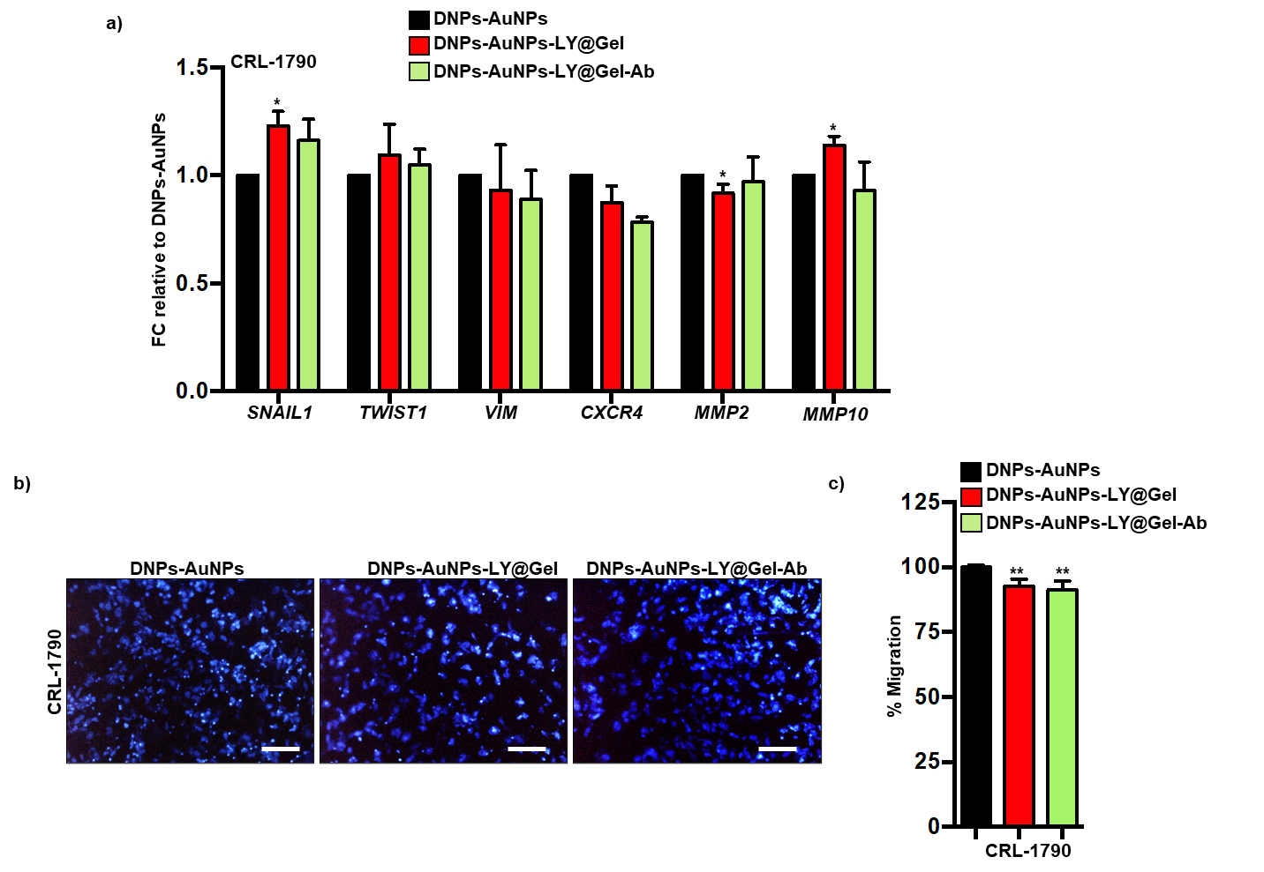

Figure S9. (a) qPCR analysis of EMT, CXCR4, and MMPs genes in CRL-1790 cells grew for 24 h in the presence of the indicated treatments. Data are normalized to GAPDH expression and are presented as Fold Change (FC) in gene expression relative to DNPs-AuNPs. *p<0.05, n≥6. (b) Migration assay for CRL-1790 cells incubated for 24 h with the indicated treatments. The nuclei were stained with DAPI (blue). (c) Migratory potential for CRL-1790 cells grew for 24 h in the presence of the indicated treatments. The scale bars are 25 µm. **p<0.005, n≥6.

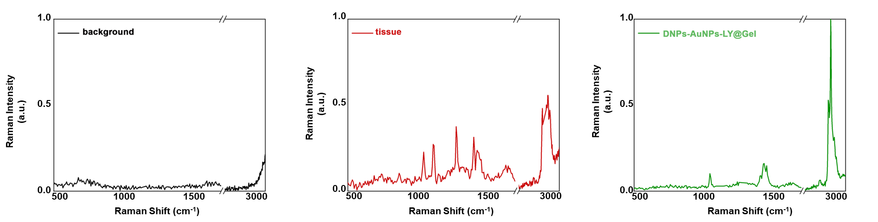

Figure S10. Representative Raman spectra of the background (left panel, black line), tumoral tissue (middle panel, red line), and DNPs-AuNPs-LY@Gel/-Ab (right panel, green line) used to generate the Raman false color maps.

Gene symbol | Forward primer (5'->3') | Reverse primer (5'->3')
GAPDH | CAGGAGCGAGATCCCT | GGTGCTAAGCAGTTGGT
SNAIL1 | CTTCCAGCAGCCCTACGAC | CGGTGGGGTTGAGGATCT
VIM | CTCAATGTCAAGGGCCATCT | TGCCCTTAAAGGAACCAATG
TWIST1 | AGCTACGCCTTCTCGGTCT | CCTTCTCTGGAAACAATGACAT
CXCR4 | GGTGGTCTATGTTGGCGTCT | TGGAGTGTGACAGCTTGGAG
MMP2 | ATAACCTGGATGCCGTCGT | AGGCACCCTTGAAGAAGTAGC
MMP10 | GGCTCTTTCACTCAGCCAAC | TCTCCCCTCAGAGTGCTGAT

Table S1. Primers used for quantitative real-time PCR.

