Supplemental Figure 1. The COPD Assessment Test (CAT)

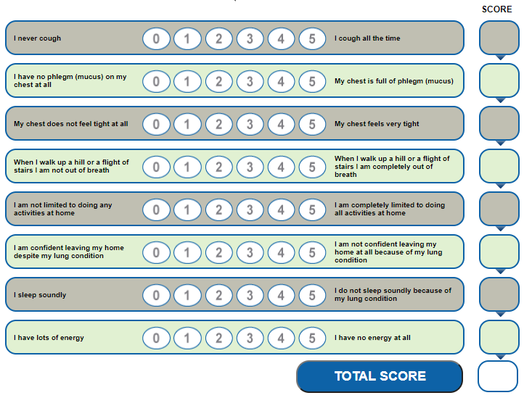

Supplemental Figure 2. Time to First Pulmonologist Visit Post-CAT by Index CAT Score.

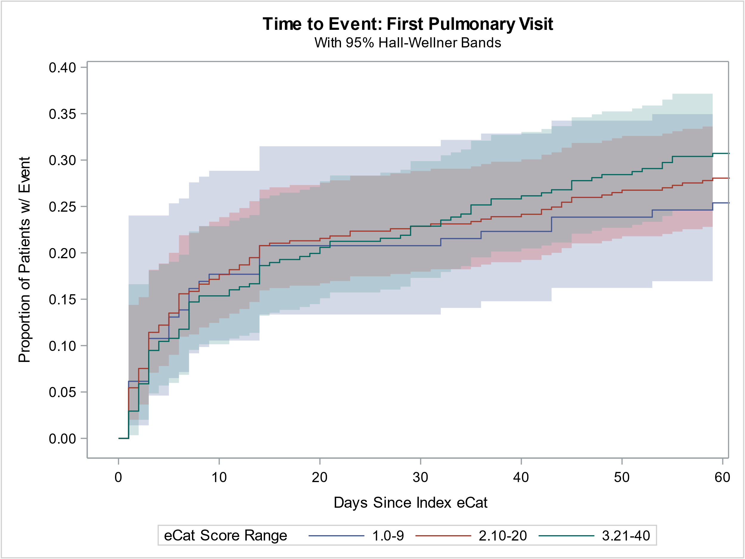

Cox proportional hazards model did not show statistical significance.
CAT 21-40 vs. CAT < 10, Hazard Ratio 1.05, CI=[0.71, 1.56]
CAT 10-20 vs. CAT < 10, Hazard Ratio 1.10, CI=[0.73, 1.66]

Supplemental Figure 3. Time to First Pulmonary Rehabilitation Treatment Post-CAT by Index CAT Score

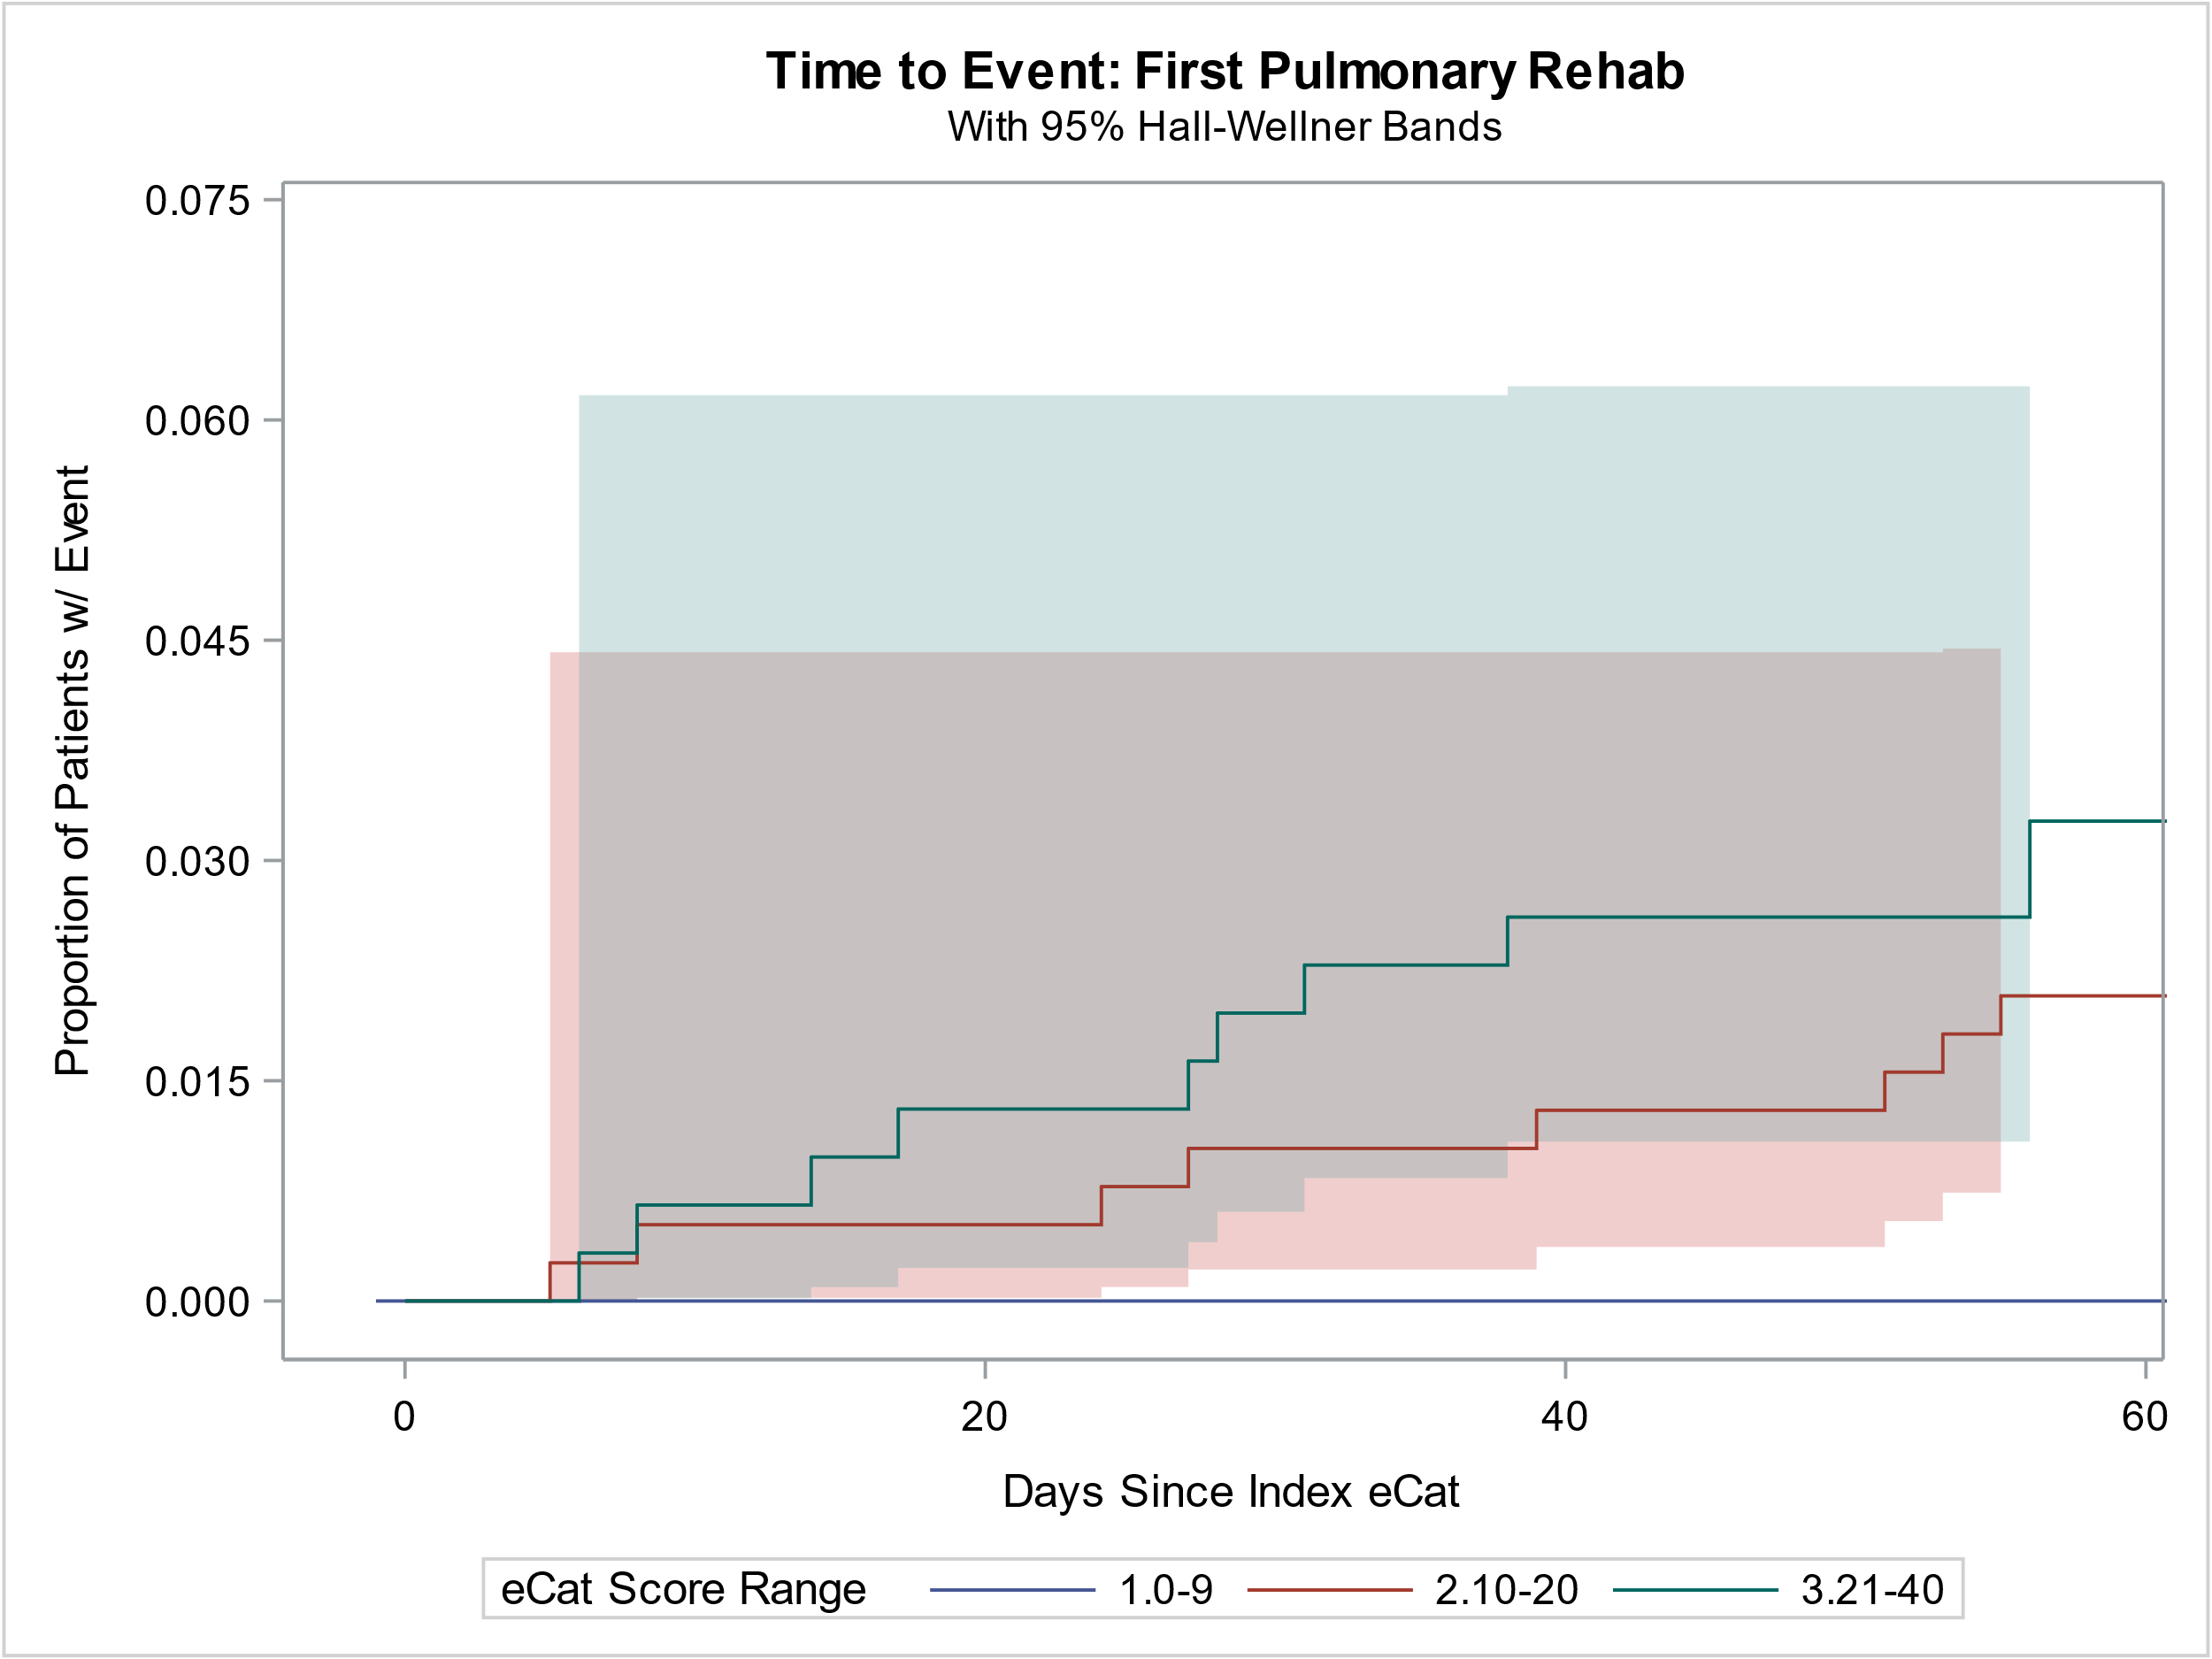

Cox proportional hazard model did not show statistical significance (N.S.
For CAT 21-40 compared to CAT 10-21*, Hazard Ratio 1.37 w/ 95% CI=[0.54, 3.49],
*No event for CAT<10, which is, consequently, not compared to the other two categories)

Supplemental Figure 4. Time to First COPD Exacerbation post-CAT by Index CAT Score.

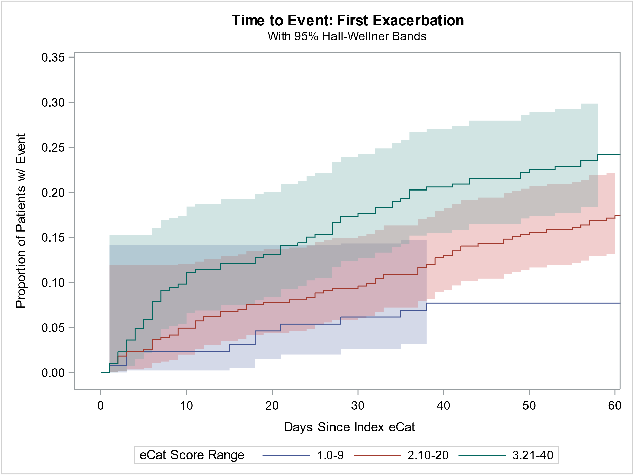

Cox proportional hazard model significant at p<0.001.
CAT 21-40 vs. CAT < 10, Hazard Ratio 2.18, CI=[1.12, 4.25]
CAT 10-20 vs. CAT < 10, Hazard Ratio 3.11, CI=[1.59, 6.06]

