Supporting Information

Section 1. Instrument parameters
Electron paramagnetic resonance (EPR): The EPR spectra were obtained from Bruker EMX PLUS. The CenterField is 3510.00 G; the SweepWidth is 100.0 G; the Power is 6.325 mW; the PowerAtten is 15.0 Db; theSweepTime is 30.00 s; the ModAmp is 1.000 G; the ModFreq is 100.00 kHz.
Transmission electron microscope (TEM): TEM images were obtained from an FEI Tecnai G2 F20s-twin D537 field emission TEM at an accelerating voltage of 200kV. Powder ORD patterns were obtained by using a Rigaku 2550 diffractometer with Cu Ka radiation (λ=1.5418Å), and the corresponding data were collected in the range of 2θ=5-30◦ at a scanning rate of 1◦ min⁻¹.
N2 adsorption-desorption: The N2 adsorption-desorption of the samples have been evaluated on the Micromeritics ASAP 2420-4MP automatic analyzer, which was carried out at 77k.

Section 2. Figures S1-14
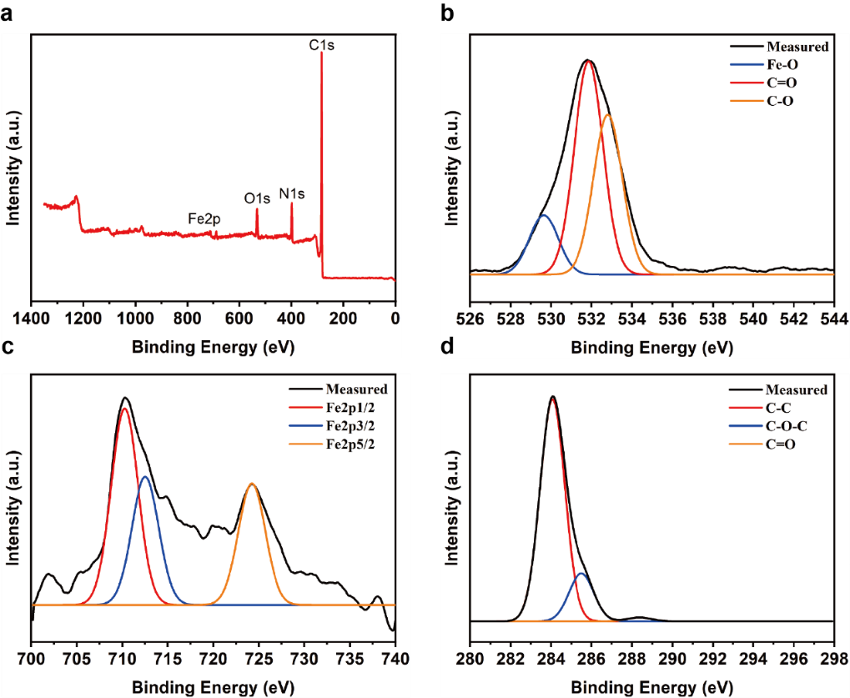
Figure S1. XPS analysis of Fe-HCOFs. a) Full spectrum analysis of Fe-HCOFs. High resolution spectrum of b) O element, c) Fe element and d) C element.

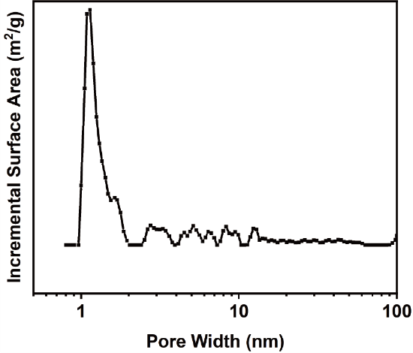
Figure S2. Cumulative pore volume curve of Fe-HCOFs.

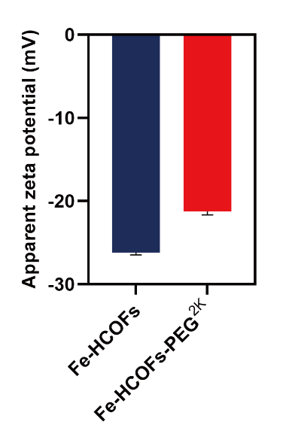
Figure S3. Apparent zeta potential of Fe-HCOFs and Fe-HCOFs-PEG²⁰⁰⁰. n=3.

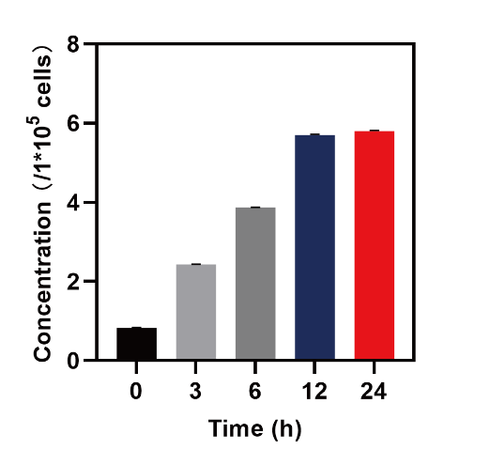
Figure S4. Cellular uptake of Fe-HCOFs in MCF-7 cells detected by ICP-MS. n=3.

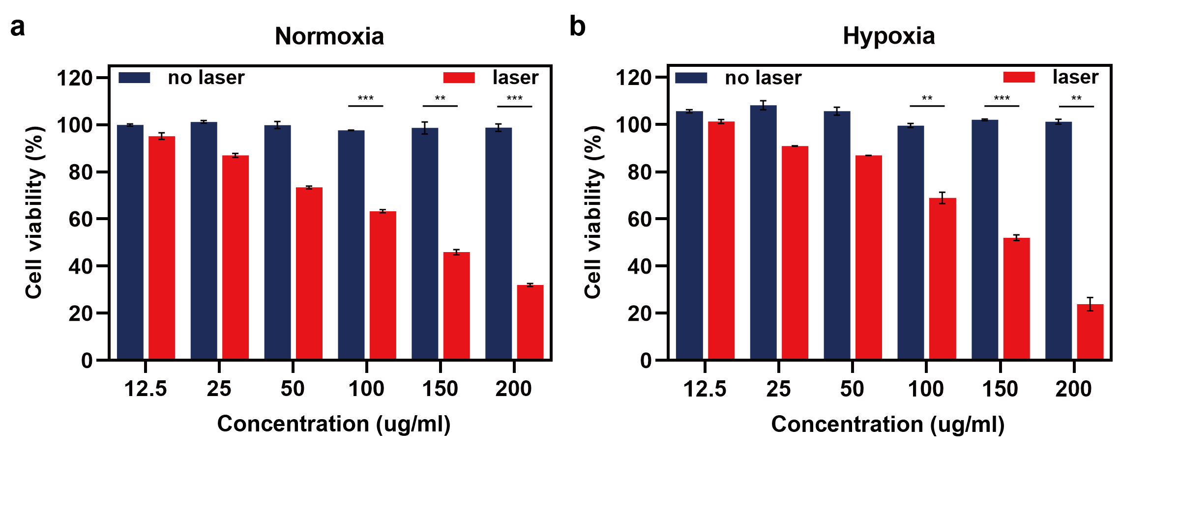
Figure S5. The relative viabilities of MCF-7 cells incubated in different Fe-HCOFs concentration with or without NIR irradiation in a) normoxia and b) hypoxia. n=3. Data are shown as mean ± SD. Student's t‐test, **p < 0.01, ***p < 0.001.

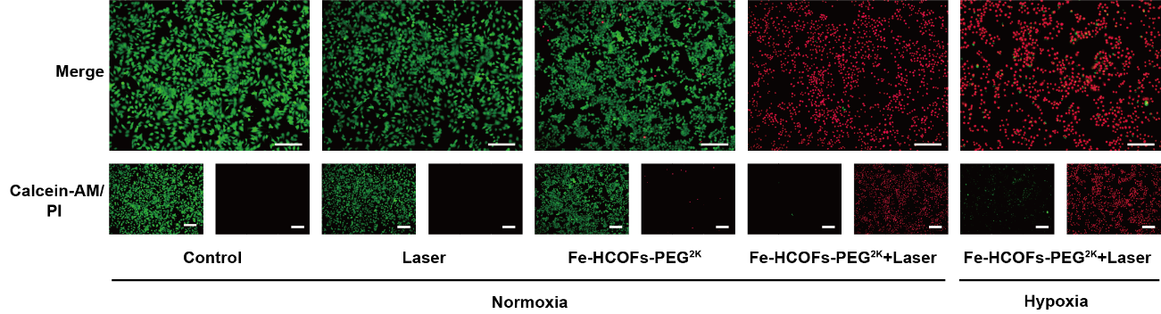
Figure S6. Fluorescence images of Fe-HCOFs-PEG²⁰⁰⁰ and laser treated or not treated MCF-7 cells stained by Calcein-AM/PI under normoxia and hypoxia. Scale bar: 100 μm.

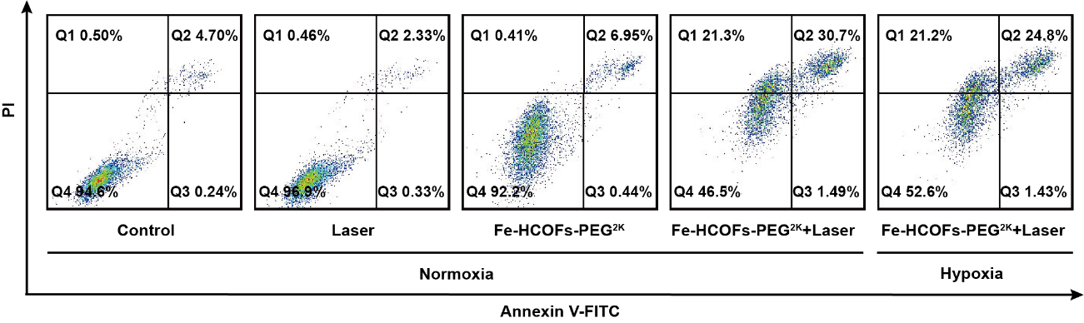
Figure S7. Flow cytometry assays of MCF-7 cells stained by Annexin V-FITC/PI at illustrated therapeutic modalities.

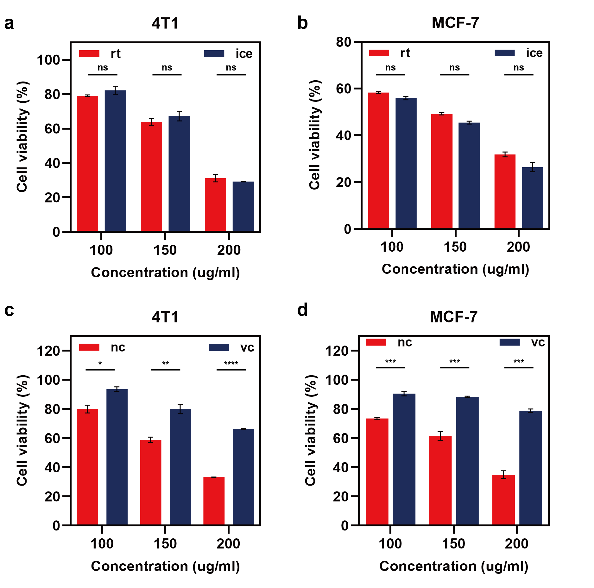
Figure S8. Cell viability of a) 4T1 cells and b) MCF-7 cells incubated in different Fe-HCOFs concentrations with NIR irradiation on ice or room temperature (rt). Cell viability of c) 4T1 cells and d) MCF-7 cells incubated in different Fe-HCOFs concentrations with NIR irradiation when they were treated with vc or not. n=3. Data are shown as mean ± SD. Student's t‐test, ns (not significant), p > 0.05, *p < 0.05, **p < 0.01, ***p < 0.001, ****p < 0.0001.

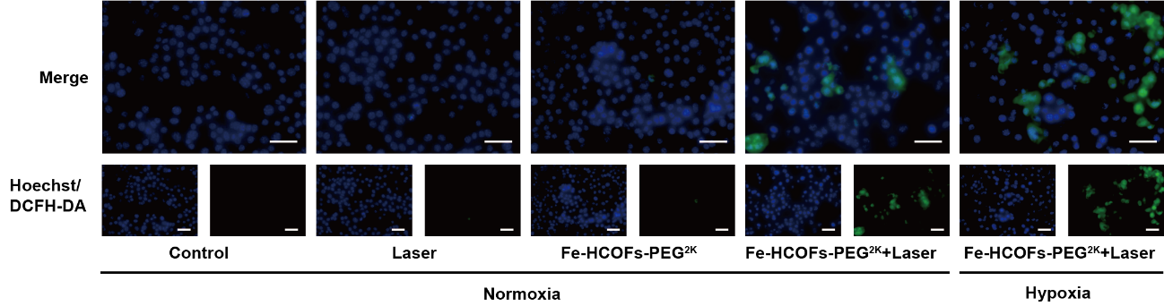
Figure S9. Fluorescence images of DCFH-DA probe bonded MCF-7 cells to detect cellular ROS generation. Scale bar: 50 μm.

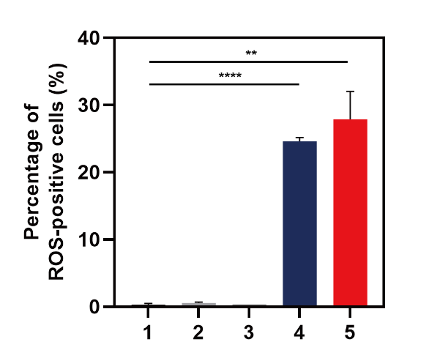
Figure S10. Quantitative intensity of ROS positive MCF-7 cells in Figure S9. n=3. Data are shown as mean ± SD. Student's t‐test, **p < 0.01, ****p < 0.0001.

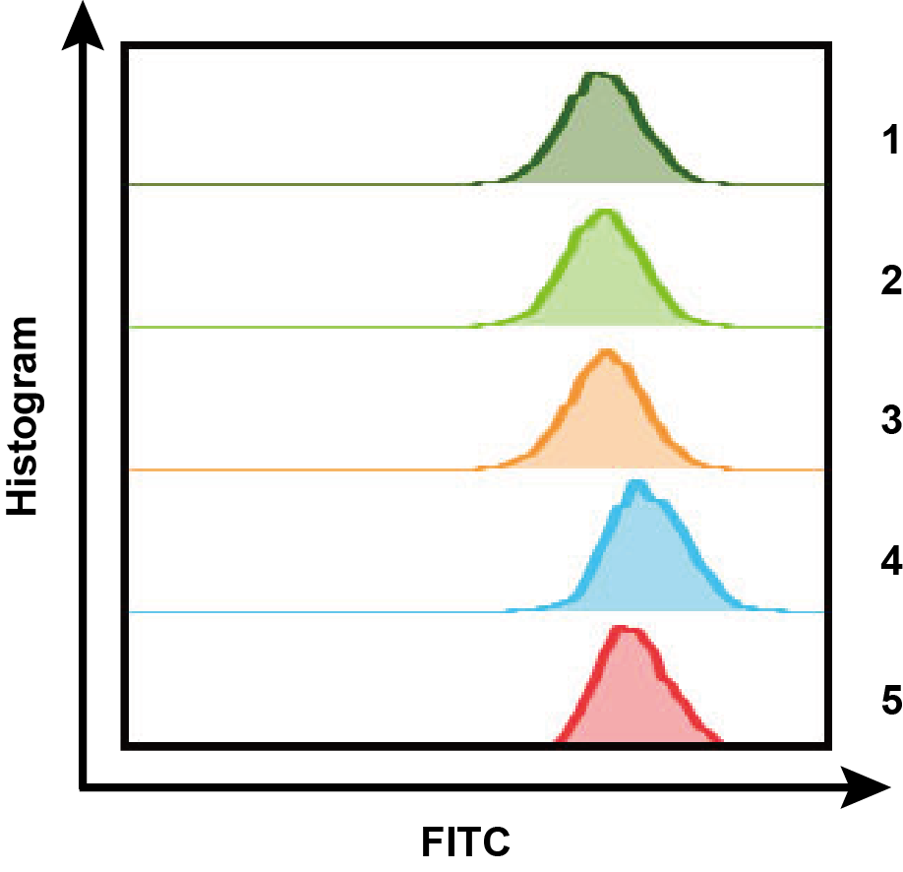
Figure S11. Flow cytometry of DCFH-DA probe bonded MCF-7 cells to detect cellular ROS generation.

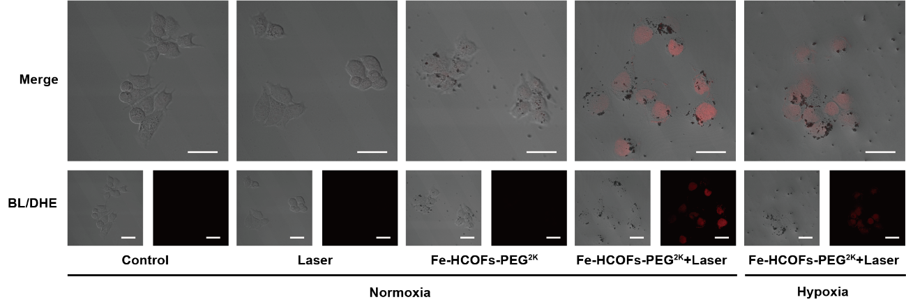
Figure S12. DHE staining images of MCF-7 cells treated with 5 definite methods to indicate O₂^{•−} positive cells. Scale bar: 20 μm.

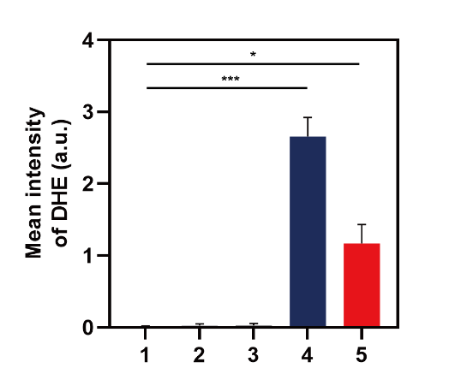
Figure S13. Quantitative intensity of DHE positive MCF-7 cells in Figure S12. n=3. Data are shown as mean ± SD. Student's t‐test, *p < 0.05, ***p < 0.001.

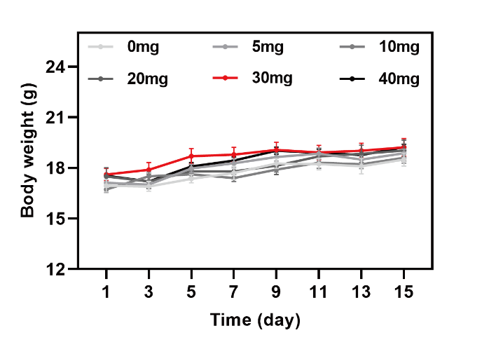
Figure S14. Body weight curve of 0, 5, 10, 20, 30, 40 mg kg⁻¹ Fe-HCOFs-PEG²⁰⁰⁰ dosage treated BALB/c mice in 14 days.

