Novel multitargeted nanotechnological platform encapsulating Riluzole against motor neuron diseases

Gerard Esteruelas^{1,2,3}, Miren Ettcheto^{4,5}, Isabel Haro-Villar³, Mireia Herrando-Grabulosa^{5,6}, Núria Gaja-Capdevila^{5,6}, Maria José Gómara⁵, Xavier Navarro ^{5,6}; Marta Espina^{1,2}, Eliana B. Souto^{7,}, Antoni Camins^{4,5}, Maria Luisa García^{1,2,5*}, Elena Sánchez-López^{1,2,3,5*}

¹ Department of Pharmacy, Pharmaceutical Technology and Physical Chemistry, Faculty of Pharmacy and Food Sciences, University of Barcelona, 08007 Barcelona, Spain
² Institute of Nanoscience and Nanotechnology (IN2UB), University of Barcelona, 08007 Barcelona, Spain
³ Department of Pharmacology and Therapeutic Chemistry, Faculty of Pharmacy and Food Sience, University of Barcelona
⁴ Biomedical Research Network Center in Neurodegenerative Diseases (CIBERNED), Madrid, Spain
⁵ Unit of Synthesis & Biomedical applications of Peptides, IQAC-CSIC, 08034, Barcelona, Spain.
⁶ Group of Neuroplasticity and Regeneration, Department of Cell Biology, Physiology and Immunology, Institute of Neurosciences, Universitat Autonoma de Barcelona
⁷ UCD School of Chemical and Bioprocess Engineering, University College Dublin, Belfield, Dublin 4, D04 V1W8, Ireland

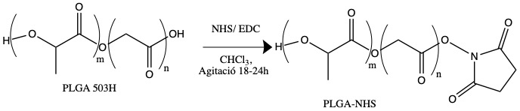

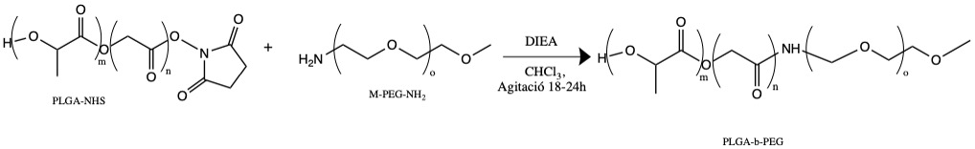

Figure S1. Chemistry reaction of PLGA-PEG synthesis.
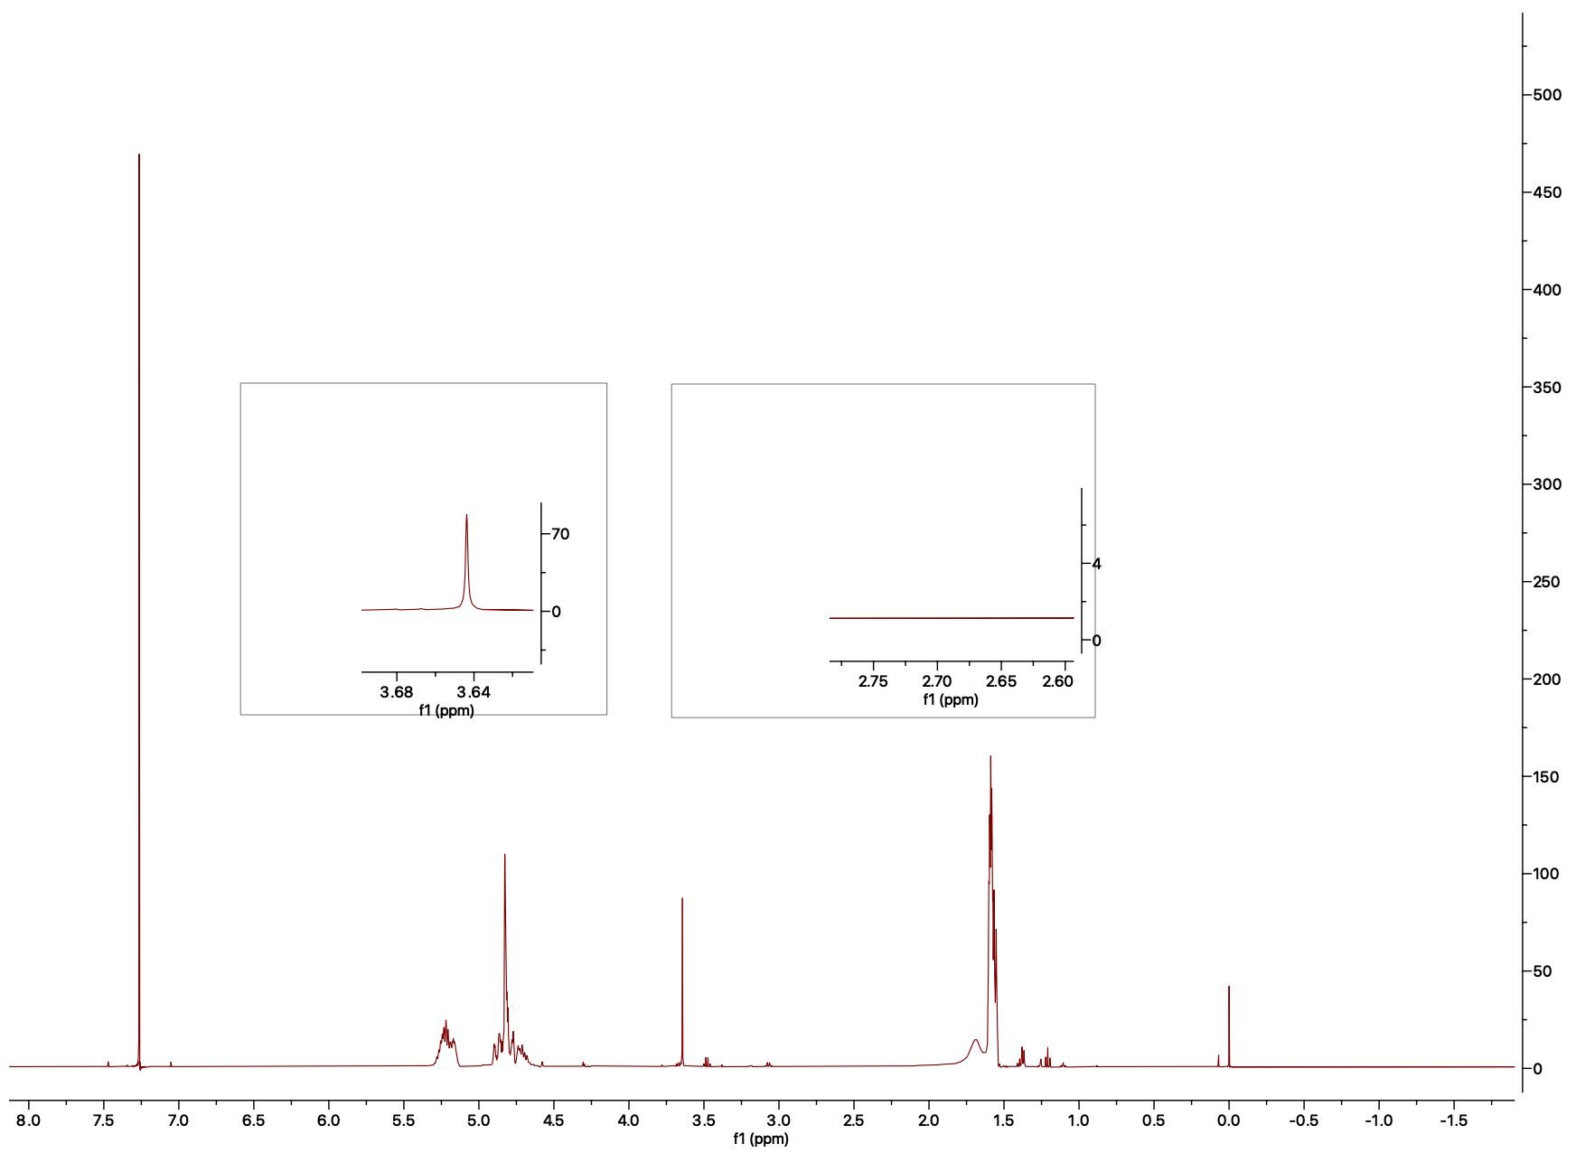

Figure S2. ¹H-NMR obtained after the synthesis of PLGA-PEG.

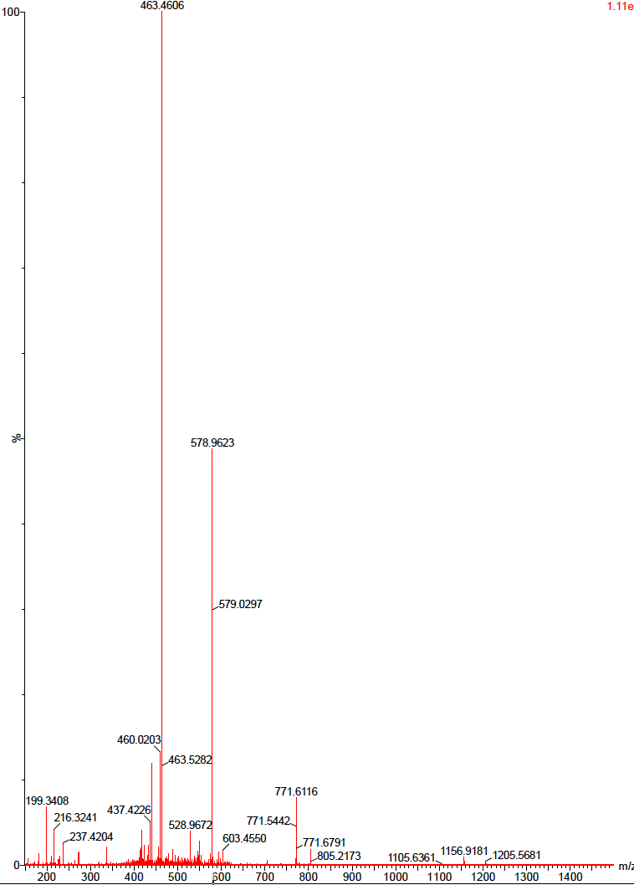
Figure S3. Mass spectrum corresponding to the synthesized pVEC.

Figure S4. Size distribution of pVEC-PEG-PLGA-RLZ NPs expressed as percentage of particles obtained by dynamic light scattering.

Table S1 Comparison of the physicochemical characterization (Z_{av}, PI, ZP and EE) of functionalized and non-functionalized nanoparticles and statistics performed.
Formulation | Z_{AV}  (nm) | PI | ZP  (mV) | EE  (%=
pVEC-PEG-PLGA-RLZ NPs | 164.0 ±1.2 | 0.115 ± 0.05 | 19.2 ± 0.2 | 95.2 ± 0.4
PLGA RLZ NPs | 148.2 ±1.4 | 0116 ± 0.011 | -30.0 ± 0.6 | 94.2 ± 0.8
P-Value | <0.0001 | ns | <0.0001 | <0.001

