Supplementary Materials

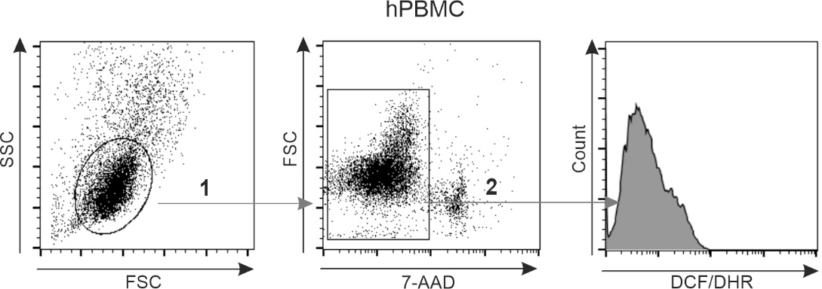
Figure S1: The gating strategy of reactive oxygen species measurement in peripheral blood mononuclear cells.
Abbreviations: 7-AAD, 7-amino actinomycin D; DCF, dichloro-dihydro-fluorescein diacetate; DHR, dihydrorhodamine; hPBMC, human peripheral blood mononuclear cells; FSC, forward scatter; SSC, side scatter;

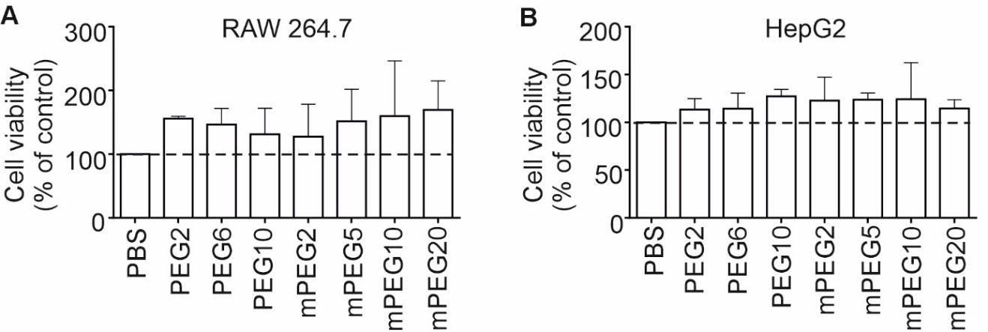
Figure S2: Viability of RAW 264.7 and HepG2 cells after incubation with polyethylene glycols.
Notes: After 24 or 48 hours of incubation in media containing PBS or PEG, or mPEG solutions, the viability of RAW 264.7 (A) and HepG2 (B) cells was analyzed using MTT. The data are presented as an average of 3 independent experiments ± SD.
Abbreviations: HepG2, human hepatoma-derived cells; RAW 264.7, mouse monocyte/macrophage cell line; PEG, polyethylene glycol; mPEG, metoxy polyethylene glycol.
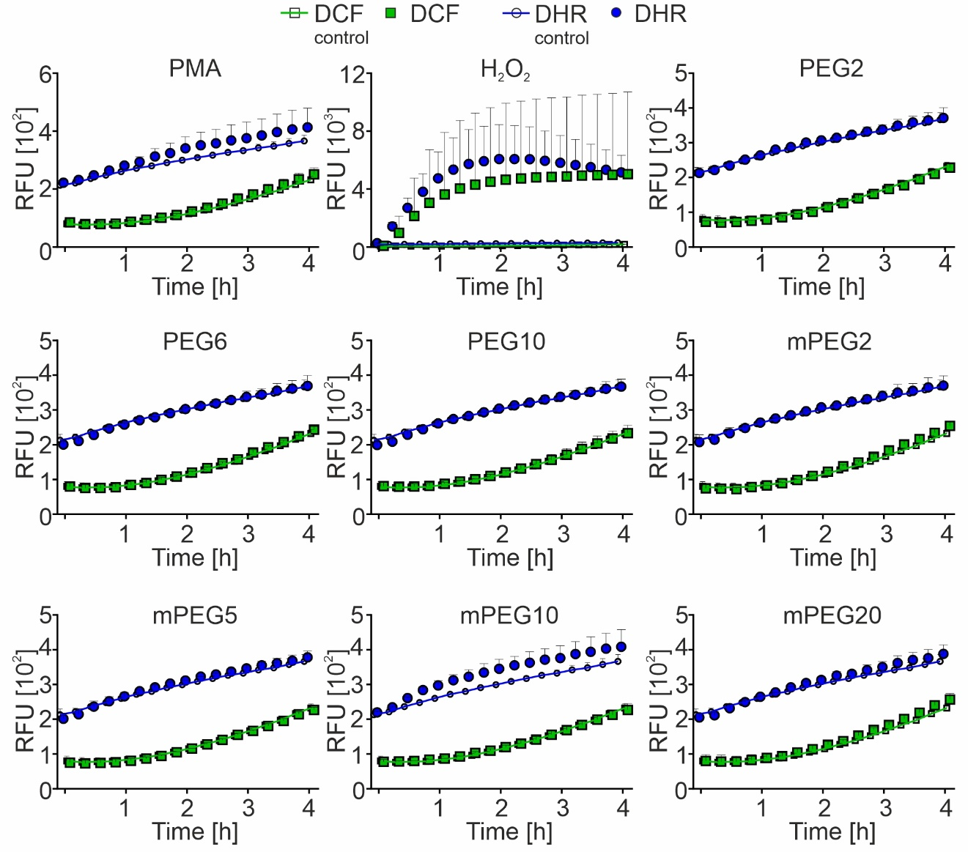
Figure S3: Kinetics of intracellular ROS production by P388D1 cells exposed to polyethylene glycols.
Notes: ROS-sensitive fluorescent probes (DCF and DHR) were added to the culture medium used for P388D1 cells. Next, P388D1 cells were treated with PBS (negative control), PEG or mPEG solutions, or PMA and H₂O₂, which served as an inducer of oxidative stress in the cells. Immediately after adding stimulants, the fluorescence intensity of DCF (470 nm/535 nm) and DHR (485 nm/525 nm) was measured. The measurement was carried out for 4 hours at 15-minute intervals, maintaining a constant temperature of 37°C. Data were presented as an average of two independent experiments ± SD.
Abbreviations: DCF, dichloro-dihydro-fluorescein diacetate; DHR, dihydrorhodamine; PEG, polyethylene glycol; mPEG, metoxy polyethylene glycol; PMA, phorbol 12-myristate 13-acetate.

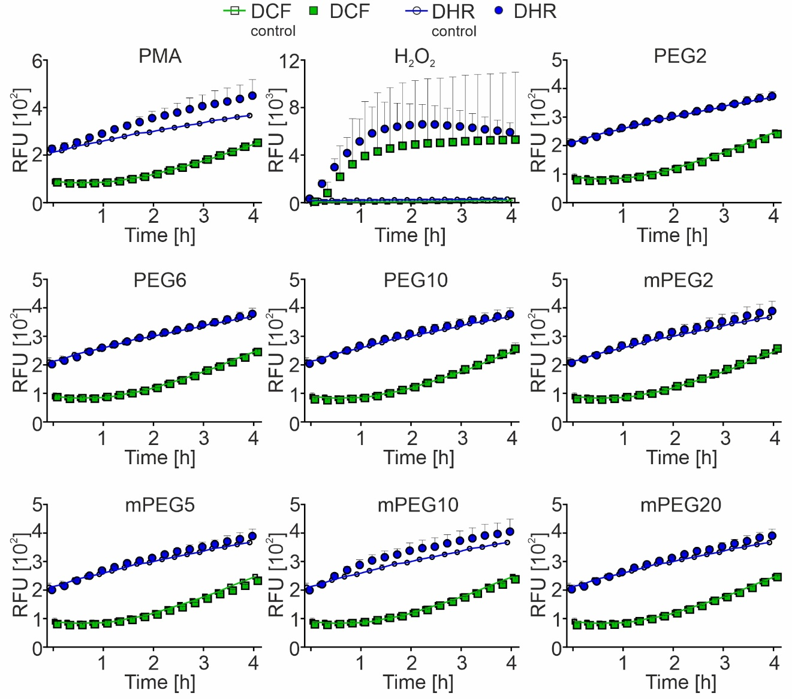
Figure S4: Kinetics of intracellular ROS production by RAW 264.7 incubated with polyethylene glycols.
Notes: ROS-sensitive fluorescent probes (DCF and DHR) were added to the culture medium used for RAW264.7 cells. Next, media containing PBS (negative control), PEG or mPEG solutions, or PMA and H₂O₂ were added to the cells (positive controls of ROS production). Immediately, the fluorescence intensity of DCF (470 nm/535 nm) and DHR (485 nm/525 nm) was measured. The measurement was carried out for 4 hours at 15-minute intervals, maintaining a constant temperature of 37°C. Data were presented as an average of at least two independent experiments ± SD.
Abbreviations: DCF, dichloro-dihydro-fluorescein diacetate; DHR, dihydrorhodamine; PEG, polyethylene glycol; mPEG, metoxy polyethylene glycol; PMA, phorbol 12-myristate 13-acetate.
Figure S5: Kinetics of intracellular ROS production by HepG2 cells exposed to polyethylene glycols.
Notes: The cells were resuspended in the media containing ROS-sensitive fluorescent probes (DCF, and DHR) and mixed with stimulants: PBS (negative control), PMA (positive control of ROS production), PEG or mPEG solutions, or PMA and H₂O₂ (positive controls of ROS production). The fluorescence intensity of DCF (470 nm/535 nm) and DHR (485 nm/525 nm) was measured using a microplate reader. The measurement was carried out for 4 hours at 15-minute intervals, maintaining a constant temperature of 37°C. Data were presented as an average of at least two independent experiments ± SD.
Abbreviations: DCF, dichloro-dihydro-fluorescein diacetate; DHR, dihydrorhodamine; PEG, polyethylene glycol; mPEG, metoxy polyethylene glycol; PMA, phorbol 12-myristate 13-acetate.

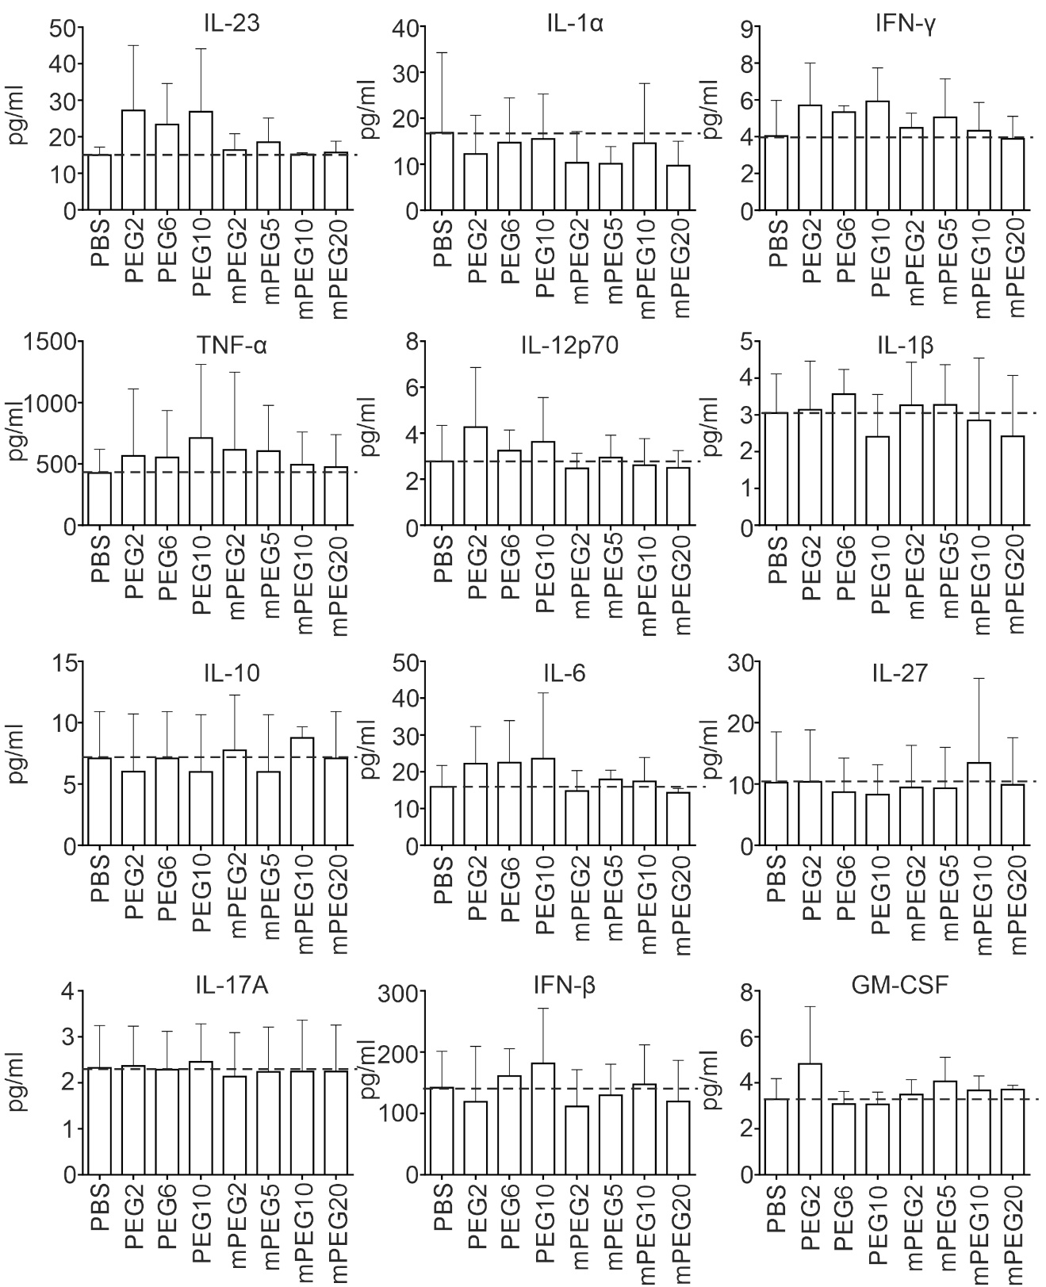
Figure S6: Cytokine levels measured in culture media collected from P388D1 after incubation with polyethylene glycols.
Notes: P388D1 cells were incubated for 48 hours in media containing PBS (negative control), PEG, or mPEG solutions. Cytokine concentrations in culture media were determined using the mouse LEGEND/Plex Inflammation Panel and flow cytometry. The data are presented as an average of 3 independent experiments ± SD.
Abbreviations: PEG, polyethylene glycol; mPEG, metoxy polyethylene glycol.
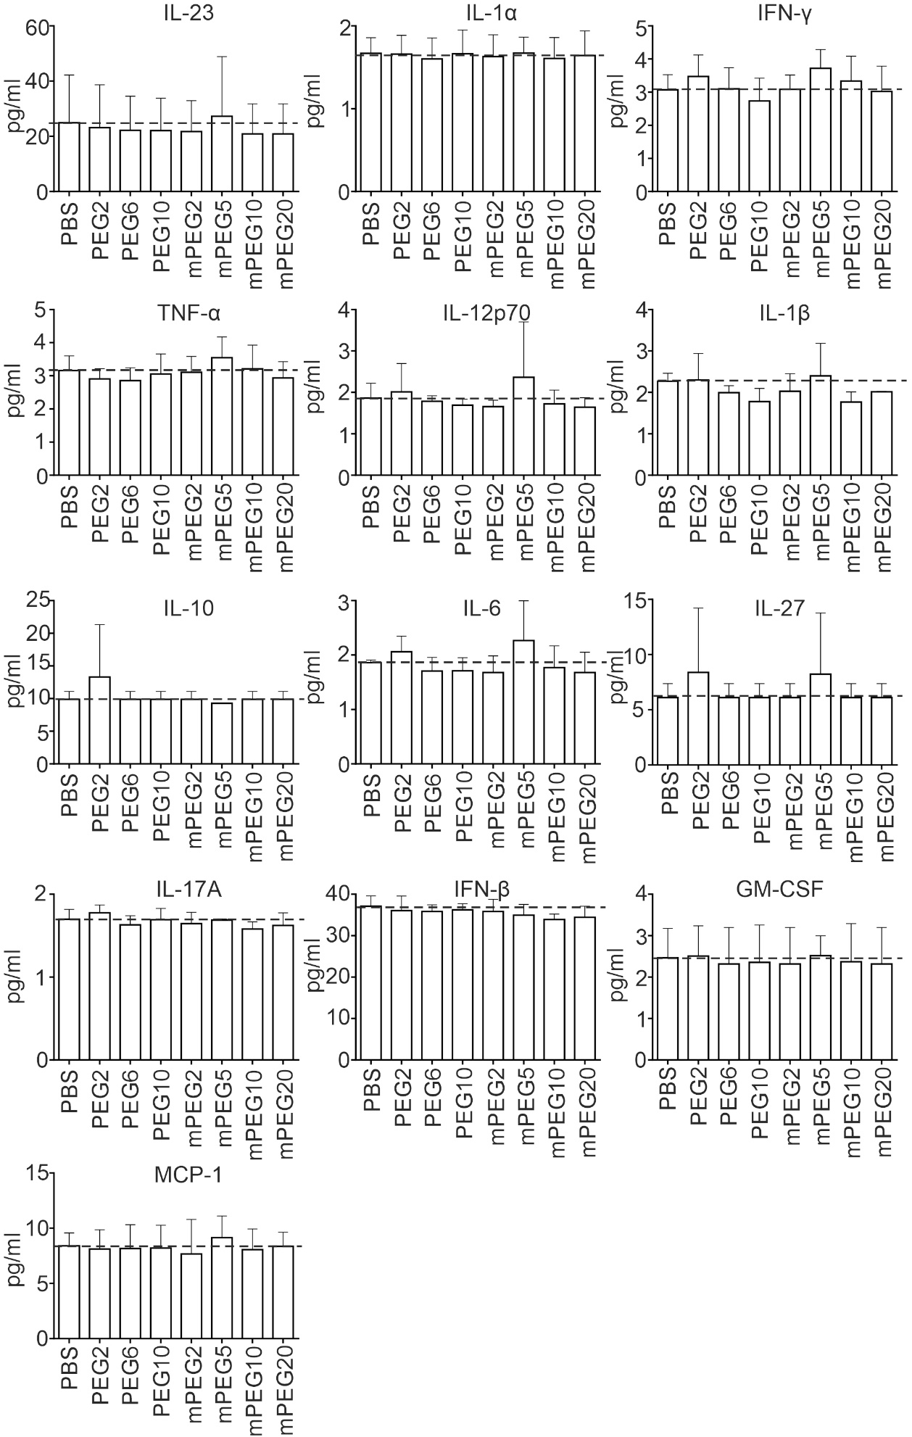
Figure S7: Cytokine levels in media collected from mPN after incubation with polyethylene glycols.
Notes: The cells were incubated for 48 hours in media containing PBS (negative control), PEG, or mPEG solutions. Analysis of cytokine concentrations in cultured media was determined using the mouse LEGEND/Plex Inflammation Panel and flow cytometry. The data are presented as an average of 3 independent experiments ± SD.
Abbreviations: PEG, polyethylene glycol; mPEG, metoxy polyethylene glycol.
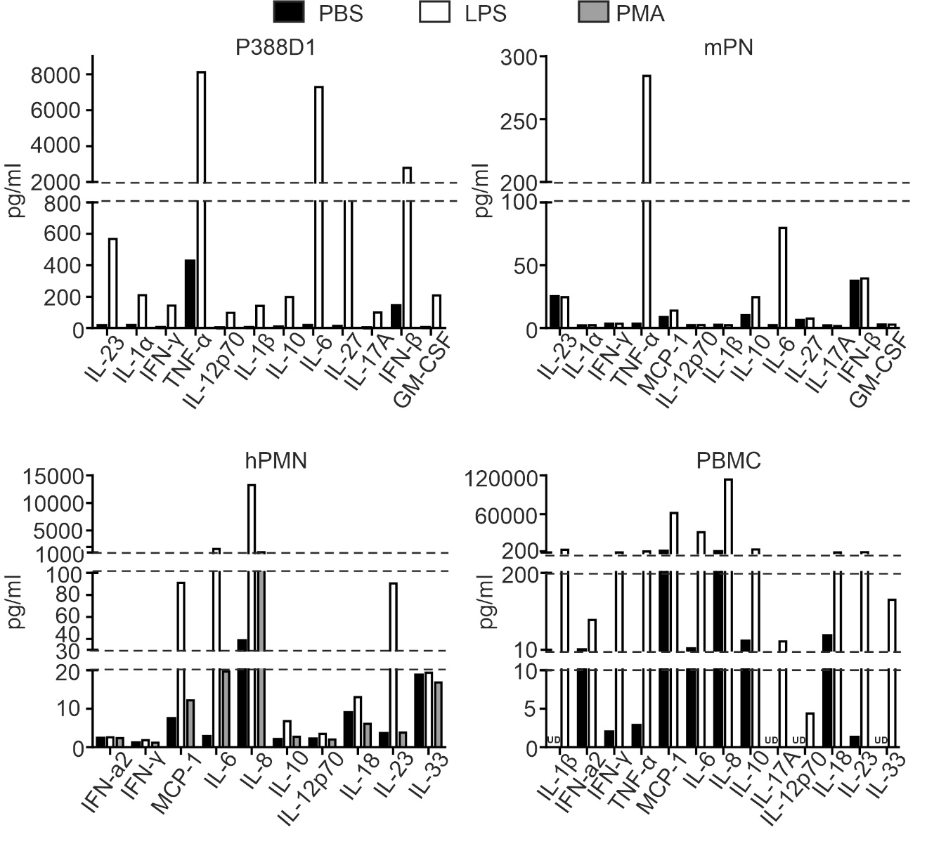
Figure S8: Production of specific cytokines by mouse and human immune cells after incubation with stimulants of the inflammatory response.
Notes: The cells were incubated with LPS or PMA for 48 hours. The concentrations of cytokines secreted by the cells to the culture media were analyzed using the mouse or human LEGEND/Plex Inflammation Panel and flow cytometry. Data are presented as a single representative result from two repetitions.
Abbreviations: P388D1, mouse monocyte/macrophage cell line; mPN, mouse neutrophils differentiated from mouse neutrophil progenitors; hPBMC, human peripheral blood mononuclear cells; hPMN, human polymorphonuclear neutrophils; PMA, phorbol 12-myristate 13-acetate; LPS, lipopolysaccharide.
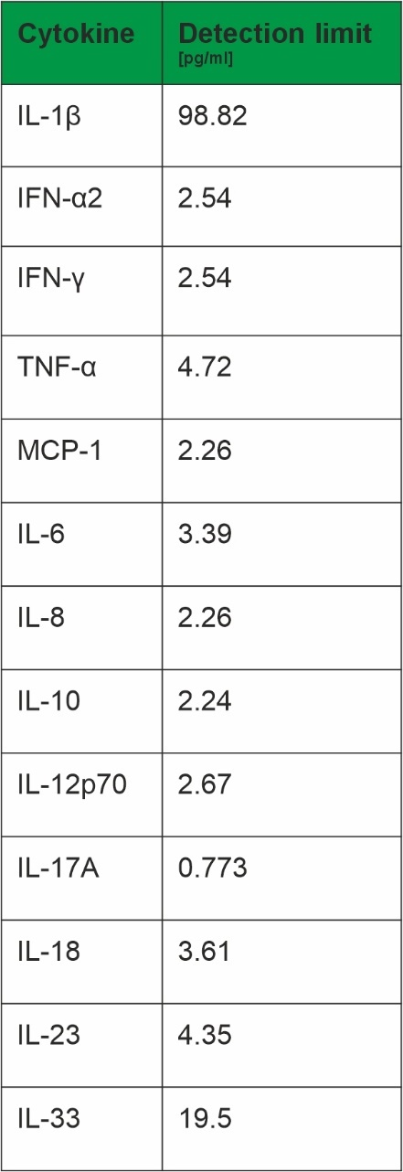
Figure S9: Detection limits of various cytokine concentrations measured using the human LEGEND/Plex Inflammation Panel and flow cytometry.

