Supplementary Table 1 Definitions of complications in children with sepsis
Complication | Diagnostic criteria
Anaemia | Haemoglobin 1-4 months: < 90 g/L
 | 4-6 months: < 100 g/L
 | 6 months to 5 years: < 110 g/L
 | 5-12years: < 115 g/L
 | >12years: < 120 g/L
Hypertension | Systolic blood pressure ≥ 120 mmHg or diastolic blood pressure ≥ 80 mmHg
Liver dysfunction | Total bilirubin > 68.4 mmol/L or elevation of alanine aminotransferase exceeding 2 times the upper limit
 | of normal (40 IU/L)
Renal dysfunction | Serum creatinine level greater than 2 times the upper limit of normal for age-matched peers
Hypoproteinemia | Serum total protein < 60 g/L or albumin < 35 g/L

Supplementary Table 2 Multivariable logistic regression model for assessing the risk of in-hospital mortality in children with sepsis
Variables | Unadjusted OR | 95% CI | P | Adjusted OR | 95% CI | P
Age
<1years | Reference |  |  | Reference
1-6 years | 1.01 | 0.50-2.02 | 0.988 | 0.82 | 0.29-2.37 | 0.718
>6 years | 1.04 | 0.45-2.44 | 0.923 | 0.55 | 0.16-1.87 | 0.335
Gender (female) | 0.91 | 0.48-1.70 | 0.760 | 0.60 | 0.27-1.37 | 0.226
Respiratory system infection | 1.37 | 0.70-2.69 | 0.362 | 0.95 | 0.36-2.47 | 0.909
Digestive system infection | 0.75 | 0.38-1.50 | 0.414 | 1.65 | 0.68-4.03 | 0.271
Blood system infection | 1.80 | 0.95-3.42 | 0.071 | 1.57 | 0.70-3.52 | 0.275
Laboratory tests
High-sensitivity CRP (>10 mg/dL) | 0.49 | 0.26-0.95 | 0.034 | 0.45 | 0.20-1.01 | 0.053
Procalcitonin (>0.5 ng/mL) | 0.89 | 0.34-2.36 | 0.816 | 0.41 | 0.11-1.56 | 0.193
CKMB（>6.8 ng/mL） | 1.50 | 0.74-3.07 | 0.264 | 0.47 | 0.17-1.28 | 0.141
Serum sodium (<135 or >145 mmol/L) | 1.62 | 0.87-3.03 | 0.131 | 1.30 | 0.56-3.02 | 0.544
Potassium (<3.5 or >5.5 mmol/L) | 1.49 | 0.78-2.85 | 0.224 | 0.55 | 0.23-1.32 | 0.178
Calcium (<2.2 or >2.7 mmol/L) | 2.12 | 1.02-4.42 | 0.044 | 1.56 | 0.58-4.16 | 0.377
Arterial blood pH (<7.35 or >7.45) | 2.26 | 1.18-4.34 | 0.014 | 1.12 | 0.46-2.69 | 0.808
Arterial blood lactate (>2 mmol/L) | 4.07 | 2.10-7.87 | <0.001 | 3.44 | 1.49-7.91 | 0.004
APTT（>49.1 s） | 2.82 | 1.46-5.45 | 0.002 | 1.59 | 0.64-3.92 | 0.319
Fibrinogen (<2 or >4 g/L) | 1.37 | 0.73-2.58 | 0.330 | 0.73 | 0.31-1.72 | 0.473
Complications
Anemia | 1.98 | 0.95-4.12 | 0.069 | 1.39 | 0.51-3.78 | 0.518
Hypertension | 0.38 | 0.13-1.12 | 0.079 | 0.34 | 0.10-1.16 | 0.085
Liver dysfunction | 2.60 | 1.34-5.04 | 0.005 | 1.36 | 0.56-3.29 | 0.495
Renal dysfunction | 2.32 | 0.99-5.45 | 0.053 | 0.55 | 0.16-1.86 | 0.334
Hypoproteinemia | 1.97 | 0.86-4.49 | 0.107 | 1.34 | 0.41-4.37 | 0.623
PCIS | 0.91 | 0.88-0.94 | <0.001 | 0.93 | 0.89-0.97 | 0.001
NLPR (>2.34) | 3.42 | 1.73-6.77 | <0.001 | 8.31 | 3.69-18.68 | <0.001
Abbreviations: APTT, activated partial thromboplastin time; CKMB, creatine kinase isoenzymes; CRP, c-reactive protein; ICU, intentive care unit; NLPR, neutrophil to lymphocyte and platelet ratio; PCIS, pediatric critical illness score.

Supplementary Table 3 Comparison of variables after propensity score matching (sensitivity analysis)
Variables | All Patients | Low NLPR | High NLPR | P
 | (n=110) | (n=55) | (n=55) | P
Age, months | 21 (7-66) | 14 (4-76) | 31 (8-59) | 0.305
Laboratory tests
Procalcitonin, ng/mL | 6.69 (2.00-34.33) | 6.69 (1.44-35.53) | 7.49 (2.25-34.33) | 0.550
Serum calcium, mmol/L | 2.06 (1.90-2.19) | 2.03 (1.82-2.19) | 2.06 (1.95-2.20) | 0.425
Fibrinogen, g/L | 2.33 (1.72-3.88) | 2.34 (1.76-3.55) | 2.30 (1.69-3.94) | 0.938
Arterial blood lactate, mmol/L | 1.7 (1.1-2.8) | 2.2 (1.1-3.3) | 1.6 (1.0-2.2) | 0.206
Complications, n (%)
Anemia | 80 (72.7) | 38 (69.1) | 42 (76.4) | 0.392
Liver dysfunction | 33 (30.0) | 18 (32.7) | 15 (27.3) | 0.533
Renal dysfunction | 11 (10.0) | 6 (10.9) | 5 (9.1) | 0.751
PCIS | 84 (76-88) | 84 (74-88) | 84 (78-90) | 0.370
Secondary clinical outcomes
Mechanical ventilation, n (%) | 62 (56.4) | 30 (54.5) | 32 (58.2) | 0.701
ICU length of stay, days | 5.0 (2.2-10.0) | 5.0 (2.3-10.5) | 4.8 (1.7-9.4) | 0.243
30-day mortality, n (%) | 25 (22.7) | 8 (14.5) | 17 (30.9) | 0.041
Primary clinical outcome
In-hospital mortality, n (%) | 29 (26.4) | 9 (16.4) | 20 (36.4) | 0.017
Abbreviations: ICU, intentive care unit; NLPR, neutrophil to lymphocyte and platelet ratio; PCIS, pediatric critical illness score.

Supplementary Table 4 Area under the curve (AUC) values for predicting hospital mortality in children with sepsis using NLPR and PCIS scores for different age groups (sensitivity analysis).
Age ≤ 16 months |  |  |  | Age > 16 months
Variable | AUC | 95% CI |  | Variable | AUC | 95% CI
NLPR | 0.796 | 0.690-0.902 |  | NLPR | 0.742 | 0.626-0.858
PCIS | 0.729 | 0.627-0.831 |  | PCIS | 0.753 | 0.643-0.863

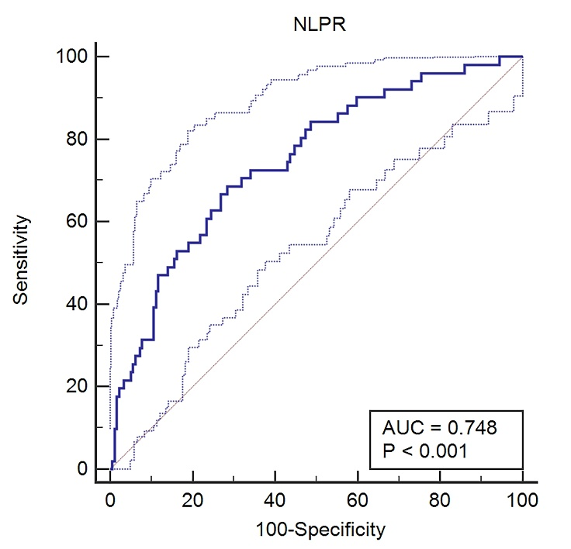

Supplementary Figure 1 Receiver operating characteristic curves for predicting hospital mortality in children with sepsis using the neutrophil-to-lymphocyte and platelet ratio (NLPR). Dashed lines represent 95% confidence intervals.
Abbreviations: AUC, area under the curve.

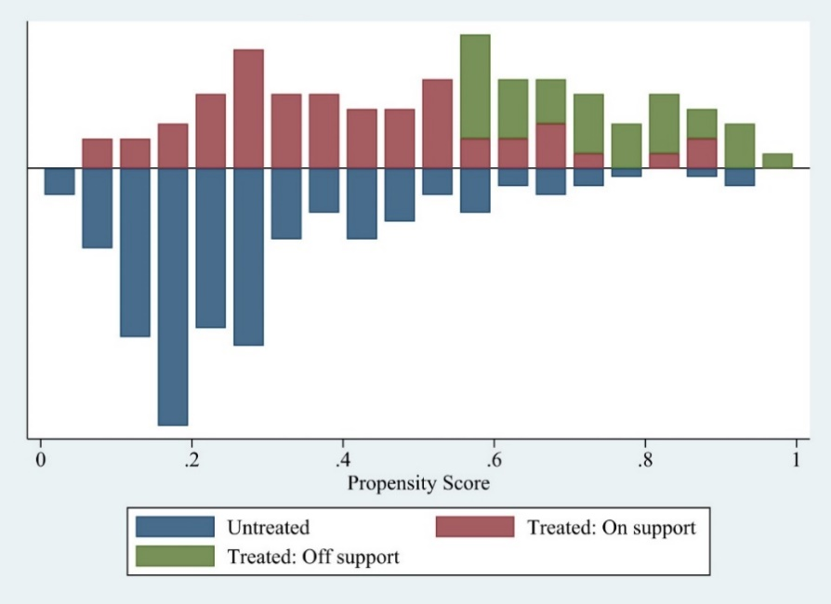

Supplementary Figure 2 Propensity scores for the high NLPR group and low NLPR group.

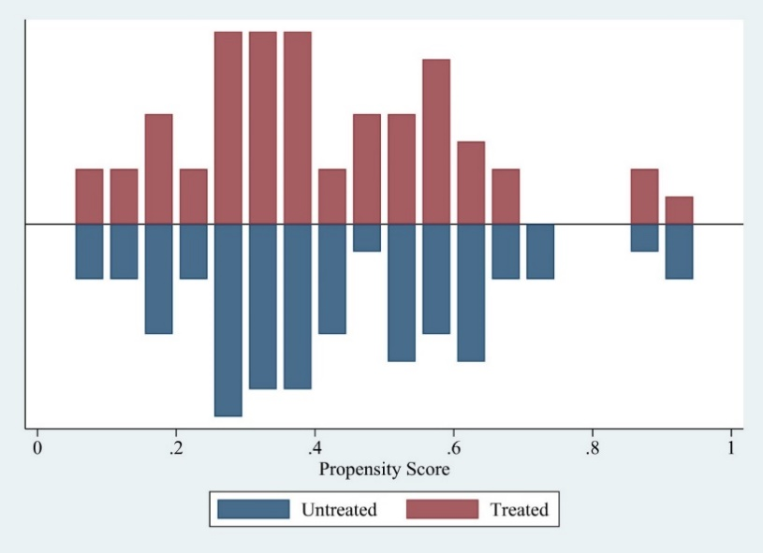

Supplementary Figure 3 Propensity scores for the high NLPR group and low NLPR group after sensitivity analysis.

