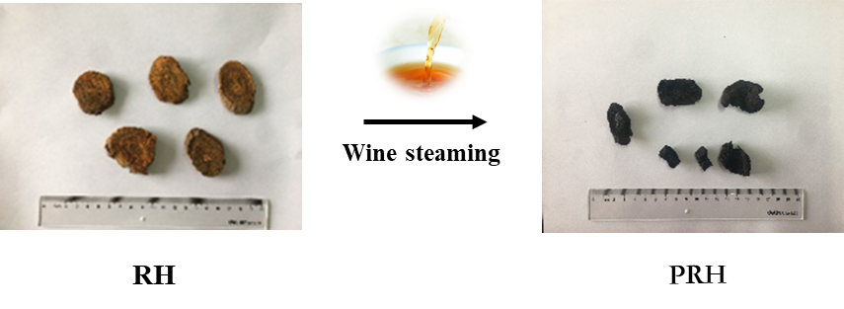

Fig. S1. The picture of RH steamed with wine before and after
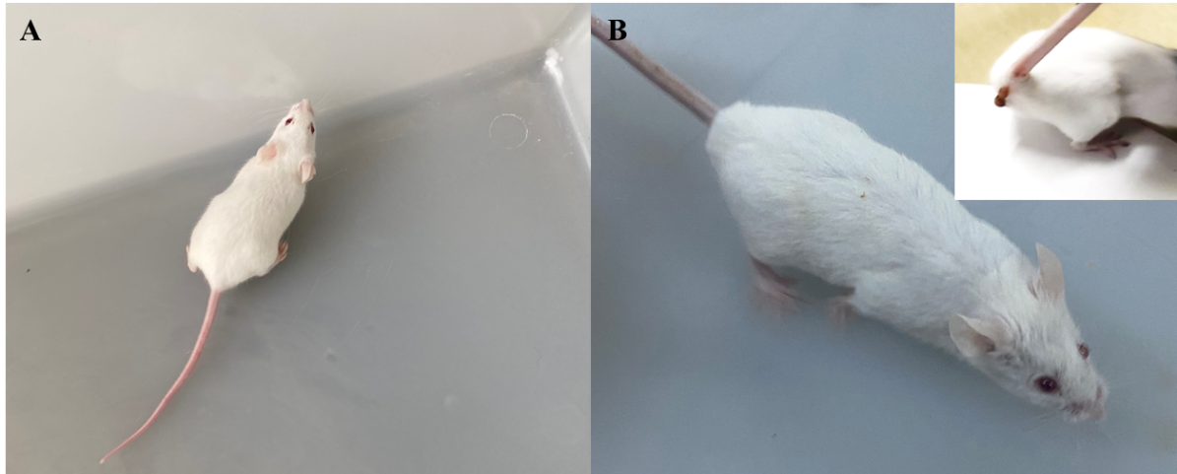

Fig. S2. The result of appearance and behavior in each group (A: control group; B: administration group)
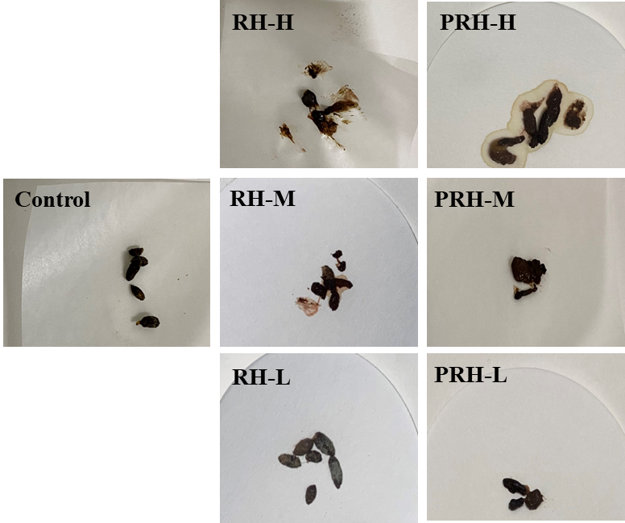

Fig. S3. The fecal morphology of each group

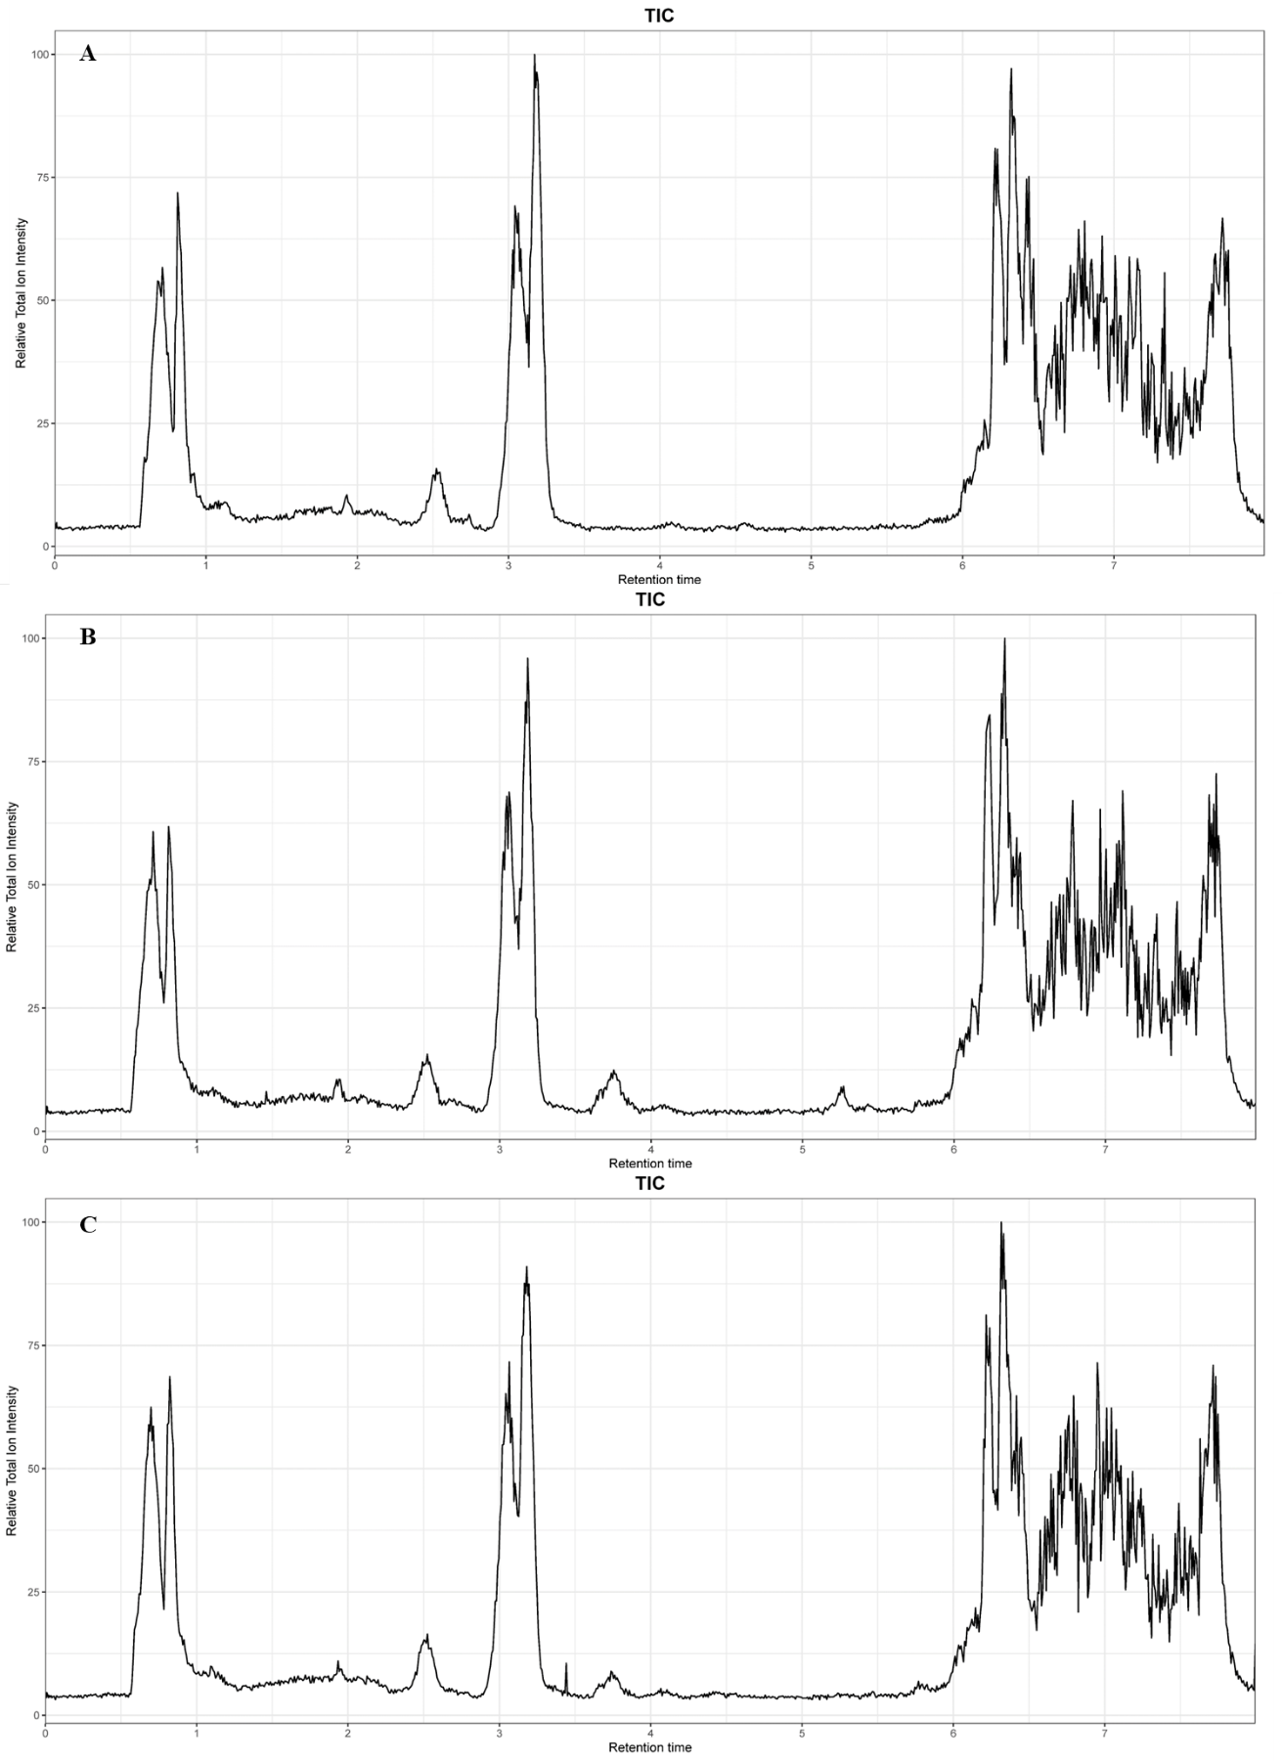

Fig. S4. Base peak intensity (BPI) chromatogram of serum samples (ESI⁺；A, Control; B, RH-H; C, PRH-H)

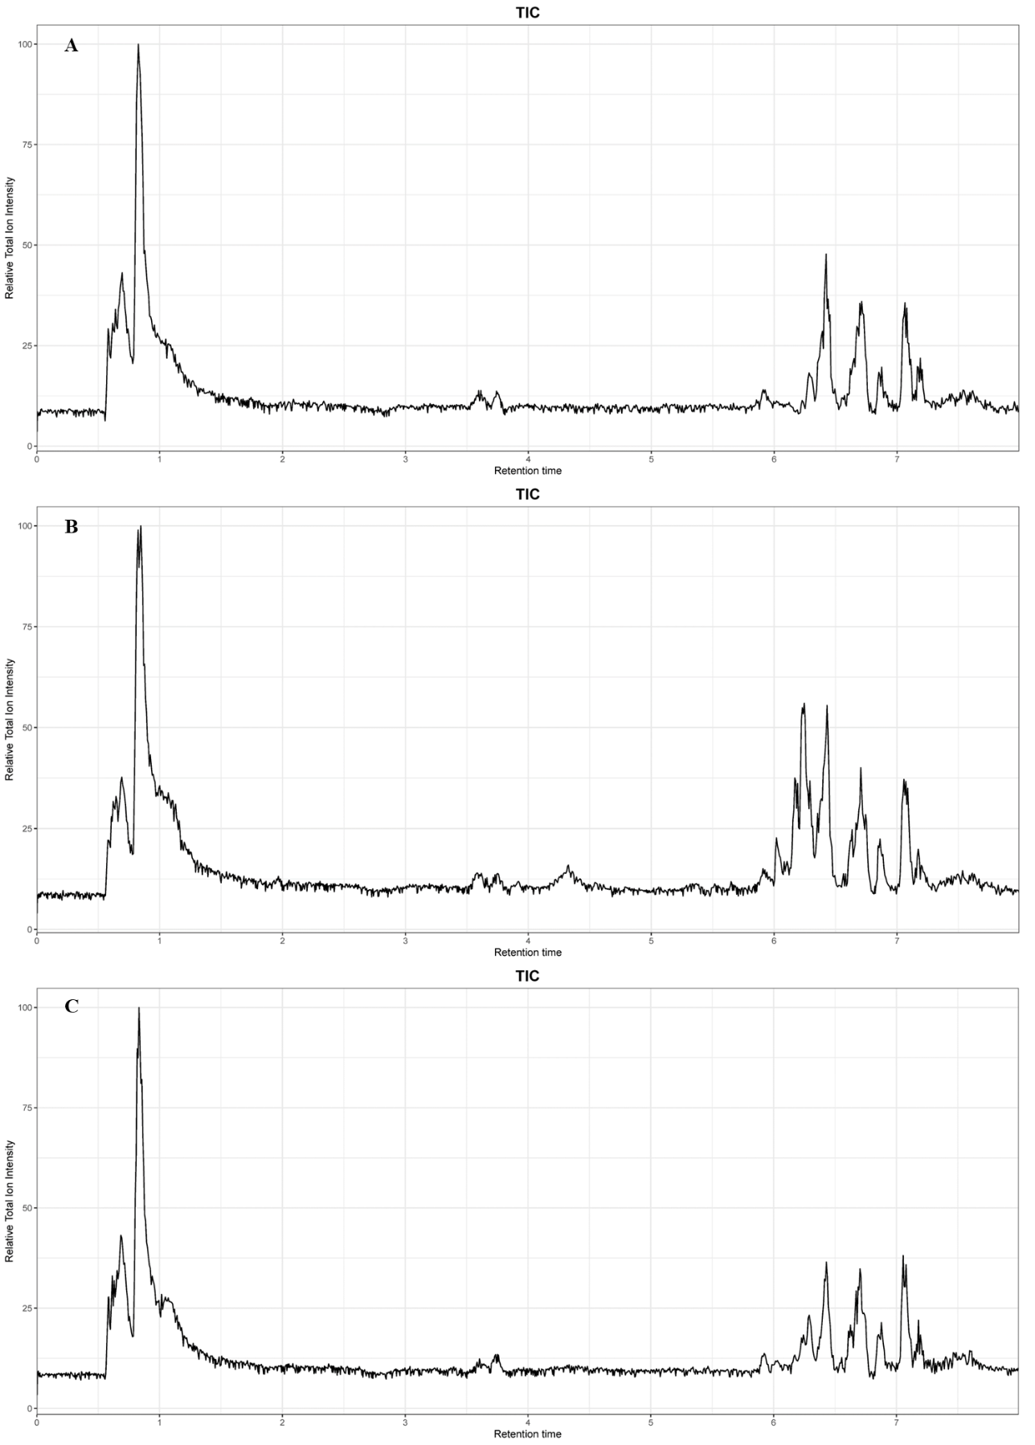

Fig. S5. Base peak intensity (BPI) chromatogram of serum samples (ESI⁻；A, Control; B, RH-H; C, PRH-H)

Fig. S6. The representative MRM chromatograms of standard solutions (Sennoside B, 1; Rhein-8-O-β-D-glucopyranoside, 2; Emodin-8-O-β-D-glucopyranoside, 3; Aloe-emodin-3-(hydroxymethyl)-O-β-D-glucopyranoside, 4; Chrysophanol-8-O-β-D-glucoside, 5; Physcion-8-O-β-D-glucopyranoside, 6; Aloe emodin, 7; Emodin, 8; Chrysophanic acid, 9; Physcion, 10)
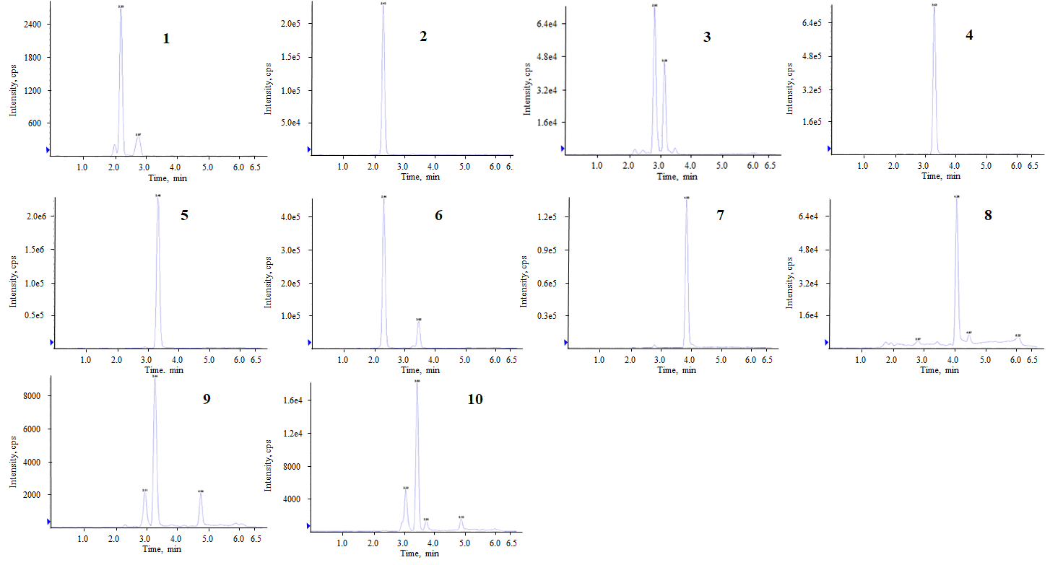
Fig. S7. The representative MRM chromatograms of RH (Sennoside B, 1; Rhein-8-O-β-D-glucopyranoside, 2; Emodin-8-O-β-D-glucopyranoside, 3; Aloe-emodin-3-(hydroxymethyl)-O-β-D-glucopyranoside, 4; Chrysophanol-8-O-β-D-glucoside, 5; Physcion-8-O-β-D-glucopyranoside, 6; Aloe emodin, 7; Emodin, 8; Chrysophanic acid, 9; Physcion, 10)
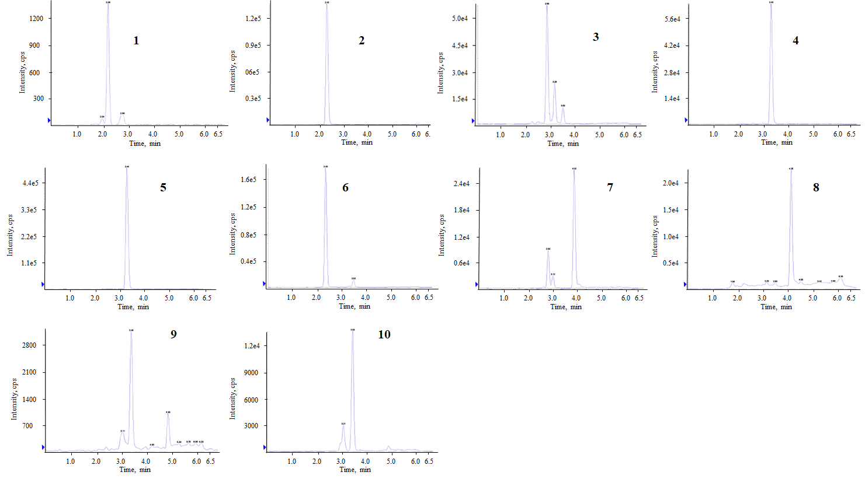

Fig. S8. The representative MRM chromatograms of PRH (Sennoside B, 1; Rhein-8-O-β-D-glucopyranoside, 2; Emodin-8-O-β-D-glucopyranoside, 3; Aloe-emodin-3-(hydroxymethyl)-O-β-D-glucopyranoside, 4; Chrysophanol-8-O-β-D-glucoside, 5; Physcion-8-O-β-D-glucopyranoside, 6; Aloe emodin, 7; Emodin, 8; Chrysophanic acid, 9; Physcion, 10)

Table S1. Identiﬁcation results of potential serum metabolites (n=6, Control vs PRH-H)
No | Metabolite | FC | VIP
1 | (R)-Lipoic acid | 1.191 | 1.687
2 | Salicylaldehyde | 0.731 | 2.721
3 | Aflatoxin G1 | 0.841 | 1.598
4 | 4-coumaroylshikimate | 0.783 | 2.754
5 | Cephalosporin C | 1.218 | 1.829
6 | Luteolin | 0.583 | 3.545
7 | Coniferaldehyde | 0.770 | 2.480
8 | Sn-glycero-3-Phosphoethanolamine | 0.676 | 2.898
9 | PG(13:0/18:0) | 1.265 | 2.104
10 | Gentisic acid | 0.548 | 3.907
11 | Pretyrosine | 0.442 | 3.649
12 | Isopropylmaleic acid | 0.792 | 2.382
13 | Hydroxyphenylacetylglycine | 0.886 | 1.720
14 | 7-Methylxanthosine | 0.591 | 3.980
15 | Apigenin | 0.872 | 1.604
16 | Salidroside | 0.522 | 4.344
17 | Ascorbic Acid | 0.588 | 3.054
18 | Genistein | 0.466 | 3.271

Table S1. Continued
No | Metabolite | FC | VIP
19 | Kaempferol | 0.757 | 2.107
20 | P-Coumaric Acid | 0.832 | 2.211
21 | Tetrahydrofolyl-[Glu](2) | 0.617 | 3.480
22 | 4-Isopropylbenzoic Acid | 0.803 | 2.039
23 | Allantoic acid | 0.704 | 2.326
24 | Isoquercitroside | 0.706 | 2.604
25 | Pimelic Acid | 0.747 | 1.883
26 | Trans-Resveratrol | 0.782 | 1.643
27 | Adenylosuccinic acid | 0.709 | 2.598
28 | Secologanin | 0.697 | 2.606
29 | 2,3-Dihydroxycarbamazepine | 0.753 | 2.270
30 | 3-deoxy-D-manno-octulosonate 8-phosphate | 0.726 | 2.414
31 | Citalopram propionic acid | 0.798 | 2.110
32 | Deoxyloganin | 0.776 | 2.296
33 | D-Sedoheptulose 7-phosphate | 0.719 | 2.719

Table S2. Pathway analysis of potential biomarkers
No. | Pathway | Total | Hits | Raw p | Impact
1 | Glycerophospholipid metabolism | 36 | 2 | 0.018003 | 0.06185
2 | Pentose phosphate pathway | 22 | 1 | 0.12436 | 0.02775
3 | Alanine, aspartate and glutamate metabolism | 28 | 1 | 0.1558 | 0.02163

Table S3. MS parameters of targeted analytes
Compounds | Molecular Weight (MW) | Ion Transitions (m/z)
1 | 863.74 | 861.400/386.200
2 | 488.46 | 445.100/239.100
3 | 432.38 | 431.200/269.000
4 | 432.38 | 431.200/268.200
5 | 416.38 | 415.200/253.100
6 | 446.41 | 445.200/283.100
7 | 270.23 | 269.100 240.100
8 | 270.23 | 269.100/225.100
9 | 254.24 | 253.200/225.100
10 | 284.27 | 283.200/240.200

Table S4 The linear regression equations, linearity range and correlation coefficients for anthraquinone/anthrone
Compounds | Regression equation | Correlation coefficient (r) | Linear range (ng/mL) | LOQ (ng/mL)
1 | Y=19.779X+533.72 | R²=0.9992 | 24.328-4533.817 | 23.501
2 | Y=4659X+10253 | R²=0.9997 | 25.399-5028.764 | 46.287
3 | Y=4017.2X+56254 | R²=0.9992 | 0.986-1103.880 | 11.952
4 | Y=14783X+127264 | R²=0.9993 | 0.987-1056.057 | 10.528
5 | Y=14918X+180361 | R²=0.9991 | 0.993-1043.685 | 32.592
6 | Y=12689X-23266 | R²=0.9996 | 0.991-1239.356 | 10.261
7 | Y=4026.1X+48060 | R²=0.9994 | 0.999-1078.589 | 15.594
8 | Y=3173.5X+27731 | R²=0.9995 | 0.992-1098.585 | 13.026
9 | Y=962.04X+4473.6 | R²=0.9995 | 1.036-1233.150 | 12.214
10 | Y=404.24X+1737.1 | R²=0.9992 | 1.002-1201.755 | 11.655

Table S5 The results of the precision, repeatability, stability and Recovery (n=6)
Compounds | Precision  RSD (%) | Repeatability  RSD (%) | Stability  RSD (%) | Recovery  RSD (%)
1 | 1.87 | 2.25 | 2.21 | 1.68
2 | 2.25 | 2.74 | 2.82 | 2.94
3 | 1.81 | 0.93 | 1.39 | 2.06
4 | 2.49 | 2.21 | 2.37 | 1.85
5 | 2.51 | 2.89 | 2.63 | 2.46
6 | 1.91 | 2.92 | 2.89 | 2.85
7 | 2.39 | 2.59 | 2.81 | 2.65
8 | 1.43 | 2.87 | 1.58 | 1.46
9 | 1.25 | 2.8 | 2.25 | 2.07
10 | 2.41 | 1.85 | 2.76 | 1.98

