Supplementary Materials
Figure S1 Flowchart showing the selection of study participants 2
Figure S2 Hazard ratios (HRs) of total mortality per 5-point increase in overall low-carbohydrate-diet and low-fat-diet scores by subgroups. 3
Table S1 Criteria for determining the low-carbohydrate-diet scores. 4
Table S2 Criteria for determining the low-fat-diet scores. 5
Table S3 Correlation matrix between six low-carbohydrate and low-fat diets scores. 6

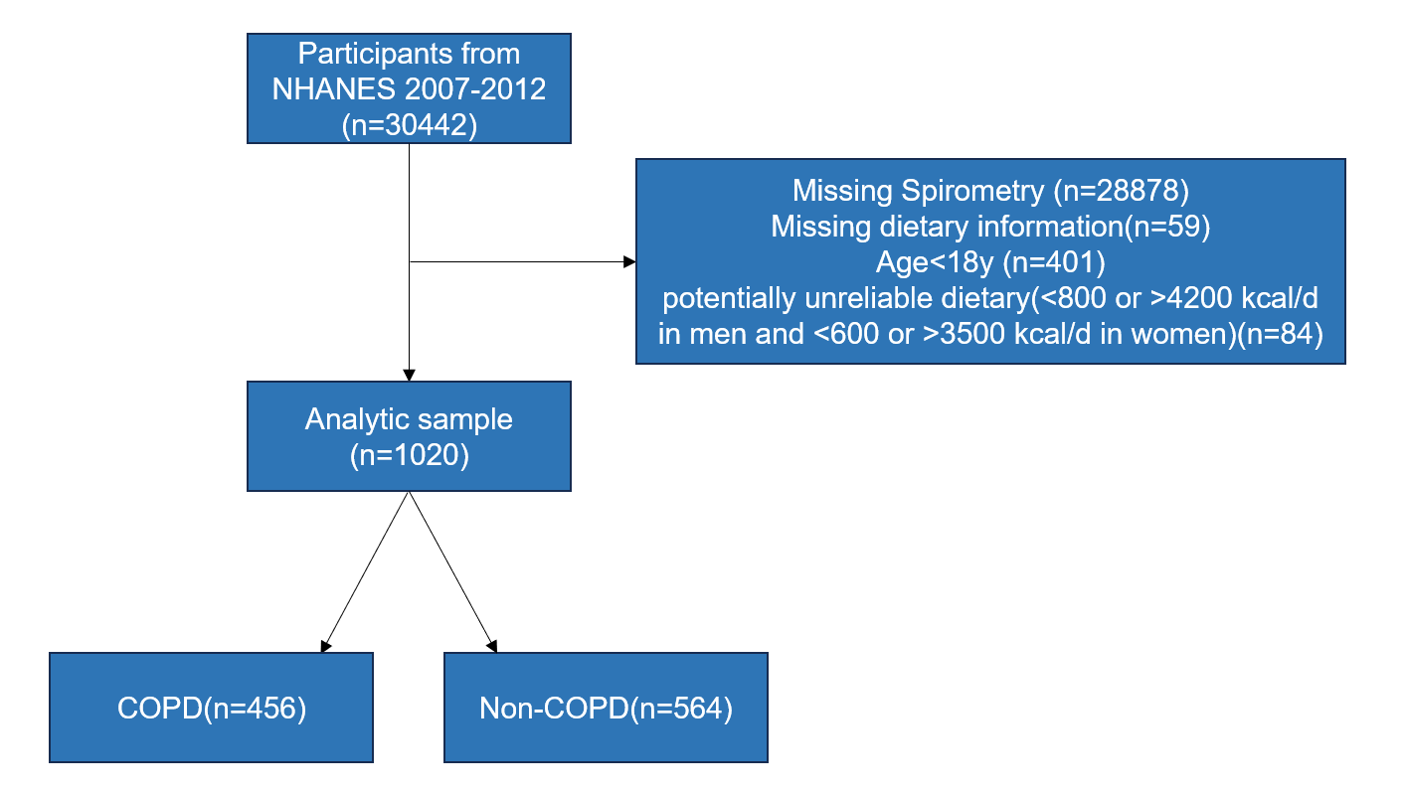
Figure S1 Flowchart showing the selection of study participants.

Abbreviations: NHANES, National Health and Nutrition Examination Survey; COPD, chronic obstructive pulmonary disease.

Figure S2 Hazard ratios (HRs) of total mortality per 5-point increase in overall low-carbohydrate-diet and low-fat-diet scores by subgroups.

Notes: Results were adjusted for Age, Sex, Race/ethnicity, BMI, Family income to poverty ratio, Smoking, Education, History of cancer, Hypertension, History of heart disease, Total calories excluding the corresponding subgroup variates.
Abbreviations: OLCD, overall low-carbohydrate-diet score; OLFD, overall low-fat-diet score.

Table S1. Criteria for determining the low-carbohydrate-diet scores.
 | Overall Low-Carbohydrate-Diet Score |  |  | Unhealthy Low-Carbohydrate-Diet Score |  |  | Healthy Low-Carbohydrate-Diet Score
Points | Total carbohydrate | Total fat | Total protein | High-quality carbohydrate | Animal protein | Saturated fat | Low-quality carbohydrate | Plant protein | Unsaturated fat
0 | >65.18 | <21.53 | <9.34 | >35.34 | <5.28 | <6.15 | >58.48 | <3.59 | <11.58
1 | 60.78-65.18 | 21.53-25.27 | 9.34-10.95 | 28.74-35.34 | 5.28-7.33 | 6.15-7.56 | 53.74-58.48 | 3.59-4.92 | 11.58-13.78
2 | 57.68-60.78 | 25.27-27.93 | 10.95-12.10 | 24.31-28.74 | 7.33-8.68 | 7.56-8.63 | 50.32-53.74 | 4.92-5.94 | 13.78-15.37
3 | 55.15-57.68 | 27.93-30.14 | 12.10-13.09 | 20.91-24.31 | 8.68-9.83 | 8.63-9.53 | 47.29-50.32 | 5.94-6.90 | 15.37-16.79
4 | 52.84-55.15 | 30.14-32.07 | 13.09-14.04 | 17.89-20.91 | 9.83-10.85 | 9.53-10.40 | 44.58-47.29 | 6.90-7.80 | 16.79-18.12
5 | 50.52-52.84 | 32.07-33.91 | 14.04-14.96 | 15.21-17.89 | 10.85-11.86 | 10.40-11.26 | 41.77-44.58 | 7.80-8.76 | 18.12-19.38
6 | 48.05-50.52 | 33.91-35.86 | 14.96-16.01 | 12.45-15.21 | 11.86-12.97 | 11.26-12.15 | 38.72-41.77 | 8.76-9.78 | 19.38-20.73
7 | 45.36-48.05 | 35.86-37.96 | 16.01-17.20 | 9.64-12.45 | 12.97-14.22 | 12.15-13.19 | 35.20-38.72 | 9.78-10.92 | 20.73-22.24
8 | 42.13-45.36 | 37.96-40.50 | 17.20-18.79 | 6.59-9.64 | 14.22-15.88 | 13.19-14.43 | 30.83-35.20 | 10.92-12.36 | 22.24-24.13
9 | 37.25-42.13 | 40.50-44.31 | 18.79-21.42 | 2.49-6.59 | 15.88-18.43 | 14.43-16.37 | 23.98-30.83 | 12.36-14.59 | 24.13-26.82
10 | <37.25 | >44.31 | >21.42 | <2.49 | >18.43 | >16.37 | <23.98 | >14.59 | >26.82

Table S2. Criteria for determining the low-fat-diet scores.
 | Overall Low-Fat-Diet Score |  |  | Unhealthy Low-Fat-Diet Score |  |  | Healthy Low-Fat-Diet Score
Points | Total fat | Total carbohydrate | Total protein | Unsaturated fat | Low-quality carbohydrate | Animal protein | Saturated fat | High-quality carbohydrate | Plant protein
0 | >44.31 | <37.25 | <9.34 | >26.82 | <23.98 | <5.28 | >16.37 | <2.49 | <3.59
1 | 40.50-44.31 | 37.25-42.13 | 9.34-10.95 | 24.13-26.82 | 23.98-30.83 | 5.28-7.33 | 14.43-16.37 | 2.49-6.59 | 3.59-4.92
2 | 37.96-40.50 | 42.13-45.36 | 10.95-12.10 | 22.24-24.13 | 30.83-35.20 | 7.33-8.68 | 13.19-14.43 | 6.59-9.64 | 4.92-5.94
3 | 35.86-37.96 | 45.36-48.05 | 12.10-13.09 | 20.73-22.24 | 35.20-38.72 | 8.68-9.83 | 12.15-13.19 | 9.64-12.45 | 5.94-6.90
4 | 33.91-35.86 | 48.05-50.52 | 13.09-14.04 | 19.38-20.73 | 38.72-41.77 | 9.83-10.85 | 11.26-12.15 | 12.45-15.21 | 6.90-7.80
5 | 32.07-33.91 | 50.52-52.84 | 14.04-14.96 | 18.12-19.38 | 41.77-44.58 | 10.85-11.86 | 10.40-11.26 | 15.21-17.89 | 7.80-8.76
6 | 30.14-32.07 | 52.84-55.15 | 14.96-16.01 | 16.79-18.12 | 44.58-47.29 | 11.86-12.97 | 9.53-10.40 | 17.89-20.91 | 8.76-9.78
7 | 27.93-30.14 | 55.15-57.68 | 16.01-17.20 | 15.37-16.79 | 47.29-50.32 | 12.97-14.22 | 8.63-9.53 | 20.91-24.31 | 9.78-10.92
8 | 25.27-27.93 | 57.68-60.78 | 17.20-18.79 | 13.78-15.37 | 50.32-53.74 | 14.22-15.88 | 7.56-8.63 | 24.31-28.74 | 10.92-12.36
9 | 21.53-25.27 | 60.78-65.18 | 18.79-21.42 | 11.58-13.78 | 53.74-58.48 | 15.88-18.43 | 6.15-7.56 | 28.74-35.34 | 12.36-14.59
10 | <21.53 | >65.18 | >21.42 | <11.58 | >58.48 | >18.43 | <6.15 | >35.34 | >14.59

Table S3. Correlation matrix between six low-carbohydrate and low-fat diets scores.
 | Overall Low-Carbohydrate-Diet Score | Unhealthy Low-Carbohydrate-Diet Score | Healthy Low-Carbohydrate-Diet Score | Overall Low-Fat-Diet Score | Unhealthy Low-Fat-Diet Score | Healthy Low-Fat-Diet Score
Overall Low-Carbohydrate-Diet Score | 1 | 0.71 | 0.77 | -0.57 | -0.46 | -0.29
Unhealthy Low-Carbohydrate-Diet Score | 0.71 | 1 | 0.28 | -0.40 | -0.03 | -0.70
Healthy Low-Carbohydrate-Diet Score | 0.77 | 0.28 | 1 | -0.57 | -0.67 | 0.18
Overall Low-Fat-Diet Score | -0.57 | -0.40 | -0.57 | 1 | 0.80 | 0.48
Unhealthy Low-Fat-Diet Score | -0.46 | -0.03 | -0.67 | 0.80 | 1 | 0.19
Healthy Low-Fat-Diet Score | -0.29 | -0.70 | 0.18 | 0.48 | 0.19 | 1

