Supplementary Materials

Effectiveness of PK-guided personalized recombinant FVIII treatment in patients with hemophilia A: Clinical case experiences based on an observational study
Yoko Mizoguchi¹
Moeko Hino²
Hitoshi Ueda³
Yasuo Miyaguchi³
Masao Kobayashi^{1,4}

¹Department of Pediatrics, Hiroshima University Graduate School of Biomedical Sciences, Hiroshima, Japan; ²Department of Pediatrics, Chiba University Hospital, Chiba, Japan; ³Japan Medical Office, Takeda Pharmaceutical Company Limited, Tokyo, Japan; ⁴Japanese Red Cross, Chugoku-Shikoku Block Blood Center, Hiroshima, Japan

Correspondence: Yasuo Miyaguchi
Japan Medical Office, Takeda Pharmaceutical Company Limited
2 Chome-1-1 Nihonbashihoncho, Chuo-ku
Tokyo, 103-0023, Japan
Tel (optional) +81 070-4921-7966
Email yasuo.miyaguchi1@takeda.com

List of Tables and Figures
Supplementary Figure 1
Supplementary Figure 2
Supplementary Figure 1 Study design overview. Star indicates PK simulation with myPKFit.
Abbreviations: ICF, informed consent form; PK, pharmacokinetic.
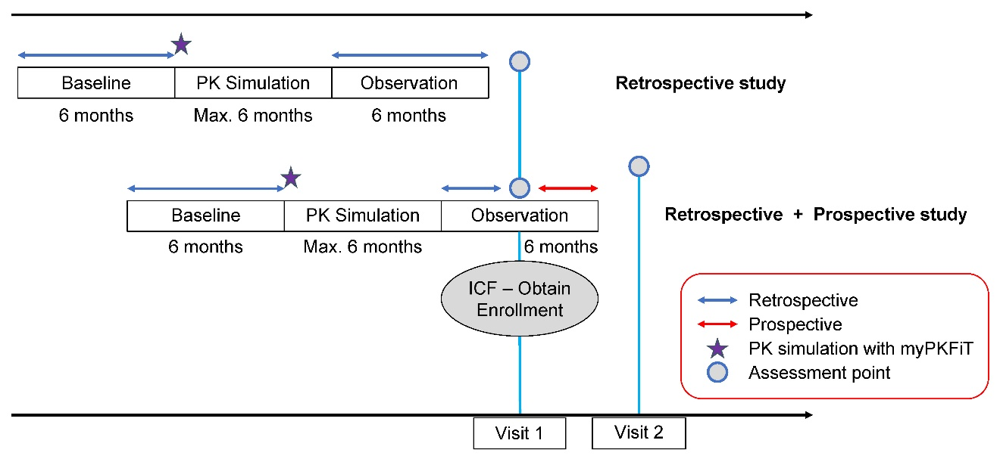
Supplementary Figure 2 Quality of life per individual patient assessed by the SF-36 for patients aged <8 years (A, B, C, D, E, F, G, H) and patients aged ≥16 years (I, J, K, L, M, N, O, P) or by the KIDSCREEN-27 form for patients aged ≥8 years and <16 years (Q, R, S, T, U).
Abbreviations: BP, bodily pain; GH, general health; MH, mental health; PF, physical functioning; RE, role-emotional; RP, role-physical; SF, social functioning; SF-36, 36-Item Short Form Survey; VT, vitality.
