Supplementary Materials

Supplementary Figure 1 Tolerability and Acceptability Questionnaire.
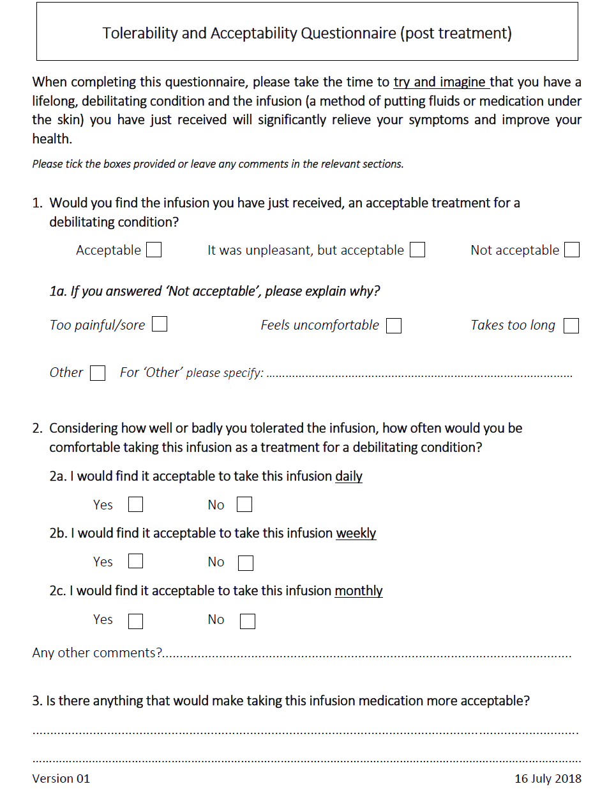
Supplementary Figure 2 CONSORT diagram.
Analyzed (n = 24)
♦ Did not receive all infusions, data were summarised for other infusion when available (n = 3)
Allocated to intervention (n = 24)
♦ Withdrew early but received treatment (n = 3)
Participant reached protocol-defined stopping criteria (n = 3)
Excluded (n = 20)
♦ Did not meet inclusion/exclusion criteria (n = 13)
♦ Logistics (Reserve not used) (n = 7)

Lost to follow-up (n = 0)

Follow-Up

Analysis

Allocation
Randomized (n = 24)

Enrolment
Assessed for eligibility (n = 44)
 |  | A  1 mL in 10 s, rate = 6.00 mL/min,  hold = 62 s,  n = 47 | B  5 mL in 1.2 min, rate = 4.17 mL/min, hold = 0 s,  n = 47 | C  4 mL in 58 s, rate = 4.14 mL/min, hold = 62 s,  n = 23 | D  5 mL in 2 min, rate = 2.50 mL/min, hold =  0 s, n = 23 | E  5 mL in 3 min, rate = 1.67 mL/min, hold = 0 s,  n = 23 | F  5 mL in 2 min  5 s, rate = 2.40 mL/min, hold = 55 s, n = 23 | G  4 mL in 2 min, rate = 2.00 mL/min,  hold = 30 s,  n = 21 | H  3 mL in 2 min, rate = 1.50 mL/min, hold = 30 s  n = 21
Leakage | 0–6 mm | 45 (96) | 38 (81) | 22 (96) | 16 (70) | 20 (87) | 20 (87) | 15 (71) | 20 (95)
Leakage | >6 mm | 2 (4) | 9 (19) | 1 (4) | 7 (30) | 3 (13) | 3 (13) | 6 (29) | 1 (5)
Local Oedema/Wheal Formation | None | 47 (100) | 45 (96) | 23 (100) | 23 (100) | 22 (96) | 23 (100) | 21 (100) | 21 (100)
Local Oedema/Wheal Formation | Mild | 0 | 2 (4) | 0 | 0 | 1 (4) | 0 | 0 | 0
Local Oedema/Wheal Formation | Moderate | 0 | 0 | 0 | 0 | 0 | 0 | 0 | 0
Local Oedema/Wheal Formation | Severe | 0 | 0 | 0 | 0 | 0 | 0 | 0 | 0
Erythema | None | 26 (55) | 23 (49) | 2 (9) | 4 (17) | 2 (9) | 3 (13) | 5 (24) | 4 (19)
Erythema | Mild | 17 (36) | 13 (28) | 8 (35) | 10 (43) | 14 (61) | 10 (43) | 5 (24) | 12 (57)
Erythema | Moderate | 4 (9) | 11 (23) | 13 (57) | 9 (39) | 6 (26) | 10 (43) | 10 (48) | 5 (24)
Erythema | Severe | 0 | 0 | 0 | 0 | 1 (4) | 0 | 1 (5) | 0
Bruising | None | 47 (100) | 47 (100) | 23 (100) | 23 (100) | 23 (100) | 23 (100) | 21 (100) | 21 (100)
Bruising | Mild | 0 | 0 | 0 | 0 | 0 | 0 | 0 | 0
Bruising | Moderate | 0 | 0 | 0 | 0 | 0 | 0 | 0 | 0
Bruising | Severe | 0 | 0 | 0 | 0 | 0 | 0 | 0 | 0
Supplementary Table 1 Infusion site assessments performed at 0 min post-treatment. Data shown as n (%), where the denominator is the number of assessments made
Note: n refers to the number of observations in the total number of participants (N = 24; number of participants in the population)
VAS, visual analogue scale.

Supplementary Table 2 Infusion site assessments performed at 1 h post-treatment. Data shown as n (%), where the denominator is the number of assessments made
 |  | A  1 mL in 10 s, rate = 6.00 mL/min,  hold = 62 s,  n = 47 | B  5 mL in 1.2 min, rate = 4.17 mL/min, hold = 0 s,  n = 47 | C  4 mL in 58 s, rate = 4.14 mL/min, hold = 62 s,  n = 23 | D  5 mL in 2 min, rate = 2.50 mL/min, hold = 0 s,  n = 23 | E  5 mL in 3 min, rate = 1.67 mL/min, hold = 0 s,  n = 23 | F  5 mL in 2 min 5 s, rate = 2.40 mL/min, hold = 55 s  n = 23 | G  4 mL in 2 min, rate = 2.00 mL/min,  hold = 30 s,  n = 21 | H  3 mL in 2 min, rate = 1.50 mL/min, hold = 30 s,  n = 21
Leakage | 0–6 mm | 47 (100) | 47 (100) | 23 (100) | 23 (100) | 23 (100) | 23 (100) | 21 (100) | 21 (100)
Leakage | >6 mm | 0 | 0 | 0 | 0 | 0 | 0 | 0 | 0
Local Oedema/Wheal Formation | None | 47 (100) | 47 (100) | 22 (96) | 21 (91) | 20 (87) | 21 (91) | 20 (95) | 19 (90)
Local Oedema/Wheal Formation | Mild | 0 | 0 | 1 (4) | 2 (9) | 3 (13) | 2 (9) | 1 (5) | 2 (10)
Local Oedema/Wheal Formation | Moderate | 0 | 0 | 0 | 0 | 0 | 0 | 0 | 0
Local Oedema/Wheal Formation | Severe | 0 | 0 | 0 | 0 | 0 | 0 | 0 | 0
Erythema | None | 39 (83) | 37 (79) | 21 (91) | 23 (100) | 14 (61) | 17 (74) | 13 (62) | 15 (71)
Erythema | Mild | 8 (17) | 9 (19) | 2 (9) | 0 | 9 (39) | 6 (26) | 8 (38) | 6 (29)
Erythema | Moderate | 0 | 1 (2) | 0 | 0 | 0 | 0 | 0 | 0
Erythema | Severe | 0 | 0 | 0 | 0 | 0 | 0 | 0 | 0
Bruising | None | 47 (100) | 47 (100) | 23 (100) | 22 (96) | 22 (96) | 22 (96) | 21 (100) | 21 (100)
Bruising | Mild | 0 | 0 | 0 | 1 (4) | 1 (4) | 1 (4) | 0 | 0
Bruising | Moderate | 0 | 0 | 0 | 0 | 0 | 0 | 0 | 0
Bruising | Severe | 0 | 0 | 0 | 0 | 0 | 0 | 0 | 0

Note: n refers to the number of observations in the total number of participants (N = 24; number of participants in the population

