Supporting Information

Iron-based nanoplatforms achieve hepatocellular carcinoma regression through a cascade of effects

Figure S1. EC content in the supernatant before and after synthesis of the GOx/EC@Fe₃O₄@CCM nanoplatforms.

Figure S2. Fe²⁺ release test from the GOx/EC@Fe₃O₄@CCM nanoplatforms.

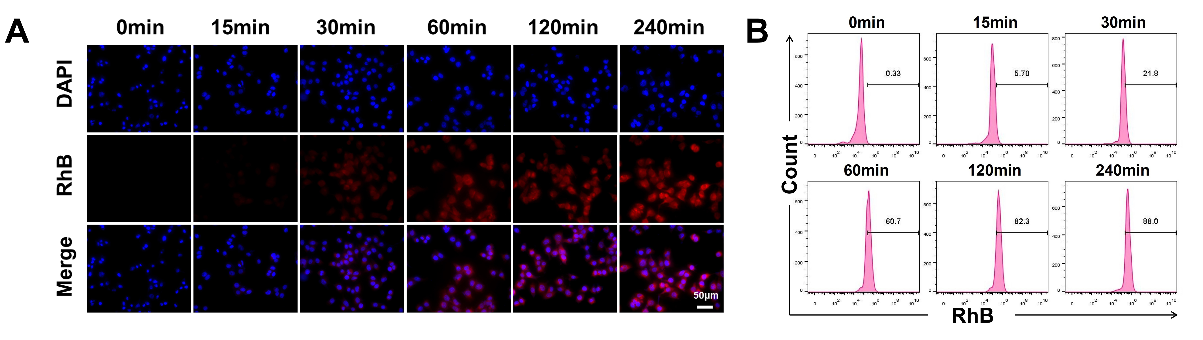

Figure S3. Fluorescence images of the uptake of RhB-labeled GOx/EC@Fe₃O₄@CCM nanoplatforms by Hepa1-6 cells at different time points (A), as well as flow cytometry (B). Scale bar: 50 μm. G1: Control, G2: GOx@Fe₃O₄, G3: EC@Fe₃O₄, G4: GOx/EC@Fe₃O₄, G5: GOx/EC@Fe₃O₄@CCM.

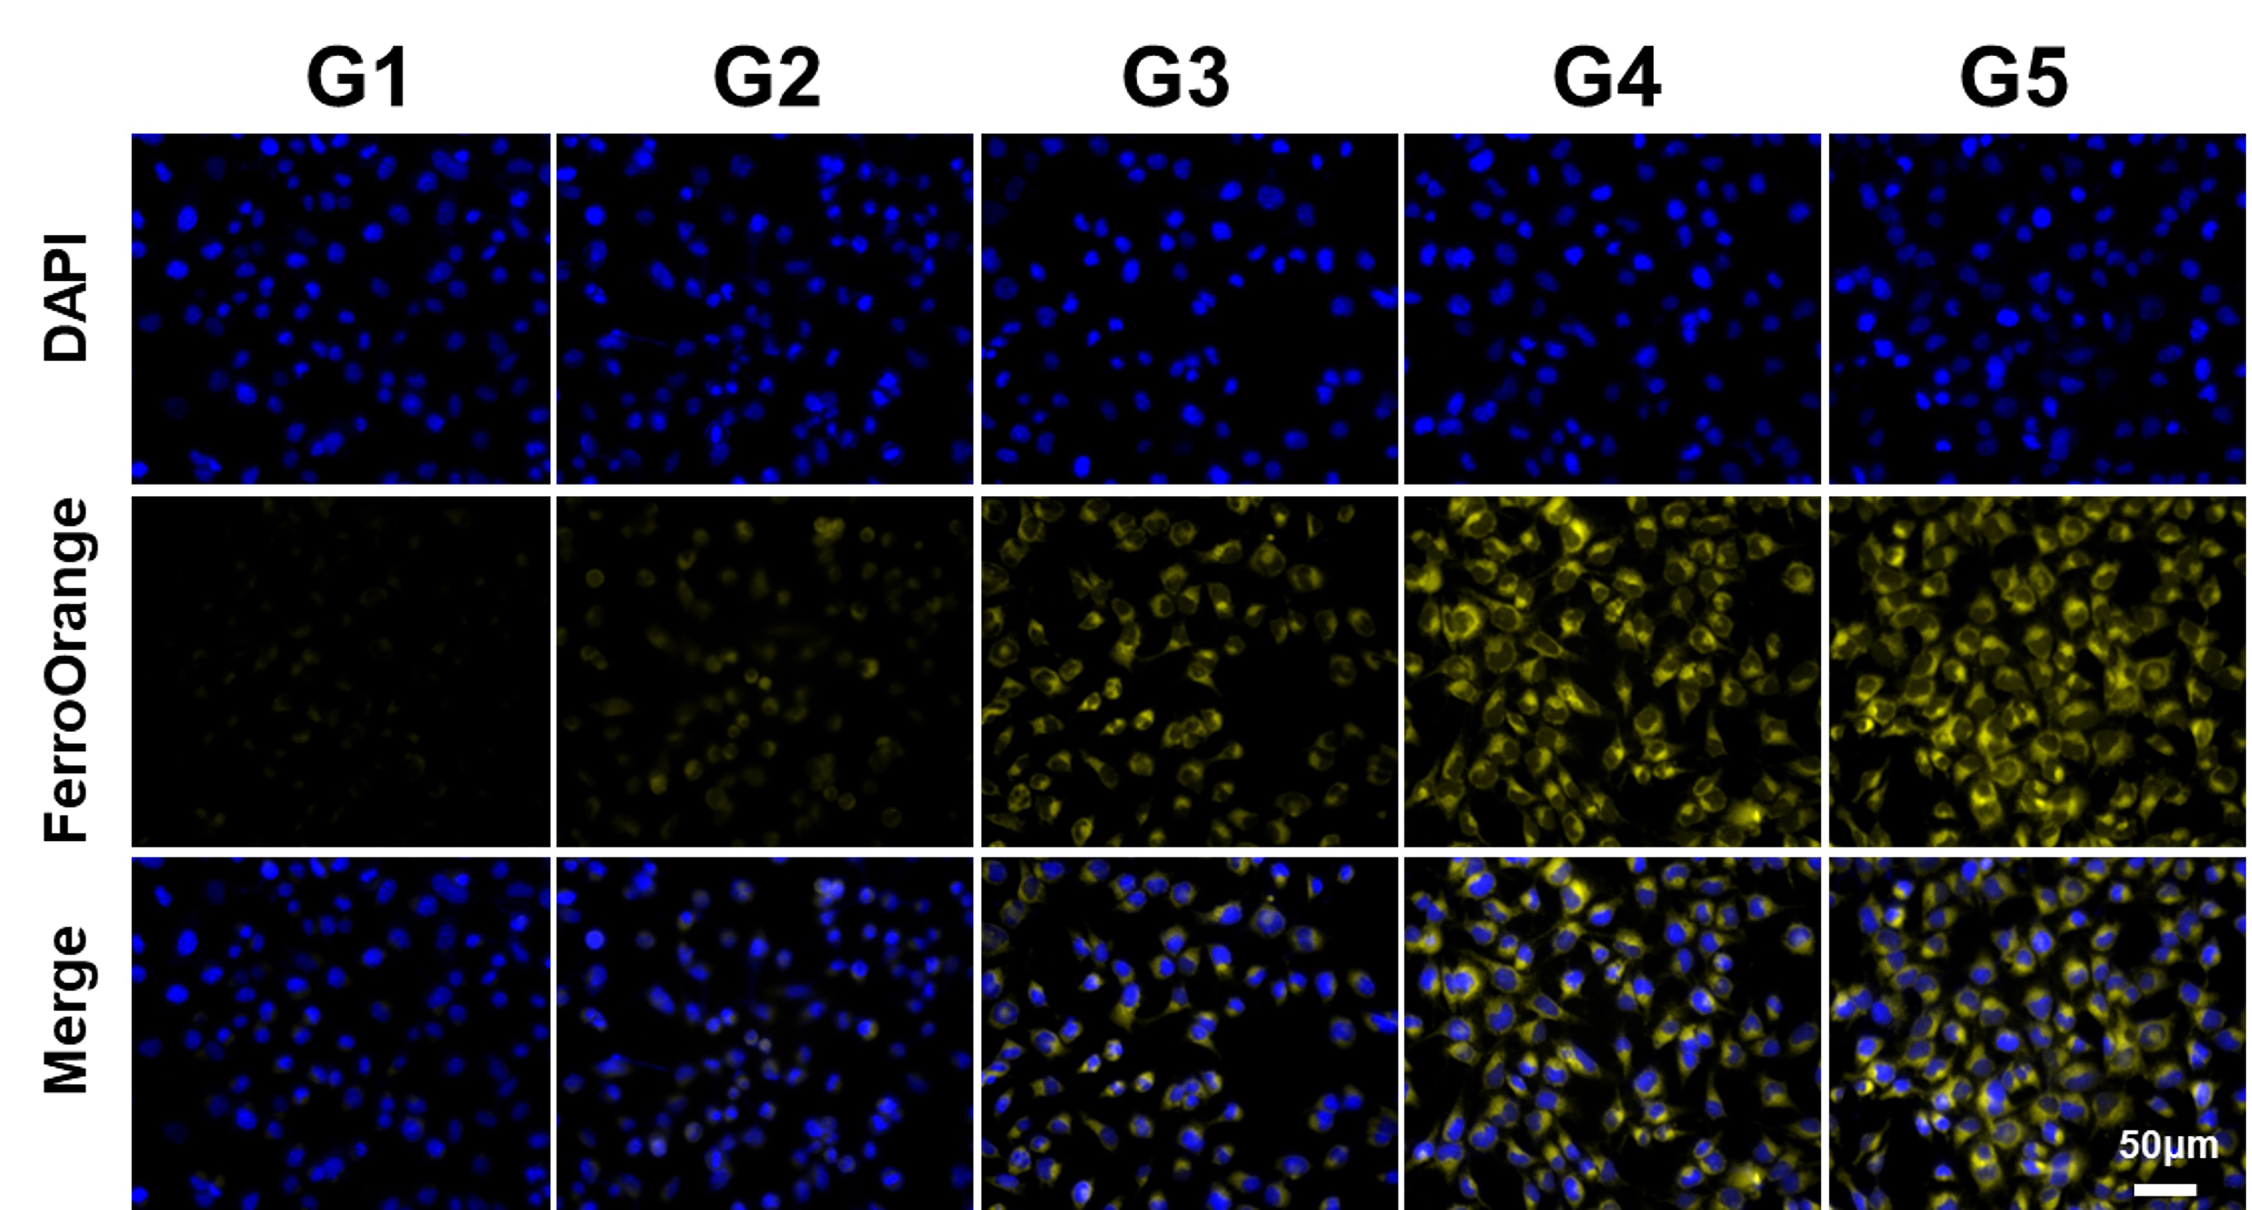

Figure S4. Intracellular FerroOrange fluorescence staining images of Hepa1-6 cells after different treatments . Scale bar: 50 μm. G1: Control, G2: GOx@Fe₃O₄, G3: EC@Fe₃O₄, G4: GOx/EC@Fe₃O₄, G5: GOx/EC@Fe₃O₄@CCM.

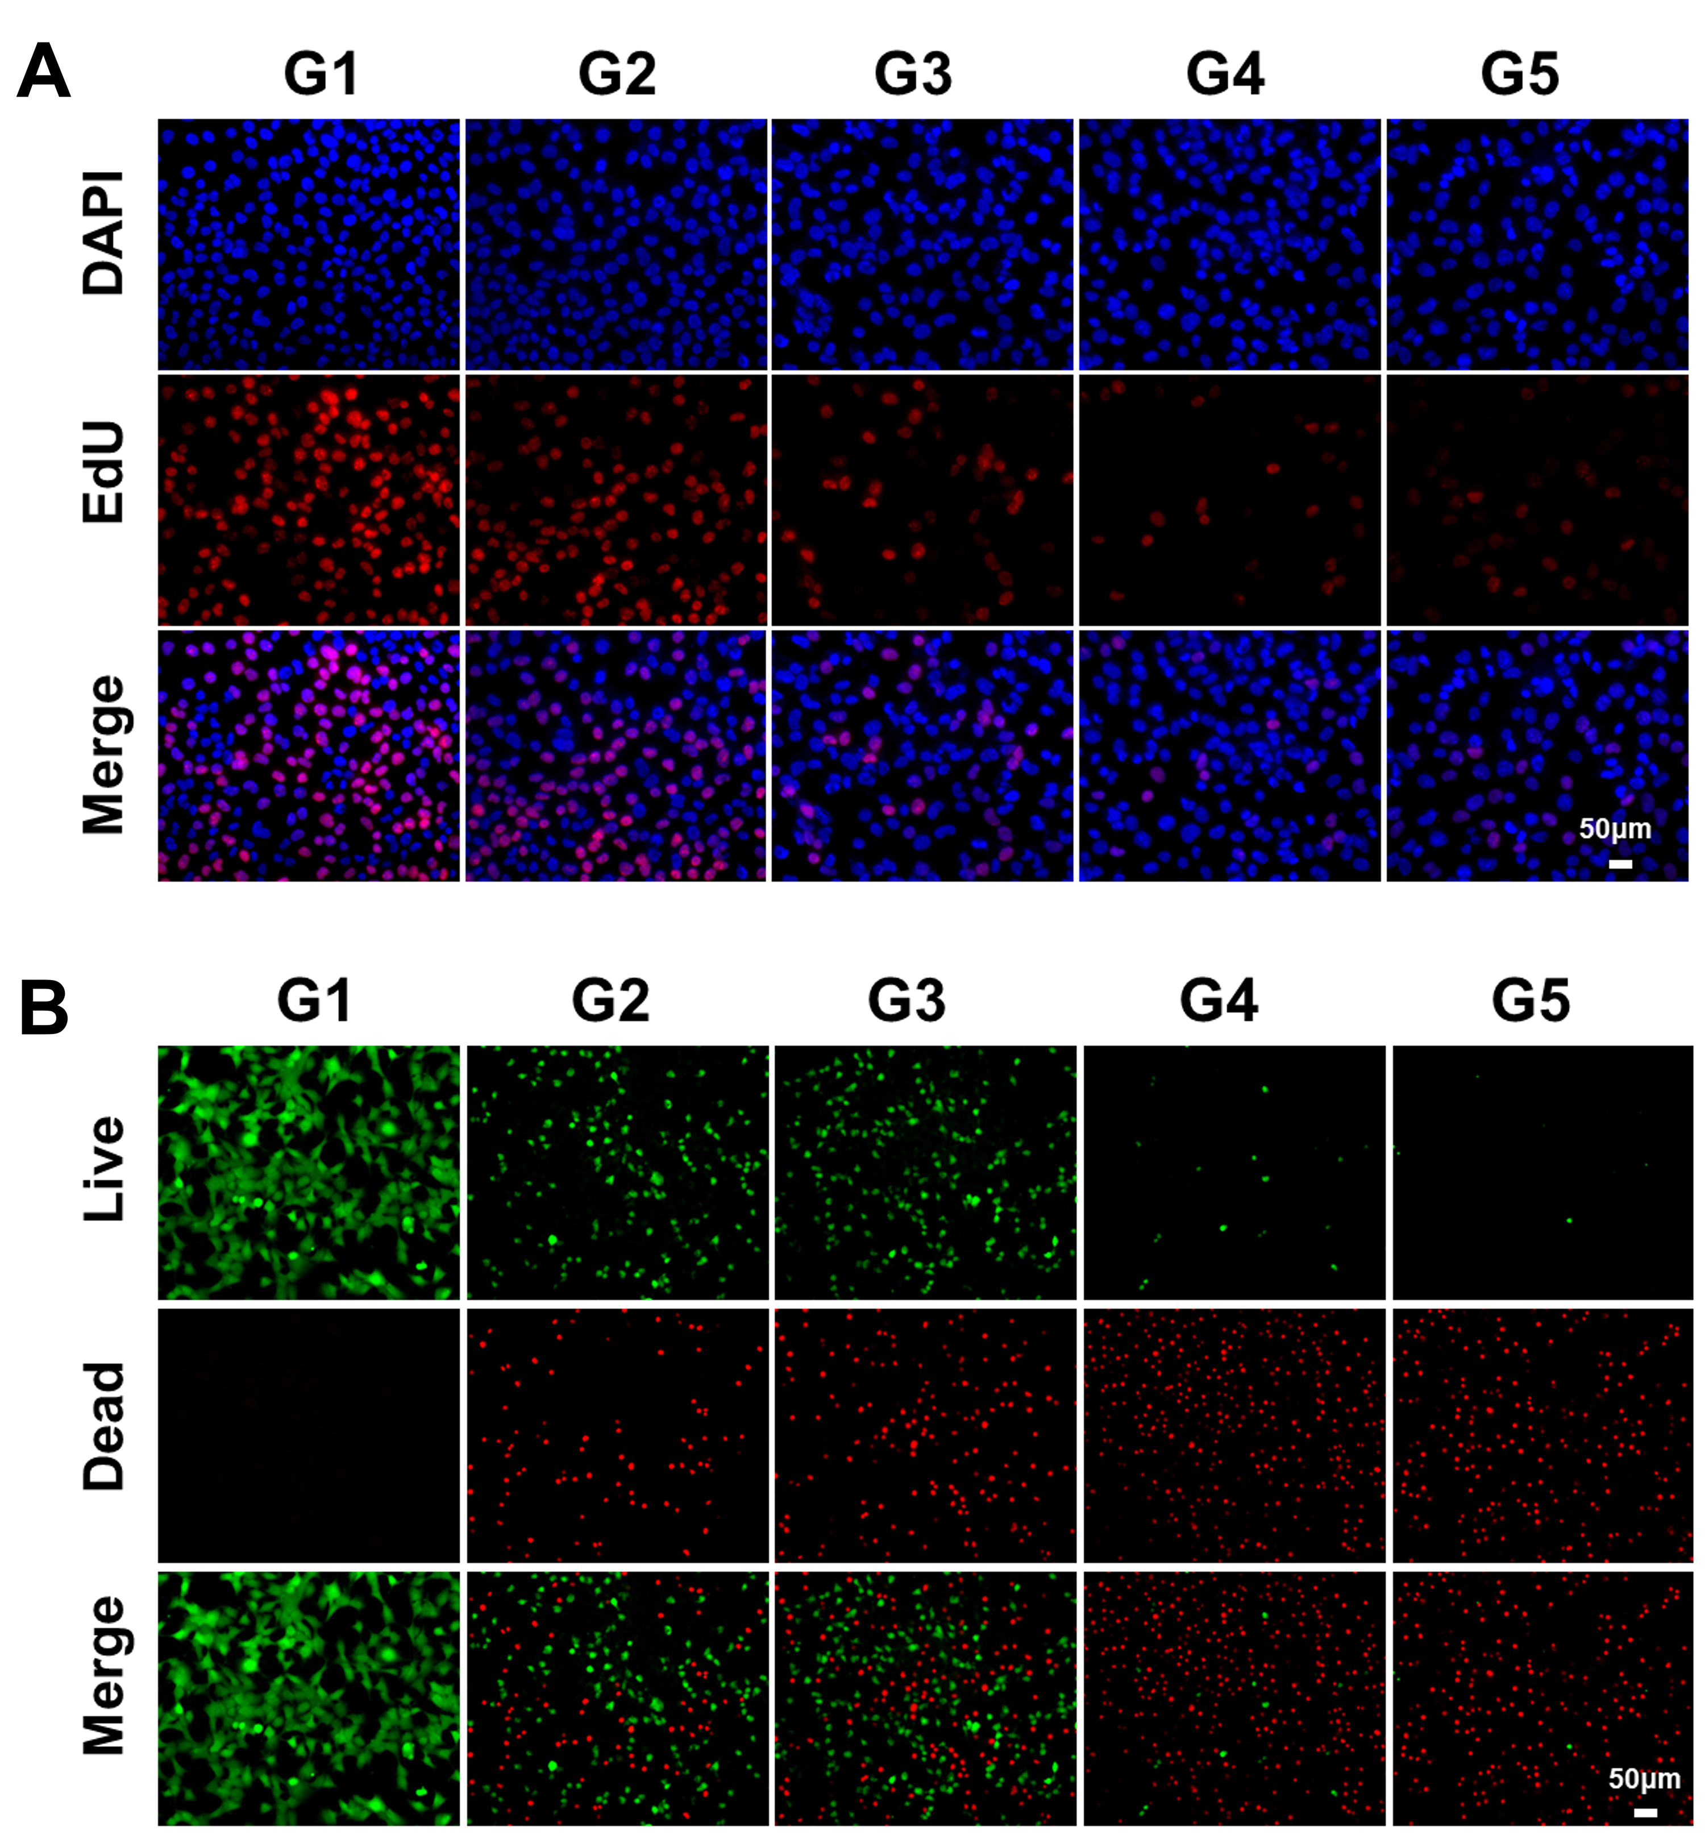

Figure S5. Images of intracellular EdU staining of Hepa1-6 cells after different treatments (A). Calcein AM/PI staining images of Hepa1-6 cells after different treatments (B). Scale bar: 50 μm. G1: Control, G2: GOx@Fe₃O₄, G3: EC@Fe₃O₄, G4: GOx/EC@Fe₃O₄, G5: GOx/EC@Fe₃O₄@CCM.

Figure S6. The GOx/ EC@Fe₃O₄@CCM nanoplatforms was used to test the safety of healthy liver THLE-2 cells in vitro.

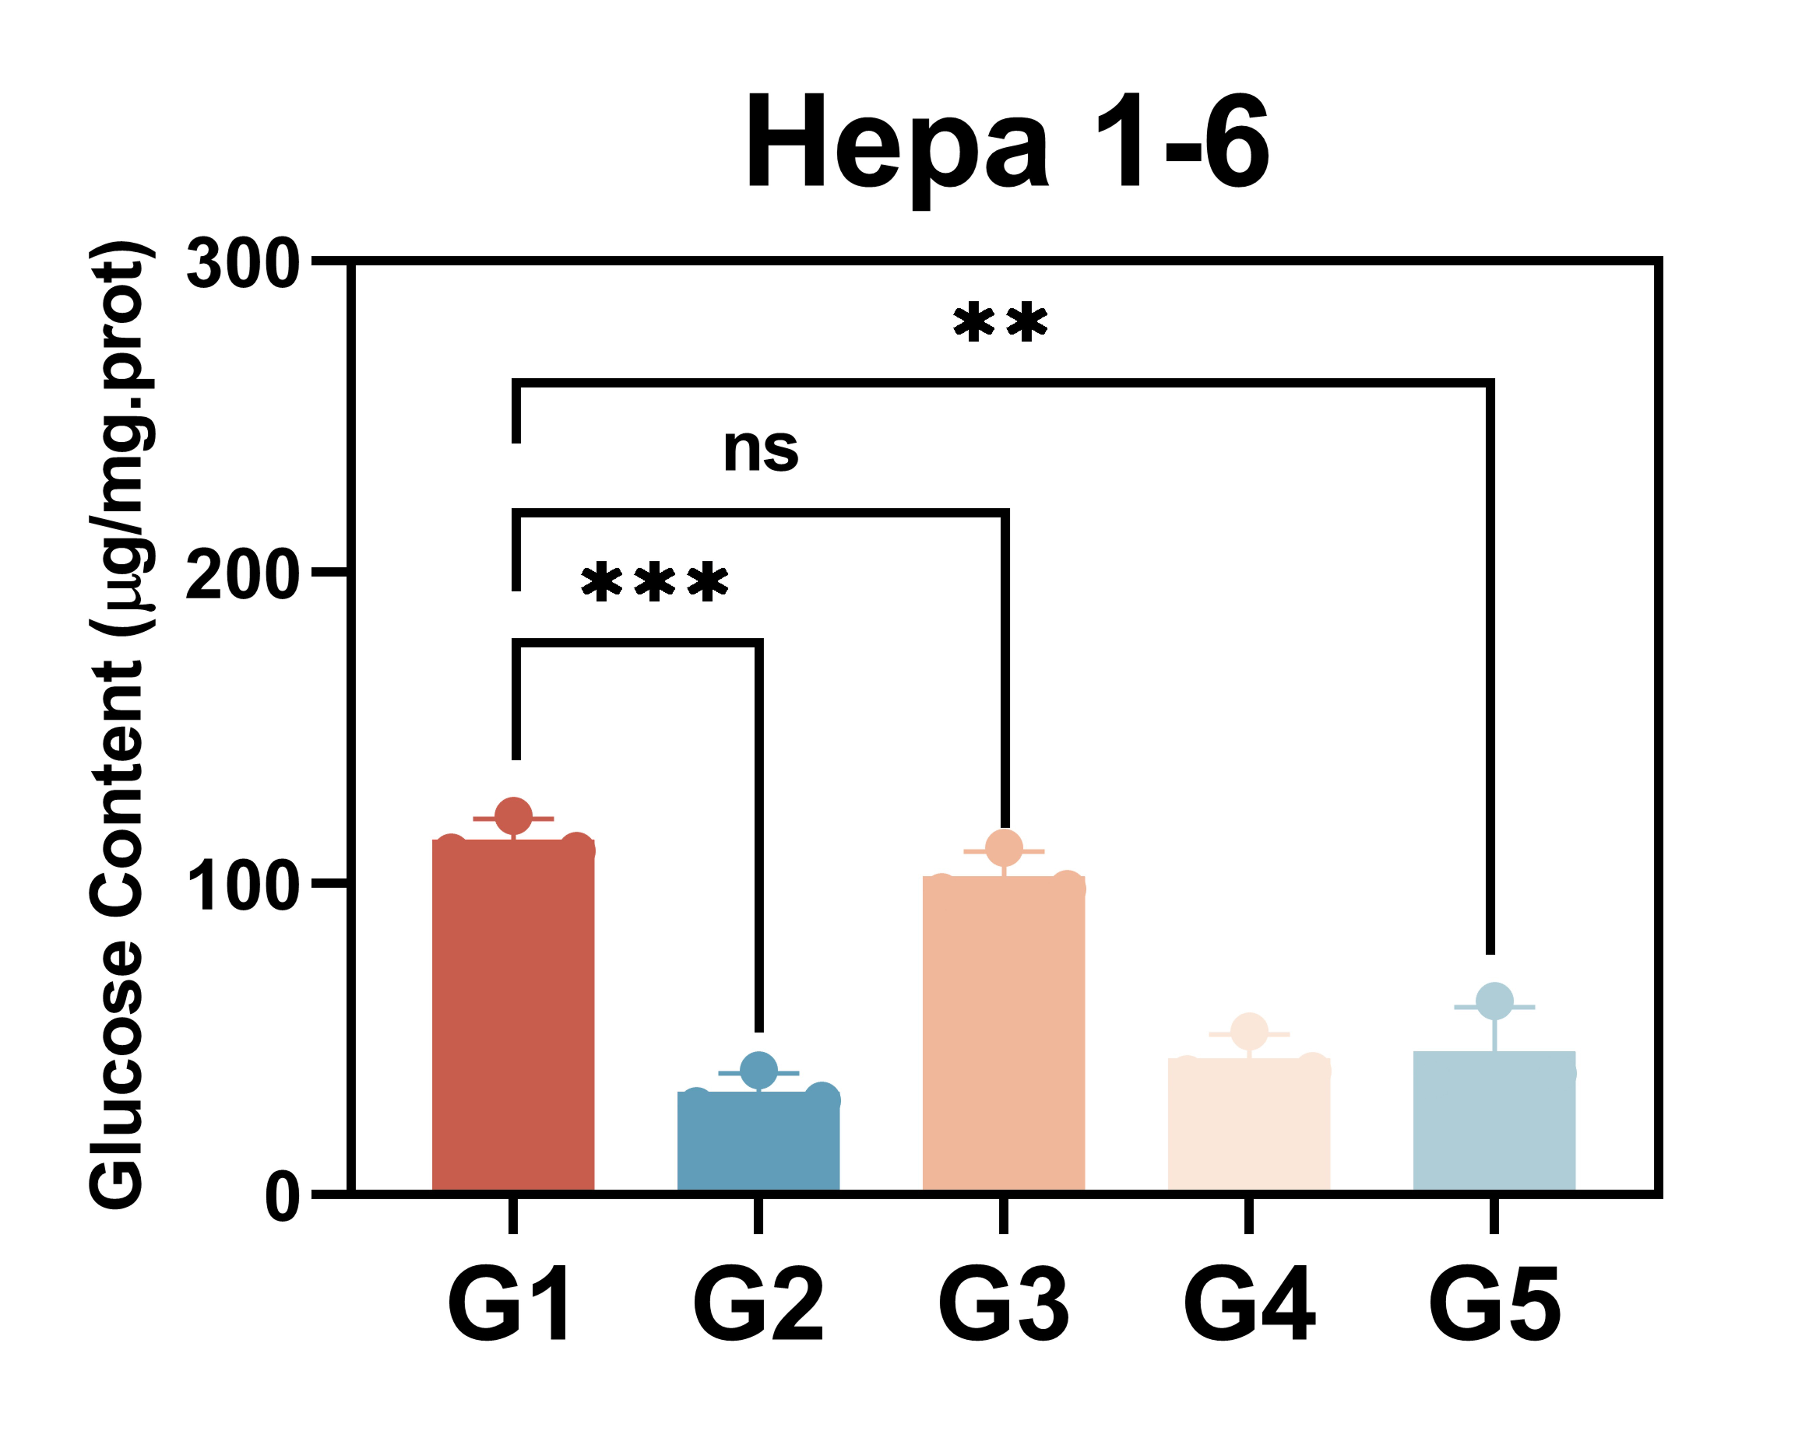

Figure S7. Measurement of intracellular glucose content in Hepa1-6 cells. n=3, ***p < 0.001，**p < 0.01. G1: Control, G2: GOx@Fe₃O₄, G3: EC@Fe₃O₄, G4: GOx/EC@Fe₃O₄, G5: GOx/EC@Fe₃O₄@CCM.

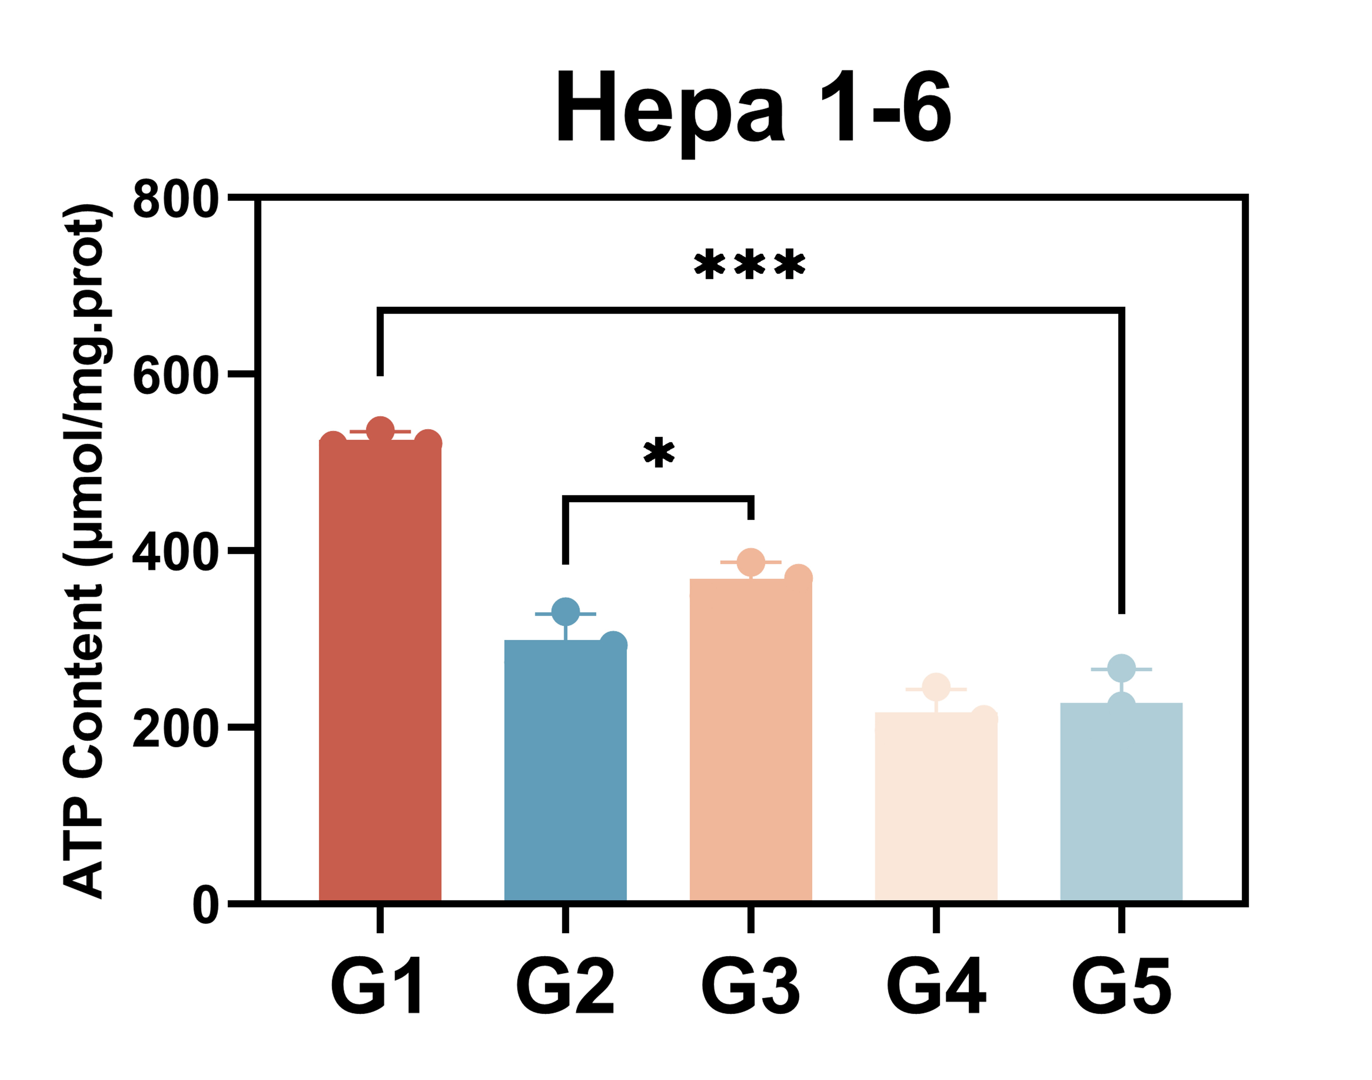

Figure S8. Relative ATP content of Hepa1-6 cells after different treatments. n=3, ***p < 0.001，*p < 0.05. G1: Control, G2: GOx@Fe₃O₄, G3: EC@Fe₃O₄, G4: GOx/EC@Fe₃O₄, G5: GOx/EC@Fe₃O₄@CCM.

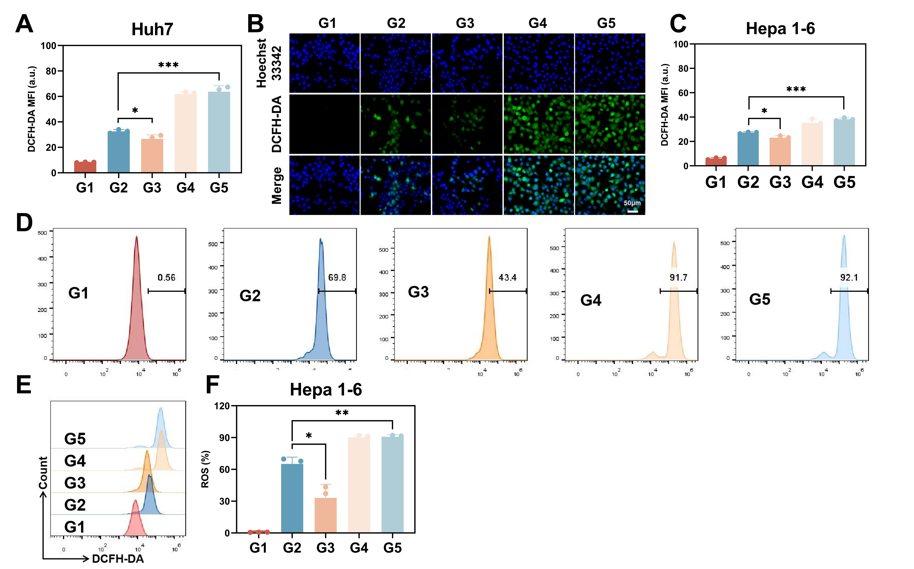

Figure S9. Quantitative analysis of intracellular fluorescence intensity of DCFH-DA staining in Huh7 cells after different treatments (A). Intracellular DCFH-DA staining images and corresponding fluorescence intensity quantitative analysis of Hepa1-6 cells after different treatments (B,C). Flow cytometry images of intracellular DCFH-DA and corresponding fluorescence intensity quantitative analysis of Hepa1-6 cells after different treatments (D-F). Scale bar: 50 μm. n=3, ***p < 0.001，**p < 0.01，*p < 0.05. G1: Control, G2: GOx@Fe₃O₄, G3: EC@Fe₃O₄, G4: GOx/EC@Fe₃O₄, G5: GOx/EC@Fe₃O₄@CCM.

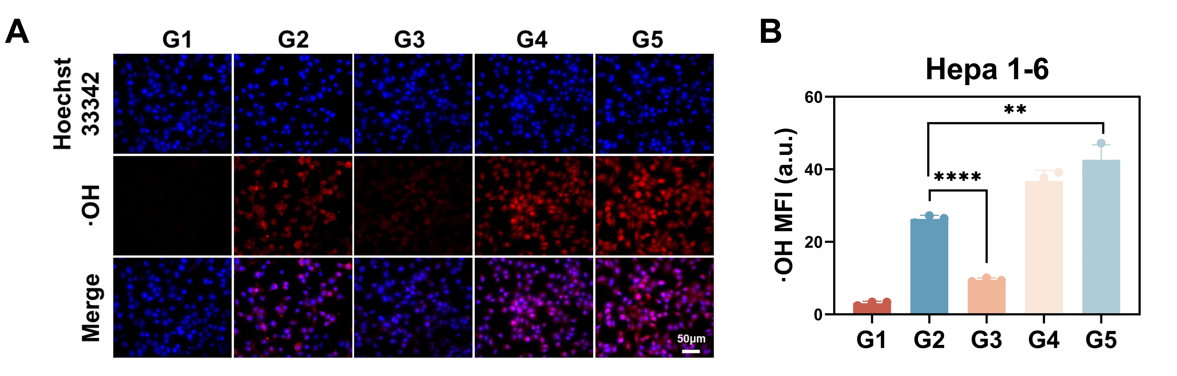

Figure S10. Intracellular hydroxyl radical staining images and corresponding fluorescence intensity quantitative analysis of Hepa1-6 cells after different treatments （A,B）. Scale bar: 50 μm. n=3, ****p < 0.0001，**p < 0.01. G1: Control, G2: GOx@Fe₃O₄, G3: EC@Fe₃O₄, G4: GOx/EC@Fe₃O₄, G5: GOx/EC@Fe₃O₄@CCM.

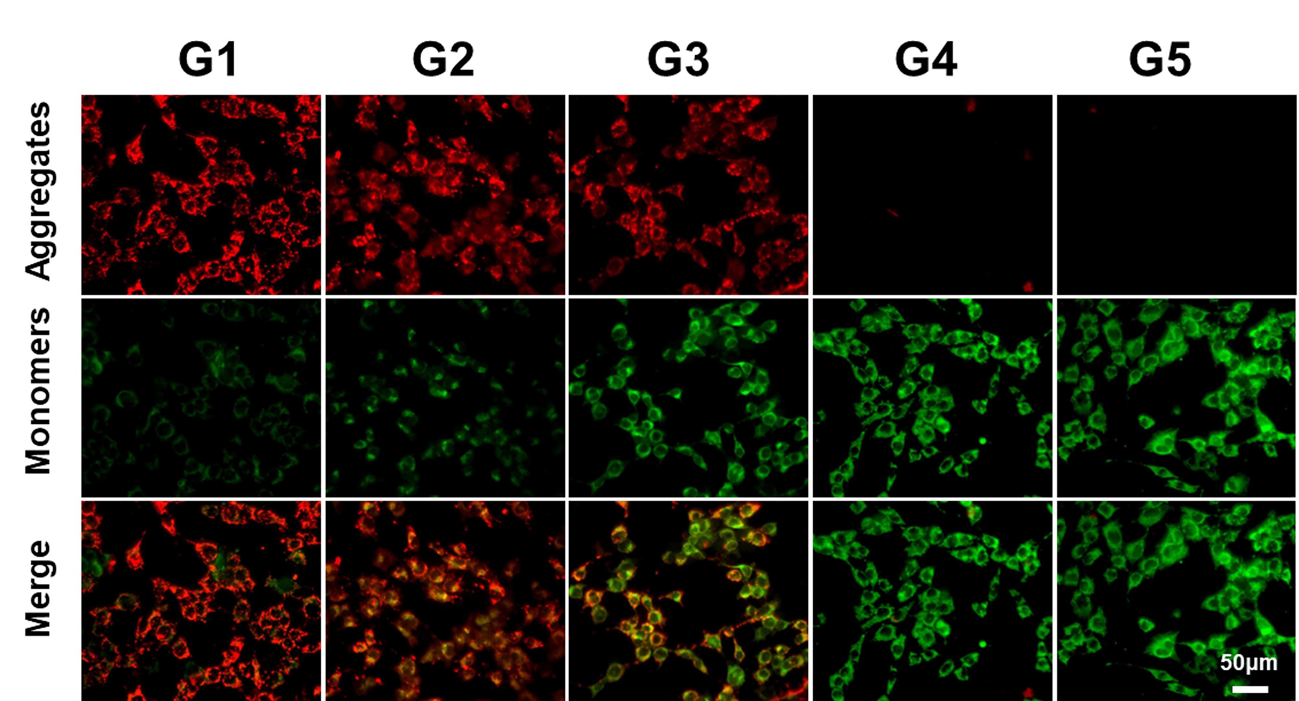

Figure S11. Mitochondrial membrane potential of Hepa1-6 cells after different treatments was shown by JC-1 fluorescent probe. Scale bar: 50 μm. G1: Control, G2: GOx@Fe₃O₄, G3: EC@Fe₃O₄, G4: GOx/EC@Fe₃O₄, G5: GOx/EC@Fe₃O₄@CCM.

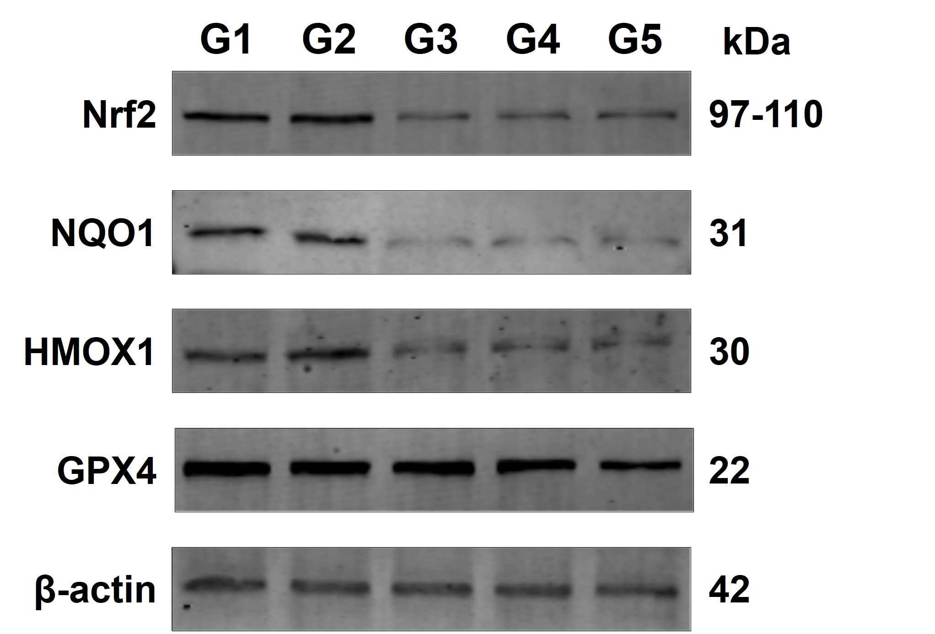

Figure S12. The expression of Nrf2, HMOX1, NQO1, GPX4, and β-actin in Hepa1-6 cells was detected by Western Blot . G1: Control, G2: GOx@Fe₃O₄, G3: EC@Fe₃O₄, G4: GOx/EC@Fe₃O₄, G5: GOx/EC@Fe₃O₄@CCM.

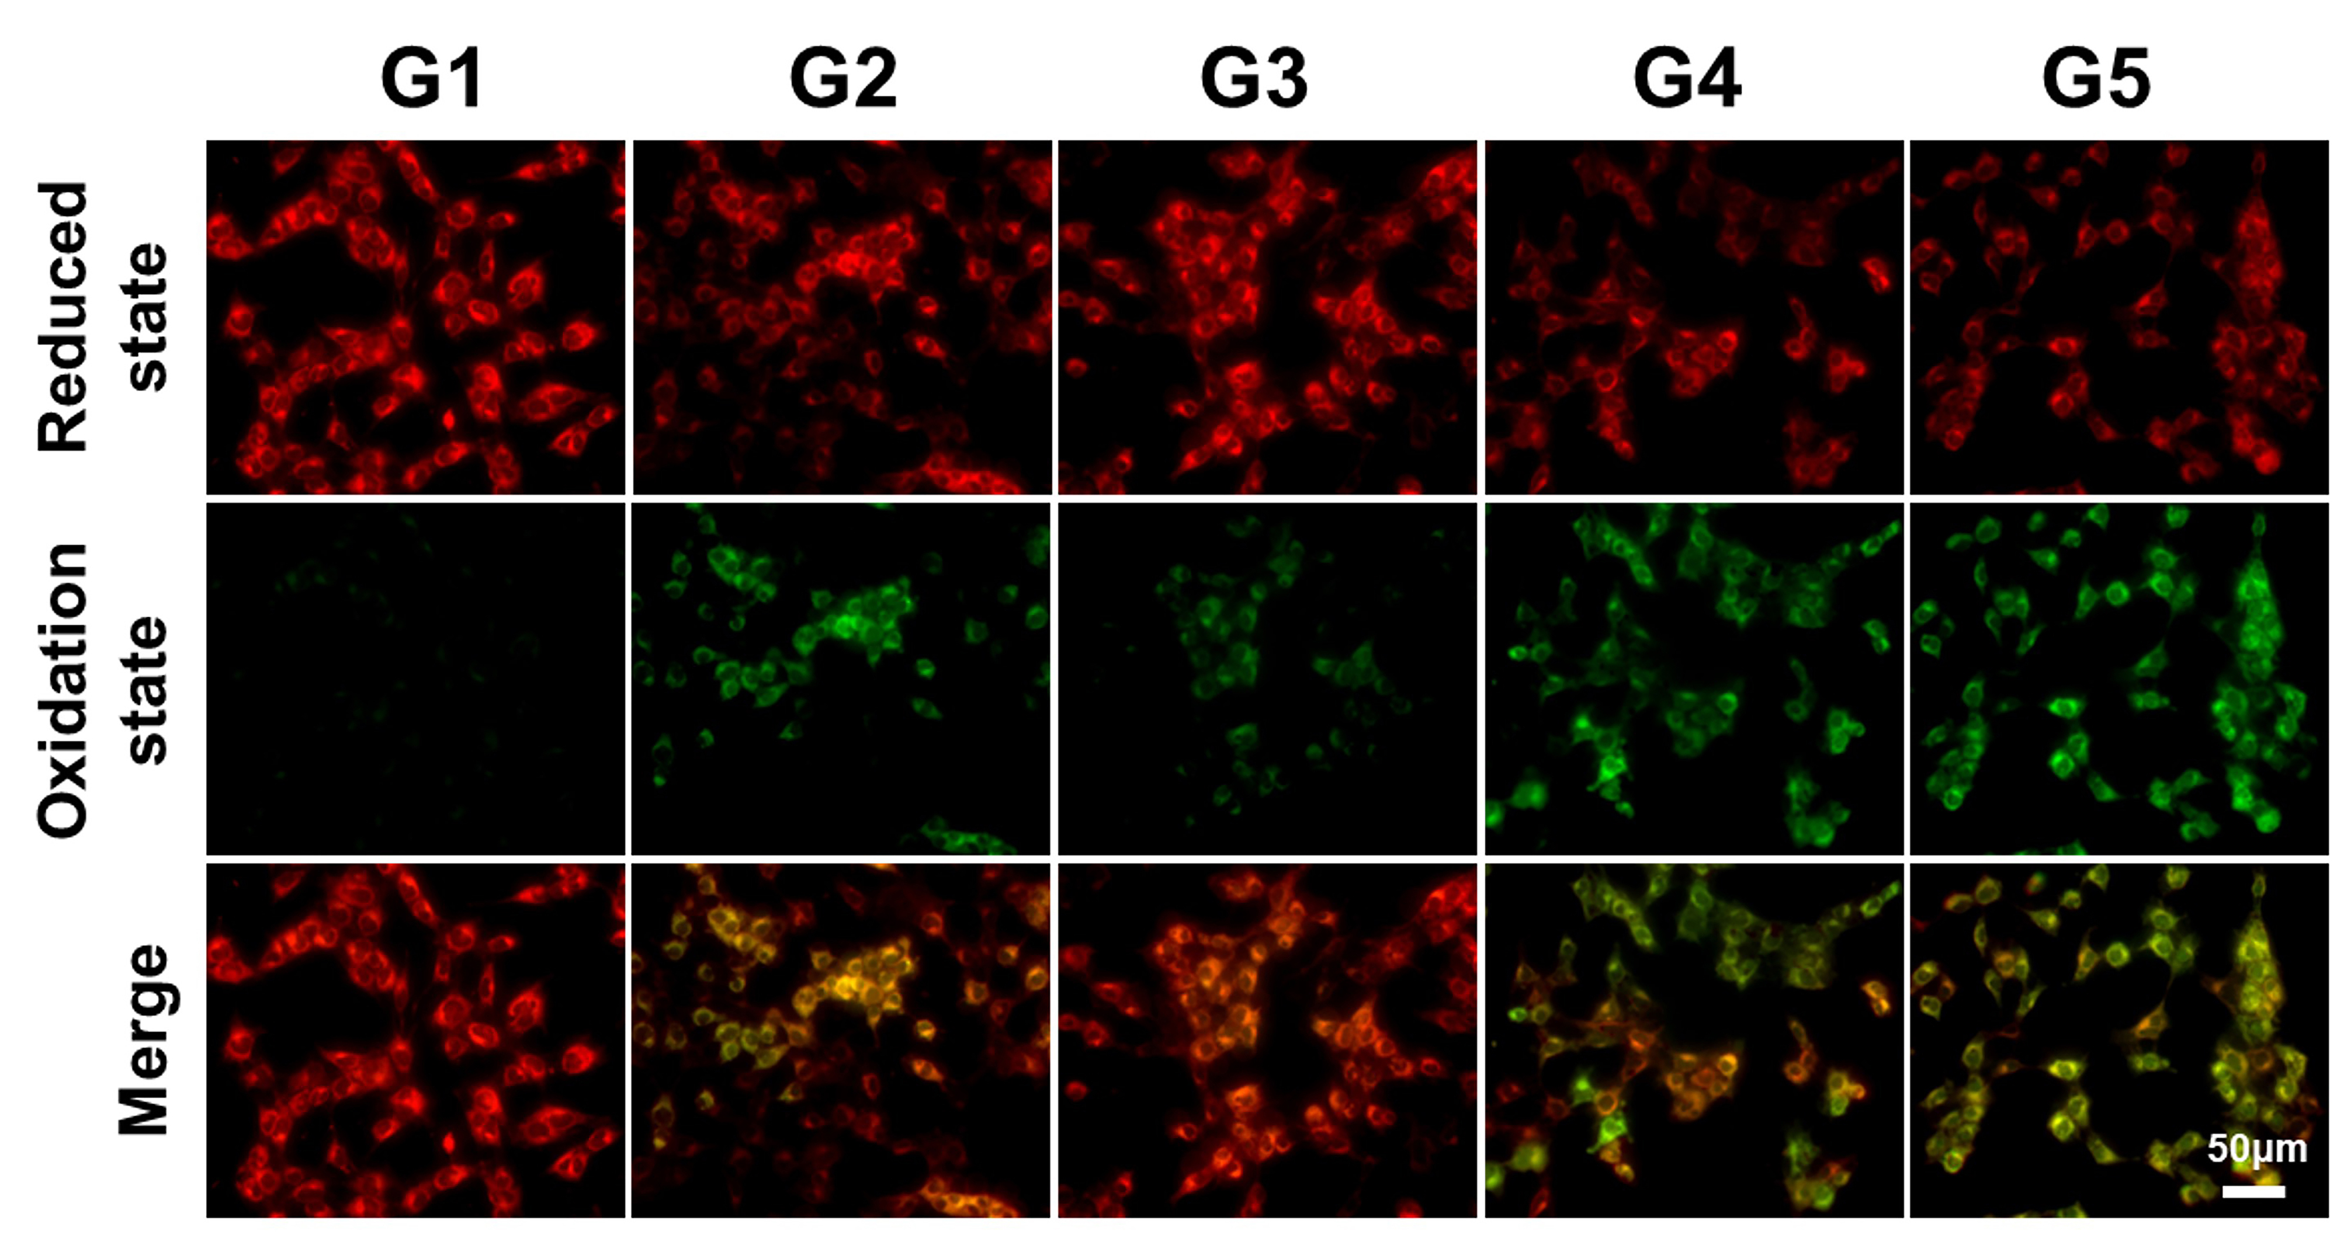
Figure S13. Intracellular C11-BODIPY fluorescent probe staining images of Hepa1-6 cells after different treatments. Scale bar: 50 μm. G1: Control, G2: GOx@Fe₃O₄, G3: EC@Fe₃O₄, G4: GOx/EC@Fe₃O₄, G5: GOx/EC@Fe₃O₄@CCM.

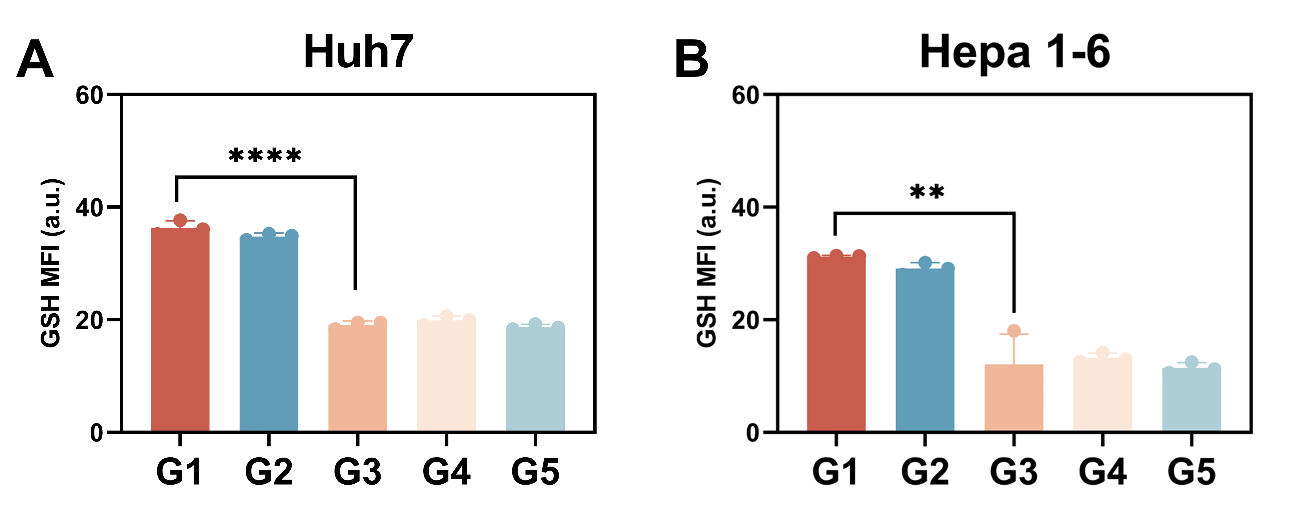

Figure S14. Huh7 and Hepa1-6 cells after different treatment of intracellular ThiolTracker ™ Violet fluorescent staining fluorescence quantitative analysis（A,B）. n=3, ****p < 0.0001，**p < 0.01. G1: Control, G2: GOx@Fe₃O₄, G3: EC@Fe₃O₄, G4: GOx/EC@Fe₃O₄, G5: GOx/EC@Fe₃O₄@CCM.

Figure S15. The volume of the tumor during treatment (n = 5).

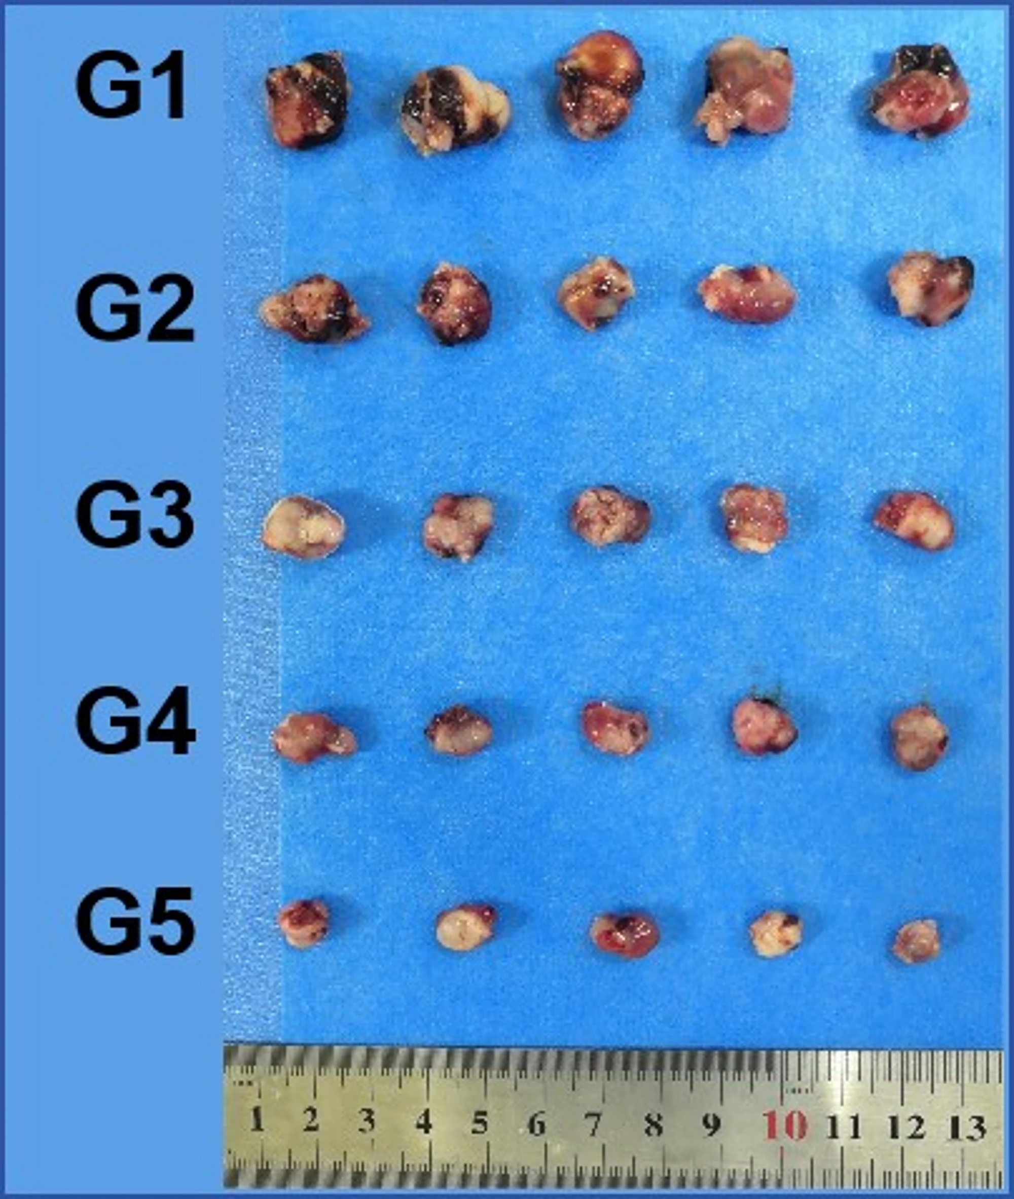

Figure S16. The picture shows the collected tumor mass. G1: Control, G2: GOx@Fe₃O₄, G3: EC@Fe₃O₄, G4: GOx/EC@Fe₃O₄, G5: GOx/EC@Fe₃O₄@CCM.

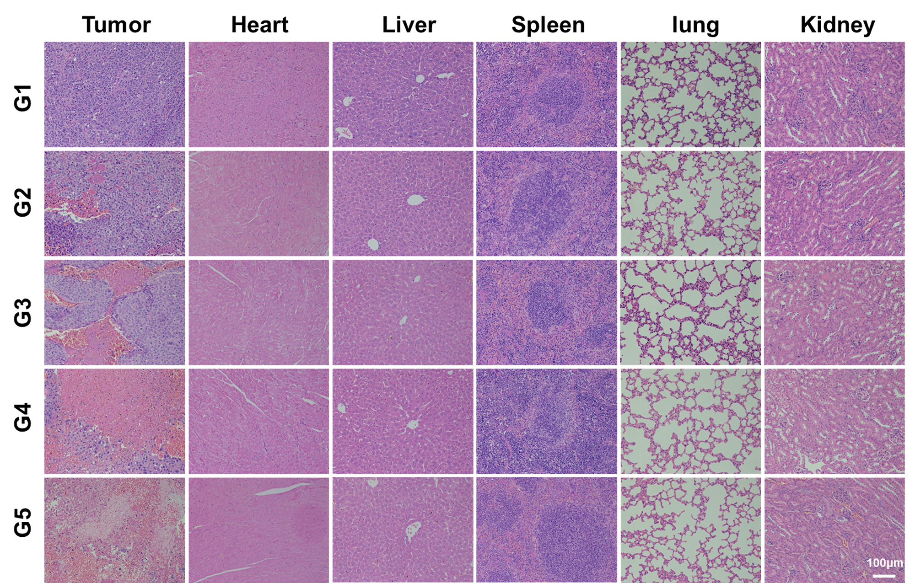

Figure S17. H&E stained images of the tumor tissue were dissected after treatment. Scale bar: 100 μm. G1: Control, G2: GOx@Fe₃O₄, G3: EC@Fe₃O₄, G4: GOx/EC@Fe₃O₄, G5: GOx/EC@Fe₃O₄@CCM.

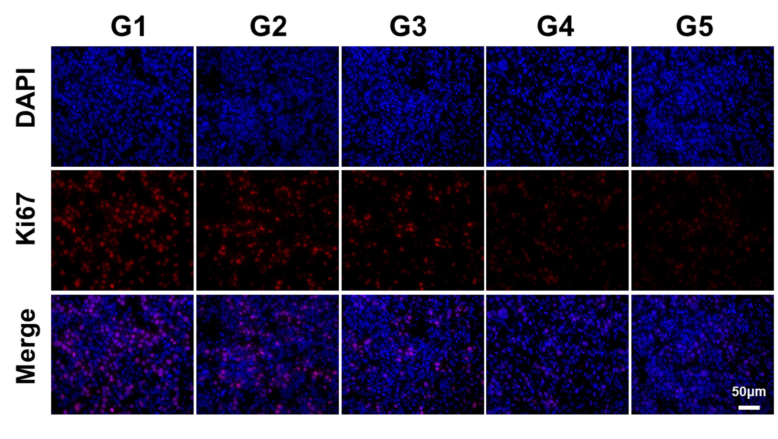

Figure S18. Ki67 staining images of tumor tissue were dissected after treatment. Scale bars: 50 μm. G1: Control, G2: GOx@Fe₃O₄, G3: EC@Fe₃O₄, G4: GOx/EC@Fe₃O₄, G5: GOx/EC@Fe₃O₄@CCM.

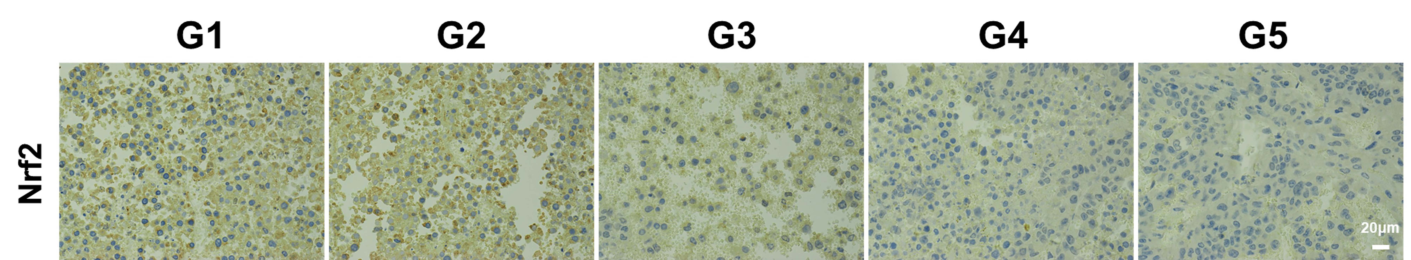

Figure S19. Nrf2 staining images of tumor tissues were dissected after treatment. Scale bars: 20 μm. G1: Control, G2: GOx@Fe₃O₄, G3: EC@Fe₃O₄, G4: GOx/EC@Fe₃O₄, G5: GOx/EC@Fe₃O₄@CCM.

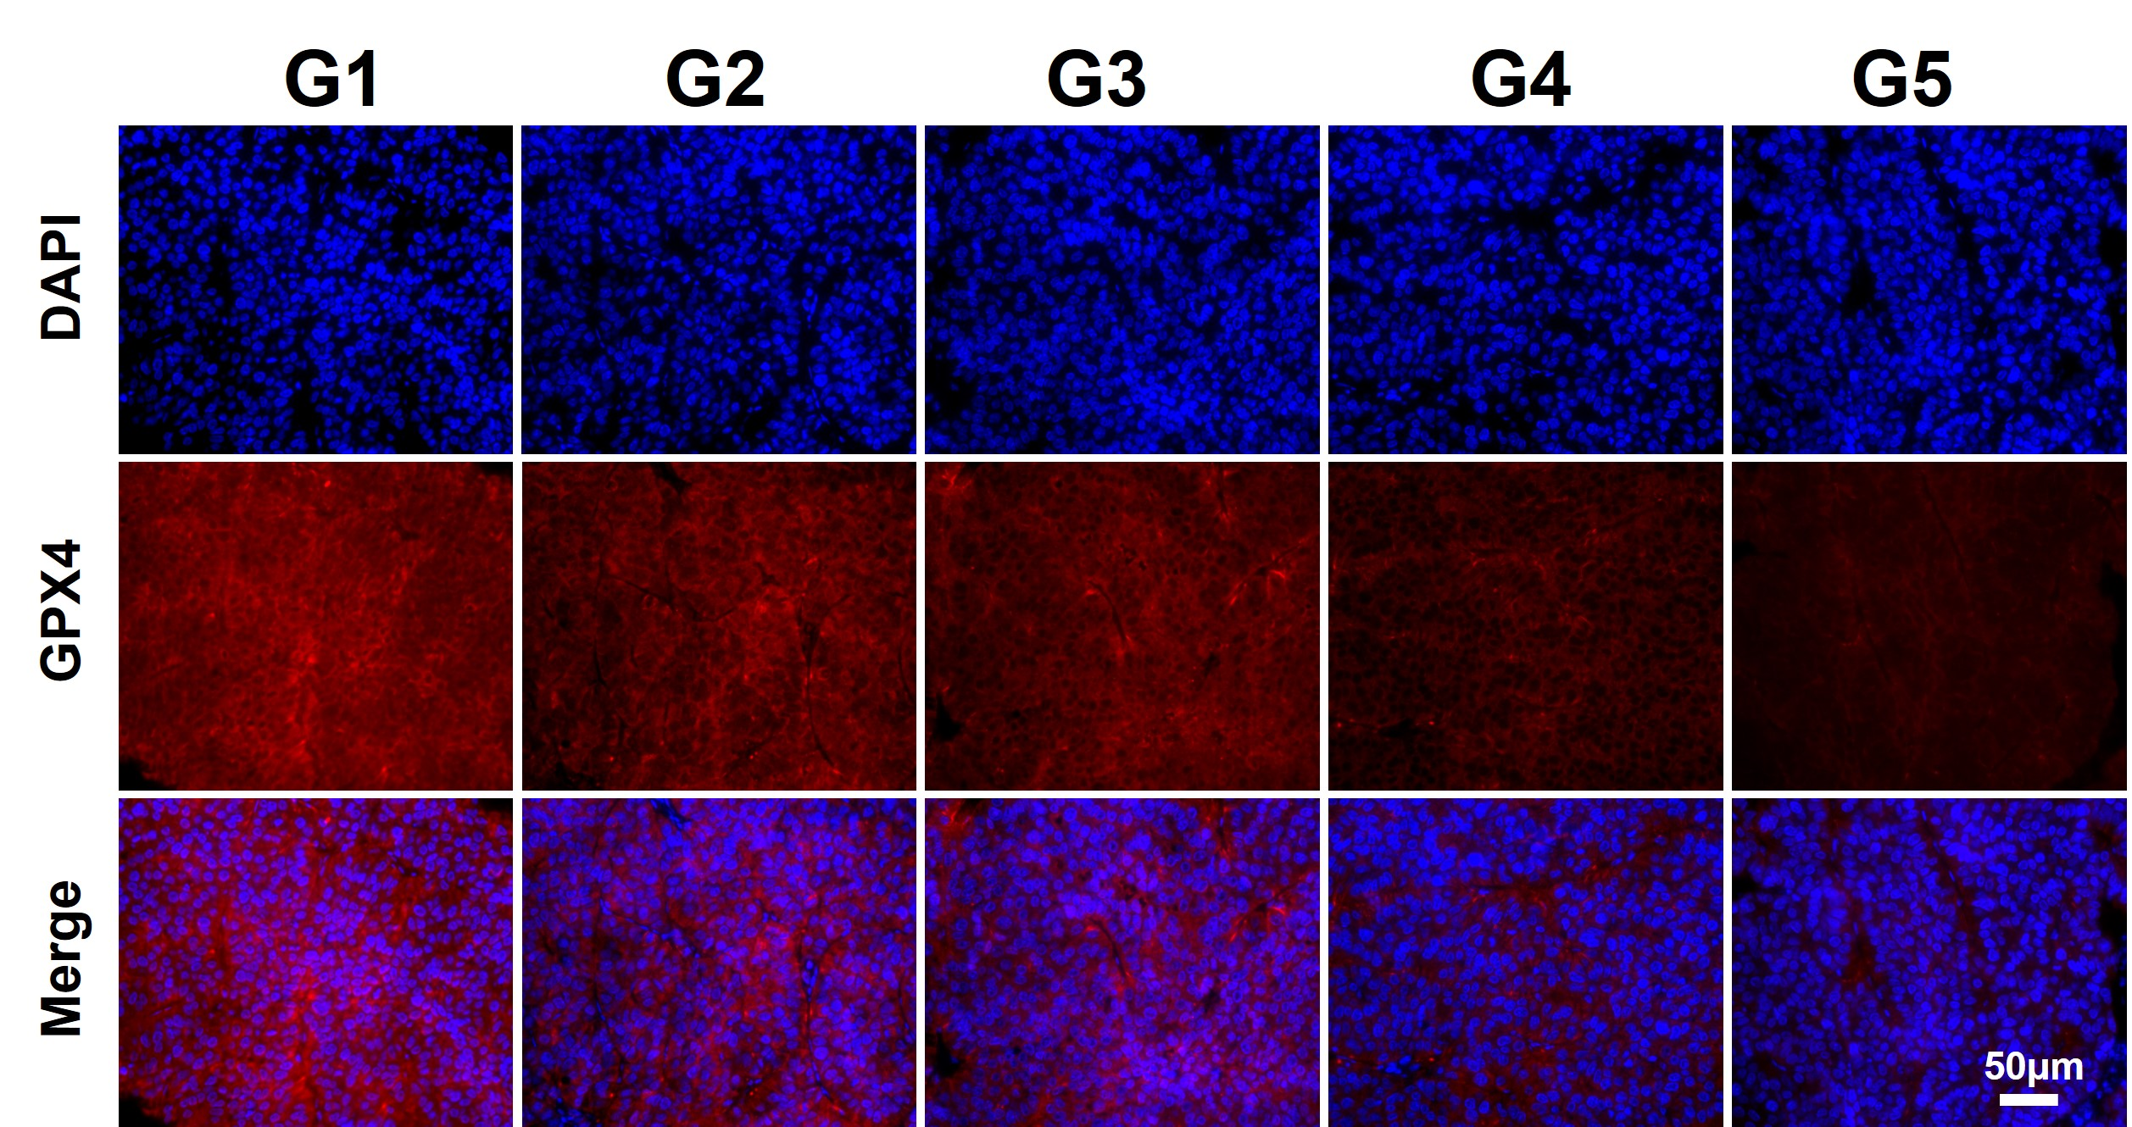

Figure S20. GPX4 staining images of tumor tissue were dissected at the end of treatment. Scale bars: 50 μm. G1: Control, G2: GOx@Fe₃O₄, G3: EC@Fe₃O₄, G4: GOx/EC@Fe₃O₄, G5: GOx/EC@Fe₃O₄@CCM.

Figure S21. The liver and kidney functions of the mice were examined after treatment (ALT、AST、ALB、ALP、BUN、CREA、UA). n=3. G1: Control, G2: GOx@Fe₃O₄, G3: EC@Fe₃O₄, G4: GOx/EC@Fe₃O₄, G5: GOx/EC@Fe₃O₄@CCM.

