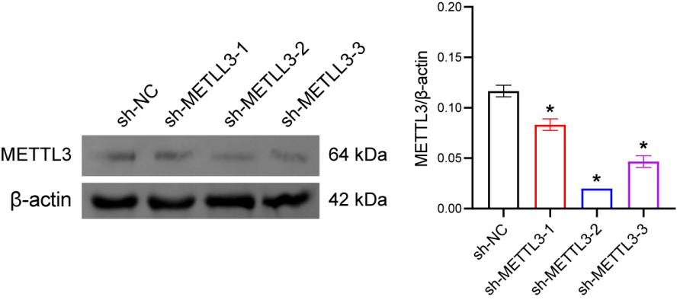
Figure S1: Detection of sh-METTL3 knockdown efficiency. RT-qPCR and Western blot analysis of METTL3 expression in HUVECs. *P<0.05 vs. the sh-NC group.

