Modified Ce/Zr-MOF nanoparticles loaded with curcumin for Alzheimer’s disease via multifunctional modulation
Yan Yang, Yiling Wang, Xinran Jiang, Jiahao Mi, Dizhang Ge, Yuna Tong, Yuxuan Zhu

Table S1. Conditions for the synthesis of different Ce/Zr-MOF products (M01, M02 and M03).
Sample | Ce:Zr（n/n） | Ce (μL) | Zr (μL) | H₂BDC (mg) | HCOOH (mL) | DMF (mL)
M01 | 1:5 | 200 | 1000 | 127.6 | 1.03 | 3.6
M02 | 2:4 | 400 | 800 | 127.6 | 1.03 | 3.6
M03 | 3:3 | 600 | 600 | 127.6 | 1.03 | 3.6

Table S2.Hydrodynamic diameter, polydispersity index and zeta potential of M01, M02 and M03. Data are presented as mean ± SD (n = 3).
Sample | Ce:Zr(n/n) | D_{H} (nm) | PDI | ZP (mV)
M01 | 1:5 | 162.59 ± 1.19 | 0.063 ± 0.001 | 42.0 ± 1.4
M02 | 2:4 | 193.49 ± 2.03 | 0.104 ± 0.003 | 42.8 ± 1.2
M03 | 3:3 | 480.20 ± 11.00 | 0.218 ± 0.002 | 43.9 ± 1.5

Figure S1.Map Sum spectrum of Ce/Zr-MOF (M02).

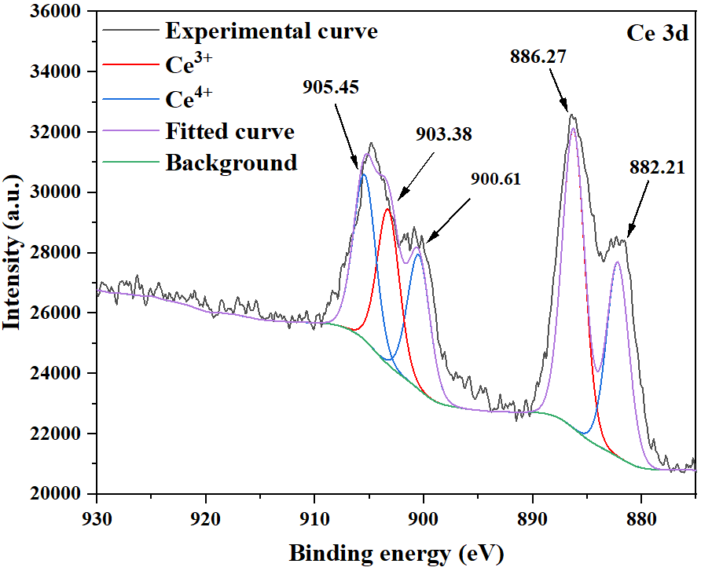
Figure S2. XPS spectra of Ce 3d.
Table S3. Loading capacity and encapsulation efficiency of curcumin. Data are presented as mean ± SD (n = 3).
Cur: Ce/Zr-MOF (m/m) | Ce/Zr-MOF (mL) | Cur (mL) | LC (%) | EE (%)
0.25:1 | 1 | 0.5 | 15.14 ± 1.60 | 75.69 ± 7.99
0.5:1 | 1 | 1 | 11.98 ± 2.34 | 35.94 ± 7.02
1:1 | 1 | 2 | 12.49 ± 2.90 | 24.99 ± 5.80
2:1 | 1 | 4 | 9.10 ± 0.98 | 13.65 ± 1.48
2.5:1 | 1 | 5 | 9.00 ± 1.74 | 12.60 ± 2.43

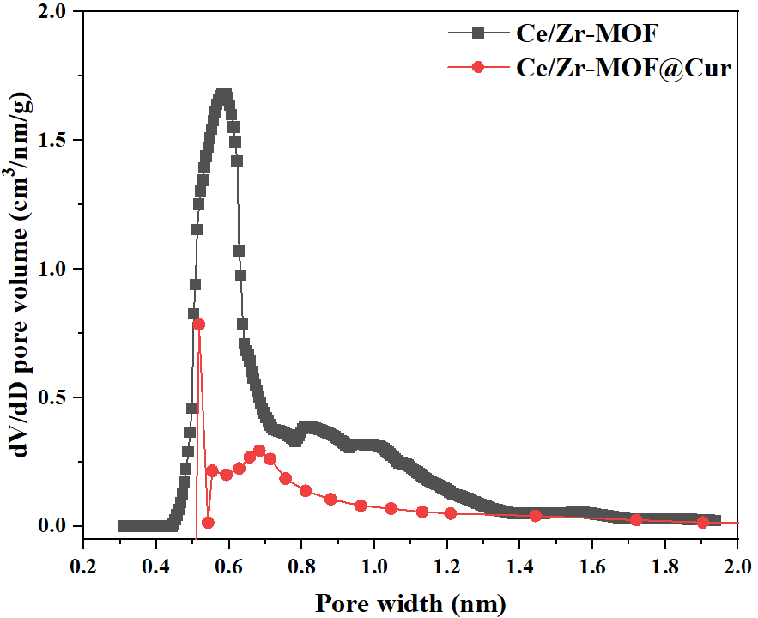
Figure S3. Pore size distribution of Ce/Zr-MOF and Ce/Zr-MOF@Cur.

Table S4. Surface area, micropore volume and pore diameter of Ce/Zr-MOF and Ce/Zr-MOF@Cur.
Sample | S_{BET}（m²/g） | Vp（cm³/g） | Pore width（nm）
Ce/Zr-MOF | 1124.207 | 0.390 | 0.5875
Ce/Zr-MOF@Cur | 349.6611 | 0.101472 | 0.51732

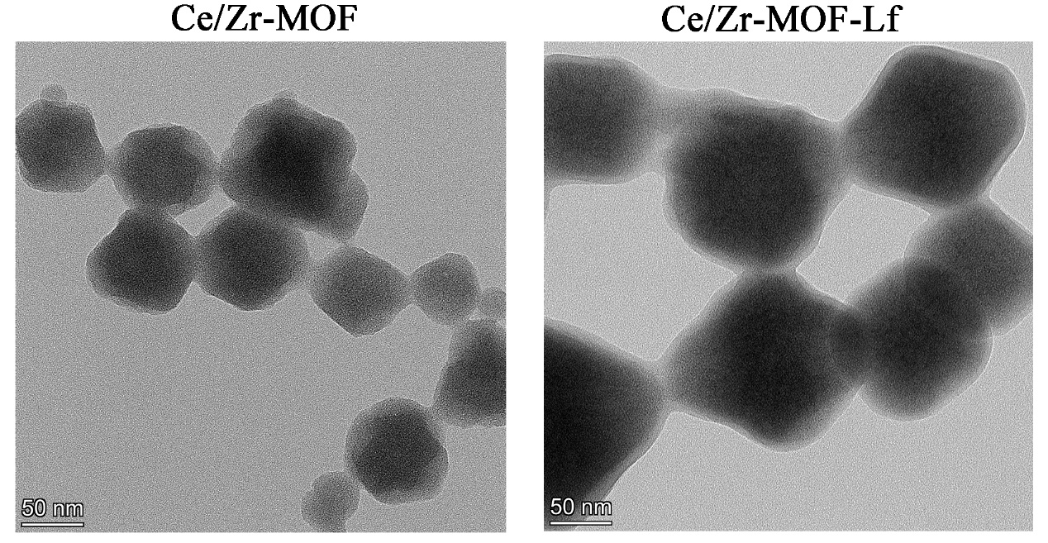
Figure S4. TEM images of Ce/Zr-MOF and Ce/Zr-MOF-Lf. Bar = 50 nm.

Table S5. Hydrodynamic diameter, polydispersity index and zeta potential of Ce/Zr-MOF, Ce/Zr-MOF@Cur, Ce/Zr-MOF@Cur-HA and Ce/Zr-MOF@Cur-Lf. Data are presented as mean ± SD (n = 3).
Sample | D_{H} (nm) | PDI | ZP (mV)
Ce/Zr-MOF | 201.1 ± 1.31 | 0.076 ± 0.007 | 41.1 ± 0.2
Ce/Zr-MOF@Cur | 243.7 ± 4.12 | 0.157 ± 0.003 | 16.3 ± 0.5
Ce/Zr-MOF@Cur-HA | 275.9 ± 11.73 | 0.210 ± 0.002 | -16.0 ± 0.2
Ce/Zr-MOF@Cur-Lf | 286.0 ± 2.77 | 0.192 ± 0.024 | 5.2 ± 0.3

Figure S5. Representative uptake images of PC12 cells after coincubation with free FITC and Ce/Zr-MOF-Lf/FITC with different concentrations for 6 h. Bar = 100 μm.

Figure S6. Representative uptake images of bEnd.3 cells after coincubation with free FITC and Ce/Zr-MOF-Lf/FITC with different concentrations for 6 h. Bar = 100 μm.

Figure S7. Representative uptake images of PC12 cells after coincubation with free FITC and Ce/Zr-MOF-Lf/FITC for 1, 2, 4 and 6 h. Bar = 100 μm.

Figure S8. Representative uptake images of bEnd.3 cells after coincubation with free FITC and Ce/Zr-MOF-Lf/FITC for 1, 2, 4 and 6 h. Bar = 100 μm.

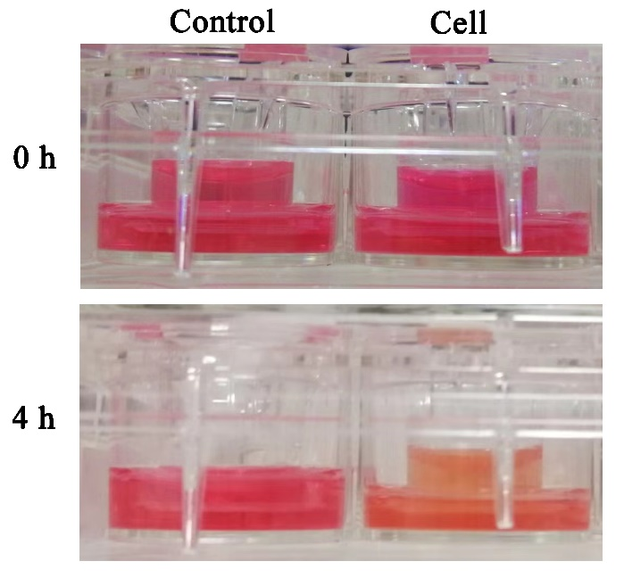
Figure S9. After adding culture medium to the upper chamber for 4 h, the photographs of plates were obtained.

To evaluate the toxicity of the nanopreparation in vivo, all mice were weighed once every two days during the treatment. Meanwhile, after the animals were sacrificed, main organs (heart, liver, spleen, lung, and kidney) were collected, subsequently fixed, dehydrated, embedded in paraffin, sectioned, stained with hematoxylin and eosin and observed with optical microscopy (AXIO imager A2, ZEISS, Germany).

Figure S10. (A) Weight changes of mice during treatment. Data are presented as mean ± SD (n=5). (B) HE staining of major organs in different groups. Bar = 100 μm. (C) The serum biochemical parameters test associated with the liver and renal.

The toxicity of the nanopreparation in vivo was evaluated via weight monitoring and HE staining of major organs. The body weight of each group showed no significant difference during the treatment. Moreover, there was no observed pathological change in the main organs, including heart, liver, spleen, lung and kidney after two weeks of treatment with Ce/Zr-MOF@Cur-Lf. Additionally, the serum biochemical parameters associated with the liver and renal were measured after treatment with Ce/Zr-MOF@Cur-Lf. No significant change was found between the Ce/Zr-MOF@Cur-Lf treatment group and the control group. In short, the Ce/Zr-MOF@Cur-Lf used in this study has excellent biocompatibility and low systemic toxicity, showing great potential in clinical application.

