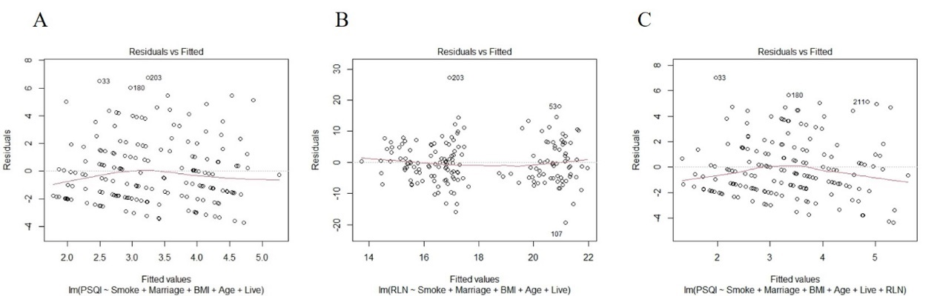
Supplementary Figure 1: Linear relationship in three models of linear regression.
Notes:
The linear relationship test of the three linear regression models. (A: model 1, B: model 2, C: model 3)

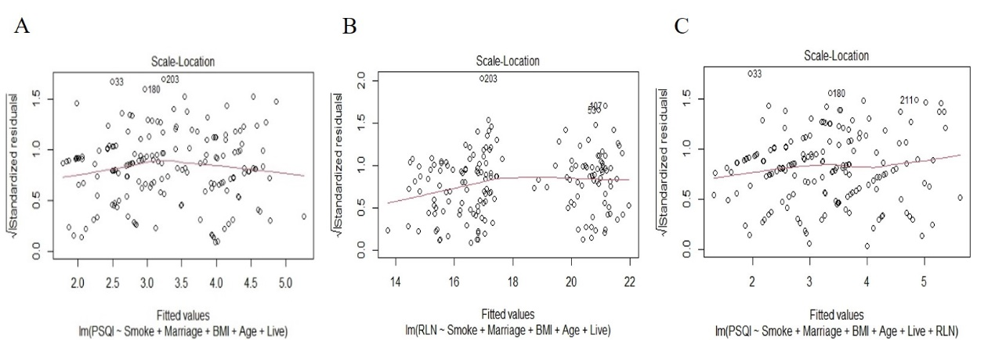
Supplementary Figure 2: Homogeneity of variance in three models of linear regression.
Notes:
The homogeneity of variance test of the three linear regression models. (A: model 1, B: model 2, C: model 3)

