ORIGINAL RESEARCH

pH-responsive charge-reversal smart nanoparticles for co-delivery of mitoxantrone and copper ions to enhance breast cancer chemo-chemodynamic combination therapy
Tao Tan¹*, Weiyi Chang^{1,2}*, Tian Long Wang¹, Wei Chen¹,Xiaobing Chen¹, Chunmiao Yang¹, Dongsheng Yang¹

¹College of Life Science, Zhuhai College of Science and Technology, Zhuhai 519041, People’s Republic of China; ²College of Life Science, Jilin University, Changchun 130012, People’s Republic of China

*These authors contributed equally to this work

Correspondence: Dongsheng Yang, College of Life Science, Zhuhai College of Science and Technology, Zhuhai 519041, People’s Republic of China, Email yds@zcst.edu.cn

Table S1 The Zeta potential, particle size and drug entrapment efficiency of the various nanoparticles，Data are mean±SD (n=3).
 | Zeta potential(mV) |  | particle size(nm) |  | Entrapment efficiency (%)
 | pH 7.4 | pH 6.5 | pH 7.4 | pH 6.5 | Cu²⁺ | MTO
TPRN-C | -2.2±1.1 | 9.0±2.5 | 128.1±2.3 | 198.6±18.5 | 91.3±6.4 | /
TPRN-M | -6.4±3.6 | -0.8±0.5 | 121.1±1.6 | 154.7±11.4 | / | 94.9±1.5
TPRN-CM | -24±1.6 | 10.3±3.7 | 127.6±9.3 | 195.4±14.1 | 94.7±2.0 | 96.1±3.7
TPN-CM | -19.2±0.6 | -4.2±1.9 | 109.7±1.6 | 140.2±1.5 | 93.0±3.5 | 94.1±5.3
PRN-CM | 1.3±0.6 | 11.2±3.8 | 187.9±5.1 | 251.6±2.7 | 93.8±1.2 | 95.1±5.2

Figure S1 Stability of (A) TPRN-C, (B) TPRN-CM, (C) TPN-CM, (D) PRN-CM in PBS (pH 7.4) and whole FBS, which was determined by EE of Cu²⁺ in the nanoparticles. Data are mean±SD (n=3).

Figure S2 Stability of (A) TPRN-M, (B) TPRN-CM, (C) TPN-CM, (D) PRN-CM in PBS (pH 7.4) and whole FBS, which was determined by EE of MTO in the nanoparticles. Data are mean±SD (n=3).
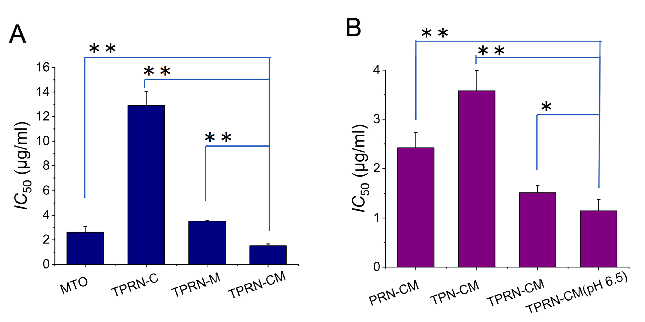
Figure S3 (A) The IC₅₀ of TPRN, TPRN-C, TPRN-M,TPRN-CM in 4T1 cells. (B) The IC₅₀ of TPRN-CM, TPN-CM, PRN-CM,TPRN-CM (pH6.5) in 4T1 cells. Data are mean±SD (n=3). ⁕P<0.5, ⁕⁕P<0.01.
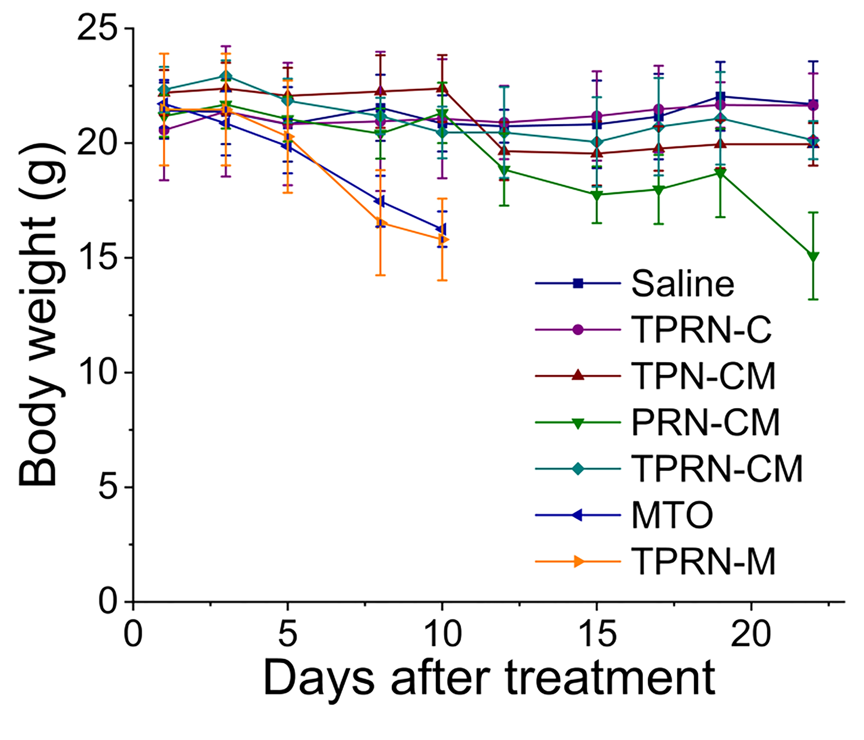
Figure S4 The body weight from each group in 4T1-induced tumor model. Data are mean±SD (n=6).

